CRM Process flow and screen flow …

- Campaign – Create new campaign
  - New screen pop-up when click new button
    - Add necessary details
    - Associate campaign teams
    - Document Templates or attachments
    - Save
  - Select the particular campaign record - Give option to Edit the existing campaign in details page or give option to navigate detail page to edit the record.
The Campaign Details screen is a centralized dashboard for viewing, analyzing, and managing a specific marketing campaign, displaying settings, performance metrics, and creative assets. It typically features key data like status, budget, audience, and ROI, alongside controls to edit, duplicate, or cancel the campaign.
Key Components of a Campaign Screen
- Campaign Information/Summary: Displays the name, description, status (e.g., active, paused), duration, and goals.
- Performance Metrics: Highlights KPIs such as CPC (cost per click), conversion rate, click-through rate, and engagement.
- Audience & Targeting: Details the intended audience segment, demographics, and channels being used.
- Creatives/Assets: Provides quick access to ads, images, videos, or email copy utilized in the campaign.
- Management Options: Includes actions to Edit, Duplicate, Pause, or Delete the campaign.
- Create Lead
Lead Lifecycle Process (End‑to‑End Flow)
1. Lead Capture
- Web forms, API ingestion, event triggers, partner uploads
- Initial syntactic validation (email, phone, mandatory fields)
2. Pre‑Processing & Normalization
- Standardize names, addresses, phone formats
- Normalize company names (e.g., remove Ltd/Inc)
- Enrich with external data (optional)
3. Duplicate Check & Merge Logic
- Fuzzy match scoring
- Auto‑merge rules for low‑risk duplicates
- Manual review queue for high‑risk duplicates
- Parent–child entity alignment (Account → Contact → Lead)
4. Lead Scoring & Qualification
- Behavioral scoring (web visits, downloads)
- Demographic scoring (industry, size, region)
- Fit score + intent score → composite lead score
- Threshold-based routing
5. Assignment & Routing
- Territory rules (geo, segment, product line)
- Round‑robin or load‑balanced assignment
- SLA timers start here
6. Sales Acceptance (SAL)
- Sales rep validates data completeness
- Accept / Reject with reason codes
- Feedback loop to marketing
7. Conversion or Nurture
- Convert to Opportunity / Account / Contact
- Or push into nurture journeys
- Update lifecycle stage and timestamps
8. Governance & Audit
- Field-level audit trail
- Lead aging, SLA breaches, and escalation
- Data quality dashboards
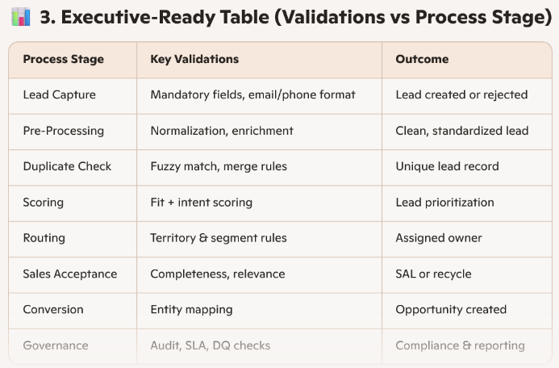
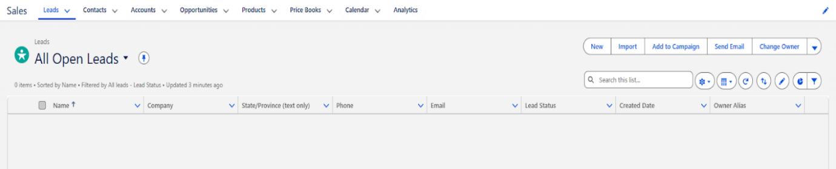
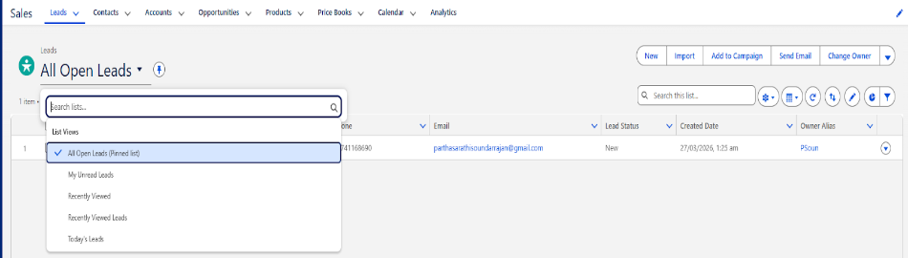
Click New button (Manual creation): open popup to capture the minimum details to create lead.
If the user submit the form using website or email – system should identify and create lead accordingly.
  - If the customer already interacted and existing lead the conversation will keep updating in the lead under mail / activities.
- 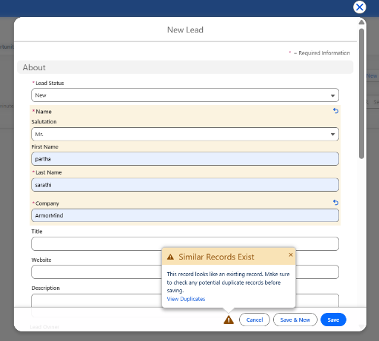
- After save the lead and navigate to detail page clicking lead name
  - Detail page screen
- 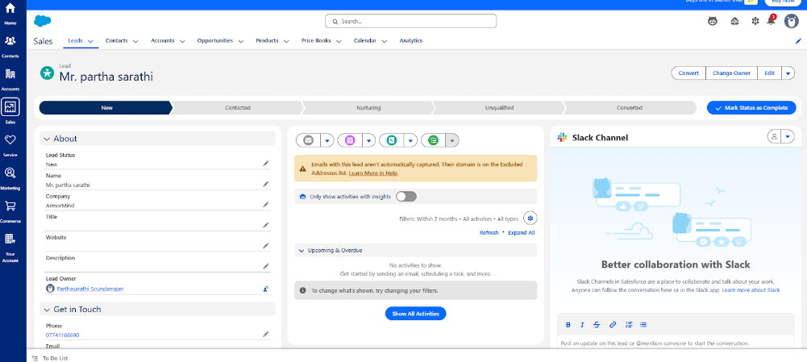
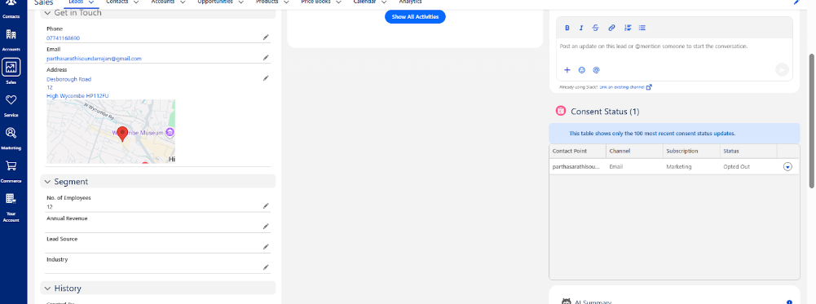
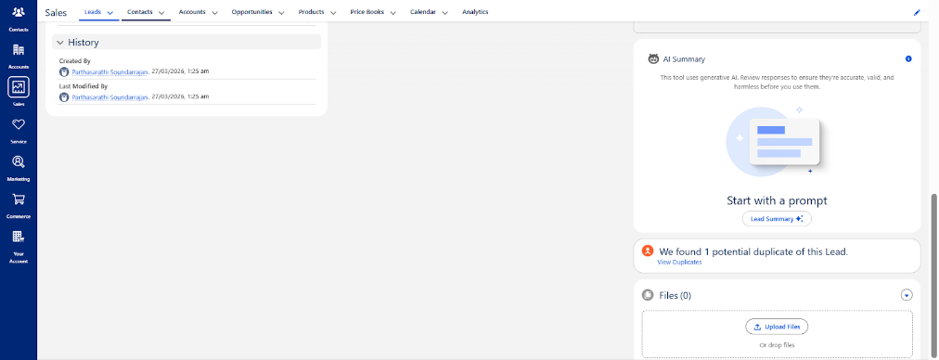

- Convert Lead to opportunity
Option 1 - Once lead stage changed to converted the new opportunity will be created with basic information
Option 2- existing customers directly new opportunity can be crated based on the new product launch/services
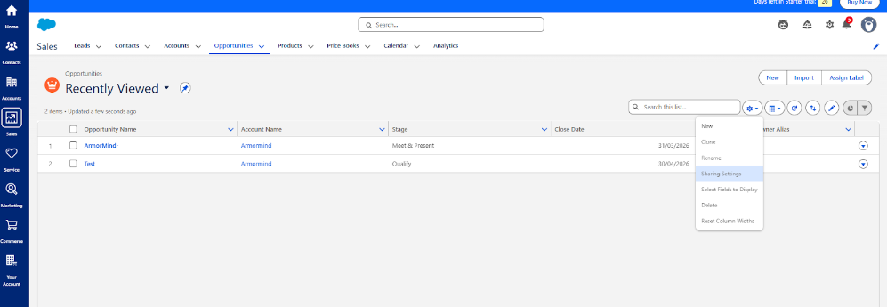
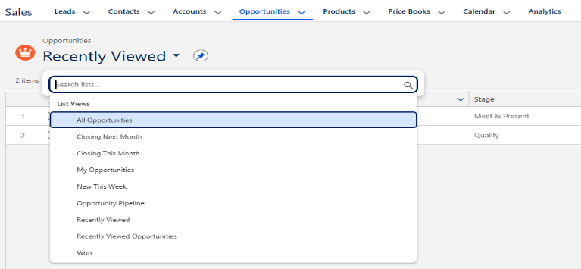
Click Opportunity name drilldowns to details page of the opportunity
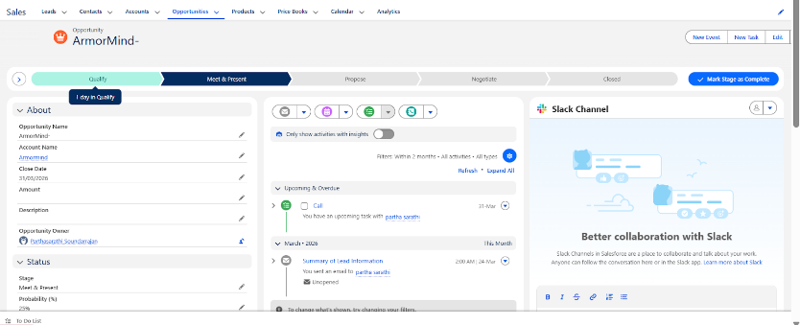
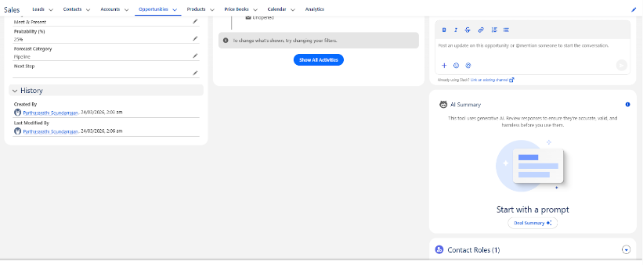
Configure the opportunity score stage screen: - optional
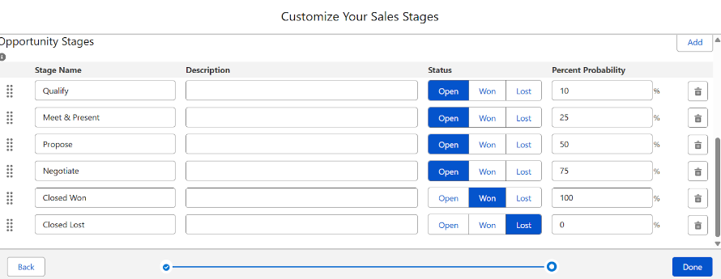
Fields
Oppportunity Name
Account Name
Close Date
Amount
Description
Opty Owner
Opty Team
Status
Stage
Probability
Forecast Category
Next Step
Created By
Modified By

