Group 2

Shota Kameyama  
Muhammad Nasim Akbary  
Mathew Van Beek  
Nils Linhoff

STATUS REPORT

Acme Manufacturing Risk Assessment

Content

Acme Manufacturing (AM) Profile Assumptions 2

Business Risks 2

Technical and business risks against proposed Enterprise Resource Planning (ERP) solutions - summary of Appendix A and B 3

Selection of Methods 3

Timeline 5

References 6

Bibliography 8

Appendix 9

Appendix A: Technical Analysis against three possible solutions 9

Appendix B: Business Analysis against three possible solutions 9

# Acme Manufacturing (AM) Profile Assumptions

AM manufactures Spork categorised as the fabricated metal products or Section C in the UK Standard industrial classification of economic activities (Office for National Statistics, 2018). The literature review provides the following profile assumptions:

* Ability to hire more employees as Department for Business, Energy & Industrial Strategy (DBEIS) (2020) reported that 41% of medium-sized businesses (MEs), or 30% of manufacturing SMEs expect employment growth.
* Expected increasing turnover in 12 months as DBEIS (2020) reported 81% MEs had increased profit, and 47% had increased turnover since 2015.
* Financially stable and holding a greater risk appetite with the DBEIS (2020) supportive reference of 86% of MEs successfully obtaining external finance.
* Low IT capabilities and resource poverty (Premkumar,2003)
* Vulnerable to natural hazards, especially Extreme Weather Events (Crichton, 2006, as cited in Wedawatta et al., 2010)

# Business Risks

* As DBEIS (2020) reported, AM has the success obstacles of 1) market competition, 2) regulations, 3) taxation, and 4) staff recruitment. 32% of manufacturing SMEs apply new or significantly enhanced processes (DBEIS, 2020), improving competitors’ competitiveness.
* May encounter significant technological and environmental uncertainties because of little influence over market prices (Welsh & White, 1981, as cited in Raymond et al., 2019:1),impacting strategy and competitiveness (Bili & Raymond, 1993; Levy & Powell, 1998, as cited in Raymond et al., 2019: 1).
* The relocation of financial services (Alvarez & Marsal, 2018), re-evaluation of business projects, lack of talents in human resources (Clarence-Smith, N.D.), uncertainty in the cash flow and economy of immediate years to come, all due to still-unknowns of Brexit, play a vital role in the organisations’ decision whether to invest for an Information Risk Management platform at this point. Uncertainty in decision-making is a major issue.
* Cybersecurity attacks, impacting business, against SMEs, including manufactures, are so common due to 1) cybersecurity underestimation, 2) limited budgets, 3) shortage of skilled security staff, and 4) huge cost of security awareness training and security auditing solutions (Saleem et al., 2017; Heikkilä et al., 2016).

# Technical and business risks against proposed Enterprise Resource Planning (ERP) solutions - summary of Appendix A and B

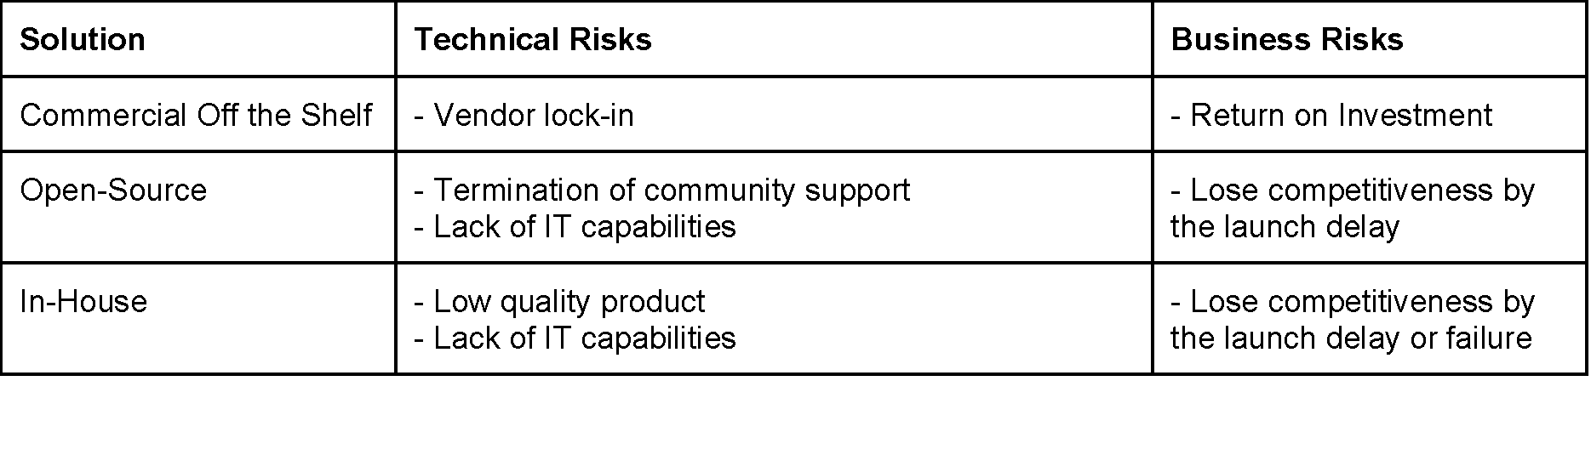

*Table 1:: Technical & Business Risks*

# Selection of Methods

Implementing an ERP system is costly and risky (Markus & Tanis 2000) and literature review reported that more than 70% failed to achieve expected benefits (Technology Strategies, 1998, as cited in Al-Mashari, 2000: 977). As Tomas (2005, as cited in Poba-Nzaou et al., 2008: 531) suggested, we apply a risk management plan to mitigate the risk.

Management and estimation are the primary focus of selecting the risk assessment methodologies. Qualitative approach is not applicable as restricted staff access. We apply and combine The Open Group Standard (TOGS) Factor Analysis for Information Risk (FAIR) and International Organization for Standardization (ISO) 27005 to ensure an effective process (TOGS, 2021).

ISO 27005 details management of risk while FAIR is the methodology, a four-stage process, as Chart 1 describes, that focuses on identifying, analysing, and evaluating the risks (TOGS, 2010). The following should be performed to establish an organisational risk management process (TOGS, 2010):

* risk identification assessments;
* development of risk treatment plans;
* defining and implementing policies and procedures for selected controls; and
* monitoring controls and the overall risk management process.

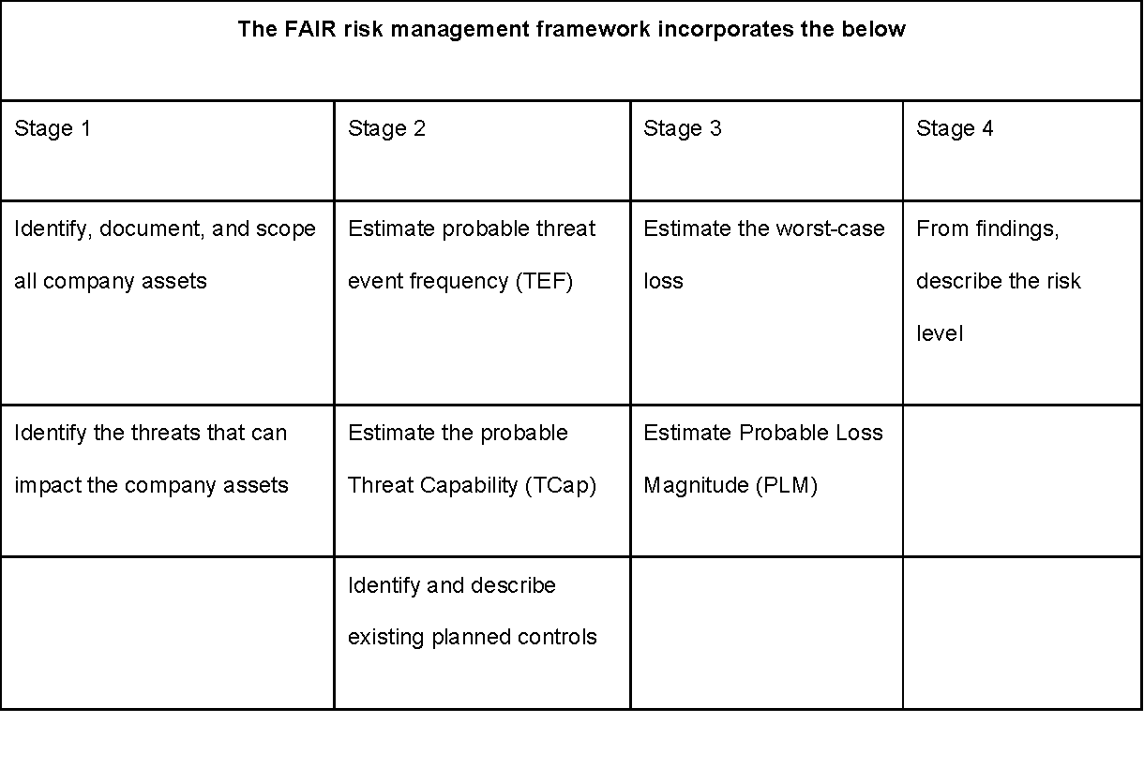

*Chart 1:: 4 stages of FAIR risk management*

Once risks are defined, the team collates a risk treatment plan (TOGS, 2021), including risk reduction, avoidance, transfer and retention.

# Timeline

Risk analysis and disaster recovery planning are the core activities for the timeframe. These tasks can start simultaneously while the cost-benefit analysis needs to factor in the early results of the risk analysis. The tasks regarding the creation of the report can begin as soon as the analysis is nearing its end, closing with the final quality check.

Ein Bild, das Text, drinnen, Screenshot, Bildschirm enthält.

# References

Alvarez & Marsal (2018) Brexit: relocation challenges for financial services firms. Available from: https://www.alvarezandmarsal.com/sites/default/files/article/pdf/brexit_relocation_challenge_report_final.pdf [Accessed 20 November 2021].

Al-Mashari, M. (2000) Constructs of process change management in ERP context: A focus on SAP R/3. *AMCIS 2000 Proceedings*. 113: 977-980.

Blili, S. & Raymond, L. (1993) Information technology: Threats and opportunities for small and medium-sized enterprises. *International journal of information management.* 13(6): 439-448.

Clarence-Smith, T. (N.D.) The Impact of Brexit on the Financial Services Sector. Available from: https://www.toptal.com/finance/market-research-analysts/brexit-and-its-effect-on-the-uk-european-and-global-financial-sector [Accessed 20 November 2021].

Department for Business, Energy & Industrial Strategy (2020) Longitudinal Small Business Survey: SME Employers (businesses with 1-249 employees) - UK, 2019. Available from: https://assets.publishing.service.gov.uk/government/uploads/system/uploads/attachment_data/file/889656/LSBS_2019_employers.pdf [Accessed 20 November 2021].

Heikkilä, M., Rättyä, A., Pieskä, S. & Jämsä, J. (2016) ‘Security challenges in small-and medium-sized manufacturing enterprises’, *2016 International Symposium on Small-scale Intelligent Manufacturing Systems (SIMS).* Narvik, Norway, 21-24 June. IEEE. 25-30.

Markus, M. L. & Tanis, C. (2000) The enterprise systems experience-from adoption to success. *Framing the domains of IT research: Glimpsing the future through the past*. 173(2000): 207-173.

Office for National Statistics (2018) Condensed SIC List in CSV format. Available from: https://www.gov.uk/government/publications/standard-industrial-classification-of-economic-activities-sic [Accessed 20 November 2021].

Poba‐Nzaou, P., Raymond, L. & Fabi, B. (2008) Adoption and risk of ERP systems in manufacturing SMEs: a positivist case study. *Business process management journal*. 14(4): 530-550. DOI: 10.1108/14637150810888064.

Premkumar, G. (2003) A meta-analysis of research on information technology implementation in small business. *Journal of organizational computing and electronic commerce*. 13(2): 91-121.

Raymond, L. Bergeron, F., Croteau, A. M., & Uwizeyemungu, S. (2019) Determinants and outcomes of IT governance in manufacturing SMEs: A strategic IT management perspective. *International Journal of Accounting Information Systems*. 35(100422):1-15. DOI: https://doi.org/10.1016/j.accinf.2019.07.001.

Raymond, L. & Uwizeyemungu, S. (2007) A profile of ERP adoption in manufacturing SMEs. *Journal of Enterprise Information Management*. 20(4): 487-502. DOI: 10.1108/17410390710772731.

Saleem, J., Adebisi, B., Ande, R. & Hammoudeh, M. (2017) ‘A state of the art survey-Impact of cyber attacks on SME's’, *Proceedings of the International Conference on Future Networks and Distributed Systems*. Cambridge, UK, 19-20 July. New York: Association for Computing Machinery. DOI: 10.1145/3102304.3109812.

The Open Group Standard (2010) Open FAIR – ISO/IEC 27005 Cookbook. Available from: https://publications.opengroup.org/c103 [Accessed 25 November 2021].

The Open Group Standard (2021) Risk Analysis (O-RA), Version 2.0.1. Available from: https://publications.opengroup.org/standards/c20a [Accessed 25 November 2021].

Wedawatta, G., Ingirige, B. & Jones, K. (2010) ‘Coping strategies against extreme weather events: A survey of SMEs in the UK’, *RICS Construction and Building research conference (COBRA) 2010*. Université Paris-Dauphine, Paris, July.

# Bibliography

Barbaglia, P., Wilkes, T. & Barzic, G. (May 12, 2021) Bankers quit London as Brexit relocations to EU step up. *Routers*.

Norton Rose Fulbright (2021) Impact of Brexit on financial institutions. Available from: <https://www.nortonrosefulbright.com/en/knowledge/publications/e47d24f4/impact-of-brexit-on-financial-institutions> [Accessed 20 November 2021].

# Appendix

## Appendix A: Technical Analysis against three possible solutions

Appendix A describes further details of technical analysis against hardware, maintenance contract, functionality, reliability, performance, support, future productivity, security and risk of the ERP solution provider. 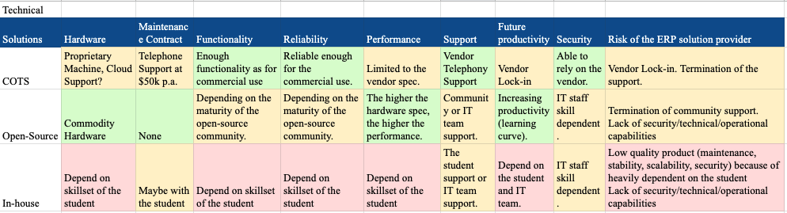

*Appendix A Technical Analysis against hardware, maintenance contract, functionality, reliability, performance, support, future productivity, security and risk of the ERP solution provider*

## Appendix B: Business Analysis against three possible solutions

Appendix B describes further details of business analysis against cost, feasibility, easiness to implement, time to release, easiness to maintain, uncertainty and business risks with discussion points and comments.

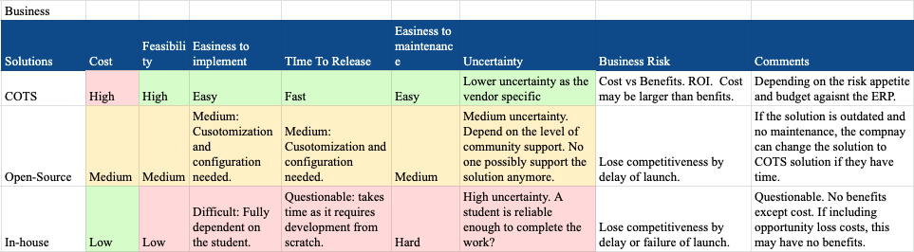

*Appendix B: Business Analysis against cost, feasibility, easiness to implement, time to release, easiness to maintain, uncertainty and business risks with discussion points and comments*

### 