**Unit 9 – Charts Worksheet**

**Exercise 9.1**

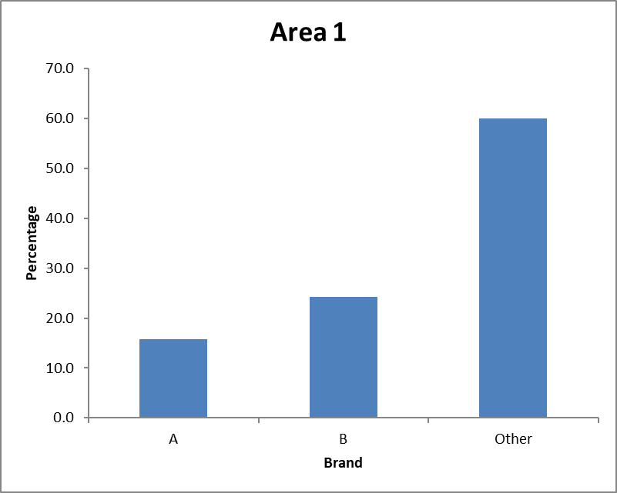Area 1

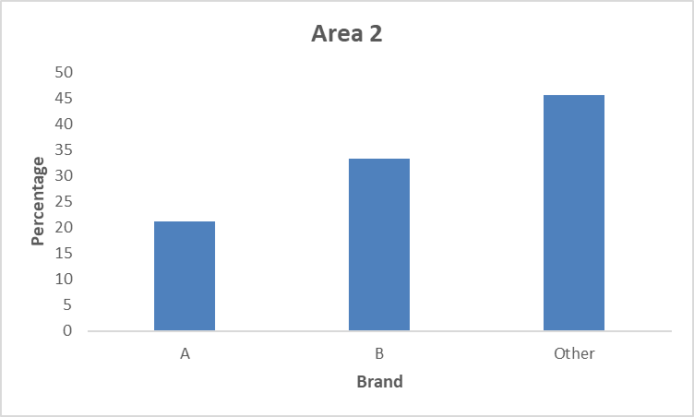 Area 2

Brand B and Other are doing well in area 1 and area 2. Brand A is the least popular in both area 1 and area 2.

**Exercise 9.2**

Frequencies Location A vs Location B

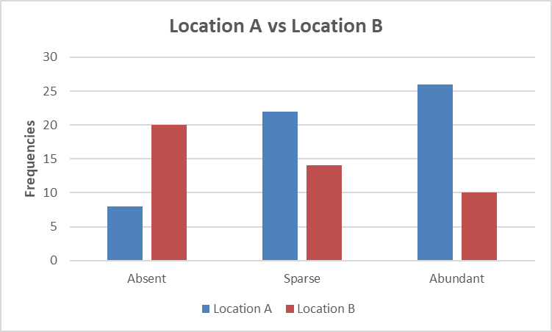

Sparse and Abundant are higher location A compared to B. Absent frequency are high in location B.

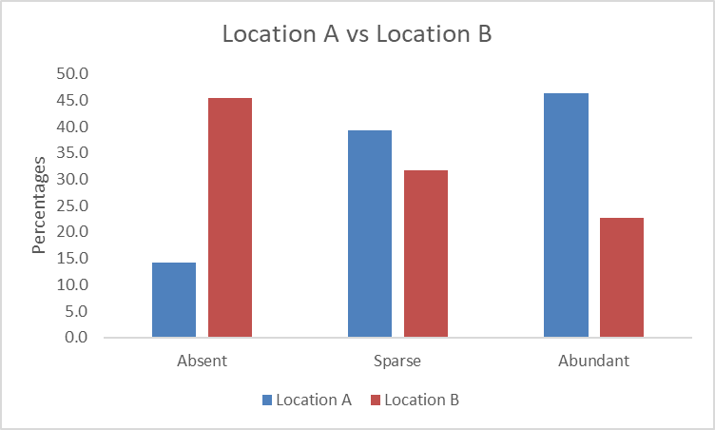

Percentages for Absent is high for location B. Percentage for sparse and abundant is high for location A.

**Exercise 9.3**

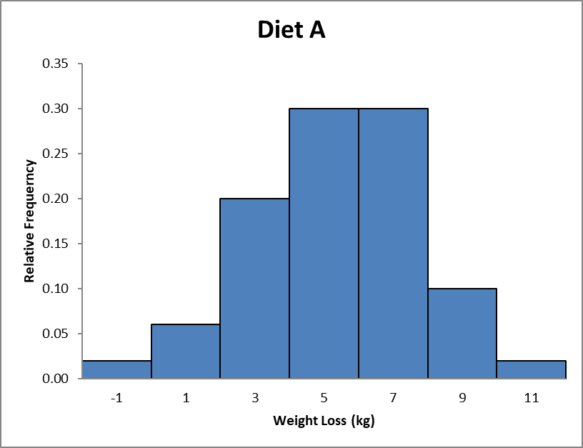Diet A Histogram

Diet B Histogram

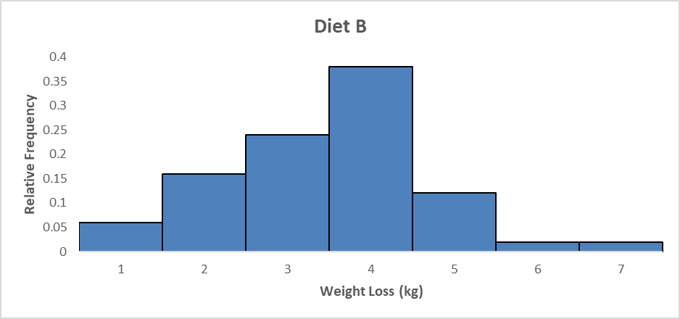

Diet A leads to a fast and steady weight loss compared to Diet B. Diet B weight loss is steady but gradual. In Diet A, the weight loss is higher towards the end compared to Diet B.