 | MANIPAL INSTITUTE OF TECHNOLOGY  (A constituent Institute of MANIPAL UNIVERSITY)  MANIPAL - 576 104, KARNATAKA, INDIA | 

Synopsis

Source Code Analysis plug-in for VBScript

SUBMITTED
BY

STUDENT NAME REG NO E-MAIL ADDRESS
Ajay Agarwal 120905394 agarwalajay04@gmail.com

Under the Guidance of:

Internal Guide External Guide

Dasharathraj K Shetty Rohit Kapoor
Assistant Professor- Senior Scale Associate, Talent Acquisition
Dept. of Computer BlackRock Inc.
Science & Engg.
Manipal Institute of Technology
Manipal University
Manipal 576104
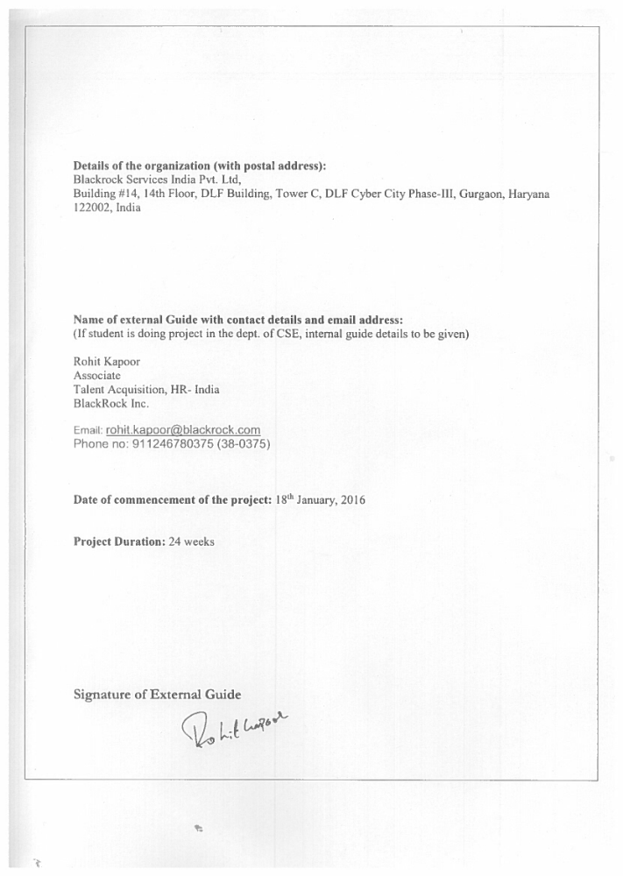
SCANNED COPY OF COMPANY’S INTERNSHIP LETTER MENTIONING THE PROJECT DURATION
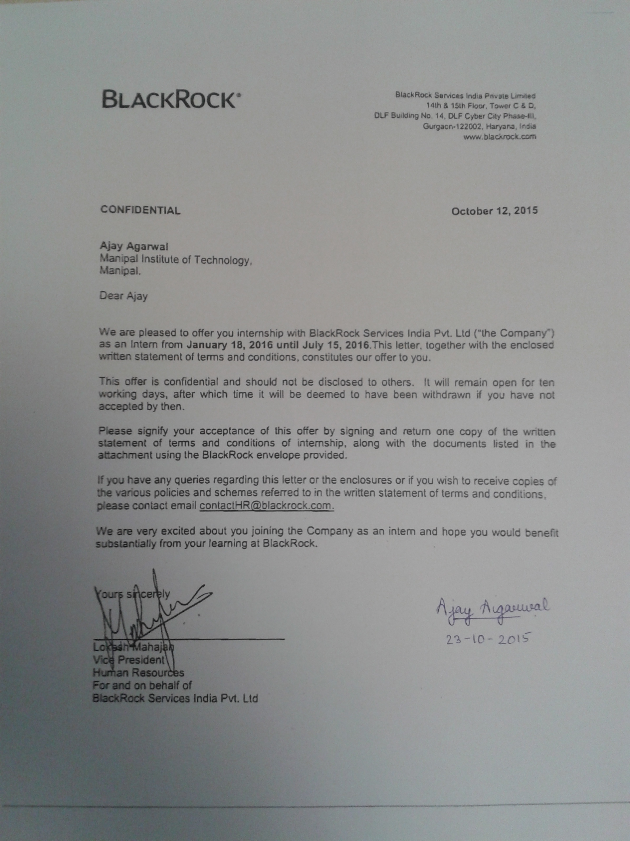
1. Introduction:

1.1 Topic

Generation of a plug-in which will perform code analysis on VBS scripts written for test automation. Code analysis will involve checking standard naming standards, dead code, indentation, duplicate lines of code, etc. This plug in will enhance developers’ experience, will help in enhancing readability, manageability of the code.
1.2 Organization

BlackRock is an American multinational asset management firm founded in 1988, which has over $4.5 trillion in assets under management. It is by far the world’s largest asset manager besides which it also provides advisory to clients (Financial Management Advisory) being under the BlackRock Solutions (BRS). BlackRock firmly believes in the following principles: We are “one BlackRock”, we are fiduciary to our clients, we are passionate about our performance and we are Innovators. BlackRock consists of various units which function interdependently. One major department is the APG (Aladdin Product Group). Aladdin (Asset Liability and Debt and Derivative Investment Network) is the platform on which BlackRock runs its complete business. The Aladdin Product Group’s mission is to build the best investment management system in the world. The team is organized to provide scalable investment and client systems which are built on a resilient technical infrastructure. The APG group mainly focusses on providing the best technology platform for investment management by developing and building BlackRock’s core platform and supporting all the various units of BlackRock.

2. Need for the project:
The problem at hand is currently writing visual basic scripts is a painful job for developers in terms of checking code standards, indentation, checking dead code to name a few.

The target is to build a tool/plug-in which helps to check:
- Whether the naming conventions of attributes and methods is followed.
- For dead code- unused variable, parameters etc.
- For duplicated code which decreases maintainability.
- For classes with high cyclomatic complexity measurements.

3. Objective:
To build a plug-in that will check styling and analyze the code of the scripts written in VBScript.

4. Methodology:

The project is carried out in into following parts

Understanding of UFT and VBScript
- Learning basics of the language including syntax.
- Getting familiar with UFT environment to be able to understand lacking functionalities in terms of code analysis and style check.

- Researching existing tools in the market
- Understanding existing tools for VBScript/ eclipse.
- Understanding if they can be integrated as a plug in in UFT or are available as workbench with their advantages and disadvantages.

- Development/ Integration of the tool
- Deciding on the language used in the development of the tool or used in integration.
- Deciding all rules to be incorporated in relation code analysis/ style check.
- Core development of scripts using appropriate language.

- Testing of tool with sample VB scripts
- Examining tool with sample input and reporting output.
- Looking for room for improvement by adding additional rules or optimizing the existing code.

5. Project Schedule:

Jan 2016: Induction and Internal Java Development Certification Module-1.

Feb 2016: Internal Java Development Certification Module-2 and Module-3. Project scoping (Setting project objectives).

Mar 2016: Understanding VBS, source code analysis, check styling, understanding existing tool in eclipse.

April 2016: Come up with basic architecture of the solution.

May 2016: Present proof of concept for a sample block.

June 2016: Extending it to complete library.

References:
  - D. C. Atkinson and W. G. Griswold, “Implementation techniques for efficient data-flow analysis of large programs,” in IEEE International Conference on Software Maintenance (ICSM’01). Los Alamitos, California, USA: IEEE Computer Society Press, Nov. 2001, pp. 52–61.
  - R. J. C. Atkinson, Stonehenge. Penguin Books, 1956. L. Aversano, L. Cerulo, and M. Di Penta, “Relating the evolution of design patterns and crosscutting concerns,” in Proceedings of the 7 th IEEE International Working Conference on Source Code Analysis and Manipulation. Paris, France: IEEE Computer Society, 2007, pp. 180– 192.
  - F. Balmas, “Using dependence graphs as a support to document programs,” in Proceedings of the 2nd IEEE International Workshop on Source Code Analysis and Manipulation. Montreal, Canada: IEEE Computer Society, 2002, pp. 145–154
  - ] R. Ettinger and M. Verbaere, “Untangling: a slice extraction refactoring,” in AOSD ’04: Proceedings of the 3rd international conference on Aspectoriented software development. New York, NY, USA: ACM Press, 2004, pp. 93–101.
  - B. Fluri, H. Gall, and M. Pinzger, “Fine-grained analysis of change couplings,” in Proceedings of the 5th IEEE International Workshop on Source Code Analysis and Manipulation. Budapest, Hungary: IEEE Computer Society, 2005, pp. 66–74.

Project Details
Student Details
Student Name | Ajay Agarwal
Register Number | 120905394 | Branch / Roll No | CSE B- 35
Email Address | agarwalajay04@gmail.com | Phone No (M) | 9740540654
Project Details
Project Title | Source Code Analysis plug in for VBScript
Project Duration | 24 weeks | Date of reporting
Organization Details
Organization Name | BlackRock Inc.
Full postal address with pin code, telephone number, Fax and email | DLF Building No. 14, 14th Floor, Tower C DLF Cyber City Phase-III, Gurgaon-122002, Haryana, India  Phone: +91 124 6780000  Email: contact.us@blackrock.com
Website address | https://www.blackrock.com/investing/
External Guide Details
Supervisor Name | Rohit Kapoor
Designation | Associate
Full contact address with pin code | Building #14, 14th Floor, DLF Building, Tower C, DLF Cyber City Phase-III, Gurgaon, Haryana 122002, India
Email address | rohit.kapoor@blackrock.com | Phone No (M) | 911246780375
Internal Guide Details
Faculty Name | Dasharathraj K Shetty
Full contact address with pin code | Dept. of Computer Science & Eng., Manipal Institute of Technology, Manipal University, Manipal. 576104
Email address | raja.shetty@manipal.edu

