**Project View**

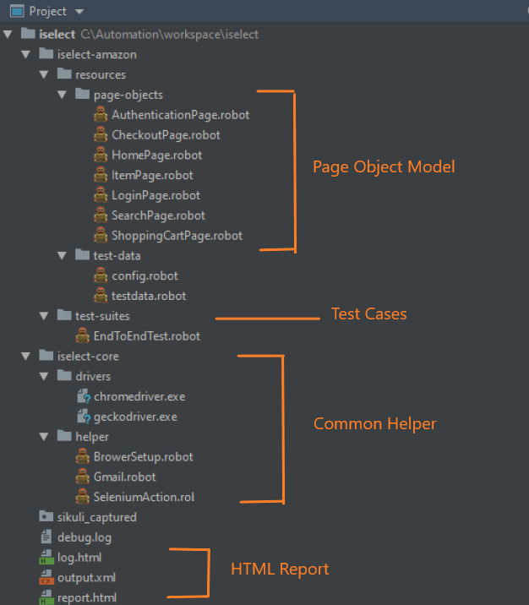

**Test Case View; Automation Framework (Keyword-driven and Data-driven)**

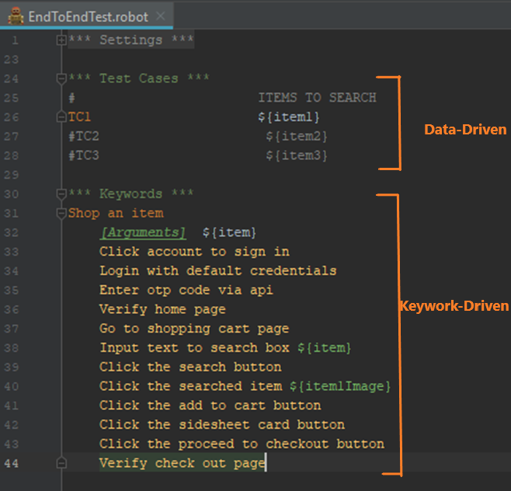

**Page Object – holds functionalities and elements**

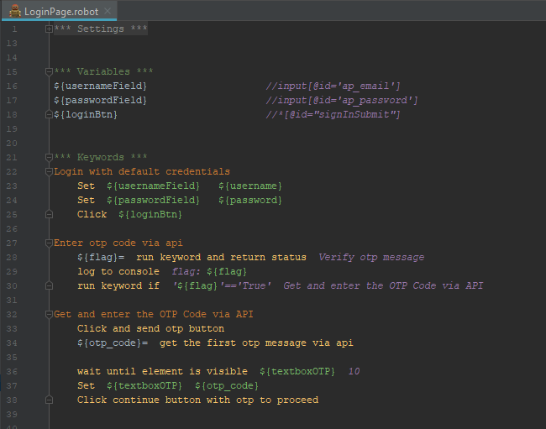

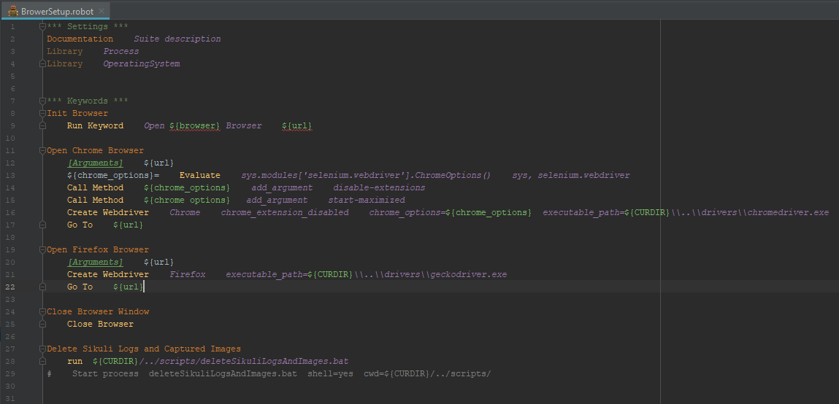**Calling Chrome Browser**

**Using ImapLibrary to connect to Gmail to get the OTP**

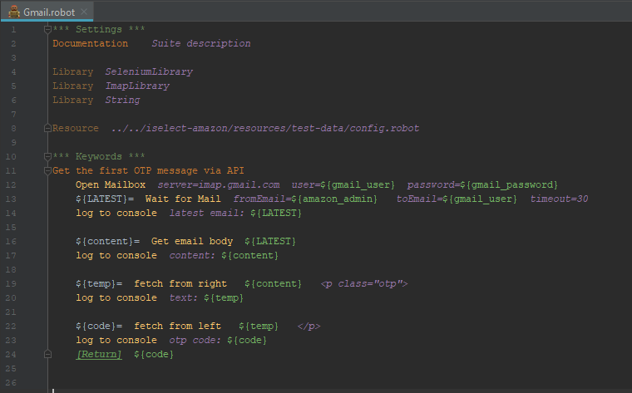

**HTML Report**

