Write a Cucumber/Java project that illustrates your proficiency in using BDD with Selenium.

1. go to http://www.vodafone.co.nz/

2. click on My Vodafone in the top right corner menu

3. on the next page (should be http://www.vodafone.co.nz/using-myvodafone/) click Login

4. on the Login page, enter wrong username and password (so something random basically) and check the login is wrong

Pre-requisites:

* Eclipse (Java)
* Cucumber & Gherkin
* Selenium

1. Create a Java Project, name it “Selenium_Cucumber_Project”. Click File > New > Java Project. Then click Next.



1. 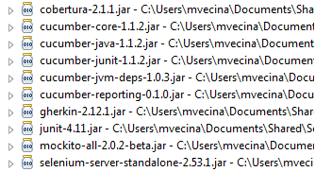Add theses JARs to implement Cucumber. Click Finish.

*Note: You can optionally install Cucumber-Eclipse plugin for English and Gherkin Syntax Highlighting and much more.*

1. Right-click on the Selenium_Cucumber_Project then select New > Folder. Name it “Features”
2. Right-click on “Features” folder then select New > File. Name it “Login.feature” (*.feature is part of Gherkin language)
3. Insert the plain-text english in the Login.feature.

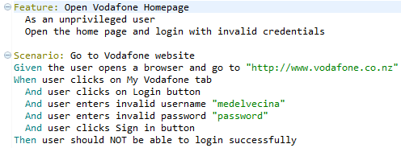

”Feature:” is the title of the feature and its description. It does not parse the next 3 lines of text.

“Scenario:” is the title of the scenario and contains a description of the scenario. The next 7 lines are the scenario steps which is matched to a regular expression defined in “StepDefinition.java”

“Given” is a step with precondition

“When” is to describe the key of action the user performs

“Then” is to observe or validate the outcomes.

1. Create a Runner File to run the test. Right-click on “src” then select New > Package, name it “Runner”.
2. Right-click on “Runner” then select New > Class, name it “TestRunner”.

You need to specify the “Feature” in the “Runner” to be able to run the test.

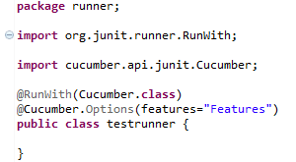

1. Now, run the TestRunner. Right-click > Run As > JUnit Test.

At the console, there are missing steps that you need to implement.

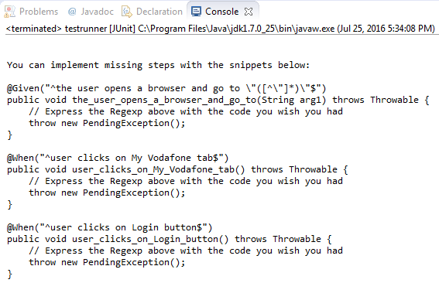

1. Create a File which contains the regular expression to match the scenario steps.

Right-click on “scr” then select New > Package, name it “Functions”

Right-click on “Functions” then select New > Class, name it “StepDefinition”

1. Copy the snippets in the console and paste it the “StepDefinition” class.

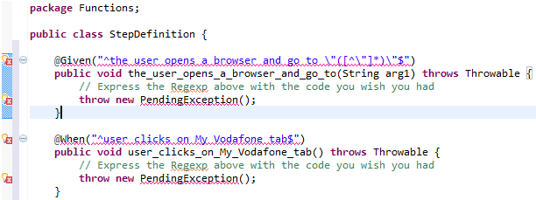

1. Hover the mouse on the error and import the cucumber api

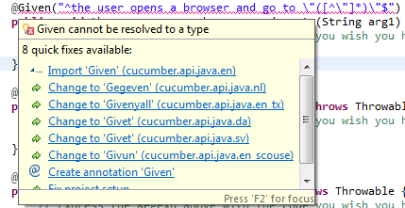

1. Remove all the dummy codes highlighted below.

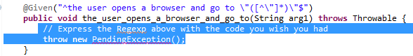

1. Import the WebDriver from Selenium.



1. Now, write the code that will match the scenario steps defined in the “Login.feature”

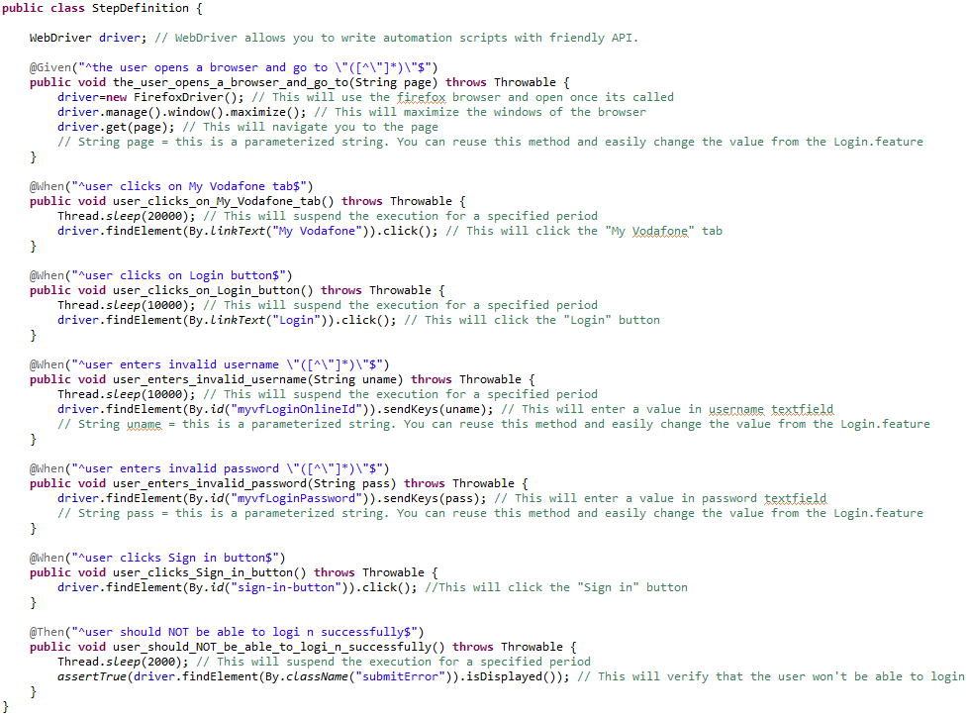

Now that we have a code that matches the scenario steps defined in the “Login.feature”

1. Add the “Function” package in the TestRunner.java

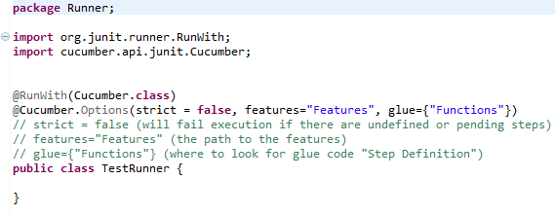

1. Now, run the TestRunner. Right-click the select Run As > JUnit Test

You will get this simple Pass and Fail results

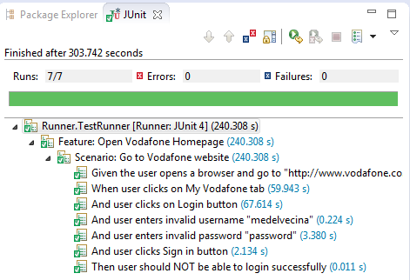

1. To get a simple Html Report, add the following code in the TestRunner.

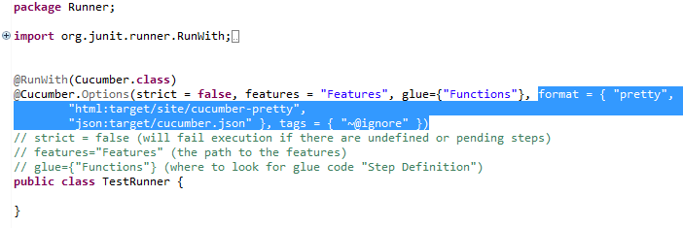

The HTML Report will look like this:

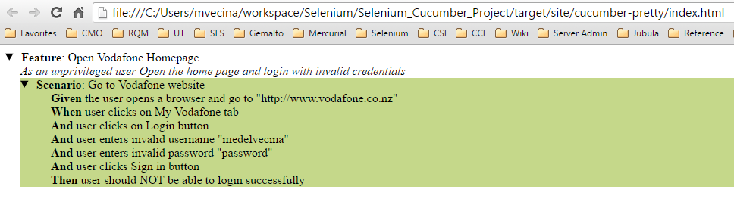

**Estimated Time Of Completion**

* Setting up workspace, download cucumber + selenium, learning about gherkin language (2 hours)
* Writing automation scripts, running tests with trial and error (45 mins)
* Creating steps on how to write scripts using cucumber and explaining everything (2 hours)

**This is the Java Project that I created**

