AZ-900
Cloud Computing: Cloud Computing is the delivery of computing services—such as servers, storage, databases, networking, software, analytics, and AI—over the internet (“the cloud”).
Instead of owning physical hardware, you rent everything from a cloud provider like:
- Microsoft Azure
- Amazon Web Services (AWS)
- Google Cloud Platform (GCP)
You pay only for what you use.
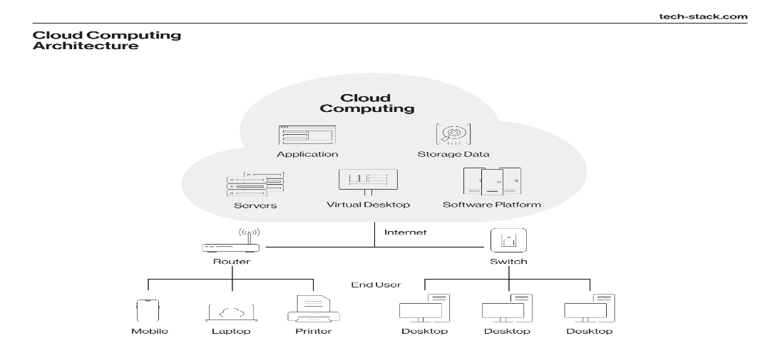
Compute power: in cloud computing refers to the processing capability provided by cloud providers (AWS, Azure, GCP) to run applications, workloads, and services without needing physical on-premises hardware.
It includes:
- CPU power (virtual processors)
- Memory (RAM)
- Storage I/O
- GPU acceleration
- Networking performance
- Scalability & elasticity
Think of it as renting computing capacity on demand.
Analytics: is the process of collecting, processing, and interpreting data to discover patterns, insights, and trends that help in decision-making.
It answers questions like:
- What happened?
- Why did it happen?
- What will happen?
- What should we do next?
Analytics is the heart of business intelligence, cloud computing, automation, and AI.
🌥️ Key Features of Cloud Computing
1️⃣ On-demand Self-Service
You can create servers, databases, and storage whenever you need—no manual approval needed.
2️⃣ Scalability
The ability of a system to increase or decrease its capacity (CPU, RAM, storage, instances) to meet workload demands.
Two types:
Vertical Scaling (Scale Up/Down)
- Add more power (CPU/RAM) to an existing server.
- Example: Upgrading Azure VM from B2 to D4.
Horizontal Scaling (Scale Out/In)
- Add or remove more servers/instances.
- Example: Adding more web servers in a load balancer.
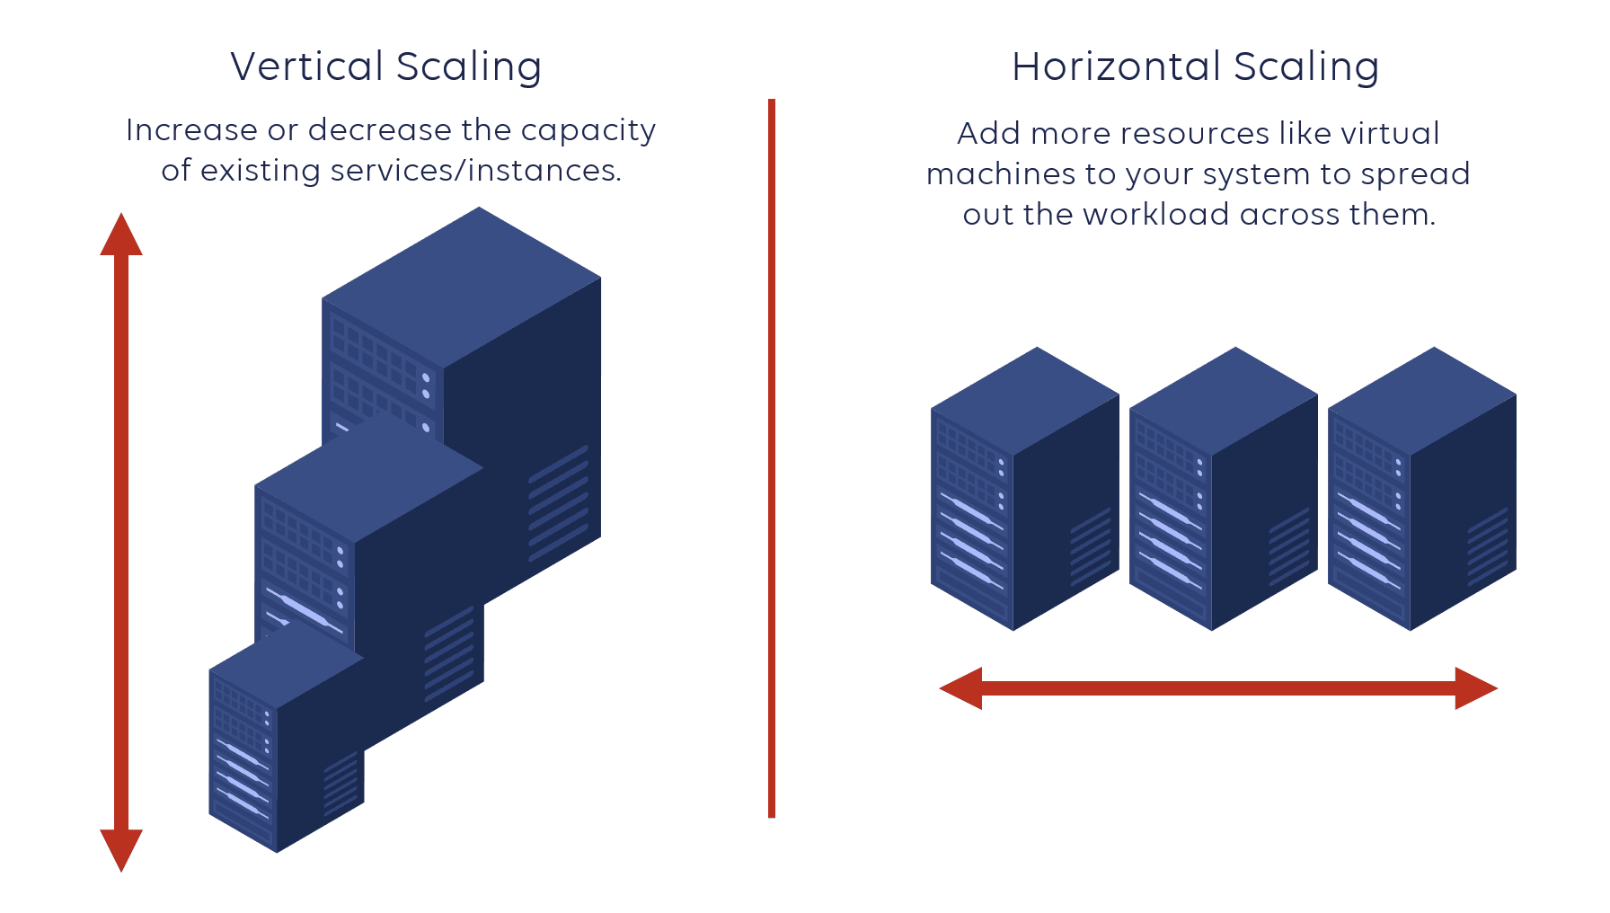
Real Example:
When a website gets more traffic, the cloud automatically adds more servers.
3️⃣ Elasticity
Elasticity is the ability of the system to automatically scale up and down based on demand.
Key point:
- Scalability = Can grow
- Elasticity = Grows automatically
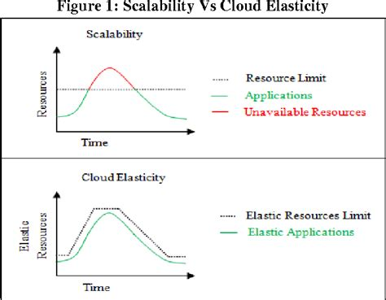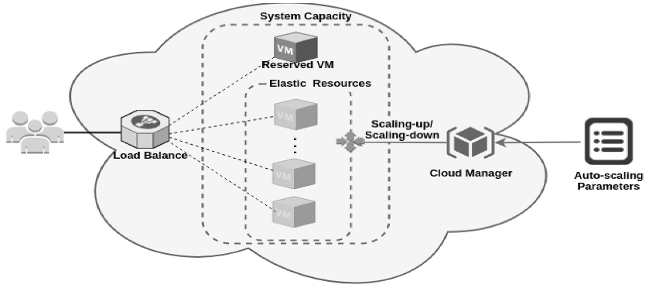
Real Example:
Azure VM Scale Set automatically adds VMs during peak hours and removes them when traffic drops.
4️⃣ Agility
Agility means the ability to quickly create, deploy, modify, or decommission cloud resources.
Cloud Example:
- Create a new virtual machine in 2 minutes
- Deploy a new application using CI/CD in seconds
- Update infrastructure using IaC (Terraform, ARM, Bicep)
Benefits:
- Rapid development, Faster innovation, Reduced time-to-market
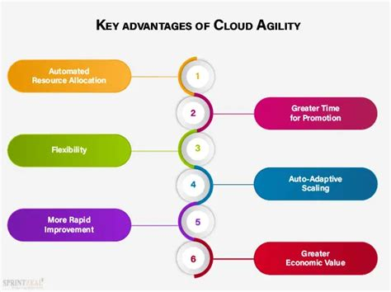

5️⃣ Pay-as-You-Go
You pay only for the resources you consume.
6️⃣ Fault Tolerance
Even if one server fails, others keep the application running.
Fault tolerance is a system’s ability to continue working even if parts of it fail.
How it's achieved:
- Redundant servers, Load balancers, Multiple availability zones (AZs), Automatic failover.
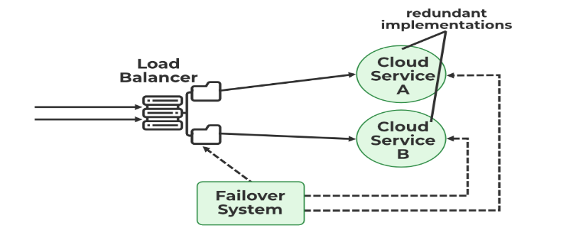
Cloud Example:
- If one Azure region fails, the workload automatically shifts to another region.
7️⃣ Global Availability
Cloud provides data centers across the world.
8. Disaster Recovery is the process of restoring IT systems, applications, and data after any large-scale event such as:
Data center failure, Cyberattack, Natural disaster, System corruption, Network outages, Human error.
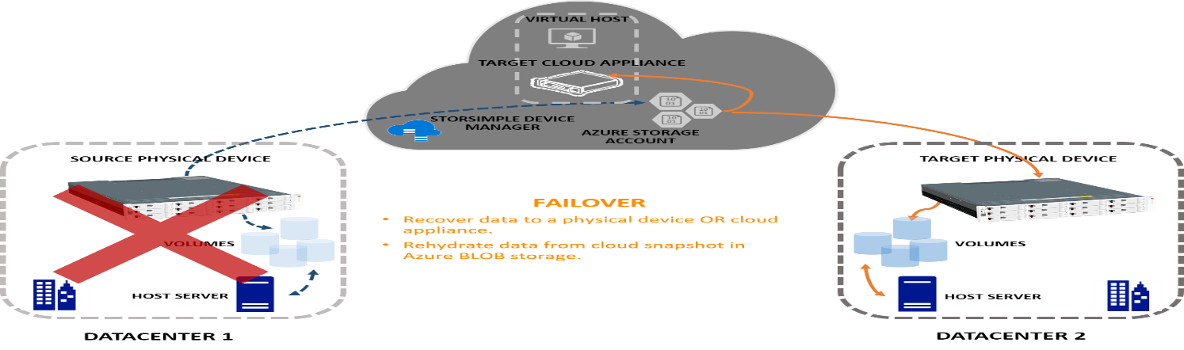
Thegoal:
👉 Resume operations with minimal downtime and minimal data loss.

Economies of scale refer to the cost advantages that a business achieves when it produces more units or operatesatalargerscale.
As the scale increases → Cost per unit decreases.
Incloudcomputing,itmeans:
👉 Cloud providers reduce costs for customers as they grow because they operate at massive global scale.

CapEx (Capital Expenditure) vs OpEx (Operational Expenditure) in Cloud Computing
CapEx is up-front investment in physical infrastructure or long-term assets.
In traditional on-prem IT: CapEx includes buying:
- Servers, Storage, Networking equipment, Data center space, UPS, cooling systems, License fees
- Hardware upgrades
OpEx is pay-as-you-go operational spending for running services.
In cloud computing: OpEx includes:
- VM usage (per hour/second), Storage cost (per GB/month), Bandwidth usage, Backup costs
- Support subscriptions, Managed service charges (DB, AI, monitoring)
Feature CapEx (On-Prem) OpEx (Cloud)
Cost model Upfront Pay-as-you-go
Scalability Difficult Easy, automatic
Risk High (overbuy/underbuy) Low
Maintenance Your responsibility Cloud provider
Flexibility Low Very high
Billing One-time + depreciation Monthly variable
Speed Slow setup Instant deployment

Consumption-based model: Means you only pay for the resources you actually use, just like:
- Electricity bill, Mobile data usage, Water meter
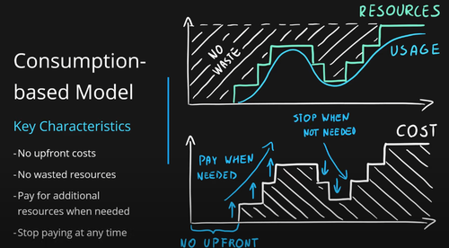
In cloud computing, this applies to:
- Compute (VM hours/seconds), Storage (GB per month), Network bandwidth (GB transfer)
- Databases (read/write operations), Serverless functions (per request/GB-seconds)

Cloud services are delivered in three main models:
🏗️ 1. IaaS — Infrastructure as a Service
You rent virtualized infrastructure:
- Virtual machines, Storage, Networks, Firewalls, Load balancers
You manage:
- OS, Runtime, Applications
Provider manages:
- Hardware, Data centers, Networking, Virtualization
💻 2. PaaS — Platform as a Service
A platform to develop, run, and manage apps without managing servers or OS.
Includes:
- Runtime environment, Middleware, Databases, Dev tools, APIs
You manage:
- The application (code)
Provider manages:
Everything else (OS, runtime, servers)
🧑‍💼 3. SaaS — Software as a Service
Fully managed software delivered over the internet.
You just use the application—no installation, no servers.
Examples:
- Microsoft 365, Google Workspace, Salesforce, Dropbox
Use Cases:
- Email, CRM, Document management, HR tools
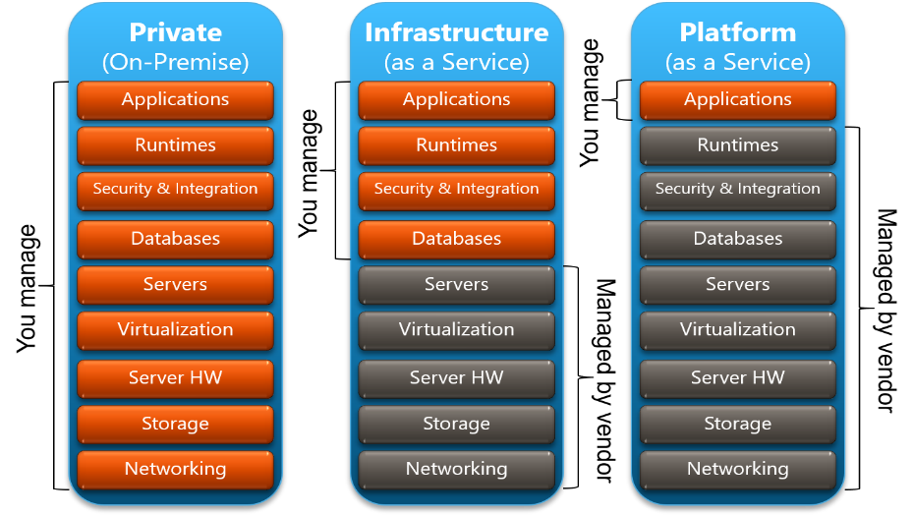

☁️ Cloud Deployment Models
🌐 1. Public Cloud
Cloud services delivered over the internet and shared across multiple organizations.
Owned & Managed by: Cloud providers like:
Microsoft Azure, Amazon Web Services (AWS), Google Cloud (GCP)
Features:
Pay-as-you-go pricing, Highly scalable & elastic, No hardware management, Widely available globally
Use Cases: Startups, Web apps, SaaS apps, Scalable workloads
Example: Deploying a Virtual Machine in Azure/AWS.
🏢 2. Private Cloud
Cloud infrastructure dedicated exclusively to one organization.
Where it's hosted:
- On-premises data center or Hosted by a cloud provider but dedicated to only one organization.
Features: High security, Full control, Customization, Expensive
Use Cases: Banks, Government, Healthcare, Large enterprises
Examples: VMware Private Cloud, Azure Stack (on-prem cloud extension)
🔗 3. Hybrid Cloud
A combination of private cloud + public cloud working together.
Key Features:
- Workloads can move between environments, Enhances flexibility
- Improves business continuity, Data sovereignty control
Use Cases:
- Large enterprises with existing on-prem data centers, Workloads that require sensitive data to stay on-prem, Disaster recovery strategies
Examples:
- Azure Hybrid Cloud (Azure Arc, Azure AD Connect), AWS Outposts
🌍 4. Multi-Cloud
Using multiple public cloud providers simultaneously.
Example: AWS for compute, Azure for identity, GCP for analytics
Features: Avoid vendor lock-in, Best-of-breed services, Better resilience
Use Cases:
- Global enterprises, Organizations needing specialized cloud services, Compliance requirements

