Zimbabwe Agro-Pastoral Management Model (ZAPMM)
Muenzaniso wekudyidzana kwavanhu, zvipfuo nezvirimwa muZimbabwe
(“a coming together in harmony of people, livestock and cropping”)
Musimboti wevanhu, zvipfuo nezvirimwa

M. V. Eitzel¹, Kleber Tulio Neves², Jon Solera³, K. B. Wilson⁴, Abraham Mawere Ndlovu⁴, Aaron C. Fisher⁵, André Veski⁶, Oluwasola E. Omoju⁷, Emmanuel Mhike Hove⁴

¹ Science and Justice Research Center, University of California, Santa Cruz, CA, US; ² Universidade Federal do Rio de Janeiro, Brasil; ³ Seven Points Consulting, Lafayette, CA, US; ⁴ The Muonde Trust, Zimbabwe; ⁵ Lawrence Livermore National Laboratory, CA, US; ⁶ Tallinn University of Technology; ⁷ National Institute for Legislative Studies (National Assembly), Nigeria

The following model description follows the ODD (Overview, Design concepts, Details) protocol (Grimm et al., 2006, 2010) for describing individual- and agent-based models. The first three sections provide an overview (pfupiso) of the model’s 1 – purpose, 2 – entities that exist in the model, the state variables that describe them, and spatial and temporal scales represented by the model, and 3 – the process overview of the different events in the model and their scheduling. The fourth section highlights the underlying design concepts (ruzivo rwakashandiswa kugadzira model) of the model. The remaining three elements provide details (zvizere) of the model, including 5 – how to set up the model’s initialization, 6 – what input data are required, and 7 – the details of submodels within the broader model.

We also include four sections in addition to the ODD description: 8 – a brief note about our model experiments using the BehaviorSpace tool in NetLogo and how we use the results, 9 – notes on our calibration of the model, 10 – sensitivity analysis of underlying parameters, and 11 – technical notes on optimization and model testing.

OVERVIEW
pfupiso
1) PURPOSE
(chinangwa)

This model has been created with and for the researcher-farmers of the Muonde Trust, a registered Zimbabwean non-governmental organization dedicated to fostering indigenous innovation. Model behaviors and parameters (mashandiro nemisiyano nedzimwe model) derive from a combination of literature review and the collected datasets from Muonde’s long-term (over 30 years) community-based research. The goals of this model are three-fold (muzvikamu zvitatu):

A) To represent three components of a Zimbabwean agro-pastoral system (crops, woodland grazing area, and livestock) along with their key interactions and feedbacks and some of the human management decisions that may affect these components and their interactions. We model the following feedbacks (see figure 1):
- Cows (mombe) eat woodland biomass to survive.
- Cows try to get into crop fields and eat those as well, if they can.
- Cows are required to plough crop fields (kurima) so that the fields’ biomass can increase and be harvested eventually.
- Woodland biomass (matemwa/masanzu) is used to make fences to keep cows out of crops.
- Farmers make a variety of decisions affecting the interactions between and sustainability of these three components.

B) To assess how climate variation (implemented in several different ways) and human management may affect the sustainability of the system as measured by the continued provisioning of crops, livestock, and woodland grazing area.

C) To provide a discussion tool for the community and local leaders to explore different management strategies for the agro-pastoral system (hwaro/nzira yekudyidzana kwavanhu , zvipfuo nezvirimwa), particularly in the face of climate change.

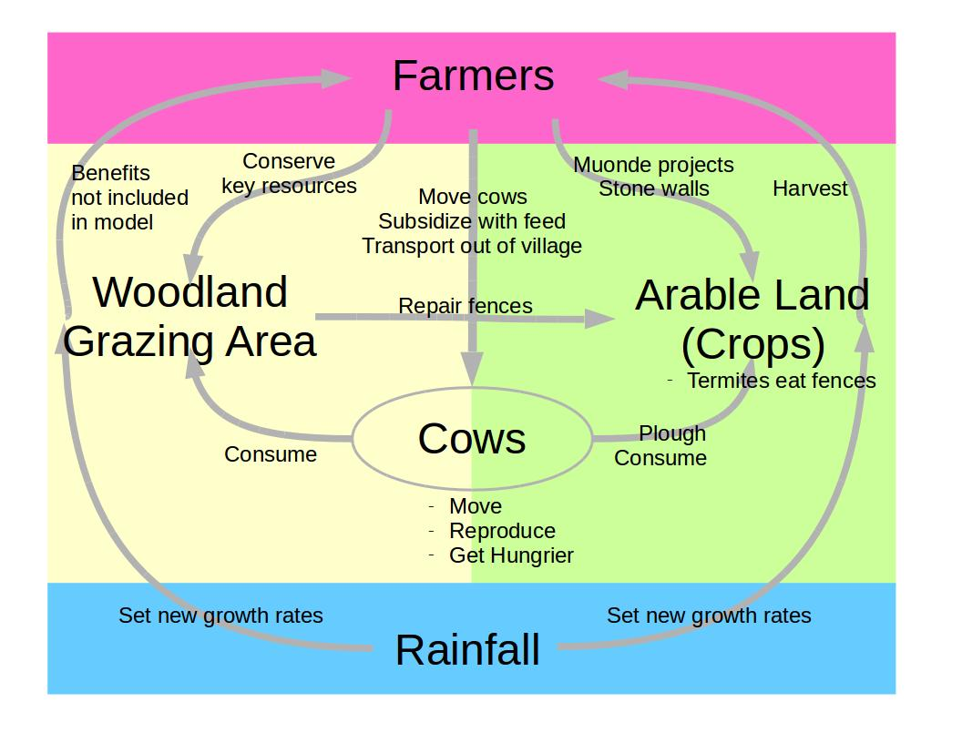
Figure 1: Diagram representing the feedbacks in the model. Farmers are implicit agents who control a variety of aspects of the system in a top-down fashion, while rainfall determines many modeling behaviors in a bottom-up fashion by influencing how much biomass is available in the system. Cows are modeled explicitly as agents in the model. See the remainder of the ODD for details on each of the feedbacks between these components.

2) ENTITIES, STATE VARIABLES, AND SCALES
(zvinhu zvinorarama, zvinochinja mazviri uye huwandu / hushoma hwesanduko yacho)

Entities & State Variables

The three explicit entities (zvinhu zvitatu zvinonyatsoonekwa muraramiro wazvzvinhu zvitatu zvinonyatsoonekwa muraramiro wazvoo) in this model are cows (agents, zvinokwanisa kufamba kubva pane imwe nzvimbo kuenda pane imwe), crops (patches), and woodland (patches, zvinoramba zviri pazviri). Note that by ‘cow’ we mean both male and female animals (mombe) and they are meant to represent livestock in general; by ‘crops’ we mean arable farming land area (regardless of the type of crop); and ‘woodland’ we mean grazing land area (regardless of the dominant tree species). We note that some state variables are fixed after setup (noted as ‘fixed’ in the units column).

Cow state variables (agents)
Name | Units | Explanation
satiety | 0-1, unitless | How hungry the cow is, and therefore how much more likely to succeed at breaking through a fence. (mombe ine nzara/zhara zvakadii) A value of 0 means starving.
body-mass | kg | Body mass of this cow.
energy-this-tick | kcal | Keeps account of energy gained/lost in a given tick, to be added/subtracted (subject to efficiency losses) from body mass at end of model time step.
is-subsidized? | True/false | Farmers can mark cows for subsidy by feeding or transportation; this variable indicates whether this cow is a subsidized cow.
is-calf? | True/false | Calves can’t work or reproduce and die at a lower mass than adult cows.
location |  | Which cell this cow is on (even when ‘frozen’ by being transported), tracked invisibly in NetLogo.

Crop & woodland grazing area state variables (patches)
Name | Units | Explanation
standing-available-biomass | kg/patch | Current primary productivity available in this Netlogo patch.
growth-rate | kg/tick | How fast does biomass increase on this patch, in kg per model time step? Based on current rainfall and type of patch (crop/woodland).
fence | unitless | The condition of the fence on this Netlogo patch (ranges from 0 to 1). Woodland is always 0, crops interior to a field are always 0. Only crops that border woodlands have fence greater than 0. ‘Invincible fences’ (stone walls) always have fence = 1. If a patch has multiple fences (for example, a crop patch completely surrounded by woodland patches), this variable represents the condition of all fences on the patch.
growth-multiplier | Unitless  (fixed) | If this patch is a faster growing patch (key resources in woodland or Muonde farming improvement projects on crops), how many times faster than the other Netlogo patches does it grow? (default is 1)
is-crop?,  is-woodland? | True/false  (fixed) | If this Netlogo patch is a crop patch, is-crop? is TRUE; if woodland, then FALSE; the reverse is true for is-woodland?.
how-many-fences | 0-4  (fixed) | How many sides of this crop Netlogo patch border a woodland and therefore require a fence? (0, 1, 2, 3, or 4)
moran-geary-denominator, moran-numerator,  geary-numerator | Unitless  (fixed) | The numerator and denominator for Moran’s I and Geary’s C are calculated per Netlogo patch, and later summed to create a global Moran’s I and Geary’s C measure of spatial autocorrelation for the entire crop/woodland configuration.
Location | (fixed) | Coordinates for this patch, tracked invisibly in NetLogo.
Cows-here |  | List of agents on this patch, tracked invisibly in NetLogo.

Environment (implicit - hazvisi pachena asi zviripo)
Because this system is susceptible to drought, we use historical annual rainfall records to represent the water limitations on the system. We therefore have global parameters governing biomass growth as a function of rainfall; these growth rates can vary from calendar year to calendar year, driving the year-to-year variation of growth rates in all patches. Several choices in the NetLogo interface reflect different models of increased rainfall variability due to climate change as well as a choice of different rainfall records from nearby sites.

Termites (implicit)
Termites eat the fences, but they appear only in the decay rate of the ‘fence’ variable and are not modeled explicitly as agents.

Farmers (implicit)
Farmer decisions are represented by variables controlled through the NetLogo interface, through which they can make a variety of choices which affect the system. In this sense, they are represented by NetLogo’s ‘observer.’ The decisions represented in the interface are made at the beginning of a model run and are then static. Farmers determine the proportion of crops and their spatial configuration (via a variable called ‘clumpiness’) and what percentage of crops or woodland grow faster than the rest (through farming innovations or woodland restoration projects). They determine how many times per day a cow is moved to a better grazing location, whether cows should be subsidized in bad years and if so, in what way: by transportation out of the village or by augmentation of their diet with supplemental feed, and what proportion of the cows to subsidize. Farmers also determine whether fences should be ‘invincible’ (meaning, stone walls instead of brush fencing) and how long to store crops. Farmers are also represented by adaptive decisions during the model run: they move cows based on patch quality and subsidize the cows when rainfall is too low. They also react to a crop patch having zero biomass by looking for a cow to plough the patch. They are not explicitly NetLogo agents, but are implied agents in many of the submodels.

Scales

The model runs for 60 calendar years (which is the length of our rainfall time-series data), with the temporal resolution set to three ticks per day (discrete time). The parameters in the model are set based on data from Mudhomori village in Mazvihwa Communal Area, Zvishavane District, Midlands Province, Zimbabwe. Mudhomori is 600 hectares in size (as measured from satellite images) so the extent of the model is intended to mirror that: world-size is set to 50x50 patches, and the number of hectares per patch is set accordingly. Many of the model’s parameters and processes have been made scale-invariant by multiplying or dividing by ticks per day or hectares per patch; however, several points should be noted. First, in our implementation, ticks-per-year must be an integer because we rely on the modulus operator to determine when the calendar year should change. Second, a world size of 50x50 means that each patch is approximately a quarter hectare, and 3 ticks per day means a tick is 8 hours. We get realistic results for these parameters. The temporal and spatial scales could be adjusted, but the user should be aware that the rate at which a cow moves across the landscape when grazing should remain realistic, as should the amount of time it takes to plough a field (though the energy is deducted all at once). If a sustainability criterion is not met for one of the three components of the model (too few cows, too little woodland, too little average harvest), then the simulation will stop (these criteria are checked yearly). Finally, note that the calendar year we display is referring to the water-year of latter half of that calendar year and the first half of the next year (1982 refers to the 1982-1983 water year). (Note that in some places we also refer to ‘landscape patches’ in the sense of landscape ecology: areas which are relatively homogeneous and differ from their surroundings; they are often classified as areas of different cover types. We therefore distinguish between landscape patches and patches or cells in the Netlogo sense.)

3) PROCESS OVERVIEW AND SCHEDULING
(pfupiso yamashandiro uye marongerwe azvakaita)

Function names in the actual code are in bold; conditionals and loops are italicized. Cows, woodlands, and crops are asynchronously (munguva dzakasiyana) updated (immediately and in random order) every tick, and all updates are per tick unless otherwise noted.

“Setup” (before the model runs):
set (initialize) global variables
make crops (and woodlands): make-crop-clumps: initialize spatial configuration
set (initialize) patch variables (crops and woodlands)
configure fences for crops
calculate-landscape-metrics
set-faster-growing patches
create-cows: calculate-initial-number-of-livestock and initialize state variables

“Go” (each tick/model step during model run):
update max/min; monitor variables for woodland, number of cows (after burn-in is over)
yearly: check-burn-in-and-and-update-year (both calendar year and years-gone)
yearly: check-timeseries-length; after 60 years, stop simulation
update-yearly-time-events
yearly: check-cow-woodland-thresholds if too little, stop simulation (after burn-in is over)
yearly: get-new-rainfall & set-new-growth-rates for patches accordingly
yearly: set-subsidized-cows if farmers are subsidizing cows and rainfall is low enough
(kupa mombe chimwe chikafu)
update-cows (loop through agents)
if farmers are moving cows, globally find suitable patches anywhere within the grazing area
if some cows are being transported outside the village, ‘freeze’ them; otherwise:
move
if farmers are moving cows, every so many ticks get moved by a farmer
otherwise find a nearby patch to eat (try to get through a fence if necessary)
move-to new location
consume
eat what is on the patch, or enough to reach max body mass, adjust energy accordingly
reduce the available biomass of the patch
update-crop-woodland-eaten trackers
get hungrier
adjust energy pool of cow to deduct maintenance energy
convert cow energy pool to mass change and update satiety
subsidize with supplemental feed as necessary (and adjust energy/mass again)
check-calf-status and graduate calves to cows if body-mass is high enough
if body mass is too low, starve
update-globally-suitable-patches list
color hungry cows red and find available cows for ploughing/reproducing in next tick
reproduce cows
if a cow has enough body mass, based on a random number draw, give-birth
update-available-cows
update crops (loop through crop patches)
if no stone walls: update-fences: (only loop through crops with fences)
find available woodland patches for fencing
get eaten by termites
if any available woodland for fencing, repair-fences
if available biomass is zero and cows are available, plough:
grow and adjust energy of cow, update-available-cows for working/reproduction
otherwise, grow: update available crop biomass based on current rainfall-driven growth rates
update crop color/symbol to represent available biomass, condition of fences
yearly: harvest:
update-annual-crop-trackers for percentage crop eaten and running list of harvests
reduce available biomass to zero
update-and-check-total-harvest; if average harvest is inadequate, stop simulation
update woodland available biomass (loop through woodland patches) grow and update symbology
advance-time-step: increment the model time step (tick), check to see if a calendar year has passed

When the model run ends (has met a stopping condition):
finish running and clean up:
Calculate actual reproductive rate (a per cow per tick variable)
Calculate amount of crop eaten per half hour (a per cow per tick variable)
Record the reason for termination (too little woodland, cows, or harvest, or 60 years has passed)

DESIGN CONCEPTS
(ruzivo rwakashandiswa kugadzira model)
4) DESIGN CONCEPTS

Basic principles
Conservation of energy and matter (ecosystem science) – this model relies heavily on the concepts of flows and conversions of different kinds of biomass to energy in order to address goal B of the model (assessing the sustainability of the system under human management and climate change scenarios). In order to test sustainability, it was important to keep careful accounting of mass and energy flows throughout the system, between trophic levels. We incorporated metabolic molecular biology concepts by including various efficiency losses between conversions. This accounting was also important for assessing the realism of the model by comparing outputs with field data. Interestingly, this level of detailed accounting was not important for goals A and C, where a reasonable level of realism was enough for the model to be useful in representing the feedbacks (goal A) and for the community to use as a discussion tool (goal C).

Resource selection, competition, predation (community ecology) – Our cows are generally choosing between two resources (though spatially limited to what they sense immediately around them): woodland and crop. Crops are typically better food sources, but harder to get (essentially, better defended). This means that crops and woodlands are apparent competitors, as well as crops benefiting directly from woodlands in a kind of predation through the creation of fences. Also, cows can overshoot the carrying capacity of the woodlands if rainfall is first high, then low, with populations falling low enough that if rainfall becomes high again, woodlands can escape predation and recover substantially. Generally speaking, this is a bottom-up driven system where rainfall drives primary productivity which in turn drives cow populations as well as harvests and fence availability. Representing these interactions are key in achieving goal A of representing the system, and as the real system is strongly driven by rainfall variability, the representation of bottom-up dynamics following from rainfall is important in achieving goal B of assessing the sustainability of the system.

Stage-based demography and carrying capacities (population ecology) – Because the cows are measured as discrete entities which reproduce and die, we have an embedded population model with exponential growth followed by equilibrium at the carrying capacity. In model scenarios where the rainfall changes, the carrying capacity changes and the number of cows shifts to a new maintenance level/equilibrium. Though our cow population structure is simple (only calves and adults, with no separation of males and females), it does contain two stages (this was necessary in order to have reasonable minimum masses for calves and adults and to ensure conservation of mass). This representation of cows as individual agents is helpful for assessing realism in sustainability questions (goal B), and is very helpful in using the model as a discussion tool (goal C), because watching the agents behave is engaging for community members and suggestive of the real system.

Feedbacks, latency, sensitivity to initial conditions (complex systems) – Our model includes several specifically modeled feedbacks (crops depend on cows for ploughing, on woodlands for fencing, cows depend on both for food), and some emergent feedbacks (for example, woodland biomass acts as a buffer that temporarily insulates the cows from starvation even as it exacerbates cow overpopulation). Because of these feedbacks, even with a bottom-up driver in the form of rainfall, there are often delays in each model component’s response (for example, woodland might begin to grow faster but it takes part of a year for the cows’ carrying capacity to adjust). These feedbacks are important in properly representing the system (goal A). The latencies are interesting emergent phenomena which point out the importance of multi-year strategies for sustainability (goals B and C). Because complex systems can display sensitivity to initial conditions, we are careful to study steady-state behavior in our system, using a carrying capacity calculation to start livestock close to equilibrium and allowing a number of model years to pass so that transient behavior due to initial conditions and spatial configurations can fade. Also, if initial cow populations are set too low, they do not respond sufficiently quickly to changing rainfall/primary productivity inputs, and if they are too high, they can crash and go extinct, halting the simulation.

Adaptive management (kukwanisa kusandura mararamiro kuti zvienderane nekusandukawo kwenzvimbo) – the farmer-researchers of Mazvihwa are constantly engaged in adaptive management: observing their fields and livestock and woodland grazing areas and making changes in their management as appropriate. We represent some of this adaptation by introducing farmers moving cows to better grazing areas and subsidizing cows in low-rainfall years, though in reality there are many more strategies which, for simplicity, we model as static: farmers might both transport and feed their cows in a bad year, or might change strategies from year to year, and farmers can choose to leave some fields fallow or change the overall proportion and arrangement of crop fields from year to year. Being able to represent some of the choices farmers make, even if they cannot be adaptively changed during a model run, makes the model more useful as a discussion tool for the community (goal C) and helps us to assess whether management strategies (if they had been or could be consistently applied across 60 years) make the system more or less sustainable (goal B).

Companion modelling/participatory action research (chifananidzo/tsvakurudzo inosanganisira vanhu vane dambudziko) – In terms of modeling approaches underlying the model’s design, collaboration with Muonde’s research team was fundamental to the model. The model behaviors and underlying data come from the community-based research team, grounded in decades of participatory action research. Trust between the modelers and the field team was essential. Iteration with research team members giving feedback, and workshops with the whole community giving feedback, were integral to the way the model developed. The degree of complexity and number of management options represented were a direct result of needing the model to look familiar enough to spark useful discussion (goal C), perhaps more so than to test their impacts on sustainability (goal B). In general, goal C of the model (creating a discussion tool) was by far the primary and most important goal, while the goal of studying the sustainability of the system as represented in the model (goal B) was secondary. Goal A (representing the system) was a prerequisite for both of the other goals.

The collaborative modeling, community ecology, and complex system feedback concepts are all important in the model’s design at the level of the whole model; while the ecosystem science, adaptive management, and population ecology concepts are mostly important at the level of submodels. Because our goal was rooted in collaborative modeling and application/synthesis of all these concepts, we were not interested in testing them for themselves but rather to apply them and see how well they can represent the underlying structure of a real system with real impacts on rural people.

Emergence (kubuda kwezvanga zvisina kutarisirwa)
All of our output variables are emergent, in the sense that interactions between cows, crops, and woodland can change the number of cows, the amount of woodland biomass, and the annual harvest in the system. Some combinations of management parameters reduce this interactive emergence, for example, making fences invincible means that no crop can be eaten by cows, and setting rainfall to remain constant means that a subsidy of cows will never be triggered. Cyclical behaviors between woodland and cows are emergent. Achievement of an equilibrium at cow carrying capacity for constant rainfall is emergent, as we do not artificially kill animals to retain a certain number; they die when there is not enough food. Cow numbers and woodland biomass (as well as crop harvest) tracking rainfall as it increases or decreases is not emergent, but latency in cow population recovery after a high-growth year followed by a low-growth year, and a consequent large increase in woodland biomass, is emergent. The actual cow reproductive rate is emergent; though we do calculate a nominal reproductive rate for cows per model time step, the random number generator chooses whether they reproduce, and they are not available to reproduce if their body mass is too low.

Adaptation (kugona kurarama nezviripo)
Cows choose new locations to feed based on the standing available biomass on the patches around them, and farmers choose new locations for cows based on a global assessment of the standing available biomass of woodland patches. Cows (and farmers) choose the patch with the greatest available biomass in order to keep cow body mass high. Farmers choose cows to subsidize if rainfall is too low. Farmers find a cow to plough a crop patch if its biomass is zero.

Objectives (zvinangwa zvimwe chete)
Cows (and farmers) want to maximize cow body mass to allow for work (ploughing) and reproduction. Farmers want to keep crops growing and will rebuild fences if there is enough woodland biomass and will find available cows to plough a crop patch if its biomass is zero.

Sensing (ruzivo nekunowanikwa zvinodiwa)
Cows are assumed to be aware of the standing available biomass of their location and the patches immediately surrounding them. Farmers know the available biomass of all woodland biomass patches, both for the purpose of moving cows and fencing crops. Farmers also know when the rainfall is below 400 mm/year and cows need to be subsidized, and when a crop’s standing available biomass is zero and needs to be ploughed. They also know how many cows (if any) are available for ploughing.

Interaction (kudyidzana)
Cows interact with each other indirectly through competition for a common resource (woodland and crop biomass). Cows interact with woodland and crop patches by consuming them. Woodland patches interact with crop patches by providing fencing material. Cows interact with crops by ploughing (allowing a zero available biomass crop to begin growing). Farmers interact with cows by moving and subsidizing them, and with woodlands by removing biomass and making fences, and with crops by plowing and harvesting them.

Stochasticity (zvisina kurongeka)
The way crop clumps are created is fundamentally stochastic, because we want a range of realistic spatial configurations and do not model the decision-making processes of local government in dictating where the fields are placed. The initialization of some variables (fence status, available biomass of woodlands, locations of cows) is random, because the actual causes of variation in these initial values are unimportant and we wish not to introduce cyclic behavior due to initial conditions (for example, rebuilding all the fences at the same time). The ability of a cow to break through a fence in order to eat a crop is random (though it also depends on how hungry the cow is and how degraded the fence is), because a cow’s success in breaking through is not guaranteed and we wanted a meaningful way to involve the fence effectiveness and cow desperation in this process. The reproduction of a cow (within the group of cows who are able to reproduce) is also random, because we aim to reproduce the nominal reproductive rate in the field data but want to see if it emerges as similar from model behavior. The order in which patches and agents are updated is random, because we have no need to model any systematic updating. In some cases, the way rainfall varies from year to year is stochastic (within historical or similar rainfall values). The intent is to parametrically or non-parametrically bootstrap the results of the model.

Observation (zvinoonekwa)
During a model run, through the NetLogo graphical user interface which updates every tick, we observe the current number of livestock (and global maximum and minimum), the accumulated number of cows that have died, the current model calendar year and the number of years the model has been running, the accumulated total harvest, the yearly percentage of the harvest eaten by cows, the amount of woodland biomass available (and the global maximum and minimum), the accumulated amount of subsidy used, and the rainfall values. These data are used when watching and assessing model behavior in initial testing and for some reported outputs (for example, figures in posters and papers). We do not use these outputs for experiments due to data volume constraints. When running an experiment through the BehaviorSpace tool, we report the following variables which are used in analysis of the model, to answer sustainability questions, and to check the calibration of the model.
Name | Units | Explanation
Years-gone | Years | How long the model ran without failing one of the sustainability criteria (maximum 60)
Max-percentage-harvest-eaten  & Crop-eaten-per-cow-per-half-hour | % | Maximum percent (up to 100%) of harvest eaten by cows checked every year & average amount of crop eaten per half hour per cow, for comparison with field data
Subsidy-used | $ | Total amount of subsidy
Total-harvest | Metric tons | Accumulated harvest over the whole model run for the whole village
Max-livestock-number  & Min-livestock-number |  | Minimum & maximum cow populations at any time throughout the model run, checked every tick
Actual-reproductive-rate | % | Number of births divided by number of cows over time, to compare with the nominal birth rate of 0.25/year
Max-woodland-mass  & Min-woodland-mass | kg | Minimum & maximum quantity of biomass in the woodland
Termination-reason |  | Either report that the model finished the run successfully (all 60 years), or report which sustainability criterion failed

DETAILS
(zvizere)
5) INITIALIZATION
(zvibodzwa zvekutangidza nazvo uye muwanikirwo wazvo)

The goal of initialization for our model is for the system to be as close as possible to equilibrium for its spatial configuration and for average rainfall, before beginning a rainfall variation simulation. When the model is in “Experiment” mode, we also give some time for model “burn-in,” allowing the model to run for five years at the mean rainfall value for the chosen time-series (from one of three nearby locations: Zvishavane, Mberengwa, and Chivi, or their average) to allow the transient model behavior inherent in the spatial configuration and the random starts for fences and woodland growth-states to die off. Then the simulation begins recording monitor variables and varying rainfall. In “Demonstration” mode, there is no burn-in and the initial value for rainfall is simply the mean rainfall, the first value in the historical timeseries, or the first randomly chosen value based on the climate variation model (see get new rainfall submodel).

The user sets the following variables through NetLogo’s interface (values shown are tested in the experiments using NetLogo’s BehaviorSpace):
Name | Units/Values | Explanation
Rainfall-type | Six choices | See get new rainfall for details
Times-per-day-farmers-move-cows | 0 or 1 times/day | How often per day to farmers move cows to better grazing? 0 means never.
Invincible-fences | True/false | Stone walls (‘invincible fences,’ ruzhowa rwusingapindike nemombe) do not require woodland biomass and animals can’t break through them.
Proportion-crops | 1%-99% | How much land is put into agricultural production?
Clumpiness | 0, 0.07, 0.22, 0.54, 0.85, 0.95, 1 | Represents the fraction of crop patches intentionally placed adjacent to other crops. (minda yakabatana zvakadii / mamiriro akaita minda)
Subsidy | None, ‘feed’, or ‘transport’ | In a bad year, farmers can choose to buy supplemental feed or to transport cattle out of the village. (kubatsira mombe nechimwe chikafu / nekuchinja nzvimbo)
Proportion-cows-to-save | 0.7, 1.0 | If subsidizing, what proportion of cows are subsidized?
Key-resources | 0%, 10% | What proportion of the woodland grows faster? (nzvimbo dzakakosha mumasango dzinogona kuraramisa mombe)
Muonde-projects | 0%, 10% | What proportion of the crops grow faster due to the Muonde Trust’s projects to increase drought-resistant crops and water harvesting techniques?
How-long-to-store-grain | 0 or 3 years | How many years are farmers able to store harvest surplus due to bumper crop harvests in high rainfall years?
Use-Muonde-thresholds | True/false | If false, minimum woodland is 0.02 x Mudhomori’s 2013 fences, minimum yearly harvest is 0.96 metric tons, minimum cows is 1. (1/50th of Muonde’s thresholds)

These variable values are based on the Muonde research team’s observations of the system. To initialize the other variables in the model in our setup function, we first set global variables. (See submodels for details on where the values come from.)

In “Experiment” mode, values in bold are perturbed within 5% above and below the stated value; variables are otherwise deterministically set.
Name | Units/Values | Explanation | Data
Spatio-temporal variables
world-size | 50 (unitless) | Linear dimension of the village in number of Netlogo patches. | Arbitrary
ha-per-patch | 0.24 ha/patch | Mudhomori is 600 ha in size: 600/ (world-size*world-size) | Muonde team
ticks-per-day | 3 ticks/day | Number of time steps per day. | Arbitrary
ticks-per-year | 1095 ticks/year | 365 * ticks-per-day (must be integer) | Calculated
calendar-year | 1952 | The water-year: the latter half of that calendar year and the first half of the next year. | Muonde team
Global fence variables
total-mud-crop-perimeter | 50,000 m | Total length of fence in Mudhomori. | Muonde team
wood-to-build-fence-per-meter | 5.77 kg/m/year | Amount of woodland biomass needed to build one meter of fence. | Muonde team
termite-activity | 2/3 (per year) | Proportion lost per year. | Muonde team
Global patch variables
Hours-to-plough-ha | 8 cow-hours | How many cow-hours to plough a hectare. | Muonde team
Zero-crop-growth-intercept | 232 mm | What is the minimum rainfall for crops to grow. | Muonde team
crop-growth-slope | 0.8731 kg/ha/mm/yr | How much do the crops grow per mm of rainfall. | Muonde team
Woodland-growth-slope | 3320 kg/ha/mm/yr | Growth function for woodland – how much does the woodland grow per mm of rainfall. | Muonde team, Rutherford (1978)
muonde-efficiency | 3.0 (unitless) | How much faster crops grow when Muonde projects have been adopted. | Muonde team
Global cow variables
Max-cow-mass, min-cow-mass | 63-296 Kg | Range of values for cow mass. | Machila et al. (2008)
Calf-birth-mass | 18 Kg | How big a calf is at birth. | Nicholson (1983)
Cow-maintenance-energy-rate | 980 kcal/kg/day | How much energy a cow burns by metabolizing and moving. | Molden (2013)
Cow-working-energy-per-hour | 920 Kcal/hr | Energy required to work. | Astatke, Reed, and Butterworth (1986)
Production-efficiency | 0.49 (unitless) | Efficiency of turning energy into more cow mass. | Johnson et al. 2012
Catabolism-efficiency | 0.9025 (unitless) | Efficiency of turning cow mass back into energy. | Johnson et al. 2012
Kcal-per-kg-of-cow | 1360 kcal/kg | Energy density of cow when metabolizing. | USDA
Livestock-not-reproduction rate | 0.75 (probability) | Probability per year of a cow not reproducing. | Muonde team
Kcal-per-kg-of-browse | 1931 kcal/kg | Energy density of woodland plants. | Astatke, Reed, and Butterworth (1986)
Kcal-per-kg-of-crop | 2325 Kcal/kg | Energy density of crops. | FAO (1992); Eastridge (2007)
Cost-of-supplemental-feed | $14.50/kg | How much supplemental feed costs. | Muonde team
Rainfall variables
rainfall | 121.5 – 1112.7  mm/year | See get new rainfall for details. | Zimbabwe government
Sustainability Thresholds
(zvinokwanisa kuramba zvichienda mberi magumo ehuwandu kana hushoma)
Minimum-cows-for-sustainability | 50 cows |  | Muonde team
Minimum-harvest-for-sustainability | 48 metric tons/year | Averaged over multiple years if crops can be stored. | Muonde team
Minimum-woodland-for-sustainability | 1.0 (unitless) | Expressed in terms of the quantity of fencing in Mudhomori village in 2013. | Muonde team

make crops
Once the global variables are set, we make all patches ‘woodland,’ count the number of patches (world-size * world-size) and based on proportion crops, establish a desired number of woodland and crop patches. We use the ‘clumpiness’ variable to establish a number of crops that should be in clumps, with the rest of them scattered evenly throughout the woodland. (Clumpiness is therefore a proportion of the crops that should be intentionally placed in clumps. Note that some crop patches may end up clumped by random chance.)

We then make crop clumps by first placing the ‘non-clumped’ crops somewhat evenly throughout the woodland, creating a chess-board-like pattern (making a woodland patch a crop patch if it has all woodland neighbors or failing that, if it has at least one woodland neighbor), and then by placing the ‘clumped’ crops (making a woodland patch a crop patch if it has all crop neighbors or failing that, if it has any crop neighbors). Which patches are crop and woodland, and what spatial configuration they are in, is randomly generated for each of our model runs.

set patch variables
Initialize fence to 0, growth-multiplier to 1, the text label to be empty, and the landscape ecology variables to 0; all these variables will be altered as appropriate in configure fences, calculate landscape metrics, and set faster growing patches. Initialize how-many-fences to 0. Make crops green and woodland brown; for crops, ‘is-woodland?’ = FALSE and for woodlands, ‘is-woodland?’ = TRUE (and vice versa for ‘is-crop?’); set standing-available-biomass (huwandu hwezvinhu zvese zvinorarama panzvimbo) to zero for crops and randomly between 0 and 5% of a year’s growth for woodland (0 to 39.84 kg/patch). (We choose between 0 and 5 % so that the livestock number and woodland biomass can equalize quickly during burn-in. We set it low because we will set cows at the carrying capacity of the woodland and therefore they should maintain their population as the woodland grows. We do not set it to zero because there is some stochasticity in the system and the additional amount is a buffer preventing unnecessary cow population crashes.) Growth-rate is not set during setup, but will be set with the first year of the model in set new growth rates.

configure-fences
We create a set of crop patches with any Manhattan/rook neighbors (NetLogo’s neighbors4) that are woodland as “crops-with-fences” and then for each crop with a fence, count how many woodland neighbors it has. We set all crops with fences to have a fence variable randomly between 0 and 1 (completely gone and completely intact). We label a crop with fences > 0 with a yellow “x”.

One innovation of the Muonde Trust is to build dry stone walls (built with interlocking stones but without mortar) rather than brush fences. These walls mean that livestock cannot break through no matter how hungry they are (how low their biomass is), and they also do not require woodland biomass to constantly repair due to termite damage. In this case, we set fence to 1 (completely intact) and label it with a white “s” for “stone.”

calculate-landscape-metrics
Once fences are configured, we calculate two spatial autocorrelation metrics and two landscape ecology metrics. ‘clumpiness’ is useful in creating the landscape configuration but not in measuring it.

We calculate two measures of spatial autocorrelation: Moran’s I (Moran 1950) and Geary’s C (Geary 1954). For the weighting factors in these indices, we include the rook or Manhattan neighbors (NetLogo’s neighbors4), all weighted equally. We set the variables moran-numerator, geary-numerator, and moran-geary-denominator for each patch by asking it how its class (crop or woodland) compares to its neighbors and weighting appropriately for Moran’s I and Geary’s C (see code for details). We then calculate the global indices based on each patch’s numerator and denominator. In addition to these measures, we calculate the perimeter of crops (the sum of how-many-fences over all crops-with-fences, multiplied by the length of the side of a patch based on world-size) and the average landscape patch size of the crop class (for each crop, grow a cluster with only crop neighbors and then record the cluster size as a list, then average their sizes), as defined in FRAGSTATS (McGarigal, Cushman, and Ene 2012). Empirically, our models give a Moran’s I from -0.6 to 0.95, a Geary’s C from 0.05 to 1.6, a crop perimeter from 1,176 m to 190,276 m, and an average contiguous landscape patch size for crops from 0.24 ha to 599 ha.

set-faster-growing patches
Some parts of the woodland grazing area grow much faster, even in low-rainfall years, than other parts. These areas can be sacred forests (rambotemwa), drainage ditches, contour ridges, and streams. Scoones (1989) estimated that the herbaceous (wezvusiri 'woody') component of these ‘key resources’ in the woodland grew up to ten times faster than other parts of the woodland, or up to four times faster for total woodland biomass growth. He estimated that up to 10-25 percent of the woodland area fell into this category; community observations suggest that the current amount is 10 percent or lower.

Similarly, some crop patches grow faster than others due to investments in agroecological innovation on the part of the Muonde Trust. These innovations vary between water harvesting techniques such as dead-level contours with paired ditches, water retention and infiltration basins (“Phiri pits”), and planting of drought-resistant crop types and varieties (e.g. millets, sorghum). Either or both of these types of innovations could allow Muonde crop patches to grow faster than others. Because we do not yet have comprehensive empirical evidence of how much faster they grow, we make a guess of 3 times faster. We test scenarios in which 10 percent of crop patches have these innovations.

We randomly choose the appropriate number of crops with Muonde projects and/or woodlands with key resources and set their growth-multiplier to muonde-efficiency (3.0) for crops or 4 for woodlands.

create-cows
We calculate the carrying capacity of the current woodland configuration and create that many cows. We place each cow randomly on a woodland patch (cows can share patches). Then start cows colored white (not hungry; they will be made red when they fall below hunger-threshold, which is set to 0.50) and a large icon size (calves will be half that size when they are born). Initially set satiety to 0.51, is-subsidized? to FALSE, and is-calf? to FALSE. We set a cow’s body-mass to be an average of the minimum and maximum cow mass, which we obtain from Machila et al (2008)’s study of a number of different ways to weigh cattle in Kenya. We use their weight ranges from the ‘gold standard’ weighing methods that use a calibrated scale: 63-296 kg for adult cows. Nicholson (1983) reported a mean birth weight of calves in Ethiopia of 18 kg, so when we create new calves, we use this minimum mass, set ‘is-calf?’ to TRUE, and make the icon representing the calf half the size of an adult. Initially we set energy-this-tick to one tick’s worth of maintenance energy.

calculate-initial-number-of-livestock
To set the initial number of cows as close to equilibrium (under constant rainfall) as possible, we calculate the potential carrying capacity of the woodland. This calculation is based on the average of the maximum and minimum weights of cows from Machila et al (2008), 179.5 kg. Essentially we sum the total biomass of the woodland per unit time, based on proportion crops, Netlogo patch-size, and adjusted for a potential proportion of the woodlands which grow up to four times faster (“key-resources”, see above and Scoones 1989); convert that biomass to cow biomass using the metabolic models given below; then divide that mass by the ongoing needs of a reference cow to get the potential number of cows supported by that amount of woodland and key resources. The ongoing needs are those associated with metabolizing and moving, not with reproduction or ploughing/working. Note that cow carrying capacity could be larger with ‘feed’ subsidies (see below), when cows are able to break through fences and eat crops, with higher-than-average rainfall, and when the initial values for the woodland growth-states happen to be higher (i.e. before the transient behavior dissipates). Empirical testing with the model indicates that this calculation does achieve a carrying capacity which starts very close to a stable state.

Total energy available from woodland biomass in kcal/time unit = (proportion-woodland)*(area of village in ha)*(1 + 4*(proportion of key resources)*(woodland growth rate in kg/ha/time unit/mm)*(average rainfall in mm) * metabolizable energy density of browse in kcal/kg of browse)

Energy cost of a reference cow = (mass of a reference cow in kg)*(maintenance energy cost for a minimum cow in kcal/time unit/kg of cow)

Carrying capacity in number of cows = (total available woodland energy in kcal/time unit)/(Energy cost of a reference cow in kcal/time unit)

6) INPUT DATA

There are no external input files for this model, partly for simplicity in sending the model to community researchers in Zimbabwe, and partly for speed when running on a cloud computing cluster.

7) SUBMODELS
(zvinhu zvidiki zvinoitwa ne'model')

check-burn-in-and-and-update-year
In “Experiment” mode, we let the model run for “burn-in-length” (currently set to 5 model-years) without recording anything, to allow transient behaviors to fade (otherwise we begin recording immediately). Every year check to see if burn-in-length has been reached and if so, set “burn-in” to false and reset the model-year clock to zero. If burn-in is false, also update the calendar-year that displays in the interface.

check-timeseries-length
Every year we check the number of model-years the simulation has run so far, stopping if we have reached 60 model-years (the length of our rainfall time-series), even if we are not using the historical rainfall as our rainfall-type model.

update max/min
Every model step, update the monitor variables for maximum and minimum woodland biomass and number of cows.

check-cow-woodland-thresholds
Every year, after the burn-in period is over, this submodel checks that both the number of cows and the amount of woodland are above established sustainability thresholds: either those established by the Muonde community research team (50 cows and enough woodland to rebuild all of Mudhomori’s 2013 fences, or 288 metric tons of woodland biomass), or, because these thresholds are optimistic, less-restrictive thresholds to test model behavior (1/50th of Muonde’s thresholds: 1 cow, and 2% of Mudhomori’s fences’ worth of woodland biomass). If these thresholds are not met, stop the model.

get-new-rainfall
We use six different rainfall models. During burn-in, rainfall is constant, held at the mean rainfall. Every year, after burn-in, we have the following six options to select a new rainfall value:

1) constant: we use the mean value of rainfall, to compare models with rainfall variation against a baseline.
2) historical: we use the historical rainfall time series as-is, which helps both in realism for rainfall variation and for modeling demonstrations (community members remember historic drought years and this makes the model more accessible to them).
3) random: we use historical values but randomly resample them with replacement (a non-parametric bootstrapping approach).
4) statistical-random: we use the mean and standard deviation of the historical distribution to select rainfall values from a normal distribution (a parametric bootstrapping approach). The normal distribution is a reasonable choice to represent this particular time-series (see figure 2) and is available within NetLogo.

The ‘random’ and ‘statistical-random’ scenarios allow us to have a sense of how important the particular ordering of historical rainfall was in the system’s outcomes, and allow nonparametric and parametric bootstrapping of historical results, respectively. However, one major concern for the community is how climate change will affect the rainfall in the system. Rainfall is already highly variable from year to year (and within years, which we do not model here), so increasing variation predicted for Zimbabwe due to climate change (World Bank Group) makes understanding resilience even more important. Some climate modeling for southern Africa indicates that the variation in rainfall could increase up to 1.5 times the existing standard deviation: Jury (2013) indicates variation on the order of 146-292 mm/yr for some simulations, where our historical standard deviation in rainfall is approximately 178 mm/yr, which is 0.81 to 1.64 times our historical variation; and Shongwe et al (2009) shows predicted rainfall anomalies in units of standard deviation with magnitudes of about 1.5 by the year 2100. To model this, we include two additional rainfall models:

5) extreme: we use the ‘extreme’ values of the existing historical data (only the upper and lower quartiles). This results in a similar mean to the historical data, and a standard deviation approximately 1.36 times the historical data. It has the advantage of still using realistic rainfall values.
6) statistical-extreme: we use the mean of the historical data and 1.5 times the standard deviation of the historical data to draw rainfall values from a normal distribution.

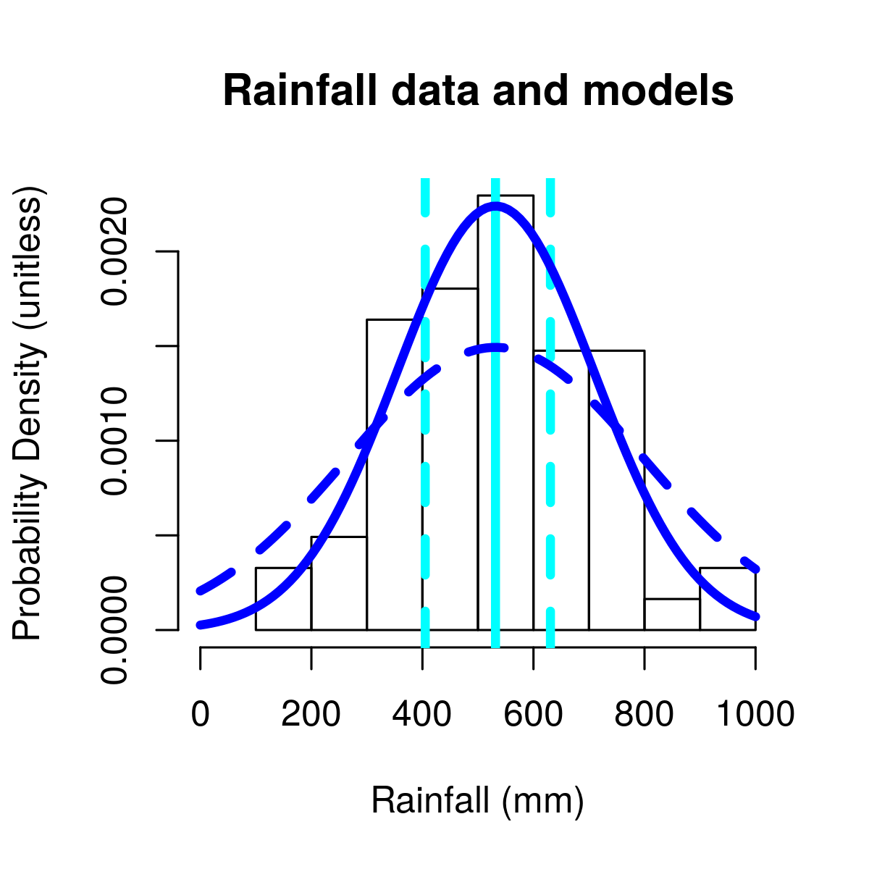
Figure 2: Rainfall data and representations of the different rainfall submodels. The histogram bars represent the historical rainfall, the average of the three nearby rain gauges; ‘historical’ and ‘random’ rainfall models use these values (in order, or randomly drawn, respectively). The solid vertical cyan line shows the mean value, used during burn-in and for the ‘constant’ rainfall model; to the left and right of the dashed vertical cyan lines are the upper and lower quartiles, used in the ‘extreme’ rainfall model. The solid dark blue line indicates a normal distribution with the mean and standard deviation of the rainfall timeseries, used in the ‘statistical-random’ rainfall model; the dashed dark blue line indicates a normal distribution with 1.5 times the standard deviation of the rainfall timeseries, used in the ‘statistical-extreme’ rainfall model.

Note that in both cases in which we draw the rainfall from a normal distribution (‘statistical-random’ and ‘statistical-extreme’), we truncate the distribution at zero, avoiding negative values for rainfall. After setting the new rainfall value, we increment the rainfall-index by one.

set new growth rates
Every year we calculate the growth rate per time step for woodland and crop patches, based on the current rainfall value. For simplicity we assume a linear relationship between rainfall and crop/woodland growth. From data and literature review (Rutherford 1978), the relationship is broadly linear over the range of rainfall observed in our system, so this is not an unreasonable assumption.

Crop growth:
We have yield data for cereals and pulses in kg/ha from interviews with Mudhomori farmers as well as governmental yearly rainfall data from three nearby locations: Zvishavane (20°18'37.52"S, 30° 3'35.81"E), Chivi (20°18'52.73"S, 30°30'30.63"E), and Mberengwa (20°28'39.74"S, 29°54'27.14"E). Fitting a linear function (Figure 3), we get a y-intercept of -203 kg/ha and a slope of 0.873 kg/ha/mm/year. Also note that our maximum harvest historically is 784 kg/ha (actually an average over households in that year), though it does not apply to Netlogo patches with Muonde improvements which increases their growth rate. Also, if the growth value is negative, we set it to zero.
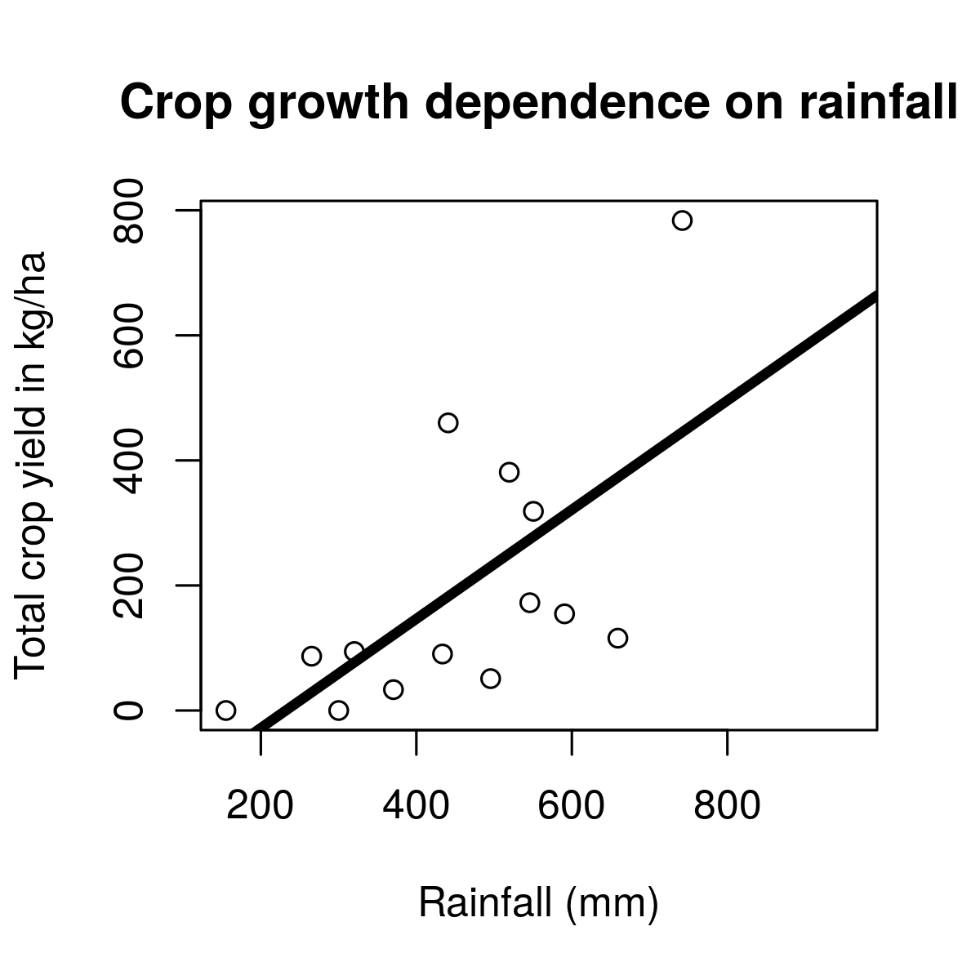
Figure 3: Crop yield as a function of rainfall. The linear fit is shown in the heavy dark line, with slope coefficient 0.873 (p=0.0132) kg/ha/mm and y-intercept -203 (p=0.188) kg/ha. Though the intercept is not significant, we know that crops will not grow without at least some rainfall so we make use of it in our model as a reasonable guess. In the model we refer to the zero-rainfall (x) intercept, which is the zero-crop (y) intercept divided by the slope, giving us 232 mm (not visible in the figure).

Woodland growth:
Rutherford, based on his own research as well as a thorough literature review, found that in semi-arid savannahs of the type found in Mudhomori, but under lower livestock densities, the total productivity was on the order of 3000kg/ha/year, with nearly two thirds of this being as woody biomass (Rutherford 1978). Livestock primarily consume herbaceous biomass, but also some woody biomass via browsing; likewise, herbaceous biomass cannot be used for fencing. We choose to simplify our model and pool all woodland biomass. To arrive at a total woodland biomass growth rate, we estimate herbaceous and woody primary production separately and then pool them.

The primary production in the herbaceous layer of savannah grasslands in Southern Africa at around 500 mm annual rainfall has been found to be around 1200-1400kg/ha/year (Kelly 1973, Knapp 1965, Bourliere and Hadley 1970); but these estimates were not made under the kind of heavy grazing regime observed in Mudhomori (Barnes 1972). Long term heavy grazing and compaction on heavy clay soils like those in Mudhomori appears to reduce primary productivity, perhaps by as much as 50%, with most subsequent herbaceous production occurring in drainage lines and similar sites where water and nutrients then accumulate (“key resources,” Scoones 1989). Therefore, we might estimate usable herbaceous layer primary production in Mudhomori’s grazing areas at unlikely to be more than around 600-700kg/ha/year. For the model, we use 600 kg/ha/year.

In our system, woodland dominated by Colophosperum mopane (zita rinodaidzwa naro Mupani ku 'Science') has been recorded to grow at about 1000 kg/ha/year (at the coppicing stage at which most of this woodland now is) while woodland dominated by Acacia spp grew as much as 4000 kg/ha/year, as measured by the Muonde research team (woodland was cut, air dried, and weighed after set time intervals of regrowth since an earlier cutting). In Mudhomori, approximately 80% of the woodland grazing area supports trees (as estimated by eye from aerial photography), and in 2013 the relative proportions of Acacia and C. mopane woodland was 80:20, so a weighted average gives approximately 2720 kg/ha/year.

This means that in a year, between herbaceous and woody biomass, 3320 kg are produced; likely our number is higher than Rutherford’s due to the coppicing (kutema miti) of the mopani woodland. For average rainfall, which is approximately 530 mm, this results in a growth accumulation of approximately 6.26 kg per additional mm of rain. Because woodland species are drought tolerant, we do not include an intercept; in our model, any rain at all will produce some growth in the woodland.

set-subsidized-cows
Farmers in Mudhomori are able to subsidize their cows during poor-rainfall years, either by feeding their cows supplementary food or transporting them to a grazing area outside their village (established from interviews). In the model, every year, start by setting all cows to be unsubsidized. Then, if rainfall is less than 400 mm, choose some cows (proportion set by user) to be subsidized, as follows.

In the user interface, one can select one of three options for subsidy: “none,” “feed,” or “transport.” To “feed,” farmers buy supplementary feed and apply it to subsidized cows during get hungrier. We track the amount of subsidy over the 60-year run of the model, scaling the amount of subsidy used in terms of the total dollar value of the feed (at $14.50 per kg) to give a sense of how costly the technique is. These numbers are as per the local marketplace in 2015, sourced from buyers and sellers of these services via interviews. Alternatively, farmers can “transport” (herd) their cows to a different grazing area outside the village. This externalizes the cost of feeding the cow as it grazes in a different system, but this was a valid way in the past 60 years that farmers have kept their cattle alive. In our model, a transported cow is “frozen” (colored blue) during update cows, before being asked to move, consume, or metabolize. These cows can, however, reproduce, and any such cows born have the same state variables as their parents.

globally find suitable patches & update globally suitable patches
In Mudhomori, farmers can move cows to better grazing areas, typically multiple times a day. In the model, before moving any cows, we (globally) search all the woodland patches for a list of enough potential locations with the highest available biomass. This list will contain at maximum either all the woodland patches (if there are more cows than patches) or as many patches as there are cows. After a cow has moved and consumed, we update the list by removing the patch with the least biomass from the list of potential destinations.

move
Cows can either be moved by a farmer to a good spot for grazing (every few ticks, depending on the number of ticks per day and the number of times per day that the farmers move them as set by the user in the interface), or if a farmer hasn’t moved them, they can look at the adjacent patches to decide if they want to try to move to that patch. Cows can share patches.

find a nearby patch to eat
When cows try to find a nearby patch to eat, they consider the four patches directly above, below, and to the left and right (nzvimbo dzekufurira dziri pedyo; these are known as their rook-neighborhood or “Manhattan” neighbors; neighbors4 in NetLogo) as well as their current patch. They will try to move to whichever patch has the highest biomass, even if it is a crop patch with a fence. The cow’s probability of breaking through the fence and getting into the crops depends on both how hungry the cow is (their satiety value) and how intact the fence is (see get eaten by termites for more information on the model for fences’ decaying effectiveness over time). We combine the two in the following way (a linear model with respect to the two variables, discounted appropriately for the number of attempts per day via the ticks-per-day variable):

fence effectiveness = (1 - (1 - cow-satiety) * (1 - fence-quality)) ^ (1 / ticks-per-day)

If a random number between 0 and 1 is less than fence effectiveness, then the cow breaks through and moves to the crop patch. If not, the cow stays on the patch it started on. Note that if there are stone walls on that crop patch, the cow will still try but always fail to break through.

consume
Once cows have been moved by farmers, tried to move and failed due to a fence or wall, or have successfully moved, they may then consume biomass on their current patch. Regardless of their own body-mass, they will either eat enough to maintain the mass of a max-mass cow for one tick, or eat whatever is on the patch (whichever is smaller). This means that a low-weight cow can build up its body mass, unless there is not enough woodland biomass. We reduce the patch’s biomass appropriately and adjust the cow’s current metabolic energy pool for the tick accordingly, as follows:

Energy gain = (mass of browse or crops in kg) * (metabolizable energy density of browse in kcal/kg of browse or crops)

We use the following logic for the values of metabolizable energy (chikafu chichashandiswa mumuviri wemombe kuipa simba). Astatke, Reed, and Butterworth (1986) calculated the metabolic rates of cattle in Ethiopia based on a diet of hay supplemented with nutrients with a metabolizable energy density of approximately 1931 kcal/kg. To compare with browse in our system, the nitrogen content of this feed was 1.32 % by volume; using a standard calculation for conversion from nitrogen to protein (FAO 2003), this is approximately 8.25% protein by volume. Compare with estimates for mopane and acacia browse: Dambe et al (2015) list crude protein for Acacia tortilis dry leaves as 10.2%, mopane bark as 4.62%, and mopane old leaves as 13.4%, which is consistent with Makhado, Potgieter, and Luus-Powell (2016), who found crude protein for mopane leaves (9.2-13.9), twigs (4.2-5.0), and pods (8.6-15.9). Because protein is perhaps the key nutrient in assessing the energetic quality of feed, we feel comfortable using Astatke, Reed, and Butterworth’s estimates of metabolizable energy for browse. Crop energy density is higher than browse: using the assumption for maize that grain is 42% of the plant by dry weight (FAO 1992) and values given by Ohio State University Extension (maize stover, the non-grain portion of the plant, has a metabolizable energy of 0.79 Mcal/lb, and grain has a metabolizable energy of 1.42 Mcal/lb; Eastridge 2007), we calculate that a maize plant has a metabolizable energy of 2325 kcal/kg. Note that because these are already estimates of metabolizable energy (rather than gross energy), assimilation efficiency (i.e. how much material passes through a cow undigested) has already been taken into account in the method of measurement.

After the cow consumes biomass, we update tracking variables for the amount of crop or woodland eaten. Woodland is tracked simply in metric tons accumulating over the model run, while crop eaten is tracked both on a per year basis in metric tons to be compared with the amount of harvest in that year (i.e. what percentage of harvest the animals ate), as well as in a per-cow-per-tick basis to compare with community data regarding how quickly animals can consume crops when they are able to break into fields (see calibration section).

get hungrier
We first deduct the energy associated with the maintenance of various bodily functions from the cow’s available energy pool for this tick. Maintenance energy consumption for grazing cattle in Africa is suggested to be 11,000 Kcal/tropical livestock unit/day, where a tropical livestock unit is 250 kg, scaled to the 0.75 power (Molden 2013). Inverting that equation ([11,000^(1/0.75)]/250) gives an energy consumption rate of 980 Kcal/kg/day. Maintenance energy includes basal metabolic functions, “thermoregulation, gut function, loss of energy in urine, and modest work for feeding and drinking” (Molden 2013). Therefore we assume that for each tick, a cow will expend 980 kcal/kg, divided by ticks-per-day, as it moves and metabolizes. Note that we assume a slow grazing pattern or slowly being herded to another location (i.e. not running fast). This number is consistent with Astatke, Reed, and Butterworth (1986) who measured cattle in Ethiopia (though they included an overall base maintenance energy as well as a factor that increased with body mass). For our model, we choose the simple assumption of Molden, because our animals are much lower-mass than Astatke, Reed, and Butterworth’s.

Energy loss for maintenance = (maintenance energy consumption in kcal/kg) * (current cow mass)

We then convert cow energy pool to mass change, calculating the cow mass change from current energy pool, finalizing the energy accounting for this tick (this may include an energy cost from ploughing in a previous tick, as update-crops happens after update-cows). If the cow has consumed an excess of energy, it adds to its own body mass. If there is an energy deficit, it burns some of its own body mass to compensate. We calculate these quantities as follows:

The energy density of cow varies from 1210-3320 kcal/kg depending on its body fat percentage (3-30%), based on the energy density in ground beef (http://ndb.nal.usda.gov/ndb/beef/show). The cows in Mudhomori are lean, so we choose a 5% fat content, and a corresponding value of 1360 kcal/kg. Though this is a calculation from a U.S. agency, these statistics include meat with very low body fat. Therefore we assume that, despite the differences between African and United States contexts, the fat content is the dominant factor in energy density despite differences in breeds of cattle and their husbandry.

When the cow builds protein and fat from available metabolic energy, there is a production efficiency loss based on metabolic pathways; we use Johnson et al.’s (2012) values for protein (0.48) and fat (0.71). Because we assume a fat percentage of 5%, we weight Johnson’s numbers accordingly and obtain 0.49 for the production efficiency of building new protein and fat when a cow consumes excess calories.

Mass gain = (Energy gain – Energy loss) * (production efficiency) / (cow energy density in kcal/kg of cow)

If a cow has not consumed enough to compensate for its maintenance energy, it loses body mass and liberates energy to address the deficit. This conversion has its own inefficiencies, however: from Johnson et al (2012), protein degradation 0.90 and fat catabolism 0.95, which we weight in the same way as the production efficiency, to get 0.9025 for what we call ‘catabolism efficiency’:

Mass loss = (Energy gain – Energy loss) * (catabolism efficiency) / (cow energy density in kcal/kg of cow)

In addition to updating the cow’s mass and setting the current energy pool to zero, we also update the cow’s satiety variable to reflect its current body mass (where we use the calf min-mass and adult min-mass as appropriate):

satiety = ( body-mass - min-mass ) / ( max-cow-mass - min-mass )

If cows are being subsidized with supplemental feed, and they are about to starve to death, we add enough maintenance energy for a maximum-weight cow for one tick (the same amount that the cow would normally consume if there were available biomass in woodlands or crops to eat). We do this after the initial energy accounting but before checking whether the cow should starve so that we have a chance to save the cow using the subsidy. We update the amount of subsidy used, and convert cow energy pool to mass change and update satiety again based on the new energy input from the subsidy. We assume an energy density for supplemental feed equivalent to that of crop, because farmers are likely to purchase feed which is higher-quality than the woodland browse.

We then check-calf-status and graduate calves to adult cows (change is-calf? to false and make the agent’s icon full-size) if body-mass is high enough (above min-cow-mass plus a day’s worth of maintenance energy). For all cows, we then check their mass: if it is below the minimum for calves or adults, respectively, then the cow starves, incrementing the accumulated count of dead cows and removing the agent from the simulation.

We update-globally-suitable-patches list to remove the potential woodland destination patch with the least biomass on it (to reduce searching time for the next cow’s move action). We then update the cow’s color according to their satiety (red if it falls below 0.5). Finally, we check the body-mass of each cow to find available cows for ploughing/reproducing in next tick. These cows must be adults and must have enough mass to expend in ploughing plus enough mass to expend for one tick’s maintenance energy (for working), or enough mass to lose in producing a new cow and to expend for one tick’s maintenance energy (for reproducing). Cows marked for subsidy can never work, though “transported” cows can reproduce. We do this check both to prevent killing the cow and to reduce Netlogo’s searching time.

reproduce cows
We adopt a simple two-stage population model of cows and calves in order to keep account of their different weight ranges (for simplicity, we do not distinguish males from females but give all adult cows a constant probability of reproducing). Note that cows have a 25%-35% chance of reproducing each year: the community research team reports that 50-60% of livestock are fertile females achieving 80% pregnancy in high rainfall years down to 50% in poor years and few in drought years. In order to calculate a per-tick probability of reproduction: if there is a 25% chance the cow reproduced this year, this means that the probability of not reproducing all year is 0.75, which is the multiplicative result of not reproducing each tick during the whole year: 0.75 = (probability-of-not-reproducing-each-tick)^ticks-per-year. The probability of not reproducing in a given tick is then 0.75^(1/ticks-per-year), and the probability of actually having reproduced in that tick is the complement: 1 – 0.75^(1/ticks-per-year). For any cow available to reproduce, we draw a random number from 0 to 1 and if it is less than the probability of reproducing in a tick, give birth: have the cow split into two cows, one with the minimum calf weight (18 kg) from Nicholson (1983), and the original cow, less the weight of the calf. We then update available cows to work/reproduce. This means that while we have nominally established a 25% reproduction rate per year (which, annually compounded over 60 years becomes 29%), in practice the rate may not match because not all cows are available to reproduce.

update fences
5.77 kg/m/year of woodland biomass is needed to maintain the fence, and 2/3 of the fence is eaten by termites in a year. These values come from the Muonde Trust research team’s field measurements of fencing typically used in Mudhomori village: brushwood (matyatya) and fence poles from a given length of fence (measured by pacing after training against a meter ruler) were weighed (using a 25kg salter scale with 100g increments), and the decay rate of fences of known age was recorded. The ‘termite-activity’ parameter is in units of1/year, and the fence status variable is scaled between 1 (completely intact fence) and 0 (completely decayed fence), decaying linearly at a rate of 2/3 per year.

Note that we skip this entire step if we are using stone walls (“invincible fences”). To update the fences in the model, first collect a list of woodland patches with enough biomass to build a fence. Then, for each of the crops which border woodlands, the fences get eaten by termites: reduce the “fence” variable by 2/3 divided by ticks-per-year. Then, for crop patches with fence = 0, repair fences: remove 5.77 kg/m * the length of the side of a Netlogo patch of biomass from an available woodland patch, one side at a time; repeat as necessary for all the sides of the crop patch that border a woodland patch. Update the “fence” variable appropriately: for example, if the crop had three sides bordering woodland and we were able to repair one of them, set “fence” to 1/3. If a woodland patch no longer has enough biomass to build a fence, remove it from the available woodland patches list.

plough
If a crop patch has zero biomass, and there are cows available to work, add biomass to the crop patch according to the growth rate set in set new growth rates (do this immediately so that the crop will not have to be ploughed again until it is harvested). Then adjust the current energy pool of the cow, using Astatke, Reed, and Butterworth’s (1986) assumption of 3.85 MJ/hr for ploughing, converted to 920 kcal/hr. Farmers in Mudhomori report that it takes four cows about two hours to plough a hectare, giving 8 cow-hours to plough one hectare. While farming conditions in Ethiopia are quite different from Mudhomori, we assume that metabolic cost is similar.

Energy loss for a working cow = (energy cost while working in kcal/hr) * (hours to plough a hectare) * (hectares per patch)

This calculation results in a total amount of energy required to plough a Netlogo crop patch. Cows are proxies for each other in our model, distinguishable from each other only by body mass and energy available, so we select a single cow with enough energy to plough the entire patch and deduct the cost of the ploughing in a single tick. In reality, this ploughing would require multiple days and/or multiple cows. Then update available cows for working/reproduction.

grow
For either woodland or crop, add biomass according to the growth rate set in set new growth rates.

update crop color/symbol
If the model is in “Demonstration” mode, update fence symbology (we display a yellow x when fence > 0) and available biomass (brighter green indicates higher biomass; this symbology saturates, i.e. if a patch gets beyond a maximum value, just choose the maximum green value). If a crop has a Muonde project on it, causing it to grow faster, display an “M” unless the crop has a fence. If the fence has decayed, display the “M” instead. If the model is in “Experiment” mode, save run time by not updating the display.

harvest
For some crops, (i.e. small grains like sorghum and especially bulrush and finger millets, as opposed to maize/corn), harvests can be stored from year to year, up to three years (depending on quality of storage bins and storability of crop type and variety). This means that if there is a bumper harvest (extremely good year) in one year, it may be possible to carry over the surplus into the next, potentially low-rainfall, year. To harvest crops in the model, we first update annual crop trackers which include a running list of the last several years’ harvests (number of years set by the user as how-long-to-store-grain). We drop the oldest element of the list, then sum all the standing available biomass of the crop patches, and add that sum to the list as the current year’s harvest. We then calculate the amount of the crop eaten by cows (if any), in two ways: we calculate the percentage of the crop eaten in the current year:

percentage-harvest-eaten = 100 * crop-eaten / ( current-harvest + crop-eaten )

which is displayed in the interface, and keep track of the maximum percentage eaten over the course of the model run. We also keep an accumulated total quantity of crop eaten by all cows over the model run, which we will later divide by the number of ticks each cow was in the crops (which we also track, because they do not spend all their time in the crops) in order to determine a consumption rate for cows illicitly eating crops (for comparison with the research team’s data in calibrating the model). We then set the crop eaten in the current year to zero, and the standing available biomass of the crop patches to zero. Finally, we update and check total harvest: add the current harvest to the accumulated total harvest for the model run, and check to see if the running average of the last several years’ harvest is above a sustainability threshold (the community’s sustainability threshold is 48 metric tons of harvest a year; we also test a minimum annual harvest of 0.96 metric tons, 1/50th of the community’s threshold); if it’s below the threshold, stop the model.

update woodland available biomass
Each tick, grow each patch according to the rainfall-based growth rates established in set new growth rates. If the model is in “Experiment” mode, update the display to reflect the available biomass (brighter brown is higher biomass).

advance-time-step
Advance the model one tick (model time step), and check to see if a calendar (model) year has passed (using the mod operator: if ticks mod ticks-per-year = 0, update the calendar year and number of model years that have passed so far).

8) MODEL EXPERIMENTS

We use NetLogo's BehaviorSpace functionality to try a variety of combinations of the user-chosen variables (for both management of cows and crops, as well as for different climate variation models). The values we tested are listed in the initialization section. We look at a subset of the input variables which are similar to the real system in order to check the of the model. To test the sensitivity of the underlying variables as well as the management and climate variables, we use the results of the entire BehaviorSpace experiment with all parameter combinations, using R version 3.2.3.

9) CALIBRATION OF MODEL
(kuongorora, kuedza kugadzirisa nekuraramisa model)

We have avoided using any tuning parameters to force the model to behave in line with the real system. Instead, we have carefully selected underlying parameters based on literature and field data collected by Muonde’s research team from interviews with farmers, and calibrate by checking against other field data from the team from known conditions. In our experiments, we also examine the behavior of the model for parameters outside the historical values, but for calibration, we specifically look at outcome variables for historical variable choices.

Variable choices to check calibration
In order to check the results of the model, we need to know what values the user-chosen variables should take. The actual proportion of crops has varied from 40% in the mid-1980s to 65% in recent years. Therefore we check model outputs based on this range. The degree to which crops have been clumped has varied, so we examine results for all of the ‘clumpiness’ values. The research team estimates that key resources are 10% or less, so we check results for 0% and 10% key resources. Muonde projects are a recent innovation, so we check results for 0% Muonde projects. Stone walls are similarly a new innovation, so we check results for invincible fences = FALSE. We use rainfall-type = “historical” or “random” (because these are the actual rainfall time-series values or a re-ordered version thereof) and rain-site = “average.” Farmers do move their cows, so we use a value of 1, and animals were subsidized, so we check results for both subsidy = “transport” as well as “feed.” The research team reports that 70% of farmers used supplemental feed, so where we subsidized with feed, we look at results for 70% of the cows being subsidized. With current storage techniques, crop harvests cannot be stored longer than three years, so we look at results for zero or three years.

Cows
From interviews, the total number of cattle in Mudhomori historically ranged from 6 to almost 200. We therefore look for model behavior in which the minimum and maximum number of cattle lies within this range.

Harvest
There are 100 homes in Mudhomori, listed in interviews and verified via Google Earth. The research team reports from interviews with farmers that harvests per household vary between 1 to 4 metric tons per year. Therefore a reasonable range for our total harvest is 100*1*60 to 100*4*60 or 6,000 to 24,000 metric tons for the 60-year run of our model.

Woodland
We do not have historical estimates of the total amount of biomass in the woodlands; this is an active question of research for the Muonde team. The team estimates that there is currently about 1/20th the amount needed to re-make all of Mudhomori’s current fences, so we use this as a benchmark (288 metric tons/20 = 14.425 metric tons)

Subsidy used
The research team reports that 70% of farmers used supplemental feed (a cow-proportion-to-save of 0.70), at an average of approximately 240 kg/household. For 100 households at 240 kg/year for 60 years and $14.50/kg, this gives a total cost of 100*240*60*14.50 or $20,880,000 over the 60-year run.

Harvest eaten
From interviews with farmers, estimates of the damage after animals had broken into fields indicated that three donkeys could eat 50% of 424 maize plants (out of 5500) after 10-25 minutes, or 7.6% of a farmer’s crop (as estimated by the farmer). Converting this to a number of plants per cow (using the standard that one donkey is 0.55 Tropical Livestock Units and one cow is 0.66 Tropical Livestock Units), we find a single cow could eat 84.8 plants. Maize plants have a mass ranging from 0.13 to 0.71 kg per plant (each ear has 300-1000 kernels, weighing between 190-300 g/1000 kernels, usually with one ear per stalk, and the grain makes up 42% of the plant by dry weight, FAO 1992). The crops eaten by the donkeys were reported to be only about 5% of an adult plant in size (about 30 cm high). This means that a single cow eating the crops in a similar fashion to the donkeys would consume 0.6-3.0 kg in 10-25 minutes.

Note that we do not know how much more food the animal would eat if it were able to stay in the field for a longer time period (the donkeys were evicted from the field as soon as they were found); at some point the animal would no longer be hungry and would not continue to eat, and our cows are not modeled as consuming food in a panic as farmers attempt to remove them from the field.

Summary of validation results (for runs that completed 60 years successfully):
Variable | Range from data | Range from model
Total village harvest over 60 years | 6,000 to 24,000 metric tons | 1,153-4,791 metric tons
Total livestock in any year | 6-200 animals | 2-85 animals
Minimum woodland in any year | 14.425 metric tons | 5.8-24.1 metric tons
Total subsidy used over 60 years | $20,880,000 | $9,866,734 (maximum)
Harvest eaten per cow per half hour | 0.6 to 3.0 kg | 0.69 to 1.20 kg

Though the harvest, livestock, and subsidy are low compared to the field data, the woodland and harvest eaten are similar. This comparison is based on only 10 of our 11,648 runs which met the criteria of finishing a run as well as having realistic management parameters, so we feel this is still confirmation that our model parameters are reasonable, especially because there are other management strategies farmers used in the historical system which we do not include in the model.

10) SENSITIVITY ANALYSIS

We wrote a function to perturb the underlying variables (those from data or literature, e.g. growth rate of woodlands, energy density of browse, and so on) by a percentage above or below the stated values. For most parameters, we perturb the variables by 5% above or below their stated value (according to Railsback and Grimm 2012’s suggestions for sensitivity analysis). We then test each variable in a generalized additive statistical model predicting whether the simulation lasted all 60 years (a measure of the sustainability of the system) to see which variables are statistically significant.

A local linear approximation is a reasonable choice for small perturbations (the underlying variables). Most management choices were modeled as categorical (e.g. farmers move cows = “yes/no”). Proportion-crops and average-contiguous-crop-cluster-size were modeled as smooth functions because we examined a wide range of these variables. Moran’s I is modeled as linear because preliminary smooth functions indicated that it was linear (Geary’s C is essentially the inverse of Moran’s I for the purposes of these data so we include only one of these two variables). Total-crop-perimeter is modeled as a quadratic function because preliminary smooth functions indicated that it was quadratic.

The parameter estimates in the table below are given on the scale of the predictors, not the probability scale, and are given in order to compare the magnitude of different effects. Note that these are preliminary results.

Summary of sensitivity analysis of underlying parameters for whether the simulation lasted 60 years (parameters significant at the p<0.05 level are in bold italic):
Variable | Parameter estimate | Statistical significance
total.mud.crop.perimeter | -5.31E-05 | 0.168296
wood.to.build.fence.per.meter | -5.90E-02 | 0.8599
termite.activity | 3.82E+00 | 0.19302
hours.to.plough.ha | -4.71E-01 | 0.051825
crop.growth.slope | -1.24E+00 | 0.581532
zero.crop.growth.intercept | -9.13E-04 | 0.914856
muonde.efficiency | -3.15E-01 | 0.324354
woodland.growth.slope | 3.34E-01 | 0.035509
cow.maintenance.energy.rate | 8.06E-04 | 0.690747
cow.working.energy.per.hour | -8.56E-04 | 0.689822
kcal.per.kg.of.browse | 1.09E-03 | 0.278041
kcal.per.kg.of.crop | -1.30E-03 | 0.11837
kcal.per.kg.of.cow | 7.20E-04 | 0.618776
production.efficiency | 5.30E+00 | 0.184125
catabolism.efficiency | 1.23E+00 | 0.566578
min.cow.mass | 3.79E-03 | 0.901947
max.cow.mass | -6.57E-03 | 0.326566
calf.birth.mass | -1.81E-01 | 0.096523
livestock.not.reproduction.rate.per.year | 4.69E+00 | 0.068496
Fortunately, most of the underlying variables did not significantly impact model sustainability. The woodland growth slope was the most important, and its parameter estimate indicates about a 3.5% difference in sustainability for a 1-unit increase in the growth slope (compared to the mean value for underlying parameters and reference values of management parameters indicated by ‘vs’ below).

For user-set variables, we used the behaviorspace functionality in NetLogo to try a range of values. In the case of ‘clumpiness’, the relationship between clumpiness and Moran’s I is nonlinear, so based on an early model run we used a nonlinear estimation method to obtain an even selection of Moran’s I values with respect to clumpiness values.

Preliminary analysis of user-set variables for the sustainability over 60 years:
Variable | Parameter estimate | Statistical significance
Subsidy, Proportion-to-save  -vs. ‘none’ | Feed, 0.7: 5.84E-01  Feed, 1.0: -6.07E-02  Transport, 0.7: 1.60E+00  Transport, 1.0: 1.42E+00 | Feed, 0.7: 0.000798  Feed, 1.0: 0.724597  Transport, 0.7: <2.00E-16  Transport, 1.0: 1.74E-14
Farmers.move.cows (true, vs. false) | -4.01E-01 | 0.001599
Invincible.fences (true, vs. false) | 1.15E-01 | 0.307707
Key.resources (10%, vs. 0%) | 8.18E-01 | 1.53E-12
Rainfall.type (compared with ‘constant’) | extreme: -7.97E+00  historical: -7.70E+00  random: -7.24E+00  statistical-extreme: -9.41E+00  statistical-random: -7.81E+00 | All: <2.00E-16
Muonde.projects (10%, vs. 0%) | 1.50E-01 | 0.181971
How.long.to.store.grain (3, vs. 0) | 6.05E+00 | <2.00E-16
moran’s I (linear function) | 1.30E+00 | 0.027447
Total crop perimeter (quadratic function) | Linear: 4.63E-05  Quadratic: -2.03E-10 | Linear: 0.000108  Quadratic: 1.02E-07
These results indicate that feeding some of the animals or transporting some or all of them increases system sustainability (but not feeding all of them!), moving cows decreases the sustainability of the entire system, higher key resources increases the sustainability, varying rainfall decreases the sustainability of the system (especially the statistical extreme model for rainfall variability), storing grain increases the sustainability of the system, a more clumped system is more sustainable, and high or low crop perimeter decreases the sustainability of the system. (Recall that these results are based on somewhat arbitrary thresholds for sustainability of individual components, however).

Because we used a spline smoother to get a smooth function of sustainability as a function of proportion crops and of average contiguous crop clump size, these variables do not have a single parameter estimate. Instead we show plots of the smooth functions generated by the program, which indicate a thresholding effect of the proportion-crops (above 60% the system isn’t sustainable), and a similar effect for crop-cluster-size (350-450 ha appears optimal):

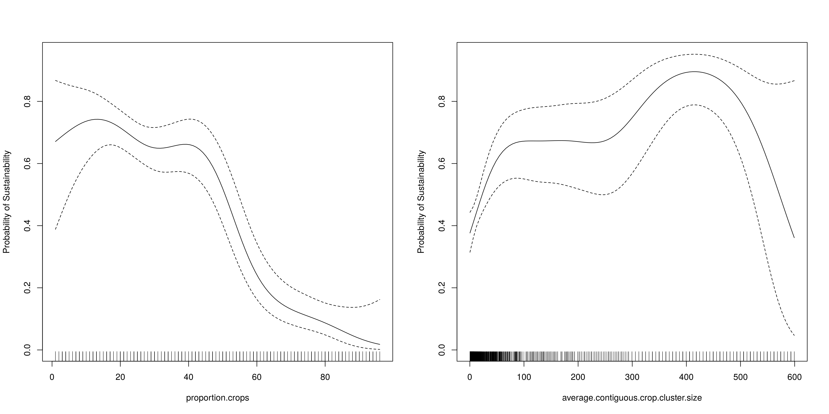
Figure 4: Smooth functions of the probability of a model being sustainable as a function of the proportion crops in the village (left; p< 2e-16) and the size of the contiguous crop clumps in ha (right; p=8.49e-05). Dashed lines indicate 95% credible intervals; tick-marks above the x-axis indicate data coverage.

11) TECHNICAL NOTES

Keeping track of available patches/agents
For efficiency, we keep account of the Netlogo patches and agents which are available for various uses (ploughing, fencing, reproducing, grazing), because not all agents or patches will be available and this reduces the searching time in NetLogo. These are dynamically updated and are not fundamentally different entities from those defined above. This efficiency is important, because our model’s complexity and varied data sources necessitates sensitivity testing of management and underlying variables – and that means running many different versions of the model. In a high-performance-computing context, making NetLogo’s ‘ask’ loops and other searches of agents or patches more efficient is absolutely critical to reduce model run time.

Model modes (nzira dzinokwanisa kushandiswa nadzo ' model' iyi)
We have three different ‘model modes’: ‘Experiment’ ‘Demonstration’ and ‘SoftwareTest.’ This is a user-chosen variable. Demonstration mode does not include burn-in (so a user does not need to sit and wait for burn-in to finish, and uses fixed values of the underlying (non-user-set) parameters. This is the mode to use to explore model behaviors; it also displays the final values of the reporters in an output area. Experiment mode does not update the display (to save run time) and perturbs the underlying parameters by 5% in order to assist with sensitivity analysis, as well as having a five-model-year burn-in to allow transient behaviors associated with initial conditions to fade. It is intended to be used in the BehaviorSpace. SoftwareTests is for checking the basic functionality of the model procedures.

Software/unit testing and model behavior testing
We have created a ‘model-mode’ designed for testing the individual outcomes of each function as a software best practice, also referred to as ‘unit testing.’ Unit testing is not embedded in NetLogo’s functionality, so in the ‘setup’ function, we check for model-mode = “SoftwareTest” and run a function which then calls all the individual software tests (“run-software-tests”), which runs all the software tests and displays whether each test was passed (in the output area). In our BehaviorSpace sensitivity tests/parameter studies, we include one BehaviorSpace which simply runs all the tests, so that every set of model outputs also has a record that the tests were working.

We wrote standard functions used in unit tests (“assert”, “assert-equal”, “assert-float-equal”) and then individual functions which test the outcome of one of our model functions, for example setting up a known spatial configuration and testing the assertion that Moran’s I and Geary’s C calculations result in a known value (verified by manual calculation), or creating one cow and setting its mass to a value low enough to cause it to die during the “consume” function, and checking the assertion that the “count cows” is zero after “consume” is called. The unit tests are designed to be run any time a change is made to the code to make sure we avoid introducing unintended behavior or bugs.

The unit tests each test a single base-level outcome of our functions, and therefore take a large amount of space in the code. In software with built-in unit testing capability, this code would be displayed in another model tab, and perhaps NetLogo could in future iterations have this kind of functionality. This would encourage modelers to think in terms of small enough model outcomes to write robust unit tests and would make agent-based models as a method more robust and defensible, particularly because of their heavy use of programming (as opposed to, for example, largely statistical models using canned procedures). In Railsback and Grimm (2012), testing is discussed but software engineering best practices are not mentioned, therefore we feel this development is a great follow-up to their recommendations.

In addition to the low-level model behaviors, there are certain emergent properties we check during our analysis of model outputs, for example that ‘invincible-fences’ = TRUE means ‘crop-eaten’ = 0 or ‘rainfall-type’=‘constant’ means “subsidy-used” = 0. A checklist for these behavior is provided in a spreadsheet.

REFERENCES

Astatke, A, Reed JD, and Butterworth MH. (1986) “Effect of diet restriction on work performance and weight loss of local zebu and Friesian x Boran crossbred oxen.” ILCA Bulletin 23: 11-14.

Barnes, D. L. (1972) “Defoliation effects on perennial grasses - continuing confusion.” Proc. Grassld. Soc. Sth. Afr. 7:138-145.

Bourliere, F. & Hadley, M. (1970) “The ecology of tropical savannas”. Ann. Rev. Ecol. Syst. 1:125-152

Dambe, L. M., Mogotsi, K., Odubeng, M., & Kgosikoma, O. E. (2015) “Nutritive value of some important indigenous livestock browse species in semi-arid mixed Mopane bushveld, Botswana.” Livestock Research for Rural Development. Article, 209(27), 10.

Eastridge, M. (2007) “Feeding Corn Stover to Ruminants.” Buckeye Dairy News: Volume 9 Issue 3. Available: https://dairy.osu.edu/newsletter/buckeye-dairy-news/volume-9-issue-3/full (Accessed February 14, 2018)

Food and Agriculture Organization of the United Nations. (1992) “Maize in human nutrition.” (FAO Food and Nutrition Series, No. 25) ISBN 92-5-103013-8 Available: http://www.fao.org/docrep/t0395e/T0395E01.htm (Accessed January 29, 2018)

Food and Agriculture Organization of the United Nations. (2003) “Food energy – methods of analysis and conversion factors.” Fao Food And Nutrition Paper 77. Available: http://www.fao.org/tempref/docrep/fao/006/y5022e/y5022e00.pdf (Accessed February 3, 2018)

Geary, R. C. (1954). “The contiguity ratio and statistical mapping.” The incorporated statistician, 5(3), 115-146.

Johnson, I. R., France, J., Thornley, J. H. M., Bell, M. J., & Eckard, R. J. (2012) “A generic model of growth, energy metabolism, and body composition for cattle and sheep.” Journal of animal science, 90(13), 4741-4751.

Jury, M.R. (2013) “Climate trends in southern Africa.” South African Journal of Science, 109(1-2), pp.1-11.

Kelly, R.D. (1973) “A comparative study of primary productivity under different kinds of land use in southeastern Rhodesia”, PhD Thesis, University of London.

Knapp, R. (1965) “Pfianzenarten - Zusammensetzung, Entwicklung und natiirliche Produktivitiit der Weide-Vegetation in Trockengebieten in verschiedenen Klima-Bereichen der Erde.” In: Knapp, R. (ed.), Weide-Wirtschaft in Trockengebieten. pp. 71-97. Gustav Fischer Verlag, Stuttgart.

Makhado, r. A., Potgieter, m. J., & luus-powell, w. J. (2016) “Nutritional value of colophospermum mopane as source of browse and its chemical defences against browsers: a review.” Journal of animal and plant sciences, 26(3), 569-576.

Machila, N., Fèvre, E.M., Maudlin, I. and Eisler, M.C. (2008) “Farmer estimation of live bodyweight of cattle: Implications for veterinary drug dosing in East Africa.” Preventive Veterinary Medicine, 87(3), pp.394-403.

McGarigal, K., SA Cushman, and E Ene. (2012) “FRAGSTATS v4: Spatial Pattern Analysis Program for Categorical and Continuous Maps.” Computer software program produced by the authors at the University of Massachusetts, Amherst. Available at the following web site: http://www.umass.edu/landeco/research/fragstats/fragstats.html

Molden, D. ed. (2013) “Water for food, water for life: a comprehensive assessment of water management in agriculture.” Routledge.

Moran, P. A. (1950). “Notes on continuous stochastic phenomena.” Biometrika, 37(1/2), 17-23.

Nicholson M J. (1983) “Calf growth, milk offtake and estimated lactation yields of Borana cattle in the southern rangelands of Ethiopia.” Joint Ethiopian Pastoral Systems Study, Research Report 6.

Railsback, S.F. and Grimm, V. (2012) Agent-based and individual-based modeling: a practical introduction. Princeton university press.

Rutherford, M.C. (1978) “Primary production ecology in Southern Africa”, in M. J. A. Werger (ed.), Biogeography and Ecology of Southern Africa Dr W. Junk, The Hague, p638

Shongwe, M.E., Van Oldenborgh, G.J., Van Den Hurk, B.J.J.M., De Boer, B., Coelho, C.A.S. and Van Aalst, M.K., (2009) “Projected changes in mean and extreme precipitation in Africa under global warming.” Part I: Southern Africa. Journal of Climate, 22(13), pp.3819-3837.

Scoones, I.C. “Patch use by cattle in dryland Zimbabwe: farmer knowledge and ecological theory” Overseas Development Institute, Paper 28b, 1989.

World Bank Group. Climate Change Knowledge Portal. Available: http://sdwebx.worldbank.org/climateportal/index.cfm?page=country_future_climate_down&ThisRegion=Africa&ThisCcode=ZWE (Accessed Feb 3, 2018)

Text in gray bold italic is in Shona, one of the languages of Zimbabwe. While our community-based farmer-researchers speak English, technical model language is unusual so we have translated some of the concepts to aid in understanding.

