**Creational Design Patterns**

**Pizza and Movies!**

**Builder**

You will create a pizza chain, Pizza Hut. When pizza’s are created they have many possible toppings and to keep the creation simple for the user you will use the builder design pattern to allow the user to clearly understand which topping will be selected.

All Pizzas can have the following toppings:

Pepperoni

Sausage

Mushrooms

Bacon

Onions

Extra Cheese

Peppers

Chicken

Olives

Spinach

Tomato and Basil

Beef

Ham

Pesto

Spicy Pork

Ham and Pineapple

**Pizza Hut**

Pizza can be made with any combination of the toppings shown above.

Pizza’s come in three sizes: Small, Medium or Large NOTE: This is **required** and must be set!

When the **eat()** method is called it should print out the pizza chain, the size and all of the toppings specific to that pizza

1. Create a driver program to create three pizzas one of each size with 3, 6, and 9 toppings to your liking and eat() all of them
2. Now assume you purchased another two pizza chains, Little Caesars, and Dominos. You want to add them to your program following the rules mentioned above.

Create the following pizzas and eat() all of them:

**Pizza Hut**

**Little Caesars**

**Dominos**

Large pizza with 3 toppings

Medium pizza with 8 toppings

Small pizza with 1 topping

Small pizza with 2 toppings

Small pizza with 6 toppings

Large pizza with 3 toppings

**Macronutrient Meals!**

**Abstract Factory, Factory and Singleton**

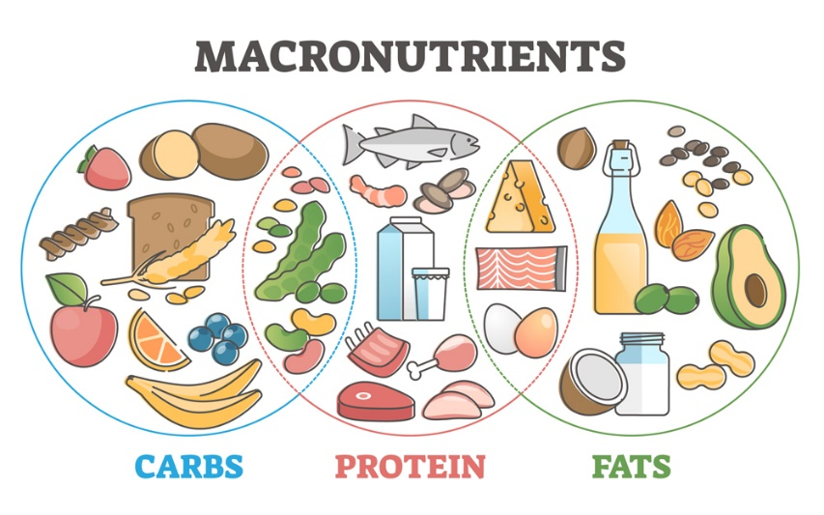

Create a Macronutrient balanced meal for customer’s based on their given diet plans. The system should generate a meal with one of the following at random: Carbs, Protein and Fats as long as it does not violate the customers diet plan.

|  |  |  |
| --- | --- | --- |
| Macronutrient Food Options | | |
| **Carbs** | **Protein** | **Fats** |
| Cheese | Fish | Avocado |
| Bread | Chicken | Sour cream |
| Lentils | Beef | Tuna |
| Pistachio | Tofu | Peanuts |

The **Customer** will provide their information specifically:

Customer name

Customer diet plan

The **Diet plan** can be one of the following:

No Restriction – Can randomly select any food item in each category.

Paleo – No Carbs except pistachio, No Tofu, No Dairy (Cheese and Sour cream)

Vegan – No Meat (Fish, Chicken, Tuna) and No Dairy (Cheese and Sour cream)

Nut Allergy - No Nuts (Pistachio and Peanuts)

The **Carbs**, **Protein** and **Fats** should all be built each using the **Factory** Design Patterns and the **Macronutrient** should use an **Abstract Factory** to create the three Carbs, Protein and Fats Factories to produce a meal for the customer at random based on their food restrictions. Additionally, there should only be one factory of each type allocated at any given time for the factories and one abstract factory to enforce this you will use the **singleton** design pattern.

Create 6 customers in your driver program to show all the various diet plans. Make sure your system randomly chooses food items in each category that meets the customers’ diet restrictions.

NOTE: The driver program will have 6 customers, and each should expect a Meal which will have one item from Carbs, Protein and Fats as shown above.