CMSC 140 Programming Project 3
Maya V. Ghazzaoui-Chelle

Output screenshot: 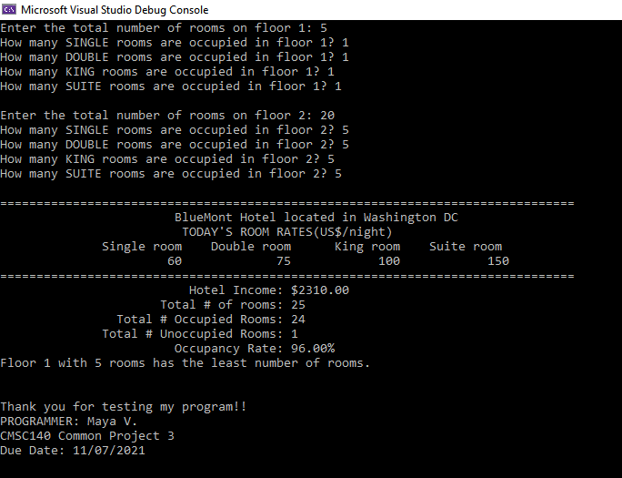

Test Plan:
Test Case # | Input | Expected Output | Actual Output | Did the test pass?
1 | loc: Washington  #of floors: 0 | The number of floors should be between 1 and 5 !! please try again | The number of floors should be between 1 and 5 !! please try again | Yes
2 | loc: Washington DC  #of floors: 2  Floor1: 5  Single 1, Double 1, King 1, Suite1  Floor2: 20  S 5, d 5, k 5, suite 5 | Occupied rooms 24  Lowest rooms floor 1  Lowest rooms 5  Total rooms 25  Lowest occupancy rate 80%  Total occupancy rate 96%  Total income 2310.00  Total unoccupied rooms 1 | Occupied rooms 24  Lowest rooms floor 1  Lowest rooms 5  Total rooms 25  Lowest occupancy rate 80%  Total occupancy rate 96%  Total income 2310.00  Total unoccupied rooms 1 | Yes
3 | Loc: South Africa  #floors 1  Floor1 rooms: 88 | The number of rooms should be between 1 and 30 !! please try again | The number of rooms should be between 1 and 30 !! please try again | Yes
4 | Loc: x  #floors 3  Floor1 rooms 22  S 5, d 10, k 10, suite 11 | Total occupied rooms on floor exceeds total rooms on floor!! | Total occupied rooms on floor exceeds total rooms on floor!! | Yes

Lessons Learned:
In this project I encountered a lot of tiny problems and learned a lot about debugging, which I used very many times in this program. I had problems such as forgetting curly braces in a while/for loop, wrongly initializing variables, and making calculations with the wrong variable type. A main problem I had was not using parenthesis when calculating and comparing variables. All of these tiny errors caused major issues, and I really improved my eye for errors and my debugging skills. It was a bit challenging to figure out the logic for all of the nested loops, but it worked in the end and now I’m quite confident in my use of loops.

Chapter(s) Covered:

- Chapter 5
Concepts tested in this project

- [All concepts covered by previous projects]
- Repetition control structure
  - The do.. while/while statements
  - The for statement
- Input validation
  - Use a repetition control structure for EACH user input

Project Description
The BlueMont chain hotels have 4 different types of room:

Single room: $60/night
Double room: $75/night
King room: $100/night
Suite room: $150/night

The size of the hotel chains in different locations may be different in terms of the number of floors and the type and the number of rooms on each floor.

You are required to write a program that calculates the occupancy rate and the total hotel income for one night and displays this information as well as some other information described below.
The program starts by asking the location where this hotel chain is located and the number of floors in the hotel. The number of floors may not exceed 5. The User then enters the total number of rooms for each floor. The program then asks specifically the number of occupied rooms for each room type on this floor. The total number of rooms on each floor may not exceed 30 and the program should check that the total number of occupied rooms on each floor does not exceed the total of rooms on that floor.

After the information is entered for each floor, the program calculates the following:

- Hotel income (based on the room type and its rate),
- The total number of occupied rooms,
- Total number of the unoccupied rooms,
- The rate of occupancy,
- Floor number with the minimum number of rooms. (Assume no two floors have the same number of rooms).
- A message to improve the occupancy rate for the occupancy rate of less than 60%.
- Programmer’s full name
- Project number
- Project due date

Project Specifications

-Use constant variables to hold room rates, max and min # of floors and rooms.
-The program should continuously ask for the correct floor number if it is not within the range of 1 and 5.
-The program should continuously ask for the correct number of rooms for each floor if it is not within the range of 1 and 30.
-The program should repeat the process of asking the number of rooms on the floor and number of occupied rooms if the total number of occupied rooms exceeds the total number of rooms on the floor.

Refer to Sample outputs for more clarification.

Sample output#1
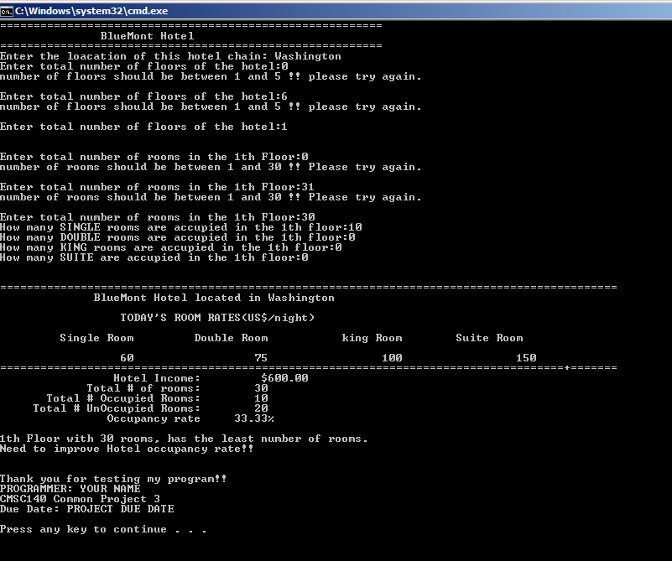

Sample output#2
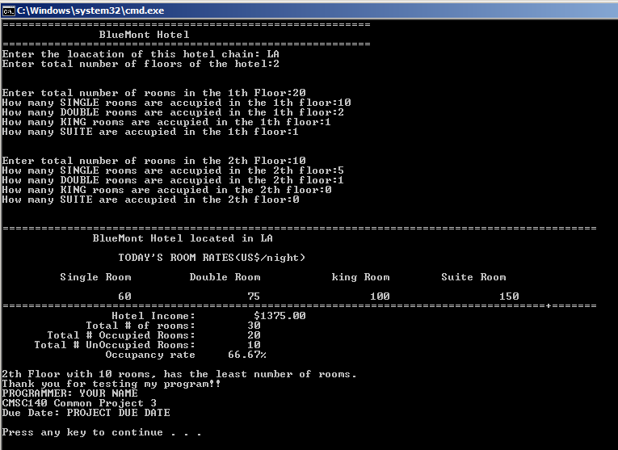

Sample Output #3

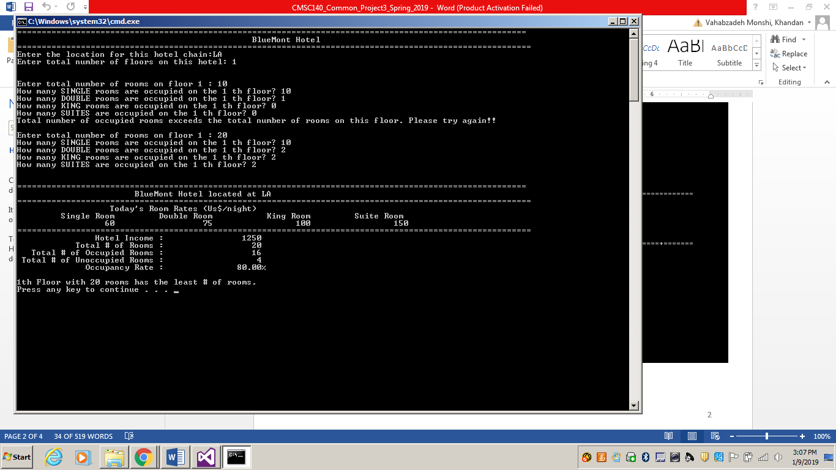

Special Project Submission Requirements

Deliverables:
- Intermediate deliverable:
Program design- Flowchart/ pseudo code for the Program due one week after project is given. An intermediate assignment will be created for submission. Flowchart/pseudo code can be submitted electronically in the following format: word document, pdf or handwritten flowchart/pseudo code picture saved as .jpg or png.

NOTE: Be sure to check also
- CMSC140 Common Project Submission Requirements (.docx)
- CMSC140 Grading Rubric_CheckList-Project 3 (.xlsx)

Test Plan Template
Test your program with at least 3 more test cases. Use the given data as an example. Record your data for input and output in the following table. Make sure your tests cover all the possible scenarios.
Test Case # | Input | Actual Input | Expected Output | Actual Output | Did the test pass?
1 | loc: Washington  #of floors: 0 |  | Number of floors should be between 1 and 5. Please try again!!
2 | loc: South Africa  #of floors: 2
3
4

