Systolic Array Verification Plan & DV Structure

1. Introduction
This document describes the verification strategy used for validating the Systolic Array design. The Design Under Test (DUT) is a cycle-accurate behavioral reference model that implements an N×N weight‑stationary systolic array architecture. The model supports diagonal data movement, weight preloading, and back‑to‑back matrix multiplications.
The verification environment is implemented using the Universal Verification Methodology (UVM) and executed on EDA Playground using the Cadence Xcelium simulator. For this verification setup the following parameters were used:
• DIN_WIDTH = 8
• N = 4

2. DUT Interface Overview
The systolic array communicates with the verification environment using a set of input and output signals. The key signals include:
clk – system clock
rst_n – active‑low reset
a_din[N] – activation inputs for matrix A
b_din[N] – weight inputs used during preload phase
c_din[N] – partial sum input (not used in current tests)
in_valid – indicates start of computation
b_preload_valid – enables weight loading
b_seed_valid – seeds the next transaction for pipelining
c_dout[N] – output data from the array
out_valid – indicates first valid output of matrix C

3. Transaction Flow
Each matrix multiplication follows three main phases:
Phase 1 – B Preload
The weight matrix B is loaded into the array diagonally. This stage prepares the weights for the computation.
Phase 2 – Swap Cycle
A single cycle where in_valid is asserted. The preloaded weights become active and the first element of matrix A enters the array.
Phase 3 – A Tail
The remaining elements of matrix A are streamed into the array with row skewing. During this phase the next matrix B may also begin preloading for pipelined execution.

4. Verification Environment Architecture
The verification environment follows a layered UVM architecture. The structure of the environment is shown below:
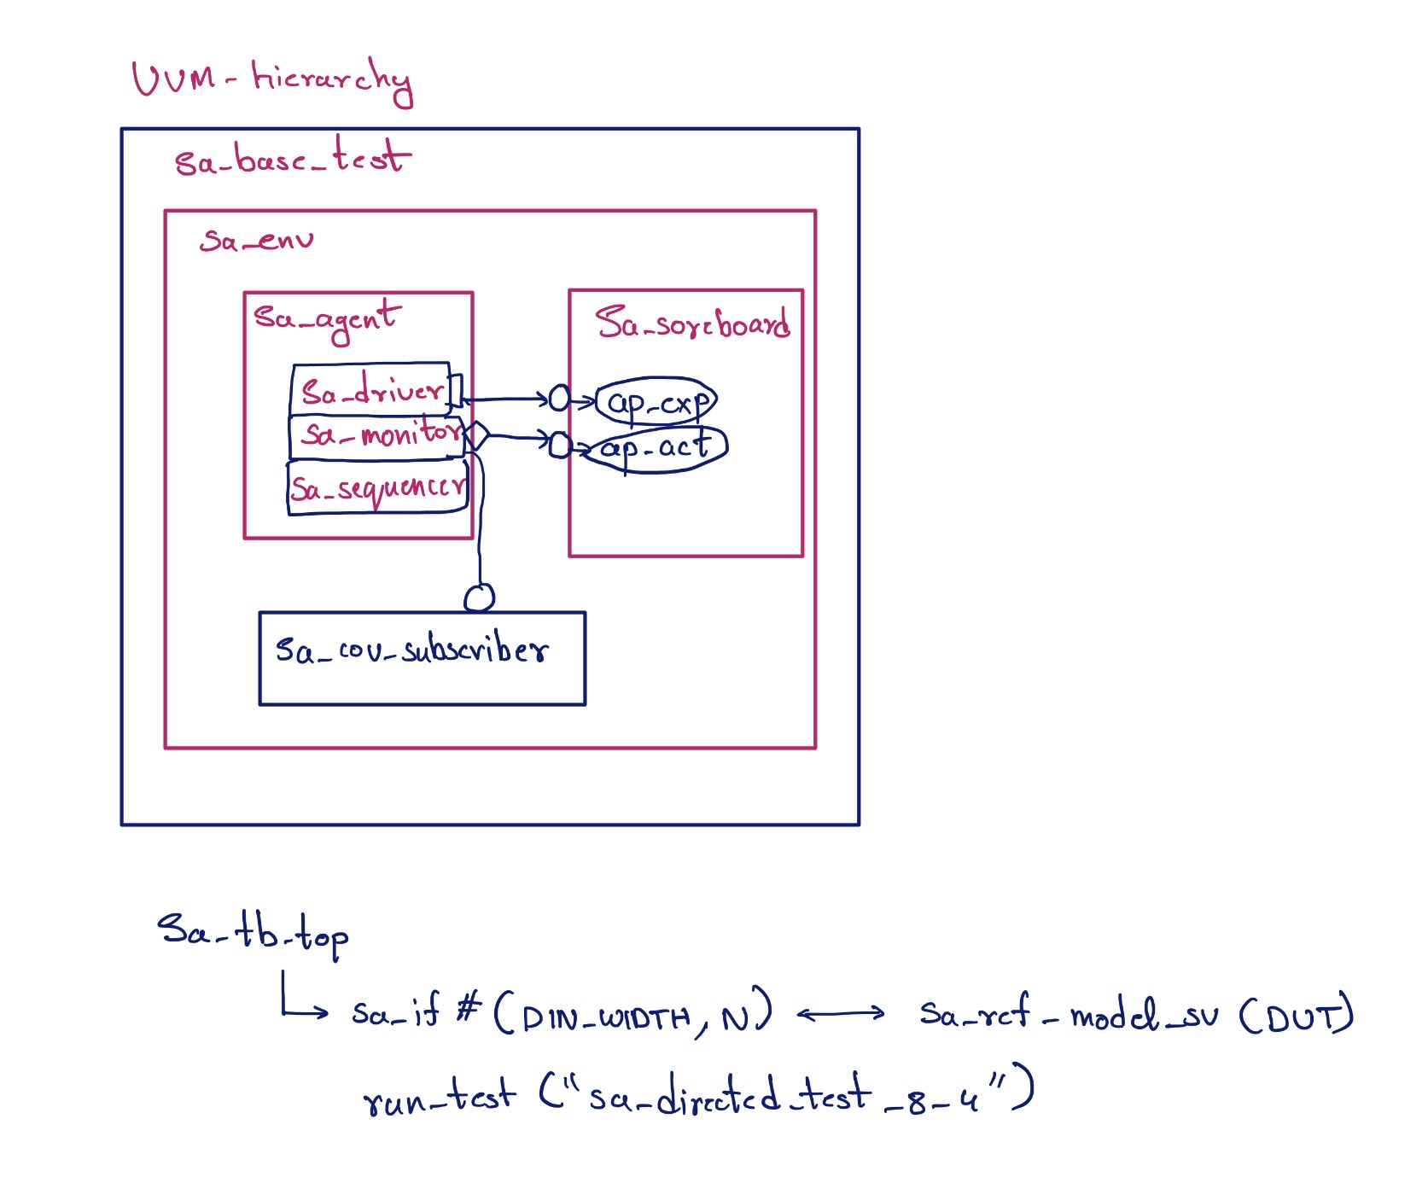

5. Key Verification Components
Driver
The driver converts high‑level matrix transactions into cycle‑accurate signal activity on the DUT interface.
Monitor
The monitor observes DUT outputs and reconstructs the matrix result from the diagonally streamed output data.
Scoreboard
The scoreboard compares DUT outputs with expected results generated by the golden reference model.
Coverage Subscriber
This component collects functional coverage information from stimulus transactions to track verification progress.

6. Golden Reference Model
A golden reference model is implemented using a software matrix multiplication function. The function calculates the expected result using the equation:
C = A × B
This model runs independently of the DUT and is used by the scoreboard to automatically verify correctness of the hardware results.

7. Test Plan
The verification environment includes several directed and random tests.
Directed Tests:
• Zero matrix test
• Identity matrix test
• All‑same value matrices
• Maximum positive values
• Minimum negative values
• Randomized matrix tests
• Back‑to‑back pipelined transactions
These tests validate both normal operation and important corner cases.

8. Assumptions
The following assumptions were made to simplify the verification setup:
• The inner dimension M is equal to N for all tests.
• Partial sum feedback (c_din) is always zero.
• The design operates in a single clock domain.
• Matrix values are limited to a safe numeric range to avoid overflow.
• Transactions are executed without external stalls.

9. Verification Optimizations
Several optimizations were implemented to improve verification efficiency:
• All components are parameterized so the environment can support different array sizes easily.
• Expected results are automatically generated using the golden model.
• The monitor uses parallel threads to capture overlapping output streams.
• The driver supports pipelined transactions to test realistic operating scenarios.
• Functional coverage is collected directly from stimulus generation.

10. Expected Results
For the directed test configuration, the simulation executes multiple matrix multiplications and compares results automatically using the scoreboard.
The expected summary is:
PASS: All matrix comparisons successful
FAIL: 0

11. Subsystem-Level Verification (Future Scope)
While this work focuses on verifying the systolic array at the module level, the same verification methodology can be extended to subsystem-level verification. At the subsystem level, the systolic array would be integrated with other components such as memory controllers, data loaders, and DMA interfaces.
Verification at this level would focus on validating data movement between modules, interface protocol correctness, system-level performance, and corner cases related to pipeline stalls or memory latency. The SA-level testbench components, such as the scoreboard and stimulus generation, can be reused and extended for subsystem verification.

