Hụi On-Chain
A trustless implementation of Vietnam's rotating savings circle (hụi) on Solana
The Business Today
Hụi is a century-old Vietnamese rotating savings and credit association (ROSCA). A group of trusted members contributes a fixed amount each round; one member receives the full pot per round until everyone has been paid once. It remains widely used in rural and low-income Vietnamese communities as informal credit — and it's not a legal gray area: hụi is explicitly recognized under Article 471 of Vietnam's 2015 Civil Code, which caps interest at 20% annually.
The pain point: traditional hụi depends entirely on a single human custodian, the chủ hụi, who collects and holds every member's deposit. This produces two recurring, well-documented failure modes — giật hụi (the organizer absconds with the pot) and bể hụi / vỡ hụi (the circle collapses when early recipients stop paying). Collapses regularly wipe out billions of VND in household savings and are a recurring headline category in Vietnam, not a hypothetical risk.
Why Onchain
The failure mode is custody, not speed or cost — one person holds the money and controls when it moves. Hụi On-Chain replaces that custodian with a Program Derived Address (PDA) escrow vault on Solana. No individual, including the circle's own creator, can withdraw or divert funds. Money only moves according to the program's fixed rules.
Payouts are also permissionless: the moment the final member's contribution for a round is confirmed on-chain, the program automatically releases the pot to that round's recipient — no approval, gatekeeping, or discretion from any party. This directly removes the exact point of failure behind giật hụi.
Regulatory fit: this isn't new legal ground. Hụi is already a recognized contract structure under Vietnamese civil law — we're digitizing an existing, legally accepted financial practice, not proposing one.
Where we're honest about limits: this MVP does not yet enforce contribution deadlines on-chain, and a member who never pays leaves a round open indefinitely rather than being skipped or refunded automatically. We scoped this deliberately — see "What's Next."
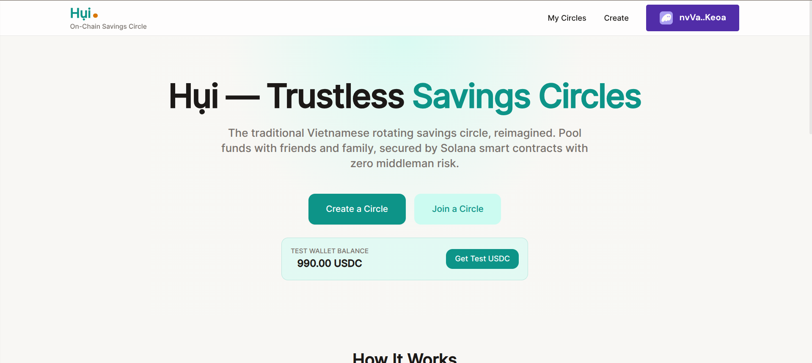
Live app — hui-mu.vercel.app
How It Works
- Creator sets up a circle — name, contribution amount, frequency, and number of slots — and picks their own payout slot during creation.
- A shareable invite code lets others join: each member enters a display name and picks an open slot (taken slots are disabled).
- Once every slot is filled, only the creator can start the circle, locking the payout order and beginning Round 1.
- Each round shows a calculated contribution deadline on-screen; contributions are still accepted late — there's no on-chain lockout in this MVP.
- When the last member contributes, the program automatically releases that round's pot to its recipient — no manual step in the normal path. A creator-only fallback button exists only to unstick a round if the automatic release fails to fire.
- An in-app faucet mints test USDC and tops up devnet SOL for gas, so anyone — including judges — can try the full flow with just a Phantom wallet, no CLI required.
- Engineering rigor: the Anchor program has 12 automated tests covering the full 5-round lifecycle, security/negative cases (double-contribution, non-member access, premature payout), and the missed-payment edge case — all passing on Devnet.
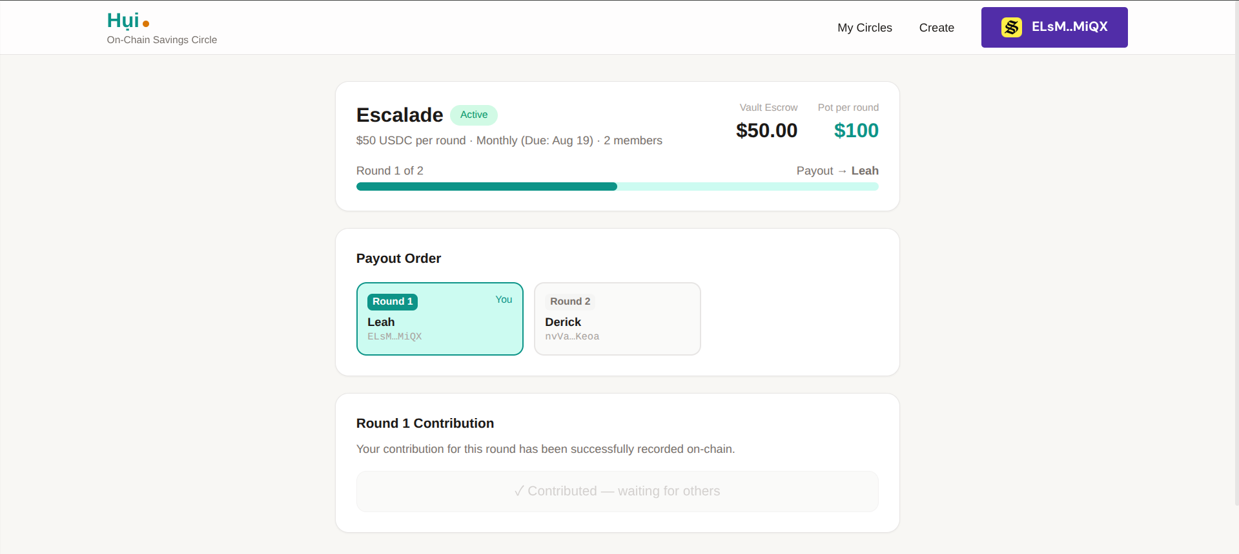
Circle dashboard mid-round: vault escrow, payout order, live contribution status
What's Next
Beyond this bounty, digitized ROSCA infrastructure is a real, recognized fintech category — and hụi specifically has an enormous, already-organized user base with no dedicated trust-safe tooling today. The roadmap:
- Pilot with one existing hụi group in Vietnam, replacing their current manual/WhatsApp-based tracking with this app — the fastest way to validate real demand.
- Interest-rate bidding rounds — the traditional hụi mechanism where members bid for early payout slots — currently fixed-order only in this MVP.
- Automatic circle closure and refund handling when a member never contributes, replacing the current "round stays open indefinitely" behavior.
- Decentralized dispute resolution — shifting missed-payment verification from a single caller to a quorum of circle members.
- Mainnet deployment with real USDC, and on-chain reputation as a portable credit signal members can use with future lenders.

Live app: hui-mu.vercel.app
Program (Devnet): BAUzUZpbXTqtfWaRd4ANUgLA1wSh6QiKTt6ChhdWWdpB
GitHub: github.com/mvianney/Hui

