

Smart Engagement & Club OS
User Guide
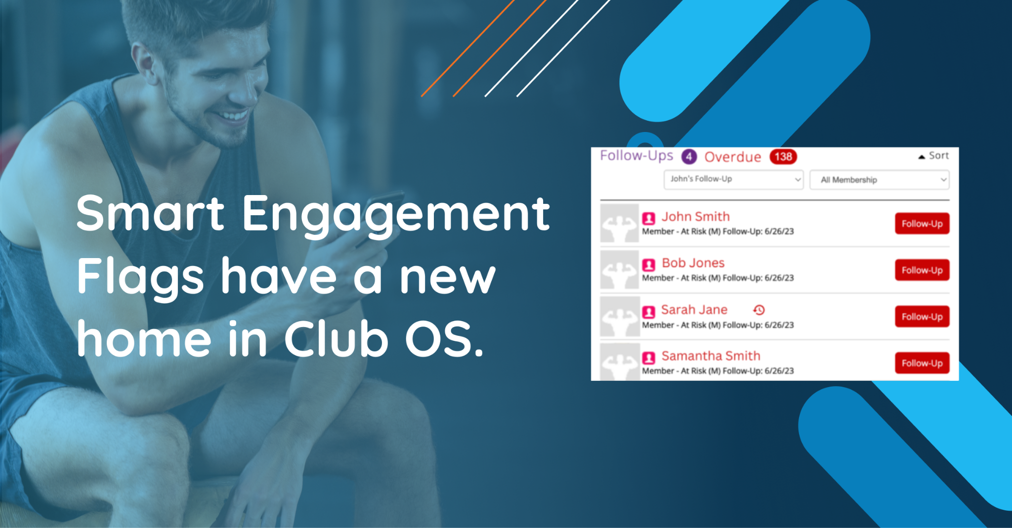

Table of Contents

What is Smart Engagement? 3
Why use Smart Engagement? 3
Overview of Member Campaigns in Club OS 4
How to use Club OS for member outreach 4
Predictive Member Outreach 4
Smart Engagement Survey 6
Workflow Overview 7
What other clubs are saying about the integration: 8
Additional Resources 8

What is Smart Engagement?

 | Smart Engagement uses predictive analytics to help you engage members when they need it most.  Historical and real-time data determine when your members’ behavior leads them to usage drop off or catch them at the right time to purchase new services like personal training.

Why use Smart Engagement?

Save your staff time. Predictive AI has identified the members most likely to benefit from outreach. With Smart Engagement, they can focus on the members who need a connection the most.

It's easy to access your new list of members each week through the Club OS dashboard and link to the Smart Engagement Web Tool or by engaging with members that appear in the follow-ups section of your dashboard in Club OS.

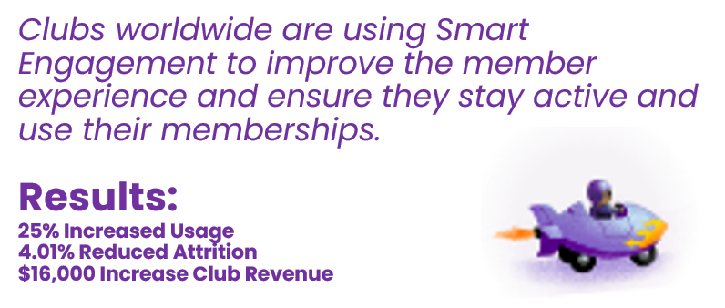

Overview of Member Campaigns in Club OS
Smart Engagement prioritizes 10-25 members per week who are flagged into different campaigns (categories). All campaigns remove “Sleeping Giants” (Members inactive for 30+ days).

Increase Usage | Members who already use the service regularly demonstrate predictive behavior patterns leading to usage drop-off and eventual attrition.
Reduce Attrition | Members whose behavior indicates decreased engagement and eventual service cancellation altogether.
Member Onboarding | Members are predicted to decrease usage within the first 2-5 weeks of a new membership without outreach. Keep them active!
End of Annual Contract | Members who are 4-12 weeks away from contract renewal and predicted not to renew their membership without outreach.
PPV | Members who qualify for insurance benefits through SilverSneakers, Renew Active, and Silver & Fit.

How to use Club OS for member outreach

Predictive Member Outreach
In Club OS, you will see campaigns in the follow-ups section. Club OS changes these members’ status from ‘Member’ to “Member- At Risk” since the member’s behavior is within a window of opportunity to support their consistent usage and decrease the chance of eventual churn.
Follow-ups and Member Profile
Like your other follow-ups, you will see your new At Risk members flagged for outreach. These members are predicted to benefit from your connection!
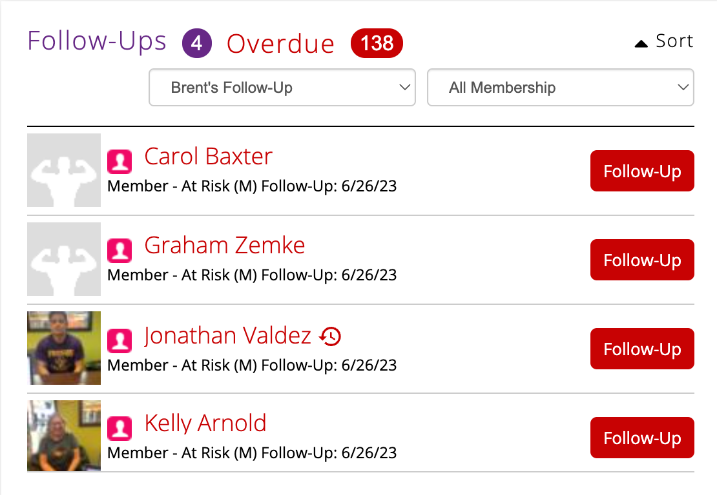
Click the Follow-Up button next to a member’s name. You will see more information displayed on the right side of the Member Profile:
- Why the member was flagged
- A recommended action to take
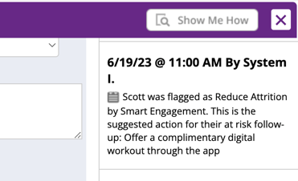

Smart Engagement Survey
When contact is made, the Smart Engagement Survey appears in the Member Profile. The outcome is either ‘Spoke’, ‘Not Interested’, ‘Scheduled Appointment’, or an email or text reply.
Note: If ‘Not Interested’ is selected, the member will move into the Not Interested status for the remainder of their membership/inactive member workflow. Please only select this if the member no longer wants to be contacted by the gym.
- If contact is attempted, but the member is not reached, you will get an automatic reminder in two days to reach out again; now that’s smart!
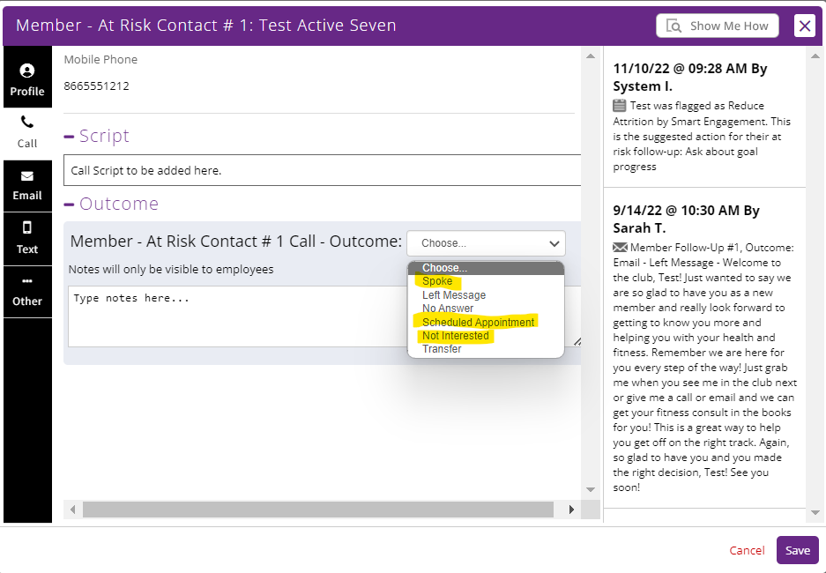
- Completing the survey after the first or second attempt removes the member from future Member- At Risk follow-up tasks.
- They will enter a one-month cooldown period from At Risk follow-ups, great job!

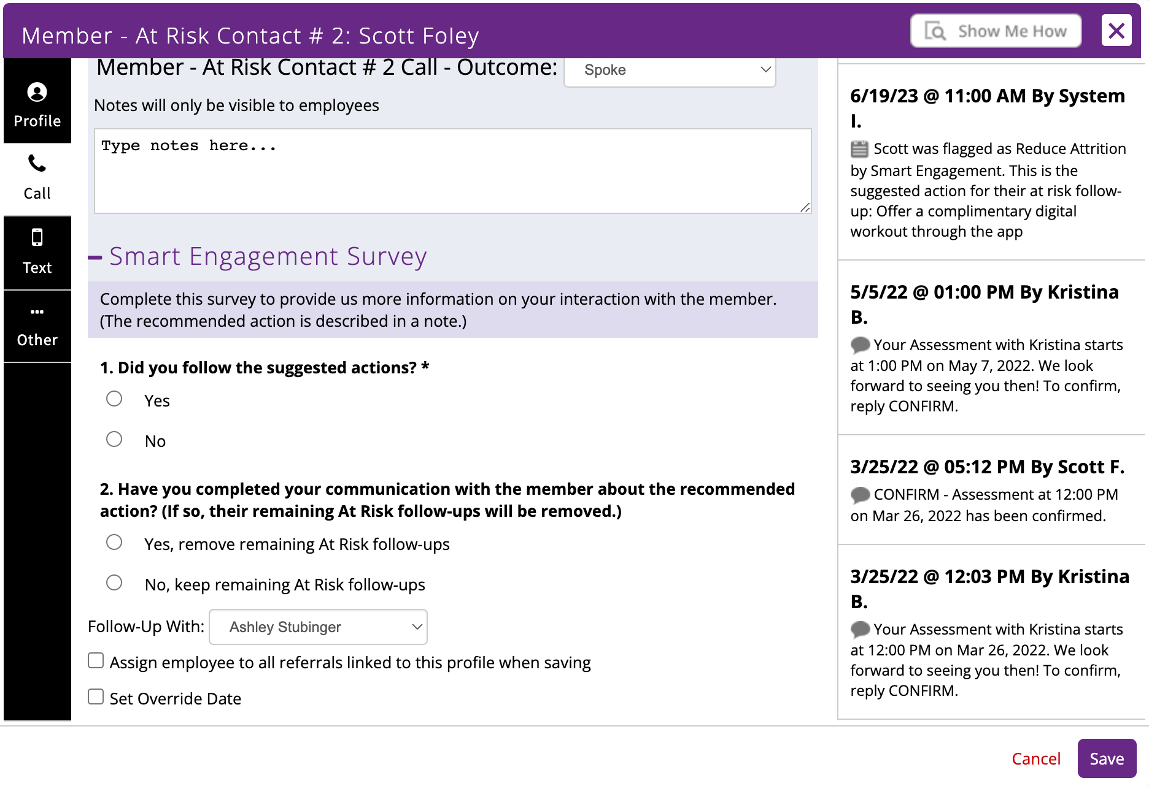

Workflow Overview
Here is how other clubs are completing these outreaches each week.

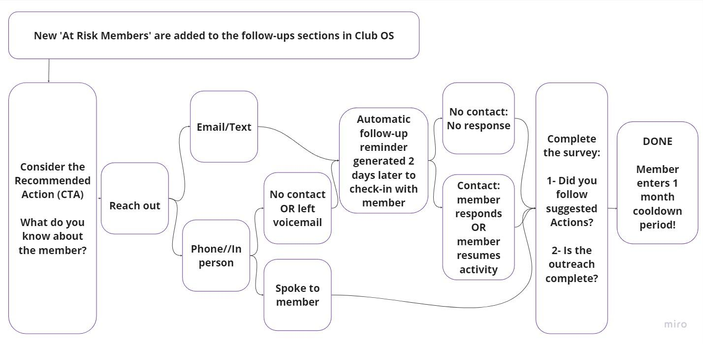

What other clubs are saying
- Automatic reminders to follow up help make workflows easier.
- Saved notes on all outreaches to help staff stay informed.
- Reaching out to members they hadn’t thought needed support builds rapport.
- Powerful AI technology is conveniently inside the tools they use every day!
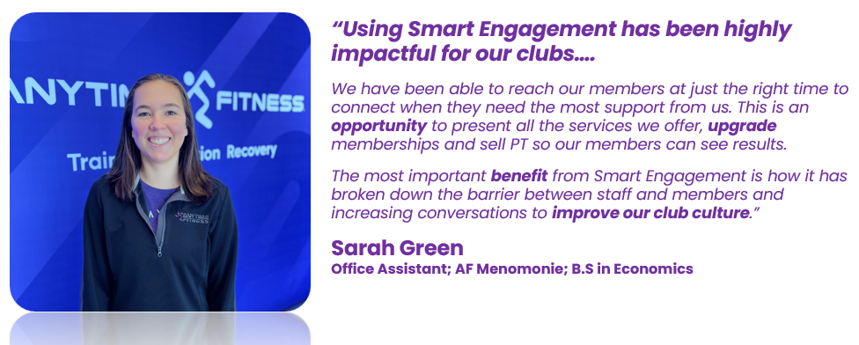

Additional Resources
- Outreach Scripting
- Email Reminder Settings for Accountability
- Web tool settings for email reminder customization
- Accessing PT Upsell Flags

