RECOVERY REVENUE PATHWAYS
HOW CAN RECOVERY AS A SERVICE HELP ME GET CLOSER TO MY “WHY”?:

MY BIGGEST BARRIER WITH RECOVERY:

RECOVERY ROADMAP: CHOOSE YOUR SERVICE
STEP 1: ANSWER THESE QUESTIONS
Do you have a coach on staff? ☐ Yes ☐ No
Do you have 80–100 sq ft of available space? ☐ Yes ☐ No
Rough budget for equipment/setup: ☐ Under $5K ☐ $5K–$15K ☐ $15K+
Use your answers to match yourself to a service using the Recovery Roadmap shown below:
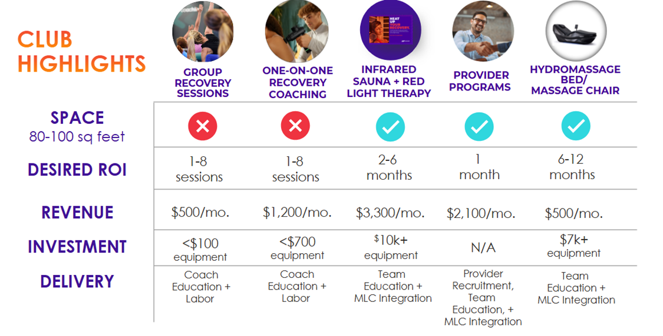
STEP 2: CHOOSE YOUR SERVICE
Based on the Roadmap, which service(s) fit(s) your club best?
☐ Infrared Sauna / RLT Bed ☐ Hydromassage ☐ Massage Chair ☐ Group Recovery Sessions
☐ Percussion / Compression ☐ Physical Therapy / Chiro ☐ Other: ___________________
STEP 3: MARKET ANALYSIS
Who nearby offers Recovery?

What are they charging?
How is your competition packaging and selling their services?

STEP 4: RUN THE NUMBERS
(Visit us at AF Recovery Office Hours on select Wednesdays at 1pm CT post-Vitals for more!)
Based on your market analysis and what you know about your members, how will you price your service?
- My price point: $__________ per ☐ session ☐ month ☐ package
- Overall package value per member: $__________
- Estimated total amount of members you will sign up: __________
- Estimate your potential revenue when fully scaled: ______________________
- This doesn’t consider attrition and different package lengths, so please join us post-vitals to get more exact numbers using the NEW AF Recovery ProForma.

MY COMMITMENT:
I plan to launch (name of service) _____________________ for $______________ by (date)_______________.

☐ I've scheduled time to follow up and take my next steps.
STEP 5: PACKAGE YOUR OFFER
How will you sell Recovery? (circle one)
☐ Add to a membership tier ☐ Long-term package (like PT) ☐ Standalone sessions ☐ Other: ________
My price point: $__________ per ☐ session ☐ month ☐ package
Offered as: ☐ Unlimited ☐ Set # of sessions per month: _____ ☐ Package
STEP 6: INTEGRATE INTO THE MEMBER LIFE CYCLE
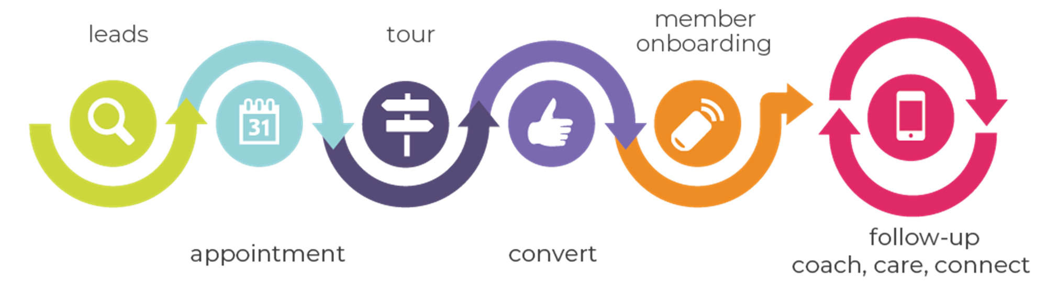
How and where will my leads learn about my Recovery service?

Write a 1-3 sentence introduction to your Recovery service for your tour:

How does a new member experience your Recovery service, even if they haven’t purchased it yet?

Write a 1-3 sentence follow-up script for members who experience your Recovery service.
Bonus points: help them connect Recovery with their “WHY.”

STEP 7: ROLE PLAY
Choose ONE Recovery offering from the options below and practice with a group.

- ANYTIME FITNESS APP
- GROUP TRAINING RECOVERY
- PERCUSSION/COMPRESSION SESSIONS
- IR SAUNA WITH RLT/RED LIGHT THERAPY BED
- PROVIDER PROGRAM
What did you notice?

STEP 8: OVERCOME OBJECTIONS
Practice your role-play response to one of the most common objections we hear:
☐ "That price sounds too high." ☐ "I won't have time to use it." ☐ "I need to check with my spouse."
My response: _______________________________________________________________
MY COMMITMENT:

☐ I've scheduled time to follow up and take my next steps.

ROLE PLAY SCRIPTS – Located in the Resource Center!
ANYTIME FITNESS APP
CLUB TOUR
"In addition to all the amenities you see inside the gym, access to equipment as a member, you have the added support of the AF app, where we have guided recovery programs, structured workouts, and other awesome features like _________. Let me show you what this looks like on your phone."
FITNESS CONSULTATION
“Looks like you’re experiencing some tightness in that right hip flexor – after we’re finished, I’m going to show you a guided stretching session you can do at home with our AF App.”

“Did you know we have free sessions to help you with your mobility and muscle recovery? Let me show you how to find them in the AF App / Apple Fitness+.”

TRAINING SESSIONS
"We hit (insert muscle group here) pretty hard today, and we did some recovery in our session – I’d like you to do some extra Recovery at home after today’s session. Take out your phone: I’ll show you our guided recovery sessions in the AF App! Your homework is to do this before I see you next."
FOLLOW-UP
"Hey! I noticed you deadlifting heavy today – nice work! Make sure you stretch out those hams after your workout. Have you seen our guided stretching / recovery sessions in the AF App? Let me show you…"
GROUP TRAINING RECOVERY SESSIONS
CLUB TOUR
"Over here, you can see the purple turf. This is where we host our small group training and recovery sessions. We love to see training and recovery come together so your muscles can get that reset they need to continue to push at your next workout. We do recovery sessions ____ times per week and I’d love to see you join us at our next session."
FITNESS CONSULTATION
“Looks like you’re experiencing some tightness in that right hip flexor – we have a recovery session with Coach (Name) this afternoon. Recovery sessions focus on mobility and give your muscles an overall reset so you can push harder at your next workout. Want to join us to try one out?"
TRAINING SESSIONS
"Hey, great job on that PR today! You’ve been working so hard in our sessions, and it SHOWS! I’m leading a recovery session today right after you finish up with me. We do mobility-based work that will be the perfect addition to your training. I have a spot for you – want to join us?"
FOLLOW-UP
"Hey (Name), I see you training hard for your marathon coming up. What’s your recovery looking like? We have a spot available in our recovery session this afternoon where we focus on mobility and overall muscle reset. I think it’ll be a game-changer for you as you prepare yourself for the race. Want to join us?"

"Hey (Name)! I have loved seeing you in the club regularly, what are you doing for recovery with your current workout split / routine? We have a group recovery session [TIME / DAY] - we use these to focus on functional strength and continued mobility. I’d love to get your thoughts on it. Would you be willing to give it a try to share your feedback with me?"

PERCUSSION / COMPRESSION SESSIONS
CLUB TOUR
"At our gym, we provide recovery within all of our programming and services so you can continue to meet your fitness goals. Have you ever experienced a percussion or compression tool?"
Show them, depending on what equipment you have.
"Our coaches are specially trained to offer percussion and compression as recovery services. Both methods help to increase blood flow to your muscles and can also help with getting areas warmed up at the beginning of a workout."
FITNESS CONSULTATION
"It looks like you’re experiencing some stiffness in your back with those squats. Have you ever experienced percussion therapy before? Let me grab the tool and show you for a minute here, then we can do the movement again."
Demonstrate, then have them perform a squat.
"Feel the difference? We incorporate recovery like percussion into our one-on-one and small group training sessions here. We can talk about that a little more in the rest of our discussion today. I think it might be a good fit based on your _____ (GOAL/FOCUS)."
"You mentioned feeling a lot of muscle soreness (or insert another ache and pain) when exercising in the past. Have you ever tried compression therapy before? I would love to get you into our compression boots to plan for your recovery as you get back into an exercise routine – would that be something you’re willing to try?"
TRAINING SESSIONS
"Hey, (Name), today, do you have an extra 15 minutes after our session? (Yes!). Awesome – I’d like to incorporate recovery into our session today to make sure you can experience our new compression boots – they help with blood flow and muscle recovery and they're a great way to end our session so you’re ready for me to kick your butt again later this week!"
At the end of the session:
"What did you think of the compression boots? What do you notice? That’s awesome! See, that’s exactly why I love them. We are seeing our clients add this to all of their training sessions because it’s a great way to bust through plateaus while making sure you’re taking care of your body in the process. Want me to add this onto your training package?"
FOLLOW-UP
"Hey, (Name)! Just warming up today? What are you working on today? I’ve got the percussion tool here – I’ve been really loving it for prepping my back and quads for a heavy lift. I’d love to see what you think – want to give it a try? It takes just a couple of minutes."
Demonstrate the movement.
"We offer these in Recovery sessions and as part of our one-on-one training – it’s a really helpful addition to your routine to make sure your muscles are getting the recovery they need to be ready for your next heavy lift. I recommend doing them (X TIMES) per week. I have [insert available times for day or week] if you want to add it in before or after your lift!"
"Hey, (Name)! Have you had a chance to try out our compression boots? They have been a lifesaver for me post-lift or when I’ve been upping my milage. I’d love to get your thoughts, do you have 15 minutes to try them out before / after your workout?"

INFRARED (IR) SAUNA WITH RED LIGHT THERAPY (RLT) // RED LIGHT THERAPY // RECOVERY ROOM
CLUB TOUR
"This is our infrared sauna with red light therapy. Have you ever heard of or experienced Infrared or RLT before? We know how important your whole health is as a part of your fitness routine; we’re excited to offer this in our club so you can bundle together your training AND your recovery to get your best results."

"Would you be interested in coming in for a session to try it out? (plant the seed, use as a sales lever at POS) -- “don’t forget we have [insert day/time] available for you to try out the IR Sauna with RLT, once we get your membership started today we can schedule that time, too!”

"And you can see over here is our Infrared Sauna with Red Light Therapy. Have you ever experienced infrared sauna before? OR Have you heard of red light therapy? Infrared technology has a whole host of health benefits – we’re most excited about how it helps you recover from workouts more quickly and bust through plateaus with training. The Red Light Therapy aspect works on a cellular level to rejuvenate – let’s get you in for a session so you can try it out!"

FITNESS CONSULTATION

"And you can see over here is our infrared sauna with red light therapy. Have you ever heard of or experienced Infrared or RLT before? It has a whole host of health benefits—we’re most excited about how it helps you recover from workouts more quickly and bust through plateaus with training. The Infrared is more comfortable than a traditional sauna, and the red light therapy aspect works on a cellular level to rejuvenate – Let’s get you in for a session so you can try it out! We have [DAY / TIME / WEEK] available. Which one works best for you?"
"How are you feeling after your IR sauna with RLT session?! What do you notice? Based on (restate their concerns), the IR sauna with RLT will help you (state their goal) and I’d recommend using it twice per week. Should we reserve your spots today?"

TRAINING SESSIONS

"Hey (Name)! I’ve got 20 minutes of time reserved for you in the Infrared sauna after today’s session for your recovery – does that work for you? I have booked some time for you ahead, because I’d love to get your thoughts on it. We are LOVING the sauna with red light therapy for (insert goals that are important to this member) and our other clients are seeing faster recovery times, and more energy."
"How are you feeling after your sauna with Red Light Therapy session?! What did you notice? Based on (restate their concerns), the sauna will help you (state their goal) and I’d recommend using it twice per week. Should we reserve your spots today?"

FOLLOW-UP

"Hey (Name)! How’s your training going today? Are you working toward a particular goal right now? You know, I’ve been using the infrared sauna with red light therapy after my sessions lately and I’ve noticed I’m bouncing back from my workouts quicker and I get to do it by relaxing for 20 minutes – like a little spa experience right inside the gym. Do you have 20 minutes after your workout today (or sometime this week)? We have this time open if you want to hop in and experience the sauna – I know it’ll be a great way to end your workout today (or sometime this week)."
Follow up with the member when they get out:
"How are you feeling after your sauna session?! What did you notice? Based on the goal you shared earlier, I’d recommend using the sauna twice per week. Should we reserve your spots today?"

PROVIDER PROGRAMS
CLUB TOUR
"We're a proud partner of (insert physical therapy / chiropractic partner), available right here in the gym. This is super exciting because they don’t just help you recover from injuries; they also do preventative work like cupping and dry needling. As a member, you can schedule a free movement assessment any time with this QR code."
Show them the poster that should be posted near provider space or in member lobby.
FITNESS CONSULTATION
"It looks like you have an injury that you might want to get checked out before you do any training here OR I know you mentioned a past injury (insert injury details here). We have a physical therapist / chiropractor named (Name) from our provider clinic called (Provider Clinic Name) here today / this week. Want to get in for a free assessment so they can check on what’s going on while we create your plan together?"
TRAINING SESSIONS
"Great work today, (Name)! I know you felt something twinge during those kettlebell swings—have you considered the free movement assessment with our (insert PT / chiropractic partner) to see what’s up? I want to get their take so we can safely get you back to training at our next session – sound good?"
FOLLOW-UP
"Hey (Name)! I see you grabbing your shoulder (or insert any other observation you have about mobility / warm-up / cool-down), how is everything feeling? Did you know we have a physical therapist / chiropractor named (Name) who can check that out to see what’s going on – let’s get you in for a free assessment!”

