INSTRUCTIONS
THIS DOCUMENT MAY BE PROVIDED TO ONLY THOSE ANYTIME FITNESS FRANCHISEES WHO HAVE SIGNED A FRANCHISE AGREEMENT FOR THE SPECIFIC LOCATION FOR WHICH THIS BUSINESS PLAN IS CONTEMPLATED.
Completing a business plan is essential to how you start, grow, and maintain your business. Per the Small Business Administration, a good business plan guides you through each stage of starting and managing your business. You’ll use your business plan as a roadmap for how to structure, run, and grow your new business. It’s a way to think through the key elements of your business.
Business plans can help you get funding or bring on new business partners. Investors want to feel confident they’ll see a return on their investment. Your business plan is the tool you’ll use to show people that working with you — or investing in your company — is a smart choice.
https://www.sba.gov/business-guide/plan-your-business/write-your-business-plan
Please follow the instructions below to complete this plan.
- This plan is provided as a TEMPLATE ONLY – YOU as the Franchisee are responsible for reviewing and revising ALL the content in this template plan to fit your own unique business circumstances. We strongly recommend you complete this form in consultation with your attorney and your accountant, tax and/or other business advisor. Anytime Fitness Franchisor, LLC is not responsible for the accuracy or applicability of the information in this template as it relates to your specific franchised location.
- Please pay particular attention to the content highlighted in yellow. Once you’ve reviewed and edited this content, remove the highlighting.
- It’s recommended you take the time to research your local competition and update the Competition section accordingly. This section was designed to give you a general idea of what the contents should be, however, each market is unique, and your specific competition should be accurately reflected in this business plan.
- For lenders and other users of this business plan to get an accurate representation of who you and your business partners are, we encourage you to update the Management Profiles section. Include the high points of your professional career and focus on those that make you an ideal candidate for running a franchise business as an entrepreneur. Think of this as your resume.
- Update the Pro Forma with figures that are representative of your business. Please note, the figures populated in the Pro Forma are those printed in the Anytime Fitness FDD. We encourage you to do a thorough analysis of your business and update any figures as necessary, even figures from the FDD that are already populated in the Pro Forma.
- Use your completed Pro Forma to write summary paragraphs and to create graphs, charts, and other visuals to include in the Financial Projections section. Visuals provide a great way to give the reader an at-a-glance overview of your financial position.

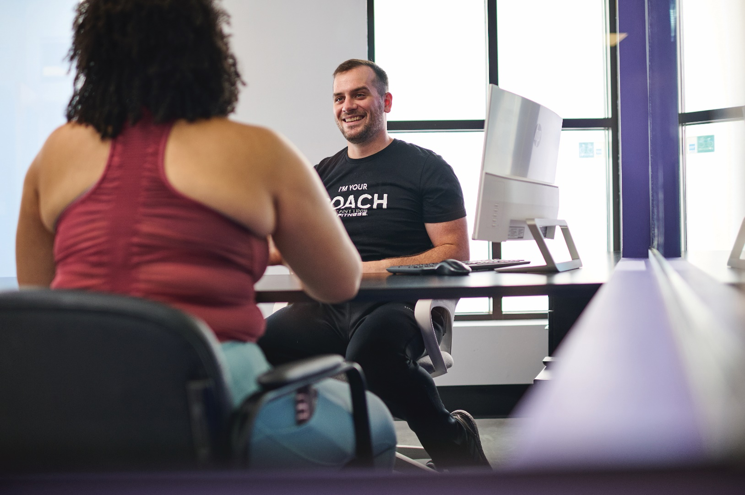

BUSINESS PLAN
Date
Franchise Owners:
First Last
First Last
TABLE OF CONTENTS
EXECUTIVE SUMMARY 5
COMPANY DESCRIPTION 7
MARKET ANALYSIS 8
Industry Overview 8
Industry Outlook 8
TARGET MARKET 9
Pricing 10
Competition 11
ORGANIZATION & MANAGEMENT 13
Organizational Structure 13
Management Profiles 14
SERVICE & PRODUCT LINE 15
Club Overview 15
Competitive Advantages 16
Franchisor Support & Development 18
MARKETING & SALES 23
Presale & Grand Opening 23
Sales Strategy 23
Growth Strategy 24
FINANCIAL PROJECTIONS 25

EXECUTIVE SUMMARY
Since its founding in 2002, the Anytime Fitness® franchise model has spurred robust growth around the world. With 5,000+ gym locations around the globe, AF is proud to be breaking records, receiving resounding industry recognition, and helping people improve their lives every day. Anytime Fitness pioneered the 24/7 gym access model, giving members the ability to come and go as they please and making it easier for franchisees to run their businesses with fewer staff on hand. With the added benefit of coaching services that provide personalized training, nutrition, and recovery support, Anytime Fitness franchises are able to address the holistic wellness needs of all their members and capitalize on multiple facets of the fitness industry.
Today, through the AF SmartCoaching ecosystem, a technology-based approach to coaching, Anytime Fitness members are able to receive personalized coaching anytime, anywhere, which encourages them to engage more, stay longer, purchase more services, and refer others. This technology is part of AF’s ongoing strategy to provide members with Anytime Fitness access and coaching both inside and outside the gym to ultimately improve their personal health.
Our company will be a franchise of Anytime Fitness located in City, State, with us, First Name Last Name and First Name Last Name, as owners. Our members will be at the center of our business. Because of this, a large factor in choosing staff will be focused on their ability to provide outstanding customer service.
Our facility will feature state-of-the-art cardio and strength equipment in a clean, safe, and convenient gym. In addition to maintaining the physical environment, we will focus on providing a world-class level of customer service by caring, coaching, and connecting with the aim of helping real people overcome the barriers to living healthier lives.
Our growth strategy will leverage personalization and customization. We will leverage the AF SmartCoaching digital fitness platform to help people meet their goals more efficiently and effectively. Through training, nutrition, and recovery coaching we will measure their progress beyond the scale and use behavioral and body composition data to deliver personalized recommendations along the way.
Additionally, we will use the marketing campaigns that are developed by the franchisor. These campaigns are developed and designed to reach the market when consumers are most likely to join fitness facilities.
The franchisor provides resources to support us in executing brand strategy and daily operations. A team of franchise business consultants works directly with franchisees to establish performance metrics, develop business goals, and track progress. An array of online tools, including a franchise dashboard, video courses and tutorials, a robust knowledge base (the Anytime Academy), and operations manual are available for ongoing reference. Targeted in-person training options (e.g. classroom training, in-club training, workshops, biennial conferences) are available not only to owners, but also to franchisee employees to assist owners with effectively onboarding their staff. As the franchisor’s brand strategy evolves, these tools are regularly modified and updated to reflect the current direction of the brand.
Accompanying this business plan is a 3-year pro forma statement that illustrates the club’s projected cash flow. We have also taken the time to complete our own analysis of our financial position and our future projections and obligations.

MARKET OVERVIEW
According to the IHRSA 2023 Global Report, the strong performance in leading fitness clubs demonstrates that the fitness habits formed during COVID and post-pandemic are not going anywhere. Even during uncertain times, consumers prioritize fitness and wellness. In 2022, “monthly visits to U.S. gyms were up roughly 13%” and the “number of facility members increased by 3.7% from 2021 to 2022.”
A Mindbody survey showed, “…that 64% of Americans believe that wellness is more important than other leisure activities. Virtually all (87%) of respondents maintained or increased wellness spending in 2022.”
Industry Outlook
The COVID-19 pandemic was a “catalyst for the digitalization” of the fitness industry and beyond as digital fitness content, products, and capabilities were on the rise. Now that consumers are not only returning, but increasing their usage of in-person facilities, leveraging both the digital and in-person experience is crucial.
Based on the 2023 U.S. Health and Fitness Consumer Report from IHRSA, “Consumers are increasingly looking for unified omnichannel offerings where the in-person experience is enhanced by digital offerings, such as personalized recommendations, wearables integration, hybrid virtual/ in-person group exercise classes, and other innovative technology deployments. To win in the future, stakeholders need to retain a human-first, tech-forward mindset to continue to be successful.”
Personalized membership plans and connecting with members inside and outside the gym are crucial to future success.
The report goes on to state that, “Personalized membership plans with options such as virtual workouts or out of gym touchpoints may be an opportunity for fitness facility operators to maintain relationships with members and cater to their new health and wellness regimens.”
*Source: IHRSA 2023 U.S. Health and Fitness Consumer Report
THE INDUSTRY’S FUTURE: HUMAN FIRST BUT TECH-FORWARD By Geoff McQueen, Managing Director, Consumer Practice, and Chuck Reynolds, Managing Director, Digital Practice, LEK Consulting

COMPANY DESCRIPTION
Anytime Fitness® is the largest and fastest-growing fitness brand in the world, serving nearly 5 million members at more than 5,000 locations in 40+ countries and territories on all seven continents. Open 24 hours a day, 365 days a year, Anytime Fitness delivers personalized and affordable health and wellness coaching through training, nutrition, and recovery guidance for our members – in the gym, in their homes, in their pockets, wherever they are and anytime they need it. All franchised clubs are individually owned and operated, and members have access to any Anytime Fitness club worldwide. Anytime Fitness takes a holistic health approach to meeting members where they’re at to help them live longer, healthier, and happier lives. We do this through a multi-service approach that increases member acquisition, engagement, and retention.
Personalized Coaching: Training, Nutrition, Recovery
As the industry continues to evolve, Anytime Fitness is at the forefront of delivering an experience centered on personalized coaching that provides the best training, nutrition, and recovery guidance accessible anytime, anywhere, and proven to improve our members’ health. This includes a robust personal training program, with strength, cardio and recovery movements, that is standardized across the franchise. In addition, the AF App, which is part of the AF SmartCoaching Ecosystem, can deliver workouts, nutritional guidance, and holistic support around the clock and in real-time. We also leverage body composition analysis technology to provide a data-fueled plan for every member.
Convenience & Safety
By providing 24-hour gym access, 365 days a year, Anytime Fitness is an ideal option for consumers who are looking for a convenient and secure solution to reach their fitness goals. Plus, we offer the exclusive benefit of global gym reciprocity, which allows members to use all Anytime Fitness locations worldwide with one standard membership.
The facilities are secured with proprietary access software, security, and surveillance technology, allowing a club to be open on a 24-hour basis. The system, which includes remote monitoring of a closed-circuit television system and personal safety devices, allows members to feel safe and secure, even when a gym is not staffed.
Culture
Where the Anytime Fitness model stands out is its emphasis on exemplary customer service and dedication to an engaged gym culture. Anytime Fitness has developed a customer service vision, which is to provide every guest with a surprisingly personable experience, delivered via the PLEASE service standards – Personal, Listen, Empathy, Anticipate, Sense of Urgency, and Encourage.
TARGET MARKET
Anytime Fitness has a Real Estate team and network of brokers that have a proven site selection process that will help us leverage the best demographics within our designated market area.
In 2023, following the COVID-19 pandemic, Anytime Fitness Franchisor, LLC hired a consumer research firm to study how fitness consumers have changed and develop an up-to-date consumer segmentation – grouping consumers together based on common characteristics, such as health and wellness traits, behaviors, motivations, and needs. By using this research to help with identifying and understanding our consumer segments, as franchisees we can focus more effectively on their specific needs and deliver more impactful products, services, and marketing.

This consumer segmentation helps Anytime Fitness understand the industry better than anyone else – not just domestically, but globally – and not just in terms of people’s physical fitness attitudes and behaviors – for their entire way of looking at their health.

Of the seven consumer segments that emerged, Anytime Fitness focused on two of the segments as the largest opportunity for growth – Weight Loss Strivers, whose main goal is to lose weight for health and how they look, and Strength Enthusiasts, whose main goal is building muscle.

Competition
Anytime Fitness' competitors include big-box gyms, 24/7 facilities, studios, locally owned gyms or personal training, and low-cost options. And as digital fitness continues to boom, we also compete with apps, subscription-based fitness like Obe, and home-based offerings like Peloton. With each competitor having a different edge, it is important to know their strengths and weaknesses.
The market we are in has a variety of fitness facility offerings including one 24-hour facility, Snap Fitness, two women-only facilities, and a community center all within 2.5 miles of our club. The map below outlines the location of our competition as it relates to our gym.
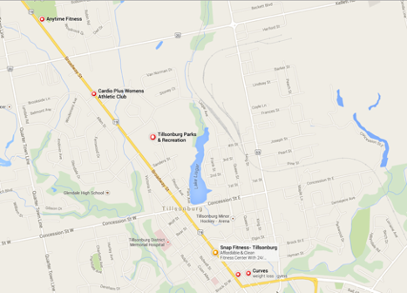
The way in which our gym fits into our market is illustrated in the table below. In almost all instances, we will be able to leverage competitive advantages (e.g. 24-hour access, welcoming environment, personalized coaching inside and outside the club, exceptional member experience) to gain market share in our area.
Facility | Specialty | Competition | Cost | AF Leverage
Snap Fitness | 24-hour convenience | High | $XX | Clean facilities, exceptional customer service, a dedicated focus on coaching
Curves | Female-gender specific, preplanned workouts | Moderate | $XX | 24-hour access, exceptional customer service, a dedicated focus on coaching
Tillonsburg Community Center | Multipurpose | Moderate | $XX | 24-hour access, exceptional customer service
Cardio Plus Women’s Fitness + Day Spa | Prader-Willi Syndrome | Moderate | $XX | 24-hour access, lower cost

ORGANIZATION & MANAGEMENT

Organizational Structure
We recognize intimidation on the part of a potential member can be a huge factor in whether they walk through the doors of a fitness club. Therefore, we understand the importance of making the customer comfortable and will look for employees that represent our core values. Some examples of staffing models are presented below. Although we are not required by the Franchisor to use one of these models, at this time we intend to use the following staffing model to help us deliver that experience: Model X
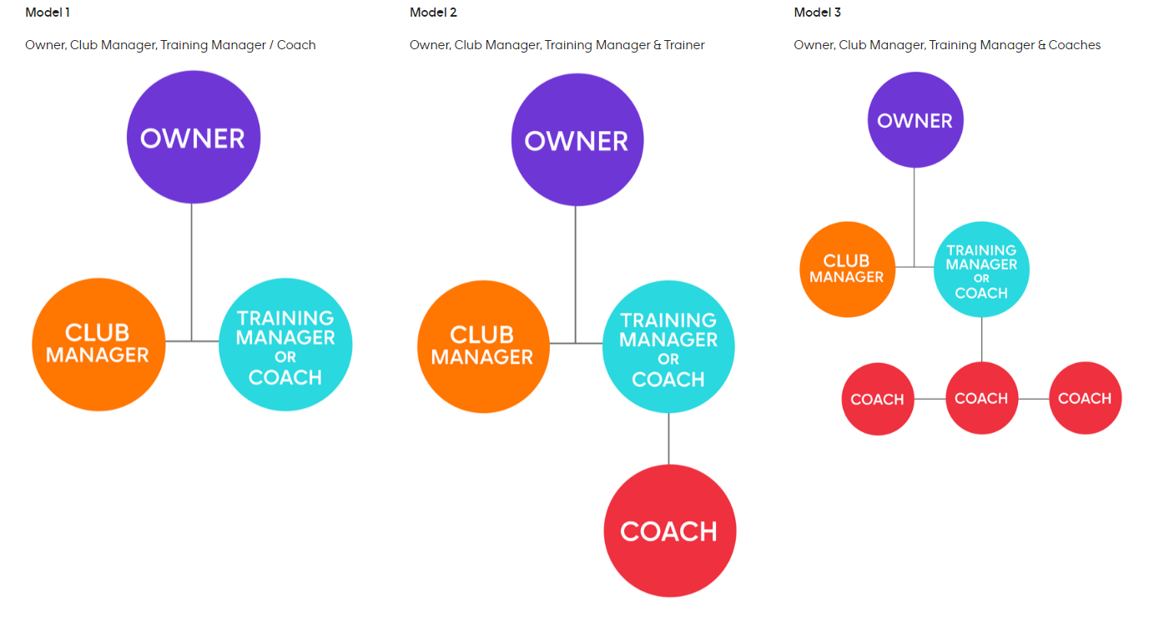
Owner:
Financial Reporting, Business Operations and Strategy, Marketing and Sales Strategy, Organizational Structure and Hiring

Club Manager:
Membership and Personal Training Sales, Brand Promoters, Daily Operations, Culture Creators, Team Builders,

Training Manager:
Personal Training Sales, Member Onboarding, Program Adherence, Team Builders, Culture creators

Coach/Trainer:
Member Onboarding, Membership/Training Sales, Club Culture and Client Service, AF Training Program Implementation

Management Profiles
{Your Name}
{Provide your work and education history or insert your resume}
{Names of any additional owners}
{Provide your work and education history or insert your resume}

SERVICE & PRODUCT LINE
The Anytime Fitness model is more than just a gym. We are a supportive community making fitness, nutrition, and wellness part of every day. Our approach to whole health coaching is rooted in science and heart. To empower every member with a personalized plan and expert guidance to live their healthy best, Anytime Fitness offers:
- 24/7 secure access
- Reciprocity to all locations around the world
- Personalized coaching and support
- Nutrition guidance
- Personal training
- Fitness recovery
- Physical therapy (select locations only)
- AF App
- Modern exercise equipment
- Supportive community

Pricing
Tiered Memberships
A tiered membership includes not only access to the gym, but also a more robust coaching element such as personal training sessions. The benefits of offering tiered memberships include:
- Increase profitability
- Improve personal training penetration and revenue
- Build the personal training lead funnel and upgrade opportunities
- Provide an opportunity to address clients' goals as soon as they join by setting them up with hands-on support from a coach
- Engage new members in coaching services from day one to follow through with the AF promise, improve results, and increase average member value

Base Membership
A Base Membership offers 24-7 access to the gym, a personalized plan with access to the AF App, and a free fitness consultation.
Total down payment – $173
- Enrollment fee – $99
- Security activation fee – $49
- Dues – $25 biweekly
- 60-minute fitness consultation ($50 value)
- Evolt body scan every 6 weeks
- Personalized health and wellness plan in the AF App

Coaching Membership
A Coaching Membership includes everything the Base Membership includes, plus two 30-minute coaching sessions per month. The monthly coaching session can be done in person or virtually via video chat, is structured around accountability and may or may not include an actual training session.

Total down payment – $143
- 1/2 off enrollment fee – $49 (normally $99)
- Security activation fee – $49
- Dues – $45 biweekly
- Two 30-minute coaching sessions per month
- Access to a coach and customized workouts through the AF App
- Evolt scan and review with a coach every 4 weeks

Competitive Advantages
The main component of the model that will differentiate our gym from others in the market is not only the convenience of 24-7 access but our anytime, anywhere personalized support value proposition. Members can find the same equipment that Anytime Fitness offers at many other fitness clubs, but it’s the value that our customers experience as a result of using our holistic services that will lower attrition rates, drive memberships, and increase lifetime value.
Brand Positioning:
No other health and wellness brand supports people better, so that they can live healthier, happier lives.

Brand Differentiators:
- Holistic support
- Convenience redefined
- Inclusive
- Welcoming community
- Unexpected ROI

The franchisor has developed operations to help us provide personalized coaching that provides the best training, nutrition, and recovery guidance accessible anytime, anywhere proven to improve our members’ health. We will receive comprehensive training from the franchisor on how to implement and execute this service in our club.

Franchisor Support & Development
The franchisor has developed an excellent support system that does more than simply walk franchisees through the various processes; it is designed to help franchisees develop their business while providing support at every stage of the business life cycle. The essentials of the support structure are illustrated in the graphic below.

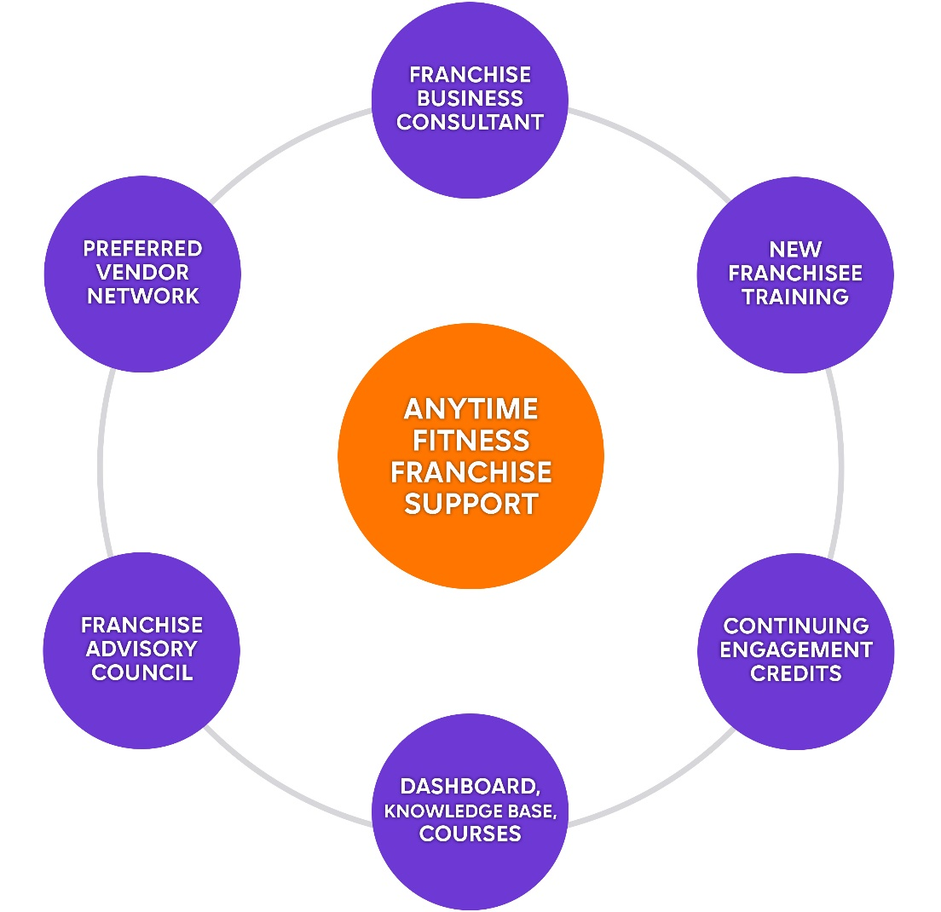

Franchise Business Consultants
Just after a franchise agreement is signed, each franchisee is assigned to a Franchise Business Consultant. This consultant has a thorough understanding of the Anytime Fitness model, the fitness industry, and works with franchisees to develop a tailored action plan to maximize financial success.
New Franchisee Training (NFT)
Prior to opening, franchisees are required to attend New Franchisee Training (NFT), hosted by the franchisor. NFT equips owners with the tools and information needed to operate an Anytime Fitness club. This training is broken into three parts:
- Online Academy coursework
- Workshop at the corporate office
- Club Shadow Experience
Continuing Engagement Credits (CECs)
Every year our business must obtain at least 1,200 Anytime Fitness Continuing Engagement Credits (CECs). Credits are earned for attending various training programs, and for other participation in our system. Some of these events include:
- Vitals Training – interactive two-day workshop that focuses on the “vital” aspects of club operations. Multi- and single-club owners, managers, and trainers can learn about timely objectives to help them grow with the Anytime Fitness brand.
- AF Training Workshop – learn how to show prospects and members how training fits into their fitness journey. See how to use the fitness consultation to assess clients and suggest training options, interpret workout plans, and take action to implement AF Training in your club.
- In-Club Operations Consultation – three-day training, specifically tailored to help you refine your club operations through hands-on support and training.
- Anytime Fitness Conference (Biennial) – the Anytime Fitness Conference is designed to communicate and educate franchisees and their staff on the current strategy of the brand and club operations. It’s a three-day event packed with seminars, professional speakers, and networking.

Franchise Dashboard & Resource Center
The franchisor has developed a system-wide extranet known as the Anytime Fitness Dashboard. This online operations manual and platform has volumes of information that can be accessed whenever an internet connection is accessible. Some of the resources on the Dashboard include:
- News & Events – Important timely and educational communications from the corporate office and field (e.g. campaigns, training event dates, initiative rollout)
- Club – Business reporting, website management tools, member feedback, digital membership agreement and staff management
- Resources – Access to knowledge base materials (e.g. operations manual, best practices, policies and procedures, job aids), online courses and curriculum, vendor network access
- Workplace – Online platform for the franchise network to share best practices, offer feedback, celebrate successes, and ask questions
- Community – Corporate directory, and Franchise Advisory Council information

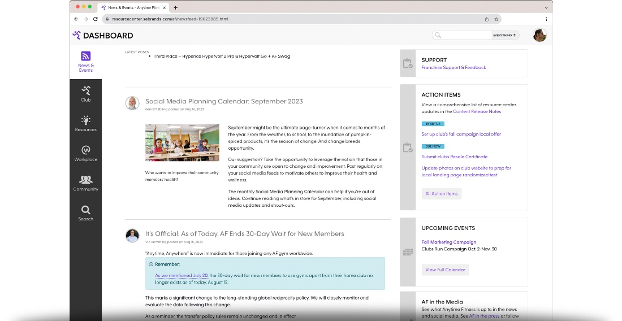
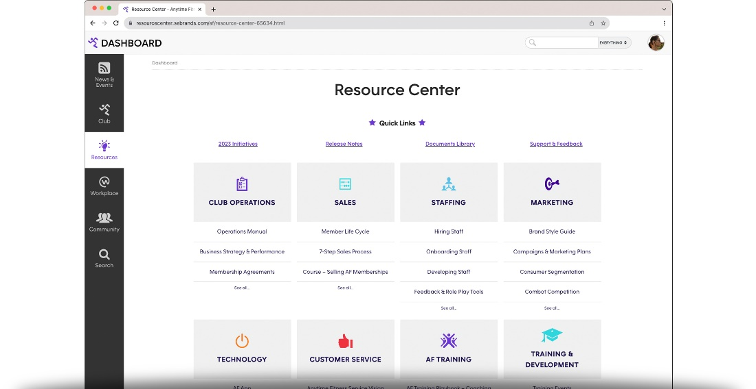
Anytime Academy
The franchisor has also developed a robust library of online learning courses for franchisees and to support franchisees with their staff development through ongoing training opportunities. This website includes self-paced courses, comprehensive curriculum, learning paths for trainers, managers, and owners, interactive applications for a more immersed learning experience, and more—all designed to get clubs up and running, and ultimately boost ongoing unit-level performance.
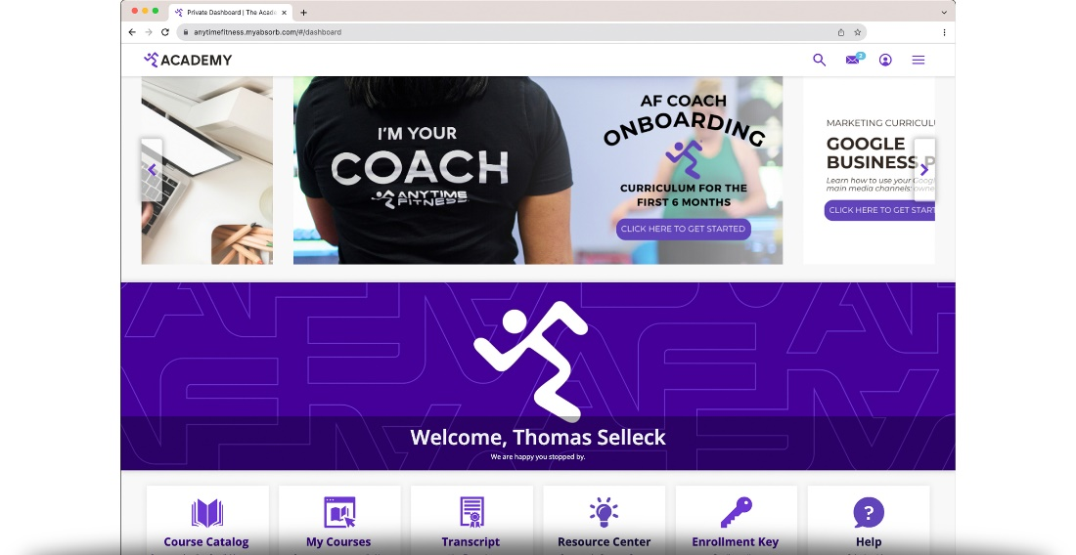
Franchise Advisory Council
The Franchise Advisory Council (FAC) is a group of franchisees who volunteer to meet and offer ideas and suggestions regarding the Anytime Fitness franchise system and its path for growth. The Franchise Advisory Council acts as a liaison between Anytime Fitness franchisees and the corporate office. Other responsibilities include:
- Act as role models for peers
- Assist franchisees with questions or concerns
- Help improve profitability for both franchisee and franchisor
- Mentor other franchisees

Preferred Vendor Network
A network of vendors has been established to provide Anytime Fitness franchisees with services and products that aid in every phase of business operation. From buildout to daily operations, this group of vendors works to help clubs perform at their best.
The vendor network has been established to:
- Open up opportunities for additional revenue streams (e.g. PPV and Insurance Processing)
- Offer specialized products and services at preferred pricing
- Ensure consistency across clubs (e.g. Mandated Vendors)

Business Life Cycle

As time passes, design and architecture trends change, as do the mechanics, functionality, and quality of fitness equipment. Therefore, we plan to undertake a club renovation approximately every five years. The franchisor provides a detailed design manual along with a dedicated team to help, thus ensuring brand consistency and a design centered on bringing coaching to the forefront.

MARKETING & SALES

Presale & Grand Opening

To effectively enter a new market, we lean on the expertise of the franchisor by using marketing strategies and recommended materials. The franchisor has put together a step-by-step presale guide to help us during the first 16 weeks of presale and opening.

Ramp Up Program

The Ramp Up Program helps new franchisees ramp up their gym membership in the weeks prior to opening their clubs. Presale is required for all new owners and involves selling memberships before the club's official opening. Through the Ramp Up Program, we’ll develop a strategic marketing campaign aimed at reaching a target of 150 members by the opening date. A successful Ramp Up campaign achieves several objectives, including raising local awareness and generating presale and post-opening leads and members.
The Ramp Up Program is a 16-week marketing initiative that uses a combination of digital and traditional paid media marketing strategies. These strategies are carried out by a preferred paid media agency within the franchisor’s vendor network. On a local level, we’ll plan and execute community marketing tactics. Ramp is designed to optimize and support marketing efforts during presale (60 days prior to opening through 60 days after opening).
The recommended marketing media spend is dependent on the population within a 3-mile radius of our club:
- Tier 1 = population > 50,000 = $23,000
- Tier 2 = population 25,000 – 49,999 = $16,000
- Tier 3 = population < 25,000 = $11,000

A grand opening event happens after our club has been open and running for 30 – 60 days. During this "soft open,” we solidify processes to ensure smooth operations. We also use this time to get to know our initial member base.

Sales Strategy
The franchisor provides training in all aspects of the sales process including a step-by-step method which illustrates the phases a prospective member experiences from the first point of contact with our club (inquiring about a membership) through member onboarding and ongoing follow-up.
We intend on following this proven strategy and will achieve this by providing a welcoming atmosphere and supportive community to everyone, personalized coaching, nutrition planning, and recovery while using the AF SmartCoaching technology to connect and motivate every prospect and member throughout their journey. We believe members will engage more, stay longer, spend more, and refer others when they recognize progress on their health goals.
Each stage of this sales process contains measurable actions that, when executed strategically, can help increase the profitability of our club.
We also understand the importance of proper staff training and will train our staff in these processes that have proven success. We will leverage our franchisor and utilize the training modules and resources provided.

Growth Strategy
Our growth strategy focuses on lead acquisition and member conversion via local marketing efforts, referral programs, and in-club engagement and retention practices. The franchisor supports all website properties and conversion rate optimization to deliver lead submissions and a robust customer relationship management system to drive lead nurture.
The franchisor executes yearly brand marketing campaigns designed to launch in the market when consumer interest in joining fitness facilities is high, driving awareness and consideration while at the local level we capitalize on lead capture. These campaigns focus on January, Spring and Fall with robust marketing and operations guidance, tools and resources designed to drive membership during these key periods.

FINANCIAL PROJECTIONS
Download and complete the Pro Forma Template and attach it to this section or provide it as a separate attachment alongside the business plan.

