Instructions
Completing a business plan can serve multiple purposes including getting you to think strategically about your business and for obtaining any lending you may need. Please follow the instructions below to complete this plan.
- The content highlighted in yellow varies from franchisee to franchisee, so you’ll need to give this content a thorough review. You may need to edit or remove the content based on your situation. Once you’ve reviewed and edited this content, remove the highlighting.
- It’s recommended you take the time to research your competition and update the Competition section accordingly. This section was designed to give you a general idea of what the contents should be, however, each club’s market is unique, and your specific competition should be accurately reflected in this business plan.
- For lenders and other users of this business plan to get an accurate representation of who you and your business partners are, we encourage you to update the Management Profiles section. Include the high points of your professional career and focus on those that make you an ideal candidate for running a franchise business as an entrepreneur.
- Update the Pro Forma with figures that are representative of your business. Please note, the figures populated in the Pro Forma are those printed in the Anytime Fitness FDD. We encourage you to do a thorough analysis of your business and update any figures as necessary, even figures from the FDD that are already populated in the Pro Forma.
- Use your completed Pro Forma to write summary paragraphs and to create graphs, charts, and other visuals to include in the Financial Projections section. Visuals provide a great way to give the reader an at-a-glance overview of your financial position.

Franchise Owners:
First Last
First Last

TABLE OF CONTENTS
EXECUTIVE SUMMARY 5
COMPANY DESCRIPTION 7
MARKET ANALYSIS 8
Industry Overview 8
Industry Outlook 8
TARGET MARKET 9
Pricing 10
Competition 11
ORGANIZATION & MANAGEMENT 13
Organizational Structure 13
Management Profiles 14
SERVICE & PRODUCT LINE 15
Club Overview 15
Competitive Advantages 16
Franchisor Support & Development 18
MARKETING & SALES 23
Presale & Grand Opening 23
Sales Strategy 23
Growth Strategy 24
FINANCIAL PROJECTIONS 25

EXECUTIVE SUMMARY
As Entrepreneur Magazine’s #1 ranked global franchise of 2016, Anytime Fitness is well on its way to actualizing its vision to “improve the self-esteem of the world.” While this message is cascaded from the franchisor, we find the combination of its simplicity and power a perfect match for how we plan to operate our business. This vision will be carried out in our club every day by providing each member and potential member with a world-class experience.
Our company will be a franchise of Anytime Fitness located in City, State, with us, First Name Last Name and First Name Last Name, as owners. Our customers will be at the forefront of our business. Because of this, a large factor in choosing staff will be focused on their ability to provide outstanding customer service.
Our facility will feature state-of-the-art cardio and resistance equipment in a clean, safe, and convenient gym. In addition to maintaining the physical environment, we will focus on providing a world-class level of customer service. The Anytime Fitness customer service standards have been fully developed by the franchisor and are an extensive component of our training as franchisees. We will fully implement and execute this service vision in our club to create a personable experience and an inclusive, welcoming environment.
Our growth strategy will leverage our club culture, focusing on referrals from existing members. As our club develops a non-intimidating, service-oriented environment, current members will be very likely to refer their friends and family to our club. Additionally, we will use the marketing campaigns that are developed by the franchisor. These campaigns are developed by marketing field experts and are designed to reach the market when consumers are most likely to join fitness facilities.
The franchisor provides an all-encompassing set of resources to support us in executing brand strategy and daily operations. A team of business consultants works directly with franchisees to establish performance metrics, develop business goals, and track progress. An array of online tools, including a franchise dashboard, video courses and tutorials, a robust knowledge base (the Academy), job aids, and operations manual are available for ongoing reference. Targeted in-person training options (e.g. classroom training, in-club training, workshops, biennial conferences) are available not only to owners, but to every role within the team to ensure success on all levels. As the franchisor’s brand strategy evolves, these tools are regularly modified and updated to reflect the current direction of the brand.
Accompanying this business plan is a 3-year pro forma statement that illustrates the club’s projected cash flow. The financial obligations and expectations were thoroughly explained to us by our Anytime Fitness sales consultant. We have also taken the time to complete our own analysis of our financial position and our future projections and obligations.

COMPANY DESCRIPTION
Anytime Fitness is the world’s fastest-growing fitness franchise with thousands of clubs and millions of members worldwide. The company has displayed resilience and continuous growth even in times of economic downturn, landing it a spot on both Entrepreneur Magazine’s “Top 500 Franchises” and “Fastest-Growing Franchises” lists for more than ten consecutive years, among many other accolades.
The franchise takes a two-pronged approach to offering members what they need to achieve long-lasting success in the areas of health and fitness:
Convenience & Safety
By providing 24-hour access, 365 days a year, Anytime Fitness is an ideal option for consumers who are looking for a convenient and secure solution for their fitness goals. Plus, we offer the exclusive benefit of gym reciprocity, which allows members to use all Anytime Fitness locations worldwide with one standard membership.
The facilities are secured with proprietary access software, security, and surveillance technology, allowing a club to be open on a 24-hour basis. The system, which includes remote monitoring of a closed-circuit television system and personal safety devices, allows members to feel safe and secure, even when a club is not staffed.
Coaching & Culture
Where the Anytime Fitness model stands out is its emphasis on exemplary customer service, coaching, and dedication to an engaged club culture. Anytime Fitness has developed a customer service vision, which is to provide every guest with a surprisingly personable experience. This vision is executed with a well-designed strategy comprised of service pillars and standards that, when combined, result in a surprisingly personable experience.
And as the industry continues to evolve, we will be supplementing our core offerings with coaching services designed to support our members inside the club and out. This includes virtual coaching through the Anytime Fitness App®, Team Workouts, and Personal Training programs. Each layer provides unique benefits for our members and can be combined to customize a program that works for them, wherever they are in their fitness journey.

MARKET ANALYSIS

Industry Overview
According to the IHRSA Canadian Health Club Consumer Report, the Canadian population’s top heath concerns are obesity, eating healthy, and exercise. This provides an ideal marketplace for fitness and health offerings where these concerns can be managed. These top concerns also illustrate that member needs both inside and outside the club must be met. Therefore, platforms such as online nutrition tools and personal trainer engagement must be well developed and executed in order to attract and retain members.
Another key driver of financial performance is the percentage of revenue that is reinvested back into the club. Those clubs that reported an increase in revenue reported investing a higher percentage of revenue to reinvestment.

Industry Outlook
IHRSA states that the key to operating a successful fitness club is growing a long-term member base for these main reasons:
- They take the pressure off of continuously selling a high volume of new memberships
- They’re more likely to have higher disposable income to purchase ancillary services at the club
- They’re an excellent referral base for getting new members *
* Source: 2016 IHRSA Health Club Consumer Report
Societal changes also impact the future of the fitness sector as the population ages, grows in cultural diversity, and becomes more value sensitive. New technologies are driving innovative ways to market the brand and receive consumer feedback.
The Canadian market has seen changes in the competitive environment even from just a few years ago, with a broad range of options available to consumers. Recently, there has been an arrival of U.S. giant box operations which have mixed in the market with Canadian chains, mom and pop clubs, workplace facilities, condo gyms, and home-based fitness options.

TARGET MARKET
Anytime Fitness’ proven site selection process allows us to leverage a promising demographic population in our territory to the fullest extent.
To strategically target the needs of our market, the franchisor has consulted with industry experts to define customer segments based on their attitudes and behaviors around health and wellness. We use this information to understand the market, the consumers in the areas around our clubs, and our current member base. Our core targets include:


“I Need a Plan” Jan / Stan


These folks make up 17% of our current member base. They need to feel heard, welcomed, and encouraged. Having guidance from trainers makes them feel more confident in succeeding. Demographics:

- 40’s-50’s
- Beginner exercise level
- Struggle with health and weight
- Intimidated and confused
- Have failed before

Opportunity: Current trends predict this group will make up 22% of our members in the future. They want help, and they’re willing to pay for coaching to get it.


“Not Right Now” Nancy

These folks are 19% of our current member base. They’re extremely busy and prioritize family over fitness. They need a realistic and sustainable fitness solution. Demographics:

- 30’s-40’s
- Beginner exercise level
- Mostly female
- Are in good health, but stressed

Opportunity: Current trends predict this group will make up 23% of our members in the future. They want to maximize their time in the gym, and they’re willing to pay for coaching to do it.
Source: Source: Kantar – The Futures Company

Recent demographic reports show, the industry derived a nearly equal percentage of its membership base from adults 25 to 34 and 35 to 44, at approximately 18% each. Adults from 45 to 54 were the third-largest segment, representing 16% of the total membership base.
The percentage of members from the 45 to 54, 55 to 64 and 65-plus demographics have all increased as a percentage of the industry membership base, while the percentage of members from the 25 to 34 and 35 to 44-year-old demographics has declined slightly.
With the market shifting to focus on those who are 44 years of age and under, it leaves the opportunity to focus on the younger demographic and capture that part of the market that the competition is not focusing on. We understand that in order to capture this part of the market, we first need to identify their needs and work to fulfill those needs in our club.
* Source: 2016 IHRSA Health Club Consumer Report

Pricing
After analyzing our market and receiving reliable guidance from the franchisor, our pricing structure will be as follows:
Fee | Amount
Enrollment | $XX
Security Activation | $XX
Membership | $XX

Competition
As a 24-hour fitness facility, Anytime Fitness' primary competition is other 24-hour, mid-sized fitness facilities. The market we are in has a variety of fitness facility offerings including one 24-hour facility, Snap Fitness, two women-only facilities, and a community center all within 2.5 miles of our club. The map below outlines the location of our competition as it relates to our club.
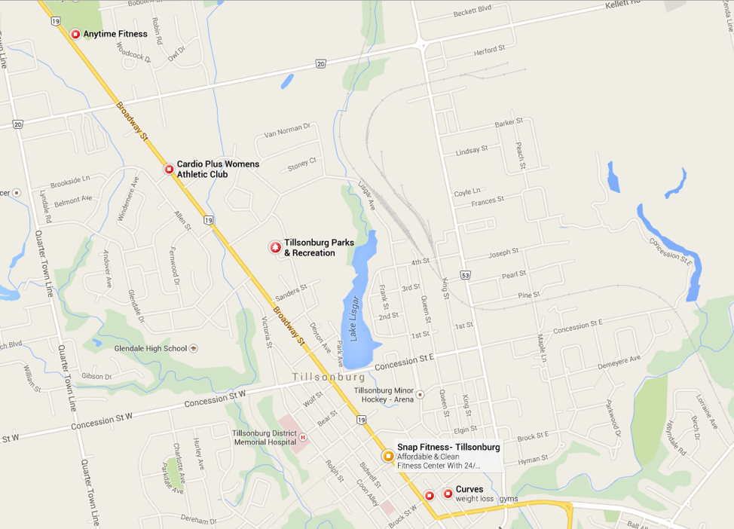
The way in which our club fits into our market is illustrated in the table below. In almost all instances, we will be able to leverage competitive advantages (e.g. 24-hour access, non-intimidating environment, dedicated focus on coaching, exceptional member experience) to gain market share in our area.
Facility | Specialty | Competition | Cost | AF Leverage
Snap Fitness | 24-hour convenience | High | $XX | Clean facilities, exceptional customer service, a dedicated focus on coaching
Curves | Female-gender specific, preplanned workouts | Moderate | $XX | 24-hour access, exceptional customer service, a dedicated focus on coaching
Tillonsburg Community Center | Multipurpose | Moderate | $XX | 24-hour access, exceptional customer service
Cardio Plus Women’s Fitness + Day Spa | Prader-Willi Syndrome | Moderate | $XX | 24-hour access, lower cost

ORGANIZATION & MANAGEMENT

Organizational Structure
We recognize that intimidation on the part of a potential member can be a huge factor in whether or not they actually walk through the doors of a fitness club. Therefore, we understand that making the customer comfortable is a key to success and that will be at the forefront during our hiring process. Our organizational structure is as follows:
[Insert Name Here]
Majority Partner
Responsibilities:
Overall management and ownership decisions
Financial reporting
Business operations
Marketing and sales strategy

[Insert Name Here]
Club Manager
Responsibilities:
Membership sales
Accounts payable / receivable
Marketing execution
Human resources

[Insert Name Here]
Trainer
Responsibilities:
AF Training sessions
Virtual coaching via mobile app
Program implementation

[Insert Name Here]
Member Experience Manager
Responsibilities:
New member onboarding
Fitness consultations
AF Training programming
Trainer education
[Insert Name Here]
Trainer
Responsibilities:
AF Training sessions
Virtual coaching via mobile app
Program implementation

Management Profiles
{Your Name}
{Provide your work and education history or insert your resume}
{Names of any additional owners}
{Provide your work and education history or insert your resume}

SERVICE & PRODUCT LINE

Club Overview
The graphic below depicts how our club will meet customer demands on the foundation of three strategy components: what, why, and how.

Consumer Demand
HOW
How do they want their fitness club demands met?
With surprisingly personable experiences.

WHAT
What do consumers demand in a fitness club?
Convenience and coaching.
Our base membership provides 24/7 access to thousands of locations worldwide. We’ll also offer customizable workout plans, virtual coaching, and AF Training to deliver the right coaching.

WHY
Why do consumers join a fitness club?
To overcome the barriers to a healthy lifestyle.
Our service will focus on being a gym that actually cares about the health of its members and takes the time to help them succeed through coaching and a non-intimidating culture.

We receive extensive training on the Anytime Fitness service vision and will offer each member of our club a surprisingly personable experience through a variety of approaches.

.

We believe our members will pay for convenience and coaching. Accordingly, the Anytime Fitness model provides convenient gyms that feature an “always open” access system and a state-of-the-art security system. Further, each member has reciprocity to thousands of Anytime Fitness clubs domestically and internationally.
The franchisor has provided us a model for our members that is welcoming, affordable, and beneficial, in that it provides specific benefits to its members in order to overcome barriers to a healthy lifestyle. Our fitness club will have a mix of the most popular fitness equipment as reported by IHRSA, including treadmills and other cardiovascular machines, resistance equipment, and free weights.*
Because group fitness can increase member accountability and foster a captivating culture, our club will feature a functional training space, which will aid in marketing to new members, as well as retaining existing members. This space can facilitate many of the most popular group and personal training activities.
To help our members reach their goals faster and more effectively, we will focus on building a culture of coaching, which offers members tailored experiences through the use of Team Workouts, Small Group Training, One-on-One Training, and virtual coaching. According to IHRSA, 12% of club members are defined as ‘core’ users of personal training. To grow the core users of personal training in our club, it is critical to not only hire effective personal trainers, but to also promote the personal training program within the club. Member success stories are a great means of overcoming the price-value equation that often times keeps members from using personal training on a consistent basis.*
Our club will offer tanning services as an additional member benefit as well as to generate an additional revenue stream. Fitness club members tan for a variety of reasons including, to relax after a workout, to accentuate the appearance of muscle tone, and simply to absorb some synthetic sunlight. By offering this ancillary service we are creating a competitive advantage over similar clubs that do not offer tanning, and we will focus on selling tanning to those members that are currently tanning at a salon. This will create an additional revenue stream for our club, and it will save the member time and money by coupling fitness and tanning services into one.
* Source: 2016 IHRSA Health Club Consumer Report

Competitive Advantages
The main component of the model that will differentiate our club from others in the market is our service vision. Members can find the equipment and services that Anytime Fitness offers at many other fitness clubs, but it’s the culture and how the service is delivered that will lower attrition rates and keep membership figures strong. The franchisor has developed a world-class customer service vision based on the premise that all customers should have a surprisingly personable experience. We will receive comprehensive training from the franchisor on how to implement and execute this service vision in our club. After all, the competition can copy what you do, but they can’t copy how you do it.
Additionally, it’s undoubtedly important to use time effectively while working out in the club, however, it’s just as important (if not more important), to focus on lifestyle outside of the club. To address members’ needs outside the gym, Anytime Fitness has developed a cross-functional coaching app—the Anytime Fitness App®—which is available to all members. The app offers a valuable list of functions, like:
- Gym visit tracking and agreement details
- A robust library of blogs and written resources
- Custom goal tracking
- App integration with Fitbit®
- Ability to book training and view a training schedule
- Coaching features (e.g. chat with a coach)
- Workout builder with a library of exercises and pre-made workouts

Franchisor Support & Development
The franchisor has developed an excellent support system that does more than simply walk franchisees through the various processes; it is designed to help franchisees develop their business while providing support at every stage of the business life cycle. The essentials of the support structure are illustrated in the graphic below.

Franchise Business Consultants
Just after a franchise agreement is signed, each franchisee is assigned to a Franchise Business Consultant. This consultant has a thorough understanding of the Anytime Fitness model, the fitness industry, and works with franchisees to develop a tailored action plan to maximize financial success.
The first formal training program that we will go through is Operations Training and Consumer Training, hosted by the franchisor. These corporately-hosted trainings are required. The training is extensive and includes the following topics:
Operations Training
Designed specifically for owners only, this training focuses on the critical aspects of ownership, including staffing, finance, brand strategy, KPIs, technology, and systems.

Consumer Training
Targeted for owners and managers, this training focuses on working with our consumers, including customer service, marketing, membership sales and onboarding, retention, and presale or grand opening.

Vitals Training
Interactive two-day workshop that focuses on the “vital” aspects of club operations. Multi- and single-club owners, managers, and trainers can learn about timely objectives to help them grow with the Anytime Fitness brand.

AF Training Workshops
Learn how to show prospects and members how training fits into their fitness journey. See how to use the fitness consultation to assess clients and suggest training options, interpret workout plans, and take action to implement AF Training in your club.

In-Club Operations Consultation
Three-day training, specifically tailored to help you refine your club operations through hands-on support and training.

Franchisee Dashboard & Resource Center
The franchisor has developed a system-wide extranet known as the Dashboard. This online platform has volumes of information that can be accessed whenever an internet connection is accessible. Some of the resources on the Dashboard include:
- News & Events – Important timely and educational communications from the corporate office and field (e.g. campaigns, training event dates, initiative rollout)
- Club – Business reporting, website management tools, member feedback, digital membership agreement and staff management
- Resources – Access to knowledge base materials (e.g. operations manual, best practices, policies and procedures, job aids), online courses and curriculum, vendor network access
- Community – A franchisee forum, corporate directory, and franchise advisory council information

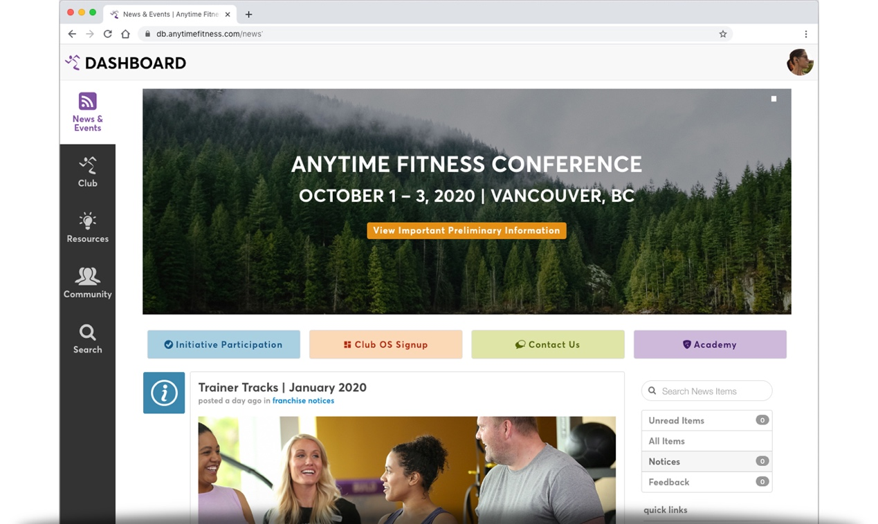

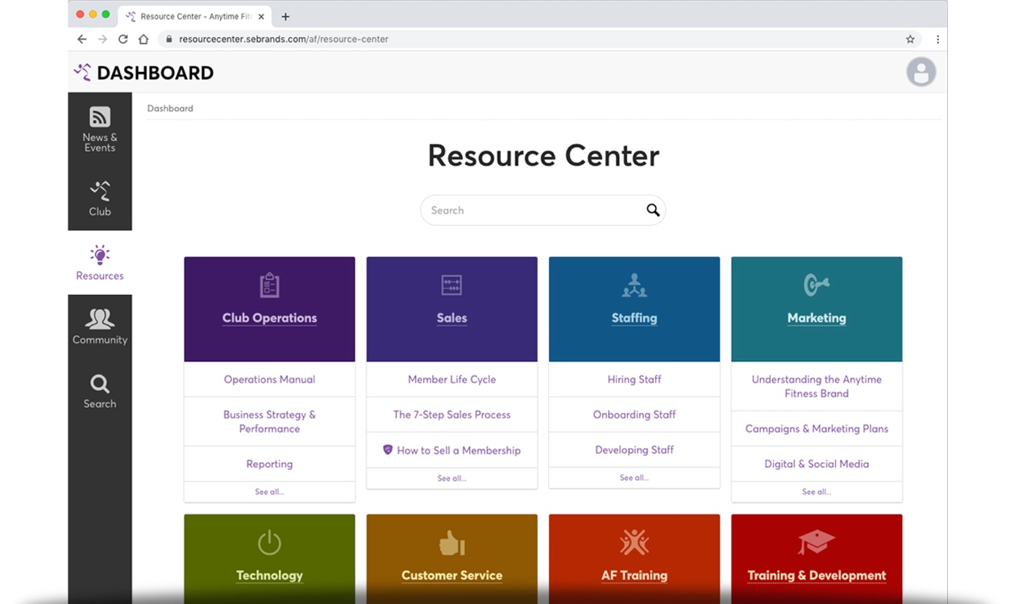
Anytime Academy
The franchisor has developed a robust library of online courses for franchisees and their staff to engage with ongoing. This website includes self-paced courses, comprehensive curriculum, learning paths for trainers, managers, and owners, interactive applications for a more immersed learning experience, and more—all designed to get clubs up and running, and ultimately boost ongoing unit-level performance.

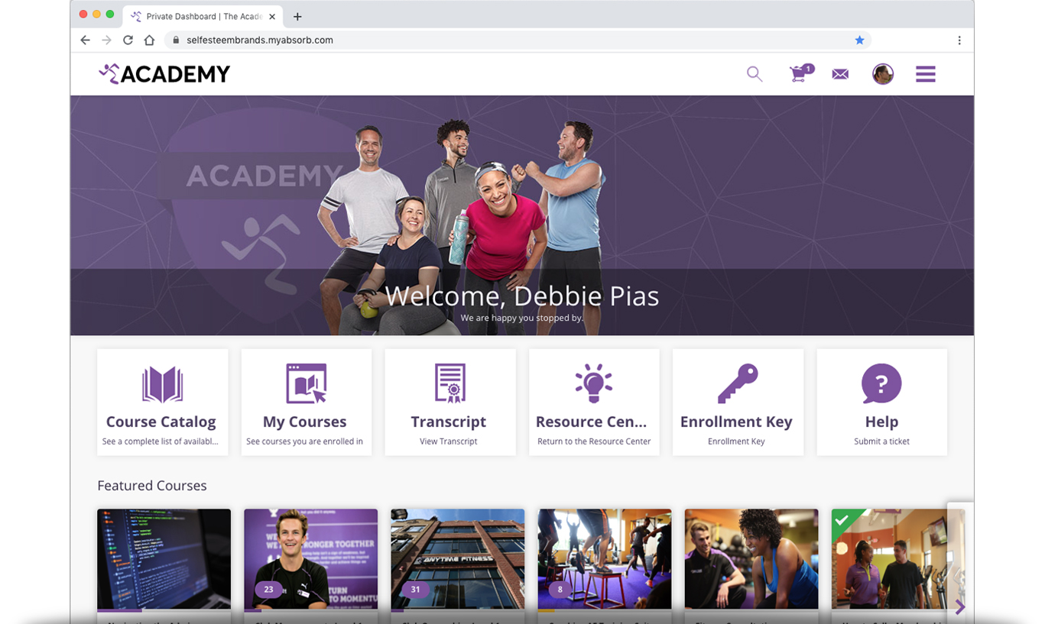

Anytime Fitness Franchisor Conference
The Anytime Fitness Conference is designed to communicate and educate franchisees and their staff on the current strategy of the brand and club operations. It’s a three-day event packed with seminars, professional speakers, and networking.
Business Life Cycle
As time passes, design and architecture trends change, as do the mechanics, functionality and quality of fitness equipment. Therefore, we plan to undertake a club renovation approximately every five years. Fortunately, the franchisor provides a detailed design book by which each Anytime Fitness club should be modeled after. The franchisor allows some decisions to be made by club owners while keeping other factors consistent across the system. The result is a seamless renovation process that keeps existing members excited for what’s to come.

MARKETING & SALES

Presale & Grand Opening
To effectively enter a new market, we must lean on the expertise of the franchisor by using the marketing strategies and recommended materials. The franchisor has put together a step-by-step presale guide for us to use during the first 12 weeks of presale and opening.
Included in the 12-week plan is a recommended marketing media spend, executed through the Anytime Fitness corporate marketing team and various media partnerships. These media buys primarily use digital marketing via paid search and paid social media to help drive awareness and lead generation during presale to grand opening. Traditional media (radio, printed materials, etc.) and public relations / partnerships are also explored.
The recommended marketing media spend is dependent on the population within a 3-mile radius of our club:
- Tier 1 = population > 50,000 = $18,000
- Tier 2 = population 25,000 – 49,999 = $13,000
- Tier 3 = population < 25,000 = $8,000
A grand opening event happens after our club has been open and running for 30 – 60 days. During this time, we solidify processes to ensure smooth operations. We also use this time to get to know our initial member base. Details of the grand opening event are listed in the Presale and Grand Opening guide provided by the franchisor.

Sales Strategy
The franchisor provides thorough training of the company’s membership sales process that strongly leverages its service vision. We intend to follow this sales process with a strong focus on the service aspect by showing each prospect we care and will take the time to help them succeed.
Our club management software is designed to effectively manage prospects with its lead management module. Prospects that inquire via the public-facing website are automatically populated in the lead management module, and those prospects that are generated from telephone inquiries, walk-ins, or email, can be manually entered. Once entered in the system, each prospect profile has the following elements used for tracking:
- Calendar appointment
- Activity history
- Notes
Lastly, we understand the importance of properly training our sales staff to grow our membership base. We will train on the membership sales process and the service vision standards, along with how to use the club operating software to manage prospects. Along with proper sales training, we will drive home the importance of creating an unmatched club culture through developing relationships with members in order to grow and sustain long-term members.

Growth Strategy
Our growth strategy will largely focus on referrals from current members and revenue earned through our coaching efforts. The franchisor has developed a process for encouraging current members to provide referrals. This is a cost-effective and less intimidating way to market our club, gain new prospects/members, and increase club retention rates. As our club develops a welcoming, non-intimidating, service-oriented culture, current members will be very likely to refer their friends and family to our club.
Along with referrals, we will also use the marketing campaigns that are developed by the franchisor. These campaigns are designed to hit the market at opportune times when consumers are looking to join fitness facilities: at the start of the New Year, heading into spring and at the start of fall. To differentiate Anytime Fitness in the market, the majority of these campaigns offer to the consumer.

FINANCIAL PROJECTIONS
Download and complete the Pro Forma Template and attach it to this section or provide as a separate attachment alongside the business plan.

