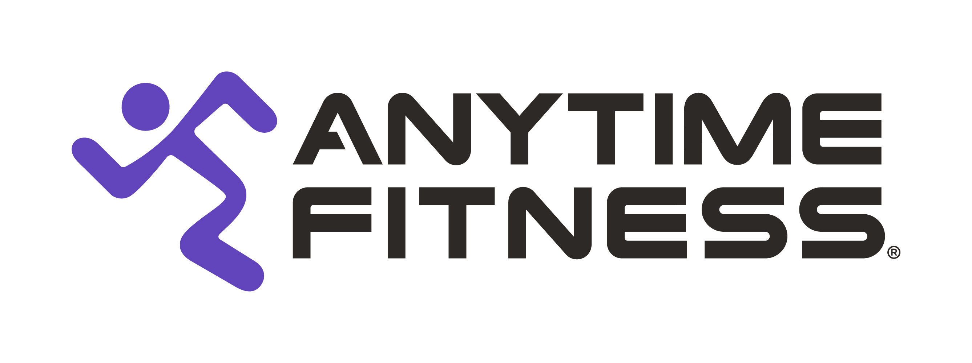

Contact:
Morgan Assenmacher
Fish Consulting
954-893-9150
massenmacher@fish-consulting.com

Anytime Fitness Launches AF SmartCoaching Technology, New App to Help Members Gain & Sustain Benefits of Holistic Health and Fitness
World’s Largest Fitness Club Brand to Offer Digital Round-the-Clock Personalized Coaching and Support for Anytime Fitness Members

WOODBURY, M.N. (April 11, 2023) – Anytime Fitness, the world’s largest fitness club brand and fastest-growing fitness franchise, announced today the launch of its AF SmartCoaching technology and AF App. AF SmartCoaching will provide Anytime Fitness members with personalized coaching that can now be accessed via the app anytime, anywhere. The tech rollout is part of the brand’s continuous strategy to provide members with Anytime Fitness access and coaching both inside and outside a club to ultimately improve their personal health.

“Anytime Fitness was founded on providing 24/7 club access to our members. Our locations are still open 24/7, but we recognize that a person’s health and wellness is influenced by fitness, nutrition and recovery, 168 hours of a week, not just the few hours they may spend in a gym,” said Stacy Anderson, president, Anytime Fitness. “Many people struggle to achieve their health and fitness goals because of lack of time, confidence, and know-how. Our AF SmartCoaching system will help people meet their goals more efficiently and effectively by delivering fitness, nutrition, and recovery coaching anytime, anywhere, measuring their progress beyond the scale and using behavioral data to deliver personalized recommendations along the way.”

Anytime Fitness’s AF SmartCoaching technology captures member activity and performance both inside and outside an Anytime Fitness club. Data and predictive analytics “super charge” Anytime Fitness coaches, helping to produce a personalized health and fitness plan for each member. Through the app, members can access their customized plan, which includes training and nutrition, as well as recovery tips and guidance. As their plan progresses, a body composition scanner is used to measure progress, allowing clients to see progress a standard scale can’t. As goals are reached, new programs are designed to match a member’s increased fitness level.

In addition, members can use the app to schedule fitness consultations, sessions for personal or group training, chat with a coach through text and video calls, and more. AF coaches can also access the member’s data and track progress in real-time, while offering motivational support and answers via written responses and short video demonstrations to important questions. Non-members can access select app features, but coaching services within the app are for members only.

“As part of Anytime Fitness’s evolution, we want to make your health and fitness goals more easily achievable – both inside and outside the four walls of an Anytime Fitness club. Accessibility has been at the core of our brand since the beginning and we’re now doing our part to ensure members, as well as non-member AF App users, can access our brand at their fingertips,” said Chuck Runyon, CEO and co-founder, Self Esteem Brands. “We’re privileged to launch our new AF SmartCoaching technology and app, but it’s so much more than that. We’re evolving from a brand that offers 24/7 access to one that provides 24/7 personalized coaching support, as well as access to more than 5,100 clubs globally. It’s an exciting time for Anytime Fitness and we believe our continued brand evolution will help improve the self-esteem of the world.”

Later this year, the app will also feature a digital key, which members will use to access any of the Anytime Fitness clubs around the world.

To download the AF app, please visit the App Store directly from your iOS or Android smartphone.

For more information about AF SmartCoaching, the app, or to locate a nearby Anytime Fitness club, please visit www.anytimefitness.com. Also follow Anytime Fitness on Facebook, Twitter, Instagram and YouTube.

About Anytime Fitness
Anytime Fitness is the largest and fastest-growing fitness brand in the world, averaging 300 new clubs per year while serving nearly 5 million members at more than 5,100 clubs in 40 countries and territories and on all seven continents. Open 24 hours a day, 365 days a year, Anytime Fitness delivers personalized and affordable health and wellness training, coaching, nutrition, and recovery guidance for our members – in the club, in their homes, in their pockets, wherever they are and anytime they need it. All franchised clubs are individually owned and operated, and members have access to any Anytime Fitness club worldwide. For more information, visit www.anytimefitness.com.

About Self Esteem Brands
Headquartered in Woodbury, Minnesota, USA, Self Esteem Brands is the world’s largest health and wellness franchisor, and is the parent company to Anytime Fitness, Basecamp Fitness, The Bar Method, and Waxing the City. With the mission to improve self-esteem around the globe, Self Esteem Brands, through its suite of health and wellness brands, has more than 5,500 operating locations across all seven continents. Additionally, Self Esteem Brands is the owner of Stronger U Nutrition, Healthy Contributions, and Provision Security. For more information on Self Esteem Brands and its various franchise opportunities, please visit https://sebrands.com/.

###

