Contents
Overview 1
Positioning 2
Provider Free Assessments 2
Events 3
Highlight Your Provider Program on your Club Website 3
Promote the Provider Program 5
Social Media 6
Email 6
In-Club Marketing and Content 6
Provider Program “COMING SOON” Assets: 6
Social assets: 6
Blast e-mail templates: 13
In-club assets: 13
Provider “NOW AVAILABLE” Assets 16
Social Media 16
Email 20
In-club assets: Digital signs (horizontal) 25
In-club assets: Digital signs (vertical) 26
Ongoing Awareness 27
Social 28
Email 31
In-Club Content 31
Timeline Recap 31

Overview
You shouldn’t wait for seasonal campaigns to promote your club’s Provider Program—you should promote it continually through ongoing marketing efforts. Use this information to create your launch and steady-state marketing strategy to attract new members leveraging your provider partnership, convert the ones you already have to provider partner patients as appropriate, and build brand loyalty and advocacy from your members.

Positioning
Anytime Fitness is different from its competitors because no other health and wellness brand​ supports people better,​ so they can live healthier, happier lives.
Through expert coaching that delivers personalized training, nutrition, and recovery support, we can help people improve their health. The provider program is one way we can fulfill the recovery aspect of our holistic approach.
A provider program inside Anytime Fitness helps us to deliver on what our consumers are looking for:
- A convenient way to treat their injury and mobility issues, in a place that feels comfortable and less intimidating.
- Genuine connections with real people and collaborative care, seamless interactions between therapists and trainers.
- A place that actually cares about their health and helps them make progress towards their goals with holistic support.

Provider Free Assessments
The best way to connect members and prospects to your provider partner is to start them with a *Free Assessment.
* Offer valid for 1 free physical therapy assessment conducted by the physical therapist. Limit 1 per person. No purchase necessary. Members with federally funded health insurance plans are not eligible; other eligibility and availability restrictions may apply. Valid only at participating Anytime Fitness clubs. No cash value, not valid with any other offer, no refunds or credits. Physical therapy services are provided by an unaffiliated third party; Anytime Fitness Franchisor, LLC and franchisee owners of participating locations do not offer and are not liable or responsible for physical therapy services. Each Anytime Fitness location is independently owned and operated. Void where prohibited.
Always offer a free assessment when a member shares pain, weakness, or sore or tight areas. Consider educating members about your provider partner at the following member touch points. See the program operations playbook in the AF Academy curriculum for more details.
- Initial Tour  - Fitness Consultation  - 6-Week Check-In | - Member Outreach  - Cancellation or Freeze Requests

Events
It is recommended to host a grand opening event for the launch of your provider partner’s space. This event should kick off the opening of the space and be held soon after the launch date. Create an exciting environment, invite in other local businesses, and make it fun! Reference the Grand Opening marketing guide for ideas on how to make the event successful and see your ‘Coming Soon' assets below.
In collaboration with your partner, schedule quarterly "Learn More" or Recovery 101 Workshop opportunities for members to learn more about recovery options at the gym. Encourage members to bring a guest. Invite non-members to come in to learn. While they're in, try to get them on board for a free assessment and membership.

Highlight Your Provider Program on your Club Website
Add your provider partner to your club amenities and put an announcement on your club website to inform prospective members that your provider partner’s services are within your walls. Use this resource center article to learn how.

- Create an AF Dashboard profile for the provider.
  - First Name: provider’s first name, partner/company name
  - Last Name: Physical Therapist
*The AF support team will do this for you, for corporate partnerships such as ATI.

2. Request a headshot and bio from the provider to add to their AF Dashboard profile. Include the provider’s schedule link or phone number in their bio.

3. Update Coaching Services to include your provider partner’s services.

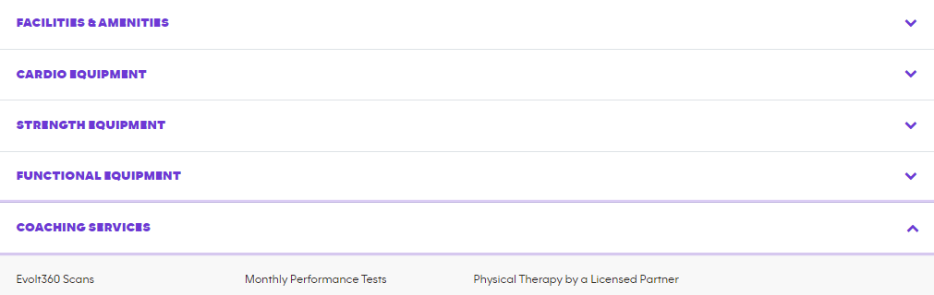

4. Include an announcement about the free assessment if applicable.

Consider something like:
“If you have chronic pain, tightness, weakness, or an injury, schedule a Free Assessment with our Physical Therapist today.”
Include the provider’s scheduling link

Promote the Provider Program
Talk with your provider partner about their marketing plan and how you can best support each other’s brand. Request collaboration and review of all marketing in support of each other and assure that your partner’s marketing follows Anytime Fitness brand guidelines, when referencing Anytime Fitness.
Anytime Fitness corporate has created marketing materials to help you promote your club's provider program with prospects and members of your club. This includes social media images and more. Use these marketing tools along with the information listed in Methods & Mediums of Marketing to get your community excited about your club’s provider program.
The marketing materials are broken down into coming soon, now available, and steady-state assets. Each stage of the program has social media posts, email blasts, and in-club content used to inform about and promote the new partnership within your club. In addition to these marketing assets, it is recommended to host a Grand Opening celebration for your club’s provider partner’s office opening. Guidance on this is provided in the “coming soon” section of this guide.

Social Media
Regularly post content on your social media accounts about your provider program. Use the social media images, videos and captions in the SOCi library labeled based on your provider partner as a starting point.
Additionally, showcase your local club provider and patients using the customizable social media assets in the Brand Marketing Center, after the provider has obtained written consent from the patient.

Email
Send email campaigns to members and prospects. Consider executing a monthly email message to members.

In-Club Marketing and Content
Use assets (available to download in the Brand Marketing Center) to create awareness of and interest in your provider program inside your club using digital screens (TVs) and print templates like flyers.

Provider Program “COMING SOON” Assets:
It is recommended to start your “coming soon” marketing 4-8 weeks (about 1-2 months) before the provider’s space is under construction to inform members that an exciting partnership is coming. As the grand opening of the space nears, use the “meet your provider” assets to familiarize members with the provider that will be practicing in your club. Continue use of the “coming soon” assets until the space is ready to open.

Social assets:
- Coming soon (for use about 8 weeks before the provider’s space is set to open):

- Local PT  - Chiropractic Care | - Viverant

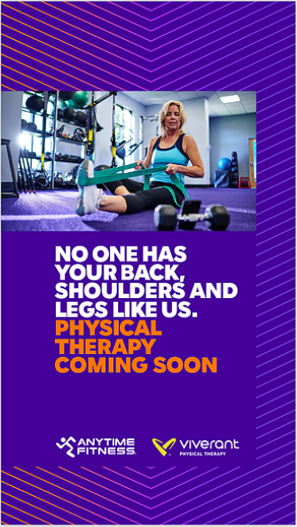

- Welcome Partner (for use about 6 weeks before the space is set to open):

“Welcome partner” social assets are available, with captions, in the SOCi library labeled based on your provider partner. Clubs will work with provider partners to provide photos for these assets.

The recommended messaging for this post is:

Welcome to our new recovery partner! We are proud to share that a [PARTNER NAME] location is coming soon in our club to serve our community and assist our members with sprains, strains or nagging pains. Click this link to schedule a free assessment: [insert scheduling link]

- Meet your provider (option to use about 4 weeks before the space is set to open, 1 week after the space is open, or both!):

“Meet your provider” social assets are available, with captions, in the SOCi library labeled based on your provider partner. Clubs will work with provider partners to provide photos for these assets. Additionally, customizable assets are available in the Brand Marketing Center

- Local
- Viverant
- Chiropractic Care
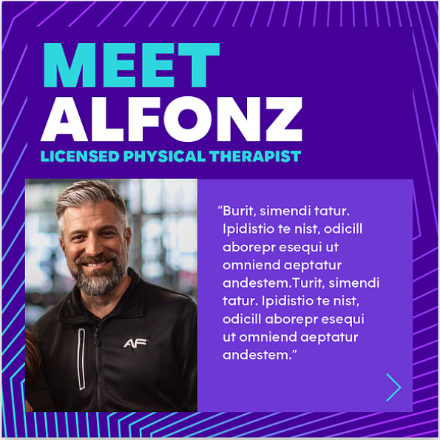

The recommended messaging for this post is:

Welcome, [PROVIDER NAME] to our great team here at Anytime Fitness [CLUB NAME]! [PROVIDER NAME] has joined us as the onsite [PROVIDER SERVICE] for [PARTNER NAME HERE], located in our club. [PROVIDER NAME] has [QUALIFICATIONS] and is here to help with any of your recovery needs."

- Join our event (use about 2 weeks, and the days leading up to, the grand opening of the provider space)
- Local  - Chiropractic care | - Viverant

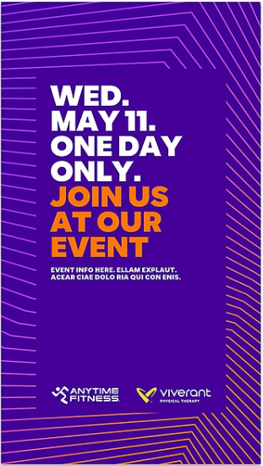
- Thank You for joining the event (recommended to share 1-2 days after the grand opening event)

"Thank you for joining our event” social assets are available, with captions, in the SOCi library labeled based on your provider partner. Clubs will work with provider partners to provide photos for these assets.

The recommended messaging for this post is:

A big Thank You! to all of the members of our AF community for helping us celebrate adding [PROVIDER PARTNER] to our location!

Blast e-mail templates:
Coming soon email templates (for use about 8 weeks before the space is set to open)
- AF-PhysicalTherapy-Local-ComingSoon
- AF-PhysicalTherapy-Viverant-ComingSoon

Meet your provider templates (option to use about 4 weeks before the space is set to open, after the space is open, or both!)
- AF-PhysicalTherapy-Local-MeetTherapist
- AF-PhysicalTherapy-Viverant-MeetTherapist

In-club assets:
Print - Flyers  - Local PT  - Viverant  - Chiropractic Care  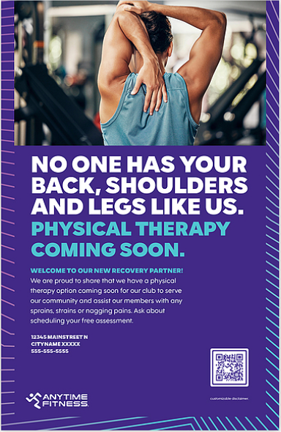 | Digital Screens (Horizontal)  - Local PT  - Viverant  - Chiropractic Care | Digital Screens (Vertical)  - Local PT  - Viverant  - Chiropractic Care  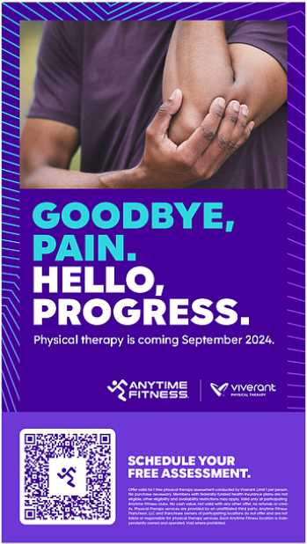

Provider “NOW AVAILABLE” Assets
It is recommended to start your “Now Available” as soon as the provider’s space opens and continue this marketing for 8-12 weeks (2-3 months) after the space has opened.

Social Media
  - Now available (to be used the day the provider space opens in the club)

“Welcome partner” social assets are available, with captions, in the SOCi library labeled based on your provider partner. Clubs will work with provider partners to provide photos for these assets.

Additionally, customizable assets are available in the Brand Marketing Center

- Local PT  - Chiropractic Care | - Viverant
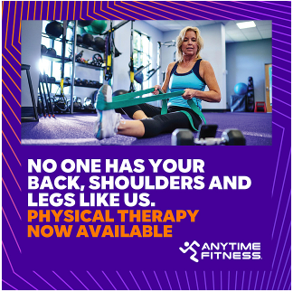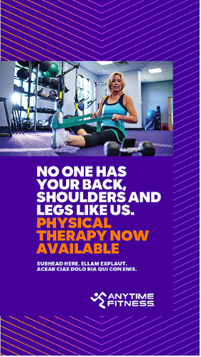
The recommended messaging for this post is:
Welcome to our new recovery partner! We are proud to share that an [PROVIDER PARTNER’S NAME] location has opened in our club to serve our community and assist our members with sprains, strains or nagging pains. Click this link to schedule a free assessment: (club insert their scheduling link)

  - Meet your provider (option to use about 4 weeks before the space is set to open, 1 week after the space is open, or both!):

“Meet your therapist” social assets are available, with captions, in the SOCi library labeled based on your provider partner. Clubs will work with provider partners to provide photos for these assets.

Additionally, customizable assets are available in the Brand Marketing Center
- Local PT
- Viverant
- Chiropractic Care


The recommended messaging for this post is:

Welcome, [PROVIDER NAME] to our great team here at Anytime Fitness [CLUB NAME]! [PROVIDER NAME] has joined us as the onsite [PROVIDER SERVICES] for [PARTNER NAME HERE], located in our club. [PROVIDER NAME] has [QUALIFICATIONS] and is here to help with any of your recovery needs.

Email
Now available email templates (for use upon the provider’s space opening in the club)
- AF-PhysicalTherapy-Local-NowAvailable
- AF-PhysicalTherapy-Viverant-NowAvailable

Meet your therapist templates (for use about 4 weeks before the space is set to open, after the space is open, or both!)
- AF-PhysicalTherapy-Local-MeetTherapist
- AF-PhysicalTherapy-Viverant-MeetTherapist

In-club assets: Print flyers
Now available:
- Local
- Viverant
- Chiropractic Care
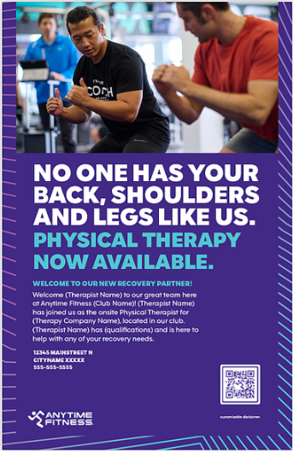

Meet therapist:
- Local
- Viverant
- Chiropractic Care
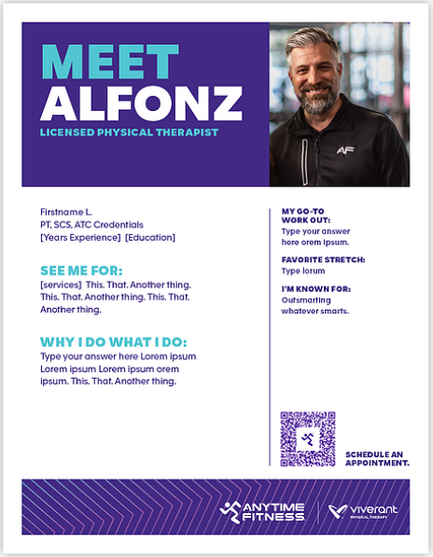

In-club assets: Digital signs (horizontal)
- Local
- Viverant
- Chiropractic Care

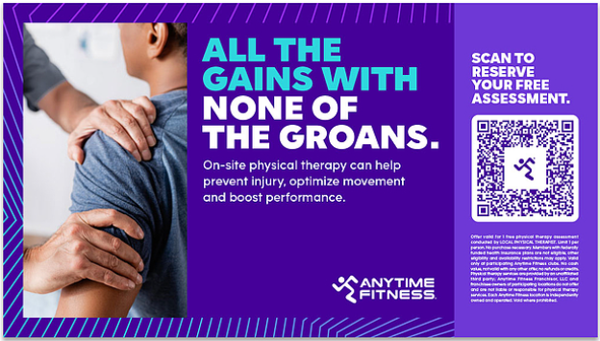

In-club assets: Digital signs (vertical)
- Local
- Viverant
- Chiropractic Care

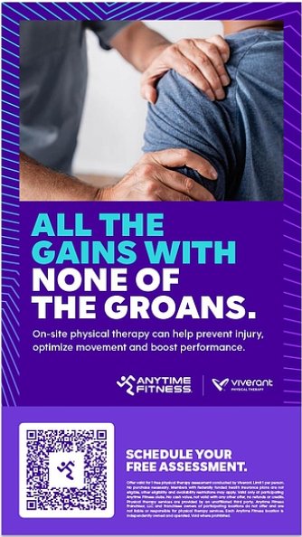

Ongoing Awareness

Social
Use these posts monthly to promote your provider program partnership within your club
- Social posts – Local PT
  - Benefits 1
  - Benefits 2
  - Benefits 3
  - Benefits 4
  - Benefits 5
  - Available 1
  - Available 2

- Social posts – Viverant
  - Benefits 1
  - Benefits 2
  - Benefits 3
  - Benefits 4
  - Benefits 5
  - Available 1
  - Available 2

- Social posts – Chiropractic Care
  - Feel the burn. Not the pain.
  - Turn your ows into oh, wows!

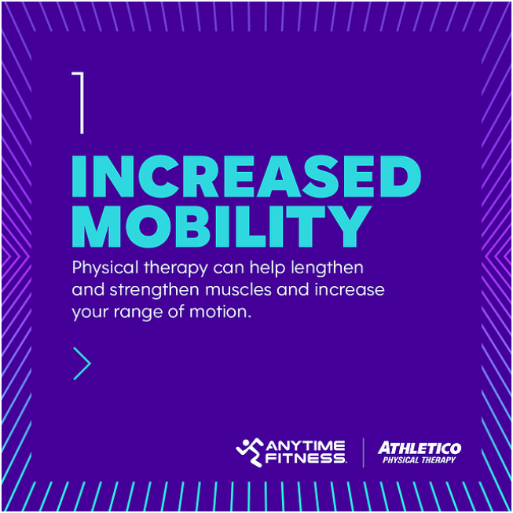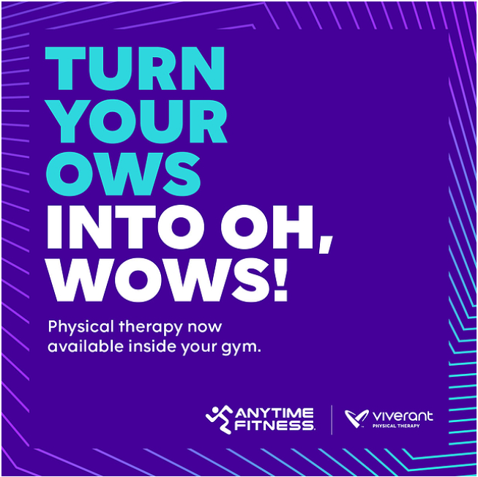

Additionally, showcase your local club provider and patients using these customizable social media assets in the Brand Marketing Center, after obtaining written consent from the patient. Written consent form:

- Meet your therapist
  - Local
  - Viverant
  - Chiropractic Care



- PT client spotlight
  - Local
  - Viverant
  - Chiropractic Care

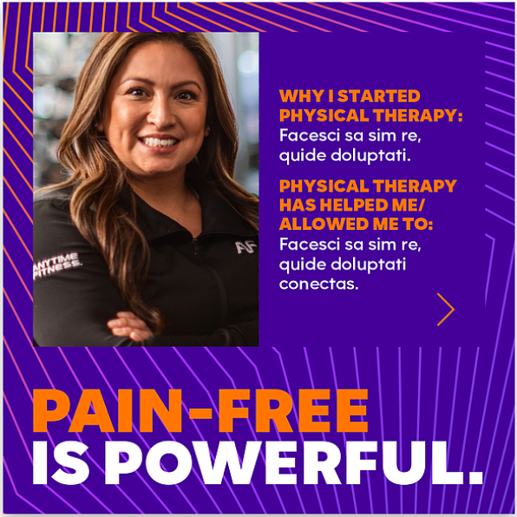

Email
- AF-PhysicalTherapy-Local-Steady
- AF-PhysicalTherapy-Viverant- Steady

In-Club Content
Digital – Use these assets (available to download in the Brand Marketing Center) to create awareness of and interest in your provider program:

Digital Screens (horizontal)
- Local
- Viverant
- Chiropractic Care

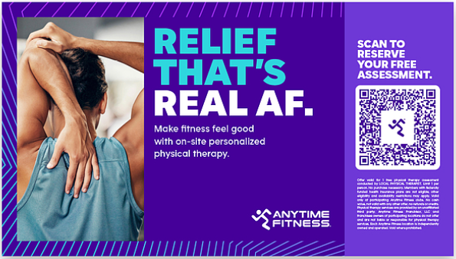

Digital Screens (vertical)
- Local
- Viverant
- Chiropractic Care

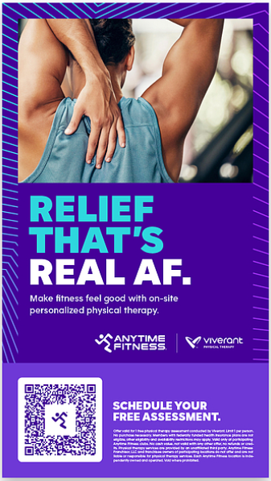

Cardio Screens
- Local
  - PreCor
    - 1024x768
    - 1024x600
  - Life Fitness
    - 1066x1038
    - 1066x768
- Viverant
  - PreCor
    - 1024x768
    - 1024x600
  - Life Fitness
    - 1066x1038
    - 1066x768
- Chiropractic Care
  - PreCor
    - 1024x768
    - 1024x600
  - LifeFitness
    - 1066x1038
    - 1066x768
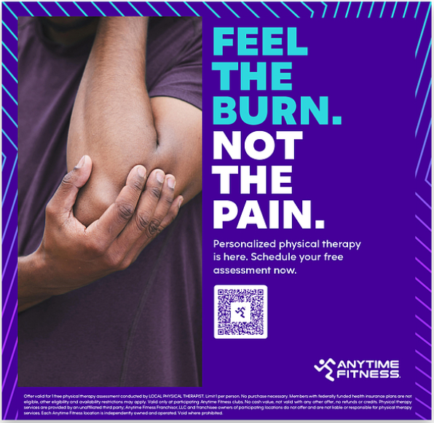

Print Assets
- Sidewalk sign
- Local
- Viverant
- Chiropractic

- Flyers
- Local
- Viverant
- Chiropractic

- Window Cling
- Local
- Viverant
- Chiropractic

Timeline Recap

