INSERT PROVIDER LOGO HERE

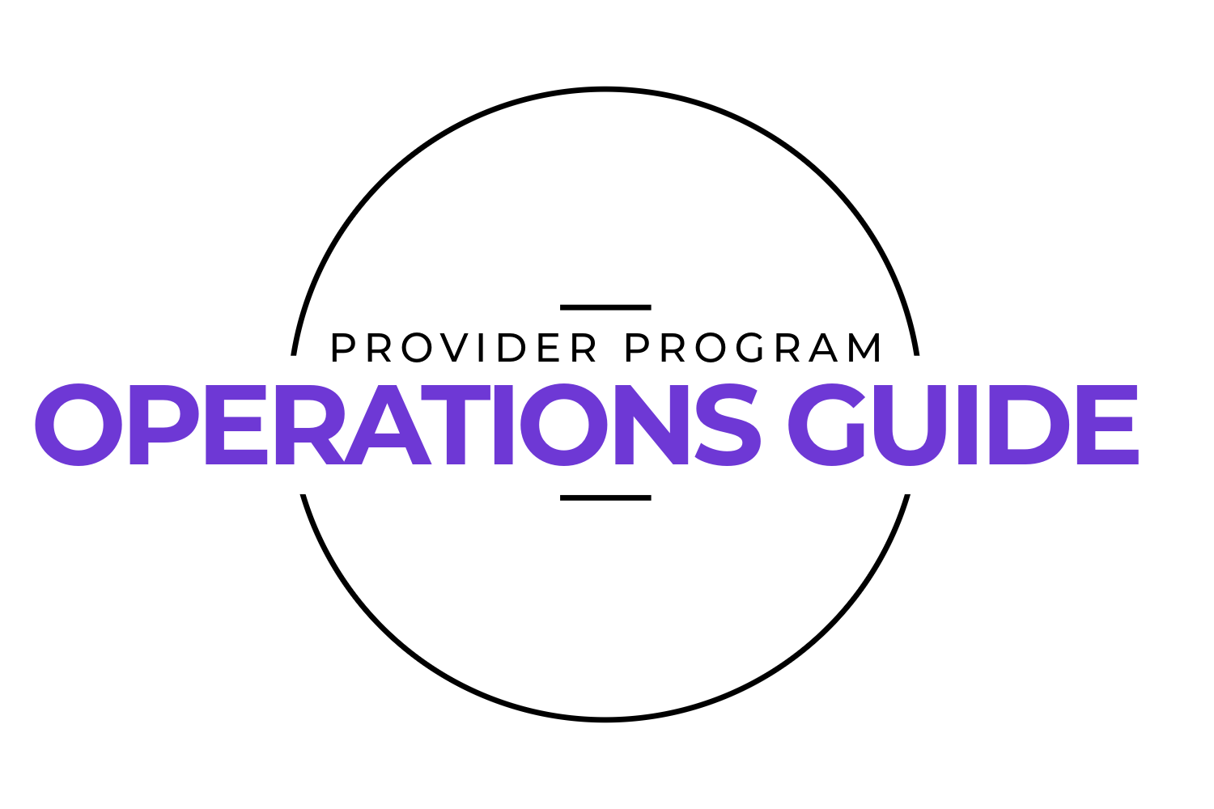

Welcome to the Anytime Fitness family!
This guide is for xxx company team members to review helpful information about club operations and to find alignment in the Provider Program.

We are excited to have you in our club and look forward to a great working relationship.

XXX COMPANY TEAM MEMBERS
- XXX employees will have full access to the club 24/7/365. It is not recommended to use the key at other Anytime Fitness’s without discussing with owners.
  - NOTE: Other AF locations can request to charge you for a membership as they are independently owned & operated.

- We ask that your personal workouts be outside of busy/peak hours as best you can and without clients or patients of either business, avoiding any conflicts of interests knowing the services we provide.

- Please do not share your key and/or tailgate family members or friends, this key is solely used for yourself. If you have special requests for a guest, please see the office.

- AF Education: we request any team member working in the club completes two educational courses to better understand the AF brand and training programs; this will give you an understanding of the hand off if/when referrals occur.
  - COURSE: COACH’S GUIDE TO THE AF BRAND:
https://360.articulate.com/review/content/dbbe07b6-99a8-4ccc-b6c5-f10603b39955/review
Password: anytime123
- COURSE: INTRODUCTION TO AF TRAINING
https://360.articulate.com/review/content/1ed852ed-fd35-4388-9a80-c512d6eb7fa2/review
Password: anytime123
- Use of equipment; we do ask Providers to respect and take care of all gym equipment including wiping down after sessions with towels & sanitizers provided.

- Cleaning room and staff Room: XXX employees have full access to our facility including the cleaning room for any supplies you may need & the staff break room for the use of the coffee machine, fridge, & microwave.

- XXX will maintain cleanliness of their own office including any regular disposal of trash.

- XXX employees as well as AF, will speak highly of both businesses and refer to one another when determining best practices, celebrating, and problem solving.

- AF Bi-Weekly meetings: our team at AF request Providers to join our bi-weekly staff meeting for any updates regarding referrals that we can both discuss amongst the team. (EDIT TO FIT YOUR MEETING CADENCE)

PHYSICAL THERAPY PATIENTS

- Active XXX Patients will be set up with a complimentary membership with a key fob. The key allows 24/7 Access & is only active at our location; the key will be returned at the end of the patient’s plan care of care with their Provider.
- All XXX patients will be required to complete a club liability waiver prior to any appointments with their Provider.
- We welcome XXX patients to use the facility for their personal workouts outside of therapy sessions & we will have Personal Training Packages available to them at any time. Once they are no longer a patient, they will have the opportunity for discounted memberships with us to continue their 24/7 full access. Please refer them to the office during office hours for more information.

- Tailgating (Sharing of keys) by patients will not be permitted. If patients share their key, AF will deactivate it for further use.



CLUB NAME

Address: CLUB ADDRESS

Club Email: CLUB EMAIL

Club Phone: CLUB PHONE

Website: CLUB WEBSITE

Staffed/Office Hours
Monday 10:00-2:00pm & 4:00-6:00pm
Tuesday 10:00-2:00pm & 4:00-6:00pm
Wednesday 10:00-2:00pm & 4:00-6:00pm
Thursday 10:00-2:00pm & 4:00-6:00pm
Friday 10:00-1:00pm
Saturday 10:00-1:00pm

Owner Contacts;
XXX

Staff Contacts;
XXX

