Third strategy : do genomic assembly on reads mapped to only one region (the Rian locus in the mouse genome)

Why the Rian locus ?

I - Get the data
I extracted the barcodes from reads mapped against the AAV vector sequence. Then I extracted reads from the mapping results against the mouse genome sharing the same barcodes. I gathered all the reads and converted the BAM file to FASTQ format. Forward and reverse reads have been separated into two compressed FASTQ files : R1 and R2 with samtools fastq. It is necessary to sort paired read alignment BAM file by name before conversion.

A) Sample 152

Total number of reads : 22 235 R1 + 22 235 R2 reads (44 470 paired reads) for sample 152

II - Read quality control on input reads
It’s done by FastQC which runs a standard series of tests on your read set and returns a report on the quality.

A) Basic statistics

1) Sample 152

Sequence length is heterogeneous : the shortest sequence in the set is 27 bp and the longest is 151 bp. A module displays the sequence length distribution : it generates a graph showing the distribution of fragment sizes in the two files which were analyzed.

For R1 (forward) reads
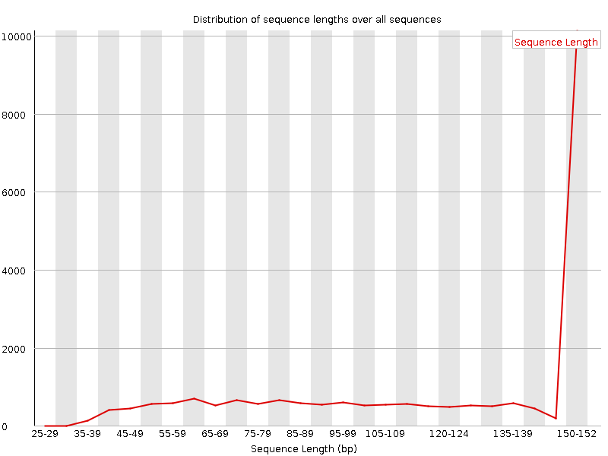

For R2 (reverse) reads
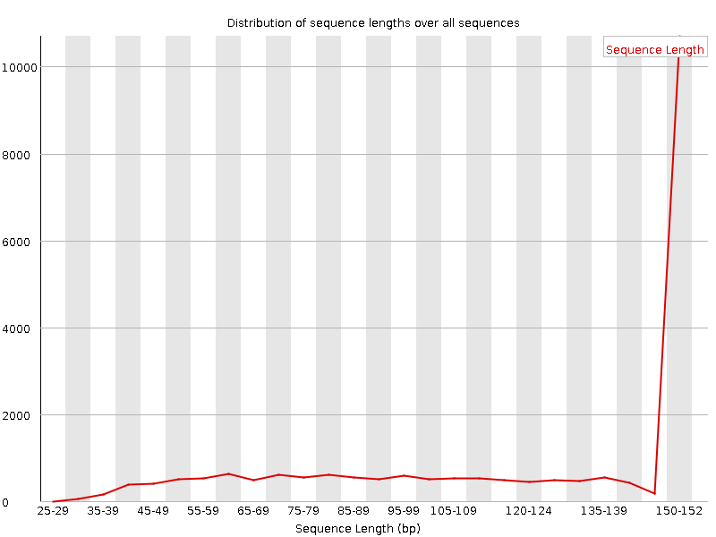
This module raised a warning because all sequences are not the same length. Given the fact that these sequences came from the BAM alignment file after barcode filtering and error correction by the Tell-Seq (tell-read module) pipeline, it’s normal that this file contains reads of wildly varying lengths.

Question : is it normal ? Because the Tell-read module doesn’t trim read just remove erroneous barcodes. Need to check the sequence length of reads in the paired-end sequencing FASTQ files. Even within uniform length libraries some pipelines will trim sequences to remove poor quality base calls from the end. Is it better to start this analysis from FASTQ files and not BAM files ?

B) Per base sequence quality

1) Sample 152

This view shows an overview of the range of quality values across all bases at each position in the FASTQ file. For each position a BoxWhisker type plot is drawn. The elements of the plot are as follows:
- The central red line is the median value
- The yellow box represents the inter-quartile range (25-75%)
- The upper and lower whiskers represent the 10% and 90% points
- The blue line represents the mean quality
The y-axis on the graph shows the quality scores. The higher the score the better the base call. The background of the graph divides the y axis into very good quality calls (green), calls of reasonable quality (orange), and calls of poor quality (red). The quality of calls on most platforms will degrade as the run progresses, so it is common to see base calls falling into the orange area towards the end of a read.
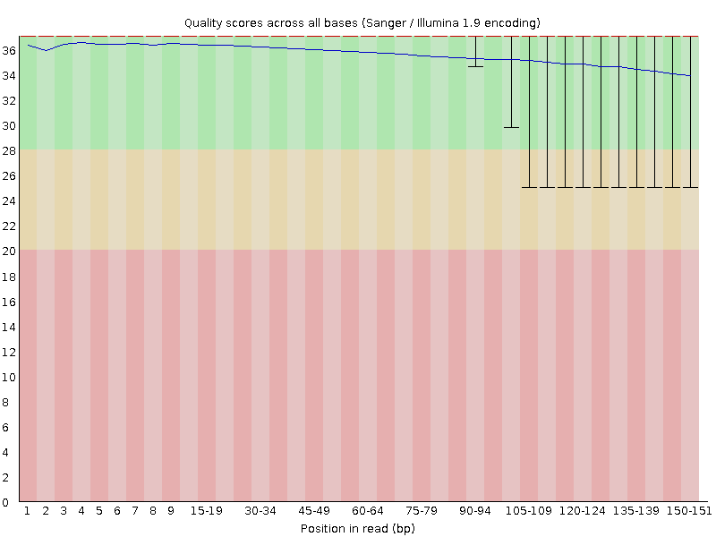
In the plot, we see that the most of the bases are up around 34-36, which is very high quality. The spread of quality values for the last few bases decreases around 32-34 with some outliers above 25. This is a very good quality dataset. Because 20 is often used as a cutoff for reliable quality.

Comment : no warning here because a warning will be issued if the lower quartile for any base is less than 10, or if the median for any base is less than 25.

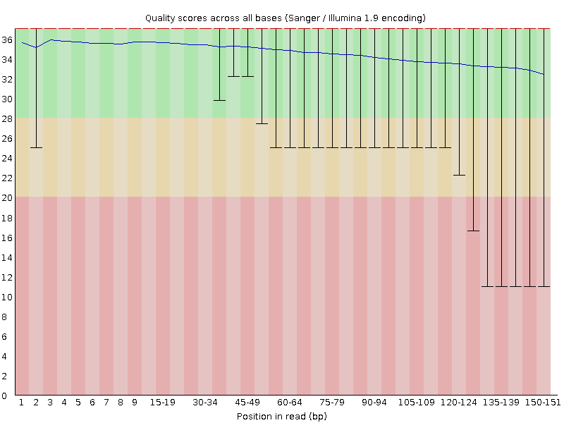
For reverse reads (R2), there is some outliers in the early bases in the beginning at 25. In the plot, we see that most of the bases are up around 34-36, then the spread of quality values decrease slowly to 32 towards the end of the read, which is very high quality. In the second half of the plot, some of the outliers are below the 28 mark and then it decrease more and some outliers are around 10 in the red background, which is very bad quality.

Conclusion : the reads associated with these very bad quality values towards the end of the reads need to be removed for the downstream analysis by trimming/cleaning methods.

C) Per Base Sequence Content

Plots out the proportion of each base position in a file for which each of the four normal DNA bases has been called. What is expected ? In a random library you would expect that there would be little to no difference between the different bases of a sequence run, so the lines in this plot should run parallel with each other. The relative amount of each base should reflect the overall amount of these bases in your genome, but in any case they should not be hugely imbalanced from each other. If you see strong biases which change in different bases then this usually indicates an over represented sequence which is contaminating your library. A bias which is consistent across all bases either indicates that the original library was sequence biased, or that there was a systematic problem during the sequencing of the library.

1) Sample 152

For R1 (forward) reads, in the first ten positions of the reads, we can see a huge imbalanced proportion from each different base. The difference between A and T or G and C is greater than 20 % in these early positions. It doesn’t reflect the overall amount of these bases in the genome even if here it’s just a part of if (Rian locus). There are strong biases which change in different bases so this usually indicates an over represented sequence which is contaminating the library. After that, there are no big difference between the different bases becauses the lines in this plot are parallel with each other until the end of the reads.
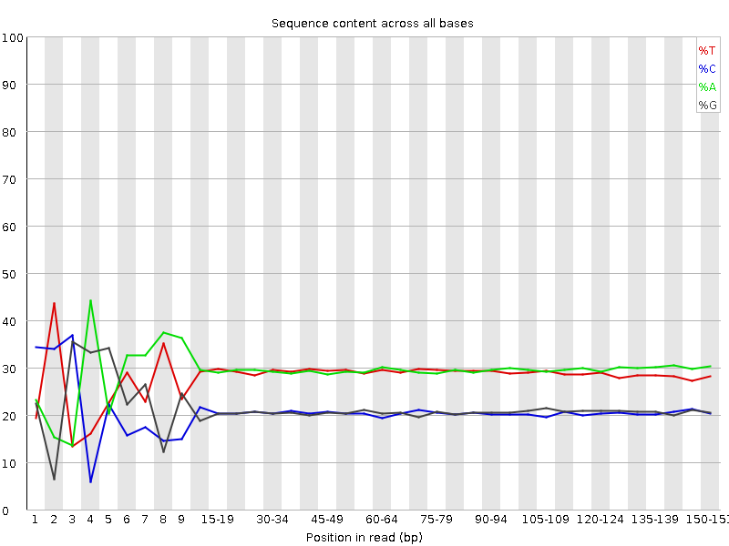

For R2 (reverse) reads, in the first ten positions of the reads, we can see a huge imbalanced proportion from each different base. The difference between A and T is greater than 10 % and the difference between G and C is greater than 20 % or more in these early positions. It’s the same result than for forward reads with these strong biases. So it’s probable that there are is over represented sequence which is contaminating the library. After that, there is no big difference between the different bases because the lines in this plot are parallel with each other except towards the end where we can see a little difference between G and C. The difference is less than 10 %.
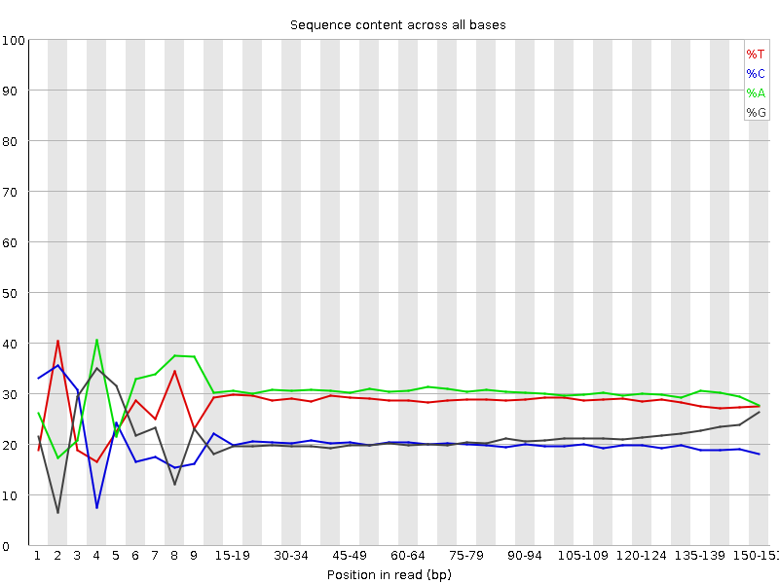
These results seem to be concordant with what was found in the overrepresented sequences module.

D) Overrepresented sequences

1) Sample 152

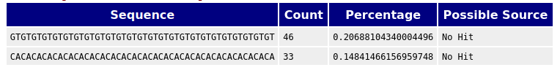
R1 reads

R2 reads
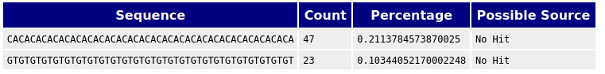
This module will issue a warning if any sequence is found to represent more than 0.1% of the total. It’s the case here for R1 and R2 reads : [GT] and [CA] were found several times. They looked like repeat elements.

E) Per Sequence GC Content

1) Sample 152

This module measures the GC content across the whole length of each sequence in a file and compares it to a modelled normal distribution of GC content. The central peak corresponds to the overall GC content of the underlying genome. Since we don't know the GC content of the genome the modal GC content is calculated from the observed data and used to build a reference distribution.

The overall %GC of all bases in all sequences of these files is 41 % (R1 reads) and 40 % (R2 reads).
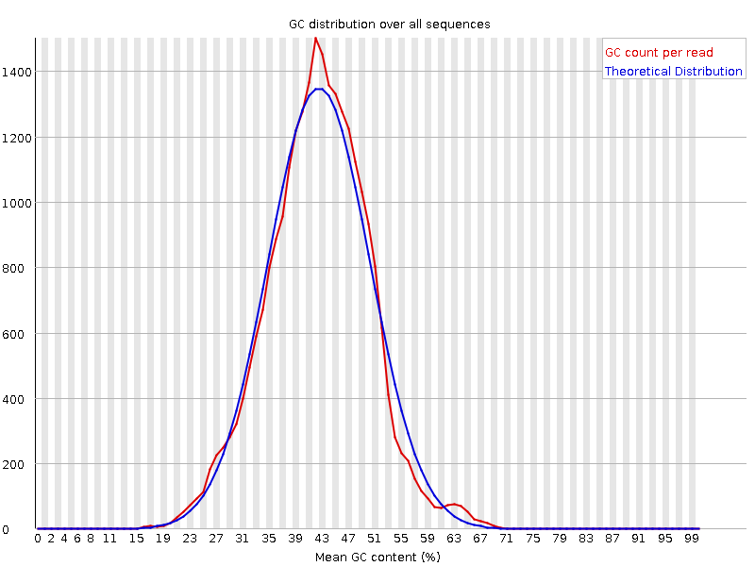
We can see a roughly normal distribution of GC content. There is no big deviation from the normal distribution. This is the same result for the R2 (reverse) reads.
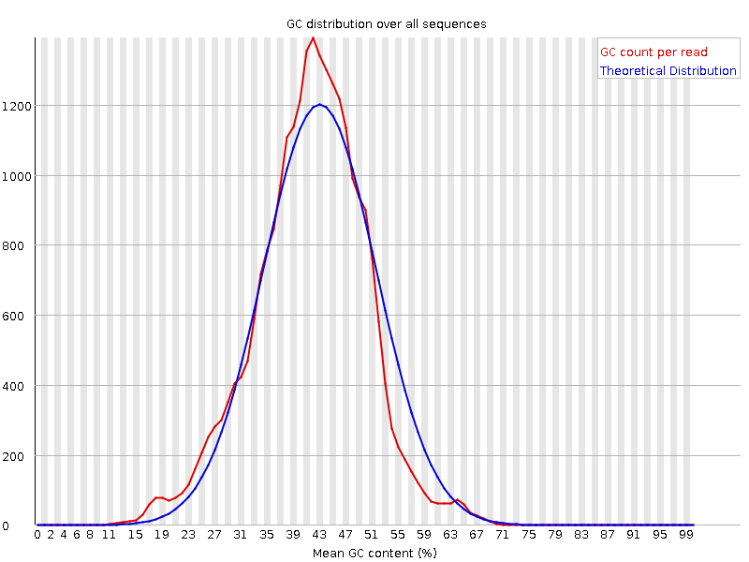

F) Per Base N content

If a sequencer is unable to make a base call with sufficient confidence then it will normally substitute an N rather than a conventional base call. This module plots out the percentage of base calls at each position for which an N was called.

It's not unusual to see a very low proportion of Ns appearing in a sequence, especially nearer the end of a sequence. However, if this proportion rises above a few percent it suggests that the analysis pipeline was unable to interpret the data well enough to make valid base calls.

1) Sample 152

Here, the results suggest that no N appears in these sequences. So, the analysis pipeline seems to be able to interpret the data well enough.
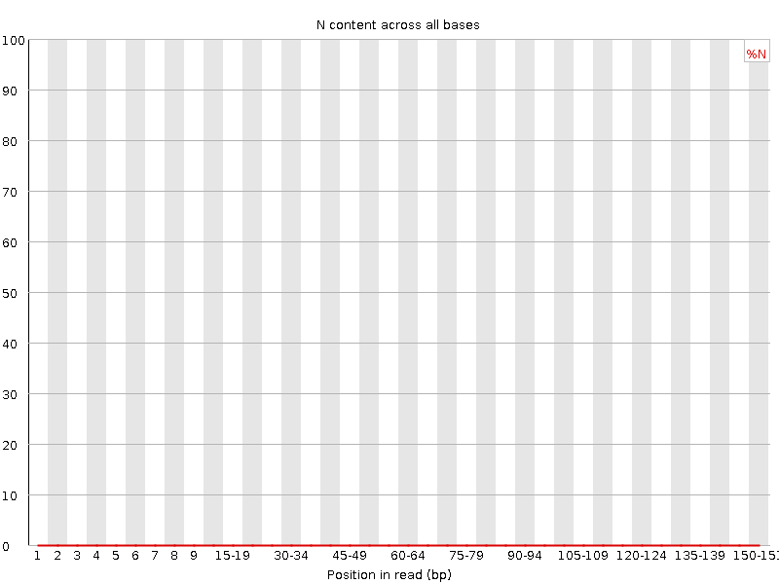

G) Sequence Duplication Levels

A low level of duplication may indicate a very high level of coverage of the target sequence, but a high level of duplication is more likely to indicate some kind of enrichment bias (PCR over amplification).

This module counts the degree of duplication for every sequence in the set and creates a plot showing the relative number of sequences with different degrees of duplication.

1) Sample 152
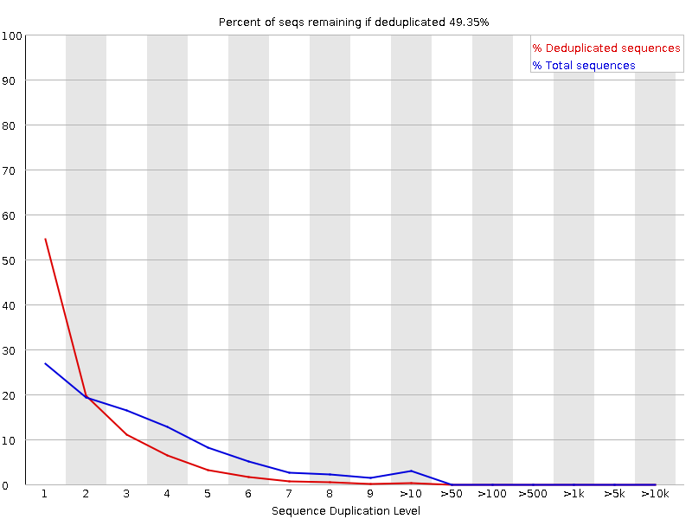

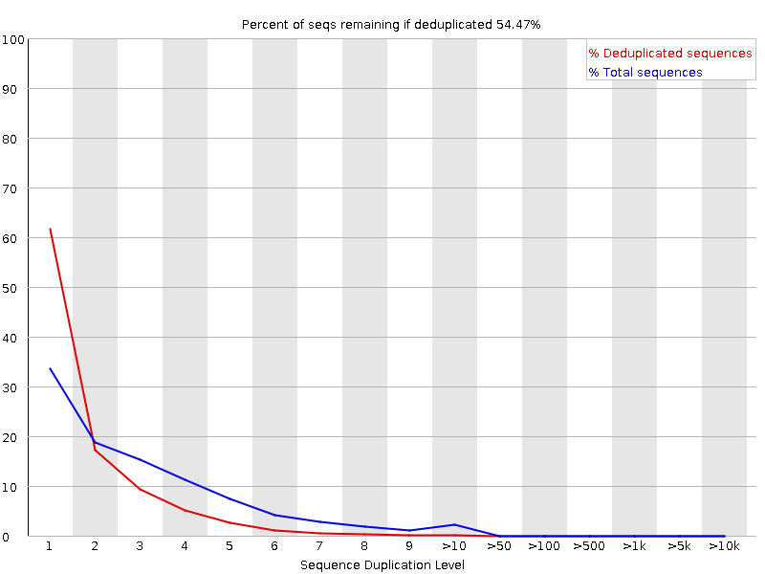

Here the module raised an error because non-unique sequences make up more than 50 % of the total (49.35 % for R1 reads and 54.47 % for R2 reads).

III - Quality trimming/cleanup of read files if necessary

To improve the overall quality before assembly, we need to remove some low quality and very short reads. We will use Trimmonatic which can handle paired-end reads. If one of the ends of a pair is removed, the orphaned read needs to be put into a separate « orphaned reads » file. It has several functions but one of them is to trim bases from the start or end of a read if they drop below a quality threshold. FastQC allows us to choose a quality threshold based on the report on input reads. One of the other functions is to be sure that after trimming steps the reads are longer than a certain threshold (based on high quality section of Per base sequence quality graph).

In the ‘Per Base Sequence Content’ graph in FastQC report, there was a huge imbalanced proportion between A and T or G and C up to 30 % in the first ten positions of the reads. It corresponds to two over represented sequences : [CA] and [GT]. To be removed or not ?

Run Trimmomatic on Galaxy with these parameters :
- Sliding window trimming : default (number of bases to average across : 4 ; average quality required : 20)
- Cut bases off the start of a read, if below a threshold quality : 20
- Cut bases off the end of a read, if below a threshold quality : 20
- Drop reads below a specified length : 20
- Cut the specified number of bases from the start of the read : 10

Run again a FastQC on the reads trimmed to check if it needs more trimming or not !

A) Sample 152

We saw that some reads have very bad quality values towards the end of the sequence in R2 FASTQ file. And the sequence length is heterogeneous (27 to 151 bp).

It generates two files : one with paired reads and another with « orphaned » reads. For R1, there is 20 601 paired + 1379 « orphaned » reads. And for R2, there is 20 601 paired + 174 « orphaned » reads. The rest of the reads have been removed for the downstream analysis.

After running again FastQC on trimmed reads, here the results :

- For R1 reads, the sequence length is between 20 and 141 bp. The spread of quality values is above 34. There is no imbalanced proportion between the different bases. The two over represented sequences found in the first report aren’t there anymore but another one appears.

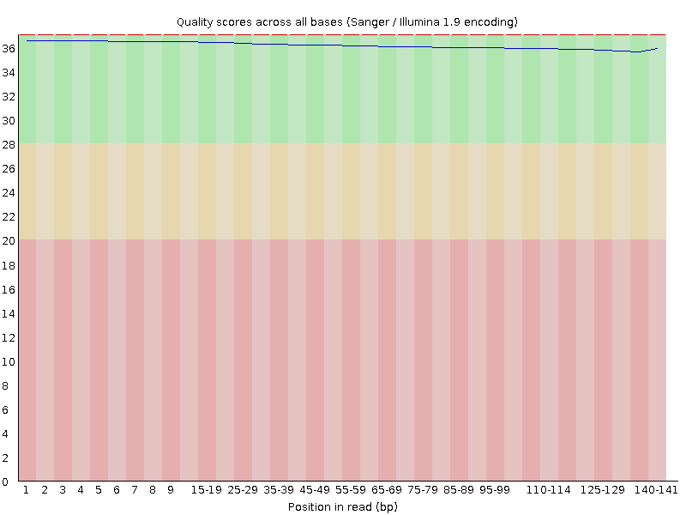

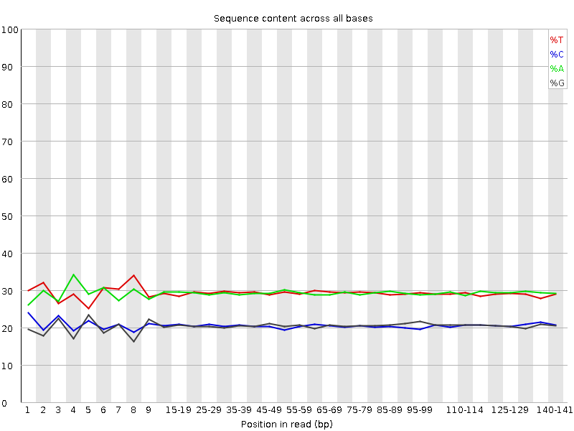

- For R2 reads, the sequence length is between 20 and 141 bp. The spread of quality valued is above 34. Some of the outliers towards the end of the reads are below the 28 mark. One of the two over represented sequences found in the first report aren’t here anymore but another appears.
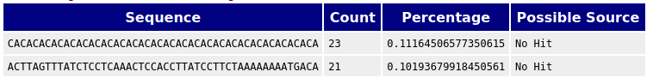
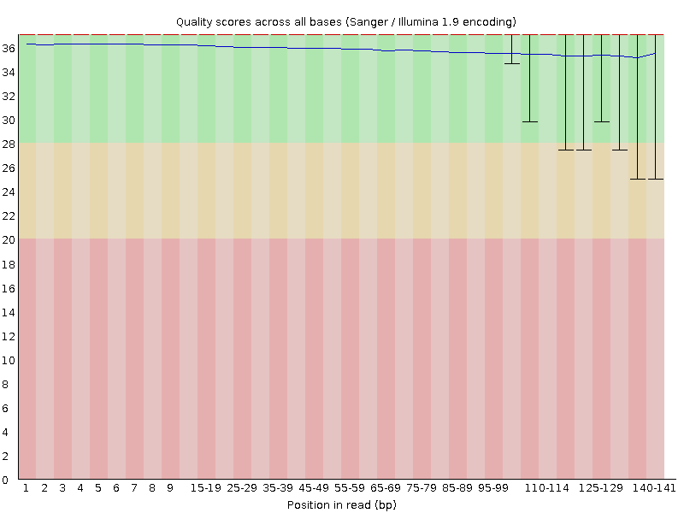

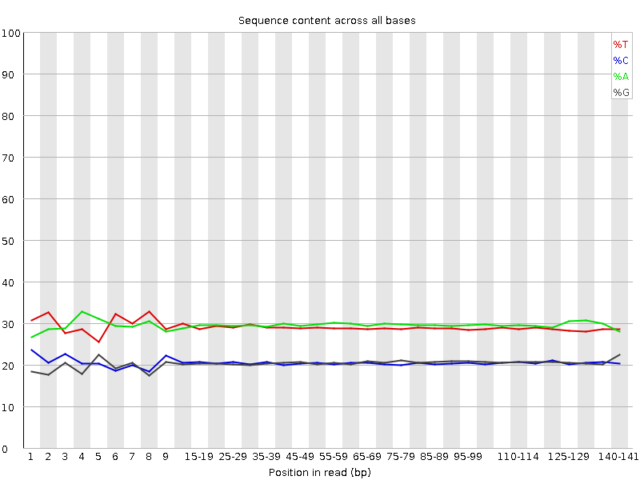

IV – Assemble reads into contigs/scaffolds

The aim here is to assemble the trimmed reads into contigs/scaffolds using Velvet and the Velvet Optimizer. Velvet Optimizer performs many Velvet assemblies in a fast and automatic manner for all datasets with various parameter sets and searches for the optimal assembly automatically.

To choose a k-mer size search range, we can look at the FastQC report and see where the quality of the reads starts to drop off and going just a bit higher can be a good end value.

Run Velvel Optimizer on Galaxy with these parameters :
- Paired : R1 and R2 paired and trimmed data
- Single : R1 unpaired and trimmed data
- Single : R2 unpaired and trimmed data

We need to add the reads in two separate libraries. One for the still paired reads and the other for the singleton reads orphaned from their pairs by the trimming process.

