A) Notes to use the `product_catalog` and `product_price` service:

1) Import the `ProductCatalogService` in to Eclipse IDE.

Mvn eclipse:clean eclipse:eclipse

2) Import the `ProductPriceService` in to Eclipse IDE.
Mvn eclipse:clean eclipse:eclipse

- Add a new server to Eclipse IDE. Tomcat 7 is used for this demo.

- Deploy both the applications to tomcat and start the server.

- The solution is implemented as web service and services will be available in the below URL.

ProductCatalogService URL:
http://localhost:8080/inboundws-pcatalog-adapter/org/nfjs/springws/productcatalog/ProductsCatalog.wsdl
ProductPriceService URL:
http://localhost:8080/product-price-services/org/nfjs/springws/productprice/ProductsPrice.wsdl

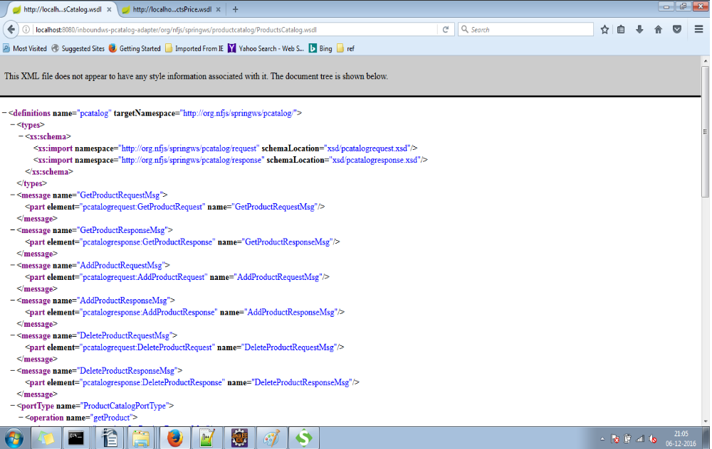

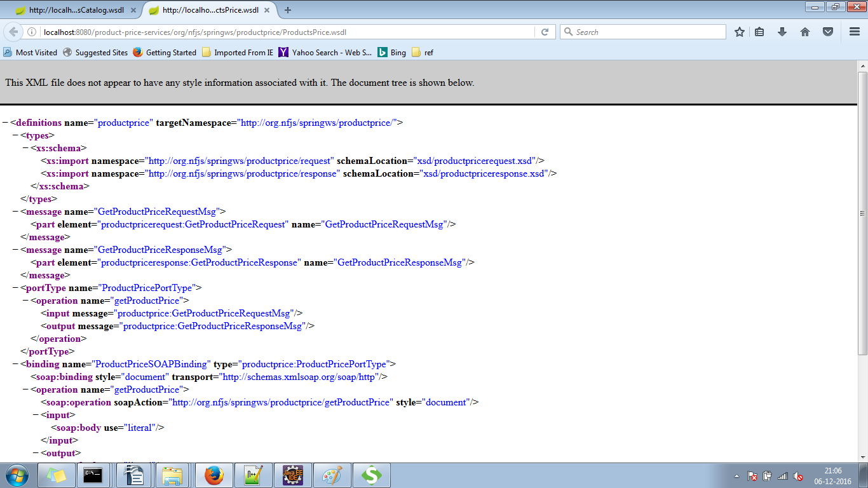

B) Working flow explanation:

    - The Product catalog service can be used to `add/delete/get` the products `to/from` product catalog database.
    - The Product price service helps to get the price of the product given in request. For demo, the service will fix a default price for products.
    - But for the product already added to product catalog using `Product catalog service`, the discount will be applied on the total price.

C) Sample Requests and Response:

The above listed service URL can be imported in SOAP UI tool to test the request and response.

1) Add New Product to Catalog - Request:

<soapenv:Envelope xmlns:soapenv="http://schemas.xmlsoap.org/soap/envelope/" xmlns:req="http://org.nfjs/springws/pcatalog/request">
<soapenv:Header/>
<soapenv:Body>
<req:AddProductRequest>
<Product>mobile</Product>
<ProductCategory>electronics</ProductCategory>
</req:AddProductRequest>
</soapenv:Body>
</soapenv:Envelope>

Add New Product – Response:

<SOAP-ENV:Envelope xmlns:SOAP-ENV="http://schemas.xmlsoap.org/soap/envelope/">
<SOAP-ENV:Header/>
<SOAP-ENV:Body>
<ns3:AddProductResponse xmlns:ns3="http://org.nfjs/springws/pcatalog/response">
<Product>mobile</Product>
<ProductCategory>electronics</ProductCategory>
<StatusMessage>mobile added successfully to catalog</StatusMessage>
</ns3:AddProductResponse>
</SOAP-ENV:Body>
</SOAP-ENV:Envelope>

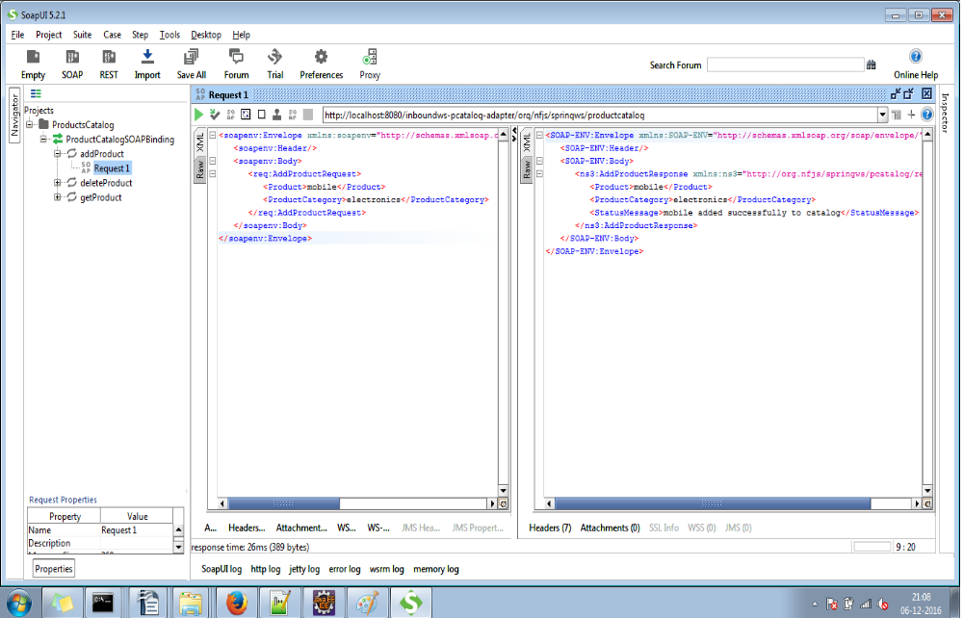
- Get Product - Request:

<soapenv:Envelope xmlns:soapenv="http://schemas.xmlsoap.org/soap/envelope/" xmlns:req="http://org.nfjs/springws/pcatalog/request">
<soapenv:Header/>
<soapenv:Body>
<req:GetProductRequest>
<ProductCategory>electronics</ProductCategory>
</req:GetProductRequest>
</soapenv:Body>
</soapenv:Envelope>

Get Product – Response:

<SOAP-ENV:Envelope xmlns:SOAP-ENV="http://schemas.xmlsoap.org/soap/envelope/">
<SOAP-ENV:Header/>
<SOAP-ENV:Body>
<ns3:GetProductResponse xmlns:ns3="http://org.nfjs/springws/pcatalog/response">
<ProductCategory>electronics</ProductCategory>
<ProductsList>
<Products>
<ProductName>mobile</ProductName>
</Products>
</ProductsList>
</ns3:GetProductResponse>
</SOAP-ENV:Body>
</SOAP-ENV:Envelope>

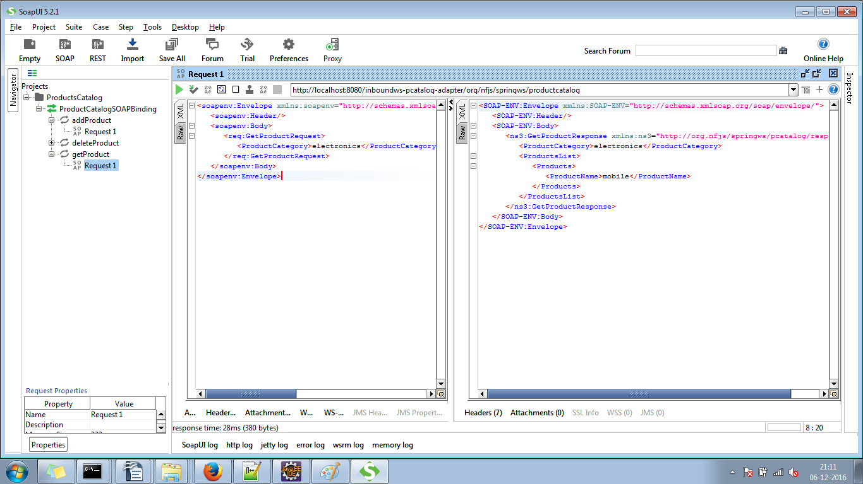
- Delete Product – Request:

<soapenv:Envelope xmlns:soapenv="http://schemas.xmlsoap.org/soap/envelope/" xmlns:req="http://org.nfjs/springws/pcatalog/request">
<soapenv:Header/>
<soapenv:Body>
<req:DeleteProductRequest>
<Product>mobile</Product>
<!--Optional:-->
<ProductCategory>electronics</ProductCategory>
</req:DeleteProductRequest>
</soapenv:Body>
</soapenv:Envelope>

Delete Product Response:

<SOAP-ENV:Envelope xmlns:SOAP-ENV="http://schemas.xmlsoap.org/soap/envelope/">
<SOAP-ENV:Header/>
<SOAP-ENV:Body>
<ns3:DeleteProductResponse xmlns:ns3="http://org.nfjs/springws/pcatalog/response">
<Product>mobile</Product>
<StatusMessage>mobile deleted successfully from catalog</StatusMessage>
</ns3:DeleteProductResponse>
</SOAP-ENV:Body>
</SOAP-ENV:Envelope>

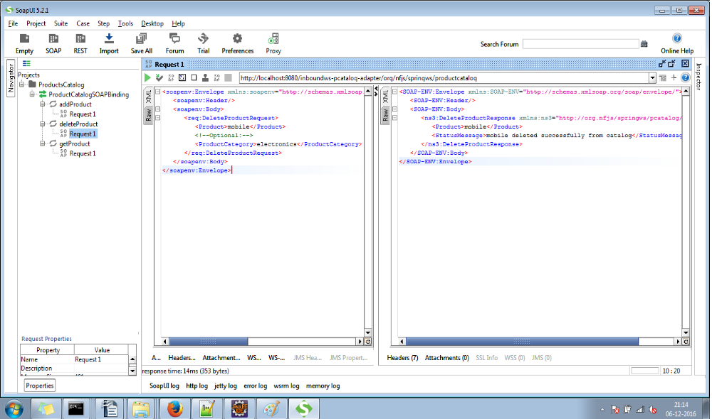

- Get Product Price - Request:

Before that we will add a new product named `laptop` in category computers as below.

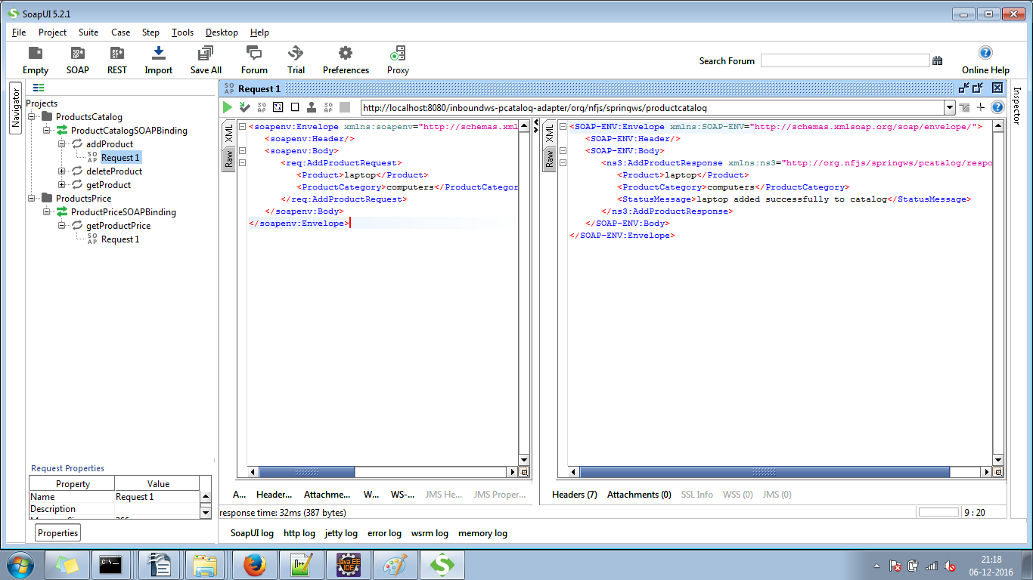

Now, we will get the price of product `laptop` which is already added to product catalog.
Discount will be applied on the total price.

Request:
<soapenv:Envelope xmlns:soapenv="http://schemas.xmlsoap.org/soap/envelope/" xmlns:req="http://org.nfjs/springws/productprice/request">
<soapenv:Header/>
<soapenv:Body>
<req:GetProductPriceRequest>
<Product>laptop</Product>
<ProductCategory>computers</ProductCategory>
</req:GetProductPriceRequest>
</soapenv:Body>
</soapenv:Envelope>

Response:
<SOAP-ENV:Envelope xmlns:SOAP-ENV="http://schemas.xmlsoap.org/soap/envelope/">
<SOAP-ENV:Header/>
<SOAP-ENV:Body>
<ns3:GetProductPriceResponse xmlns:ns3="http://org.nfjs/springws/productprice/response">
<Product>laptop</Product>
<ProductPrice>90</ProductPrice>
<Currency>INR</Currency>
<DiscountOfferMessage>30 INR : Discount applied from product catalog</DiscountOfferMessage>
</ns3:GetProductPriceResponse>
</SOAP-ENV:Body>
</SOAP-ENV:Envelope>

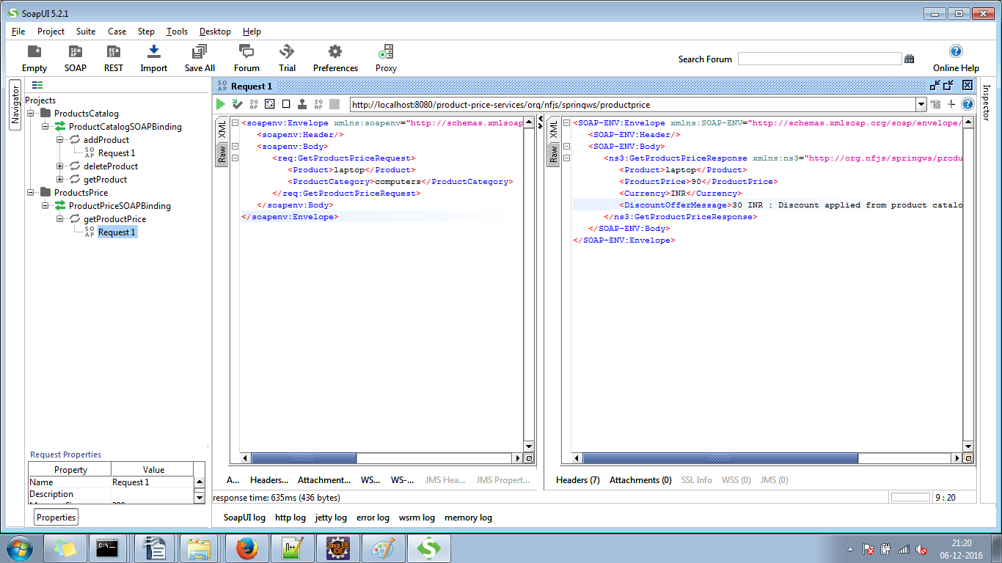

Now, we will get the price of product `desktop` which is not in product catalog.
In this case, discount is not applied on the price of product.

Request:

<soapenv:Envelope xmlns:soapenv="http://schemas.xmlsoap.org/soap/envelope/" xmlns:req="http://org.nfjs/springws/productprice/request">
<soapenv:Header/>
<soapenv:Body>
<req:GetProductPriceRequest>
<Product>desktop</Product>
<ProductCategory>computers</ProductCategory>
</req:GetProductPriceRequest>
</soapenv:Body>
</soapenv:Envelope>

Response:

<SOAP-ENV:Envelope xmlns:SOAP-ENV="http://schemas.xmlsoap.org/soap/envelope/">
<SOAP-ENV:Header/>
<SOAP-ENV:Body>
<ns3:GetProductPriceResponse xmlns:ns3="http://org.nfjs/springws/productprice/response">
<Product>desktop</Product>
<ProductPrice>120</ProductPrice>
<Currency>INR</Currency>
<DiscountOfferMessage>Product not eligible for discount</DiscountOfferMessage>
</ns3:GetProductPriceResponse>
</SOAP-ENV:Body>
</SOAP-ENV:Envelope>

