Data Analytics Capstone
Synopsis
Early Detection of Coronary Heart Disease Using Machine Learning

Vinaya Bhushan M
Walsh College
QM640: Data Analytics Capstone
Mentor: Vikas S
April 2026

1. Introduction

1.1 Background and Context
Coronary Heart Disease (CHD) is one of the leading causes of death worldwide. It occurs when the coronary arteries that supply blood to the heart muscle become narrowed or blocked due to the build-up of fatty deposits, known as atherosclerosis. According to the Centers for Disease Control and Prevention (CDC, 2023), heart disease is the number one cause of death in the United States, claiming approximately 695,000 lives each year. Globally, the World Health Organization estimates that cardiovascular diseases account for 17.9 million deaths annually, with CHD being the single largest contributor.
What makes CHD particularly dangerous is that it often develops silently over many years. By the time symptoms such as chest pain, shortness of breath, or a heart attack appear, the disease has already reached an advanced stage. Early detection is therefore critical. Identifying high-risk patients before symptoms develop allows clinicians to intervene with lifestyle changes, medication, or preventive procedures that can significantly reduce mortality risk. However, early-stage CHD diagnosis typically requires specialist involvement and expensive tests such as coronary angiography or stress echocardiography, resources that are not readily available in primary care settings or in lower-resource environments.
Over the last decade, machine learning (ML) has emerged as a powerful tool in healthcare, particularly for pattern recognition in clinical data. Research has shown that well-trained ML models can achieve diagnostic sensitivity and specificity above 90% for cardiac conditions, making them genuinely useful for supporting clinical decisions (Rahhal et al., 2024). This project explores whether similar ML techniques can be applied to routine clinical data to flag high-risk patients earlier, without requiring expensive imaging upfront.
The study sits within the healthcare domain, focusing on supervised classification using structured clinical data. The stakeholders who would benefit most include primary care physicians, cardiologists, and hospital administration teams looking to improve screening workflows and reduce diagnostic delays.

1.2 Problem Statement
Despite the availability of clinical risk indicators, Coronary Heart Disease is frequently diagnosed late because routine patient data — including resting blood pressure, cholesterol levels, maximum heart rate, and ECG readings — is not being systematically used for early risk prediction at the primary care level. Specialist-dependent diagnostics such as angiography are costly, time-consuming, and unavailable in many settings, creating a diagnostic gap where high-risk patients are missed at the point of first contact.
This study addresses that gap by investigating whether supervised machine learning models trained on standard clinical features can reliably identify CHD at an early stage. The objective is to develop a data-driven screening tool that supports clinicians in prioritising patients for further cardiac investigation, without requiring specialist resources upfront.

1.3 Purpose of the Study
The purpose of this study is to develop and evaluate machine learning classification models for early CHD detection using structured clinical data. Specifically, the study sets out to identify which clinical features are most predictive of CHD, determine which ML algorithm performs best for this classification task, assess whether there are statistically meaningful differences between CHD-positive and CHD-negative patients, and examine how gender affects both the clinical patterns and the model's reliability. The findings are intended to be practically useful, not just academically interesting.

2. Scope and Research Questions
The study uses the UCI Machine Learning Repository Heart Disease Dataset, which combines clinical records from four international centres: Cleveland (USA), Hungarian, Switzerland, and VA Long Beach (USA). After cleaning, the dataset contains 918 patient records and 11 usable features. The target variable is binary, indicating whether the patient has heart disease (1) or not (0).
Four research questions guide the study:

Research Question 1 (RQ1):
Which clinical features are the most statistically significant predictors of CHD, and how much do they contribute to model performance?
Research Question 2 (RQ2):
Which supervised ML algorithm, among Logistic Regression, Decision Tree, Random Forest, Gradient Boosting, SVM, and KNN, achieves the best classification performance for CHD detection?
Research Question 3 (RQ3):
Are there statistically significant differences in resting blood pressure, cholesterol, and maximum heart rate between CHD-positive and CHD-negative patient groups?
Research Question 4 (RQ4):
Does gender influence the relationship between clinical features and CHD diagnosis, and does this affect how fair and generalizable the model is?

3. Sample Size Calculation
Having enough data is not just a technical requirement. It directly affects how reliable the results are. If the sample is too small, even a well-designed model can produce misleading findings. The calculations below confirm that the dataset used in this study is adequately sized for all four research questions.

Table 1: Sample Size Requirements by Research Question
RQ | Method | Key Parameters | Min. Sample (N)
RQ1 | CI Method | α = 0.05, p = 0.553, e = 0.05 | n = Z² × p(1−p) / e² | 380
RQ2 | Two-Proportion Test | α = 0.05, Power = 0.80, Effect size h = 0.30 | 88
RQ3 | Power-based (Accuracy) | α = 0.05, Power = 0.80, p₁ = 0.85, p₂ = 0.80 (5% diff) | 906
RQ4 | CI Method (Recall) | α = 0.05, p = 0.85, e = 0.05 | n = Z² × p(1−p) / e² | 196
Final (Max) | — | Maximum of all four RQs drives the required sample size | 906

The largest minimum sample size across all four research questions is 906, required for RQ3 (model comparison at 80% power, detecting a 5% accuracy difference). The cleaned dataset contains 918 records, which exceeds this requirement. The study is therefore well-powered across all analyses. A 5-fold stratified cross-validation yields 734 training records and 184 test records per fold, providing sufficient data for reliable model building and evaluation. Additionally, the Events Per Variable (EPV) ratio is 50.8 (508 positive cases across 10 predictors), well above the recommended minimum of 10.

4. Data Description

4.1 Data Source
The primary dataset is the UCI Machine Learning Repository Heart Disease Dataset (DOI: 10.24432/C52P4X). It combines clinical records from four centres and is publicly available under a Creative Commons Attribution 4.0 International (CC BY 4.0) licence. No Kaggle data is used in this study, in line with course policy requirements.
Source: https://archive.ics.uci.edu/dataset/45/heart+disease
GitHub: https://github.com/mvinayabhushan/Capstone

4.2 Dataset Preview
The table below shows the first eight records of the cleaned dataset to illustrate its structure. Each row represents one patient and each column represents a clinical measurement or derived variable.

Table 2: Dataset Preview — First 8 Records of Cleaned UCI Heart Disease Dataset
age | sex | cp | trestbps | chol | fbs | restecg | thalach | exang | oldpeak | target | target_binary
63 | 1 | 1 | 145 | 233 | 1 | 2 | 150 | 0 | 2.3 | 0 | 0
67 | 1 | 4 | 160 | 286 | 0 | 2 | 108 | 1 | 1.5 | 2 | 1
67 | 1 | 4 | 120 | 229 | 0 | 2 | 129 | 1 | 2.6 | 1 | 1
37 | 1 | 3 | 130 | 250 | 0 | 0 | 187 | 0 | 3.5 | 0 | 0
41 | 0 | 2 | 130 | 204 | 0 | 2 | 172 | 0 | 1.4 | 0 | 0
56 | 1 | 2 | 120 | 236 | 0 | 0 | 178 | 0 | 0.8 | 0 | 0
62 | 0 | 4 | 140 | 268 | 0 | 2 | 160 | 0 | 3.6 | 3 | 1
57 | 0 | 4 | 120 | 354 | 0 | 0 | 163 | 1 | 0.6 | 0 | 0

4.3 Data Dictionary
Table 3 below describes each feature in the dataset, including its type and clinical significance.

Table 3: Data Dictionary — UCI Heart Disease Dataset Features
Feature | Type | Description | Clinical Relevance
age | Continuous | Patient age in years | Older patients carry a higher baseline risk of CHD
sex | Binary | 1 = Male, 0 = Female | Gender influences CHD prevalence and symptom presentation
cp | Categorical | Chest pain type (1–4) | Asymptomatic type (4) is strongly associated with CHD presence
trestbps | Continuous | Resting blood pressure (mmHg) | Elevated BP is a well-known cardiovascular risk factor
chol | Continuous | Serum cholesterol (mg/dl) | High cholesterol is linked to arterial narrowing and CHD
fbs | Binary | Fasting blood sugar > 120 mg/dl | Acts as a diabetes indicator; diabetes raises CHD risk
restecg | Categorical | Resting ECG results (0, 1, 2) | ST-T wave abnormalities indicate possible cardiac stress
thalach | Continuous | Maximum heart rate during exercise | Lower max HR during stress testing is associated with CHD
exang | Binary | Exercise-induced angina (1 = Yes) | Direct sign of reduced blood flow to the heart muscle
oldpeak | Continuous | ST depression (exercise vs. rest) | Higher values strongly indicate ischaemia and CHD risk
target_binary | Binary | 0 = No Disease, 1 = Disease | Dependent variable used for classification

4.4 Data Cleaning Summary
The raw dataset came with a number of quality issues that needed to be resolved before any analysis could begin. Table 4 summarises the cleaning steps taken.

Table 4: Data Cleaning Steps and Outcomes
Issue Identified | Action Taken | Outcome
2 duplicate records | Removed | 918 clean records retained
Cholesterol = 0 (172 records) | Treated as missing, imputed with median (240) | No zero values remain
Resting BP = 0 (1 record) | Treated as missing, imputed with median (130) | No zero values remain
Missing values in trestbps, chol, fbs, restecg, thalach, exang, oldpeak (<10% each) | Imputed with column median | 0 missing values in final dataset
slope (33.6% missing), ca (66.4% missing), thal (52.8% missing) | Columns dropped | 11 features retained
Target: 5 severity levels (0–4) | Binarised: 0 = No Disease, 1 = Disease | Balanced classes: 44.7% / 55.3%

5. Analytic Approach

5.1 Solutions by Research Question
RQ1 — Feature Significance:
Pearson correlation and Random Forest feature importance scores will be used to rank each clinical variable by its contribution to CHD prediction. For continuous features like age, thalach, and oldpeak, independent samples t-tests will assess whether the difference between CHD-positive and CHD-negative groups is statistically significant. For categorical features like sex and cp, chi-square tests will be used instead. Effect sizes (Cohen's d for continuous, Cramer's V for categorical) will be reported alongside p-values to give a complete picture of practical significance, not just statistical significance.
Hypothesis: CHD-positive patients will show significantly lower maximum heart rate and higher ST depression compared to CHD-negative patients (p < 0.05).
RQ2 — Model Comparison:
Six supervised classification algorithms will be compared: Logistic Regression, Decision Tree, Random Forest, Gradient Boosting, Support Vector Machine (SVM), and K-Nearest Neighbours (KNN). All models will be trained on an 80% split of the data and evaluated on the remaining 20%. Five-fold stratified cross-validation will be used to check that results hold up across different subsets of the data. Gradient Boosting and Random Forest are expected to perform best, based on prior literature on ensemble methods in healthcare classification tasks.
RQ3 — Group Differences:
Independent samples t-tests will compare mean resting blood pressure, cholesterol, and maximum heart rate between the two patient groups. Levene's test will be run first to check whether the assumption of equal variances holds. A significance threshold of α = 0.05 will be used throughout. Where significant differences are found, Cohen's d will quantify how large those differences are in practical terms.
RQ4 — Gender Moderation:
The dataset is 79% male, which is a meaningful limitation. To investigate whether this affects the model's reliability, separate confusion matrices and AUC-ROC curves will be generated for male and female subgroups. A chi-square test will assess whether the distribution of CHD cases differs significantly by gender. If it does, this will be clearly documented as a constraint on how broadly the model's findings can be applied.

5.2 Evaluation Metrics
The table below lists all evaluation metrics that will be computed for each model, along with their formulae. In a clinical setting, Recall is the most critical metric because missing a true CHD case (a false negative) carries more risk than an unnecessary referral (a false positive).

Table 5: Model Evaluation Metrics with Formulae
Metric | Formula | Why It Matters
Accuracy | (TP + TN) / (TP + TN + FP + FN) | Overall proportion of correct predictions
Precision | TP / (TP + FP) | Of all predicted positives, how many are real cases?
Recall (Sensitivity) | TP / (TP + FN) | Of all actual CHD cases, how many did the model catch?
F1 Score | 2 × (Precision × Recall) / (Precision + Recall) | Balances precision and recall in one number
AUC-ROC | Area under the ROC curve | Overall ability to separate CHD from non-CHD cases

6. Preliminary Results

6.1 Exploratory Data Analysis
Before building any models, exploratory analysis was carried out to understand the data and identify which features are likely to matter most. Figure 1 below shows the key EDA findings across all major variables.

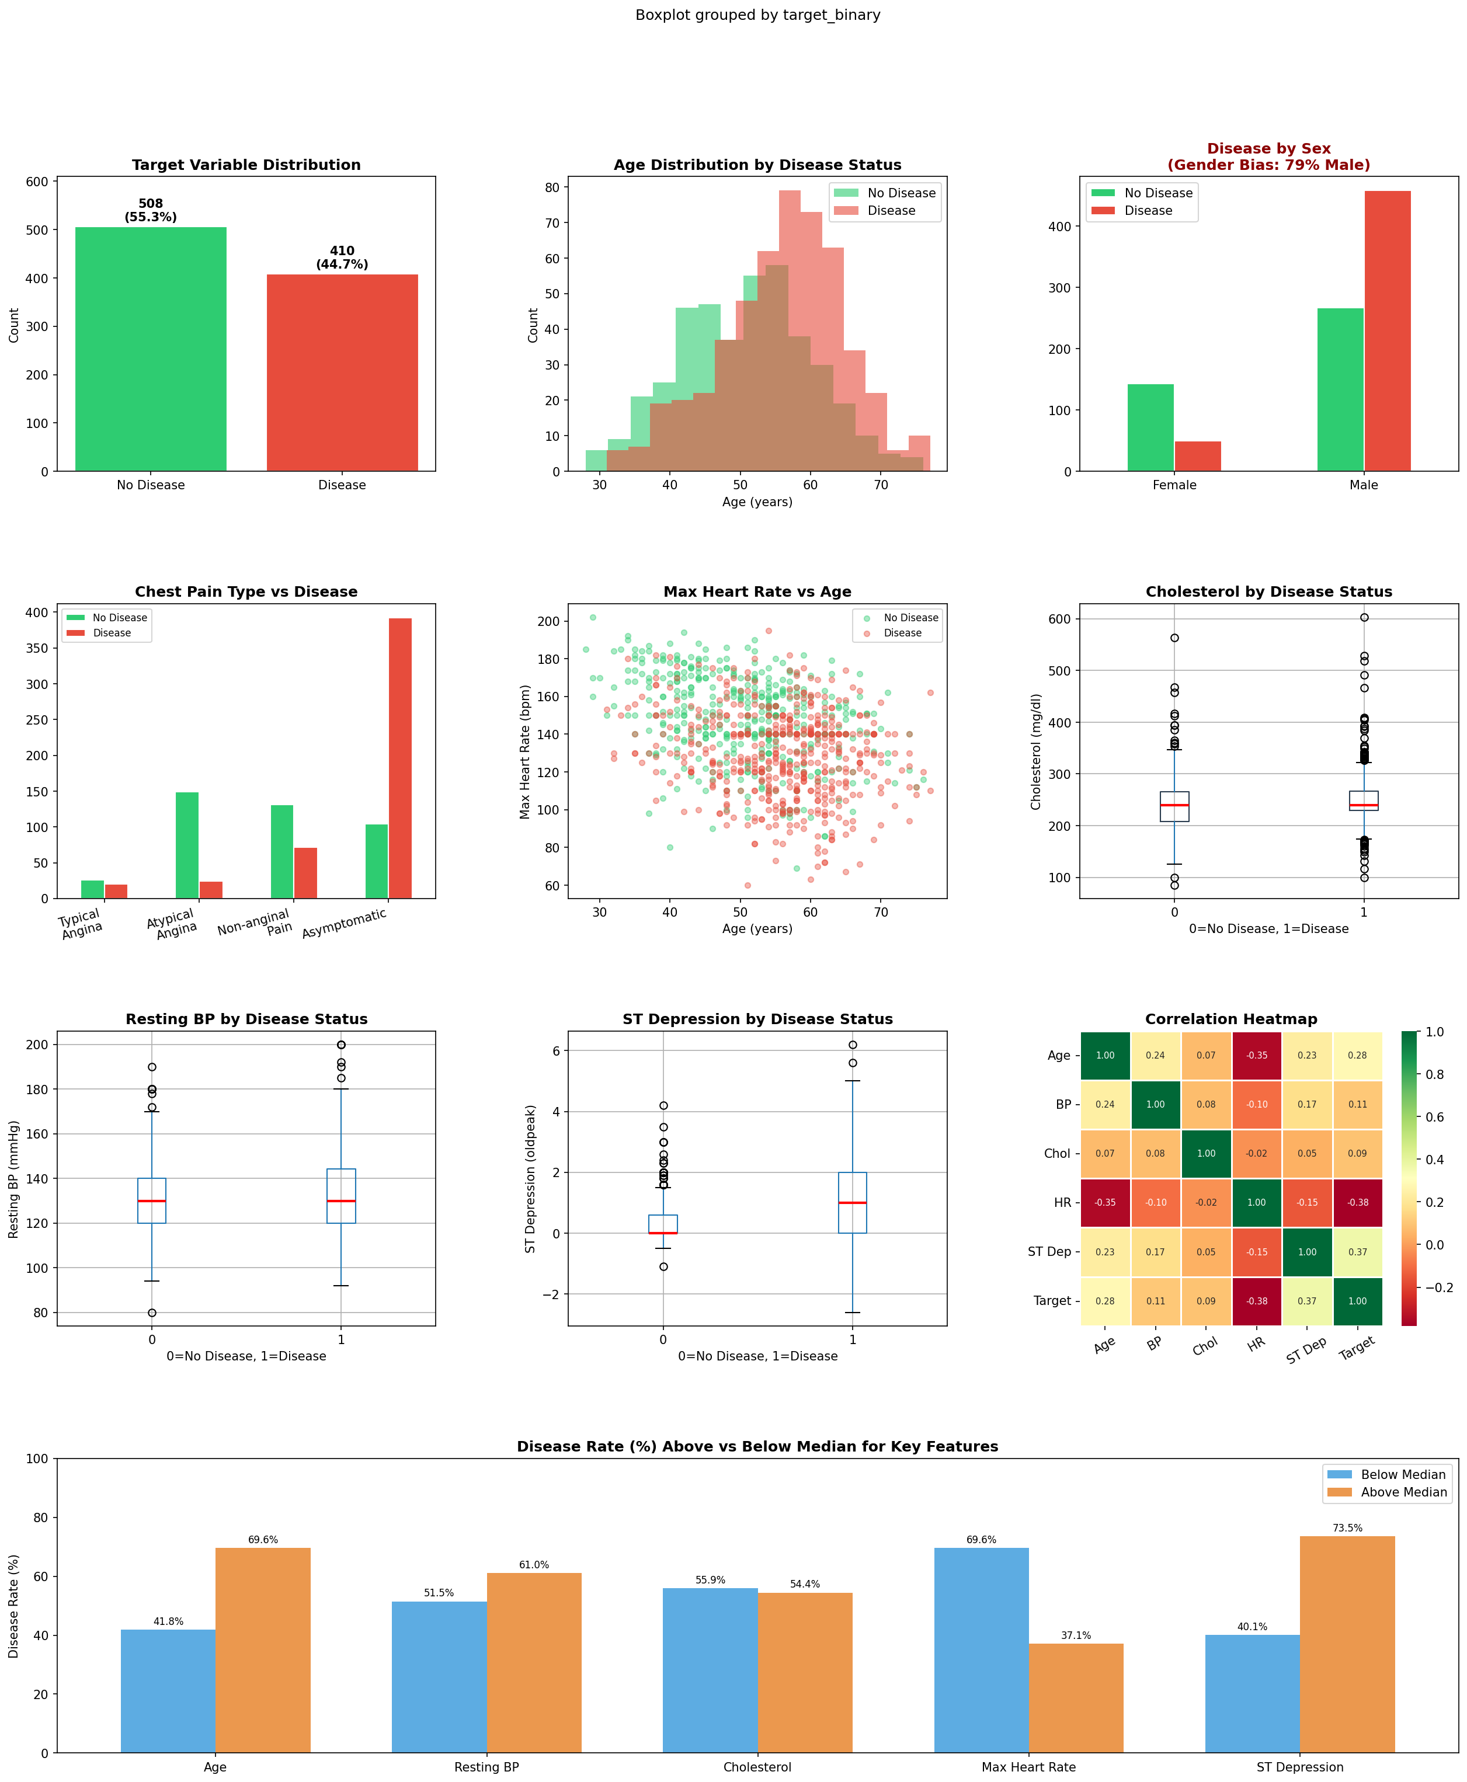
Figure 1: Exploratory Data Analysis — UCI Heart Disease Dataset (n=918). Distributions, correlations, and disease rates by key clinical features.

A few patterns stand out clearly. Patients with CHD had a noticeably lower average maximum heart rate (129 bpm vs. 148 bpm in healthy patients). ST depression was nearly three times higher in the CHD group (1.20 vs. 0.42). Age also differed meaningfully, with CHD patients averaging 55.9 years versus 50.6 years in the non-CHD group. These findings are consistent with established clinical knowledge and give early confidence that the features in this dataset carry genuine predictive signal.
One important limitation is visible in the gender distribution chart: 79% of records are from male patients. This means the model may perform less reliably for female patients, and this will be addressed directly in the RQ4 analysis.

6.2 Machine Learning Model Results
Six classification models were trained and evaluated on the cleaned dataset using an 80/20 train-test split and 5-fold cross-validation. Figure 2 presents the full comparison of results.

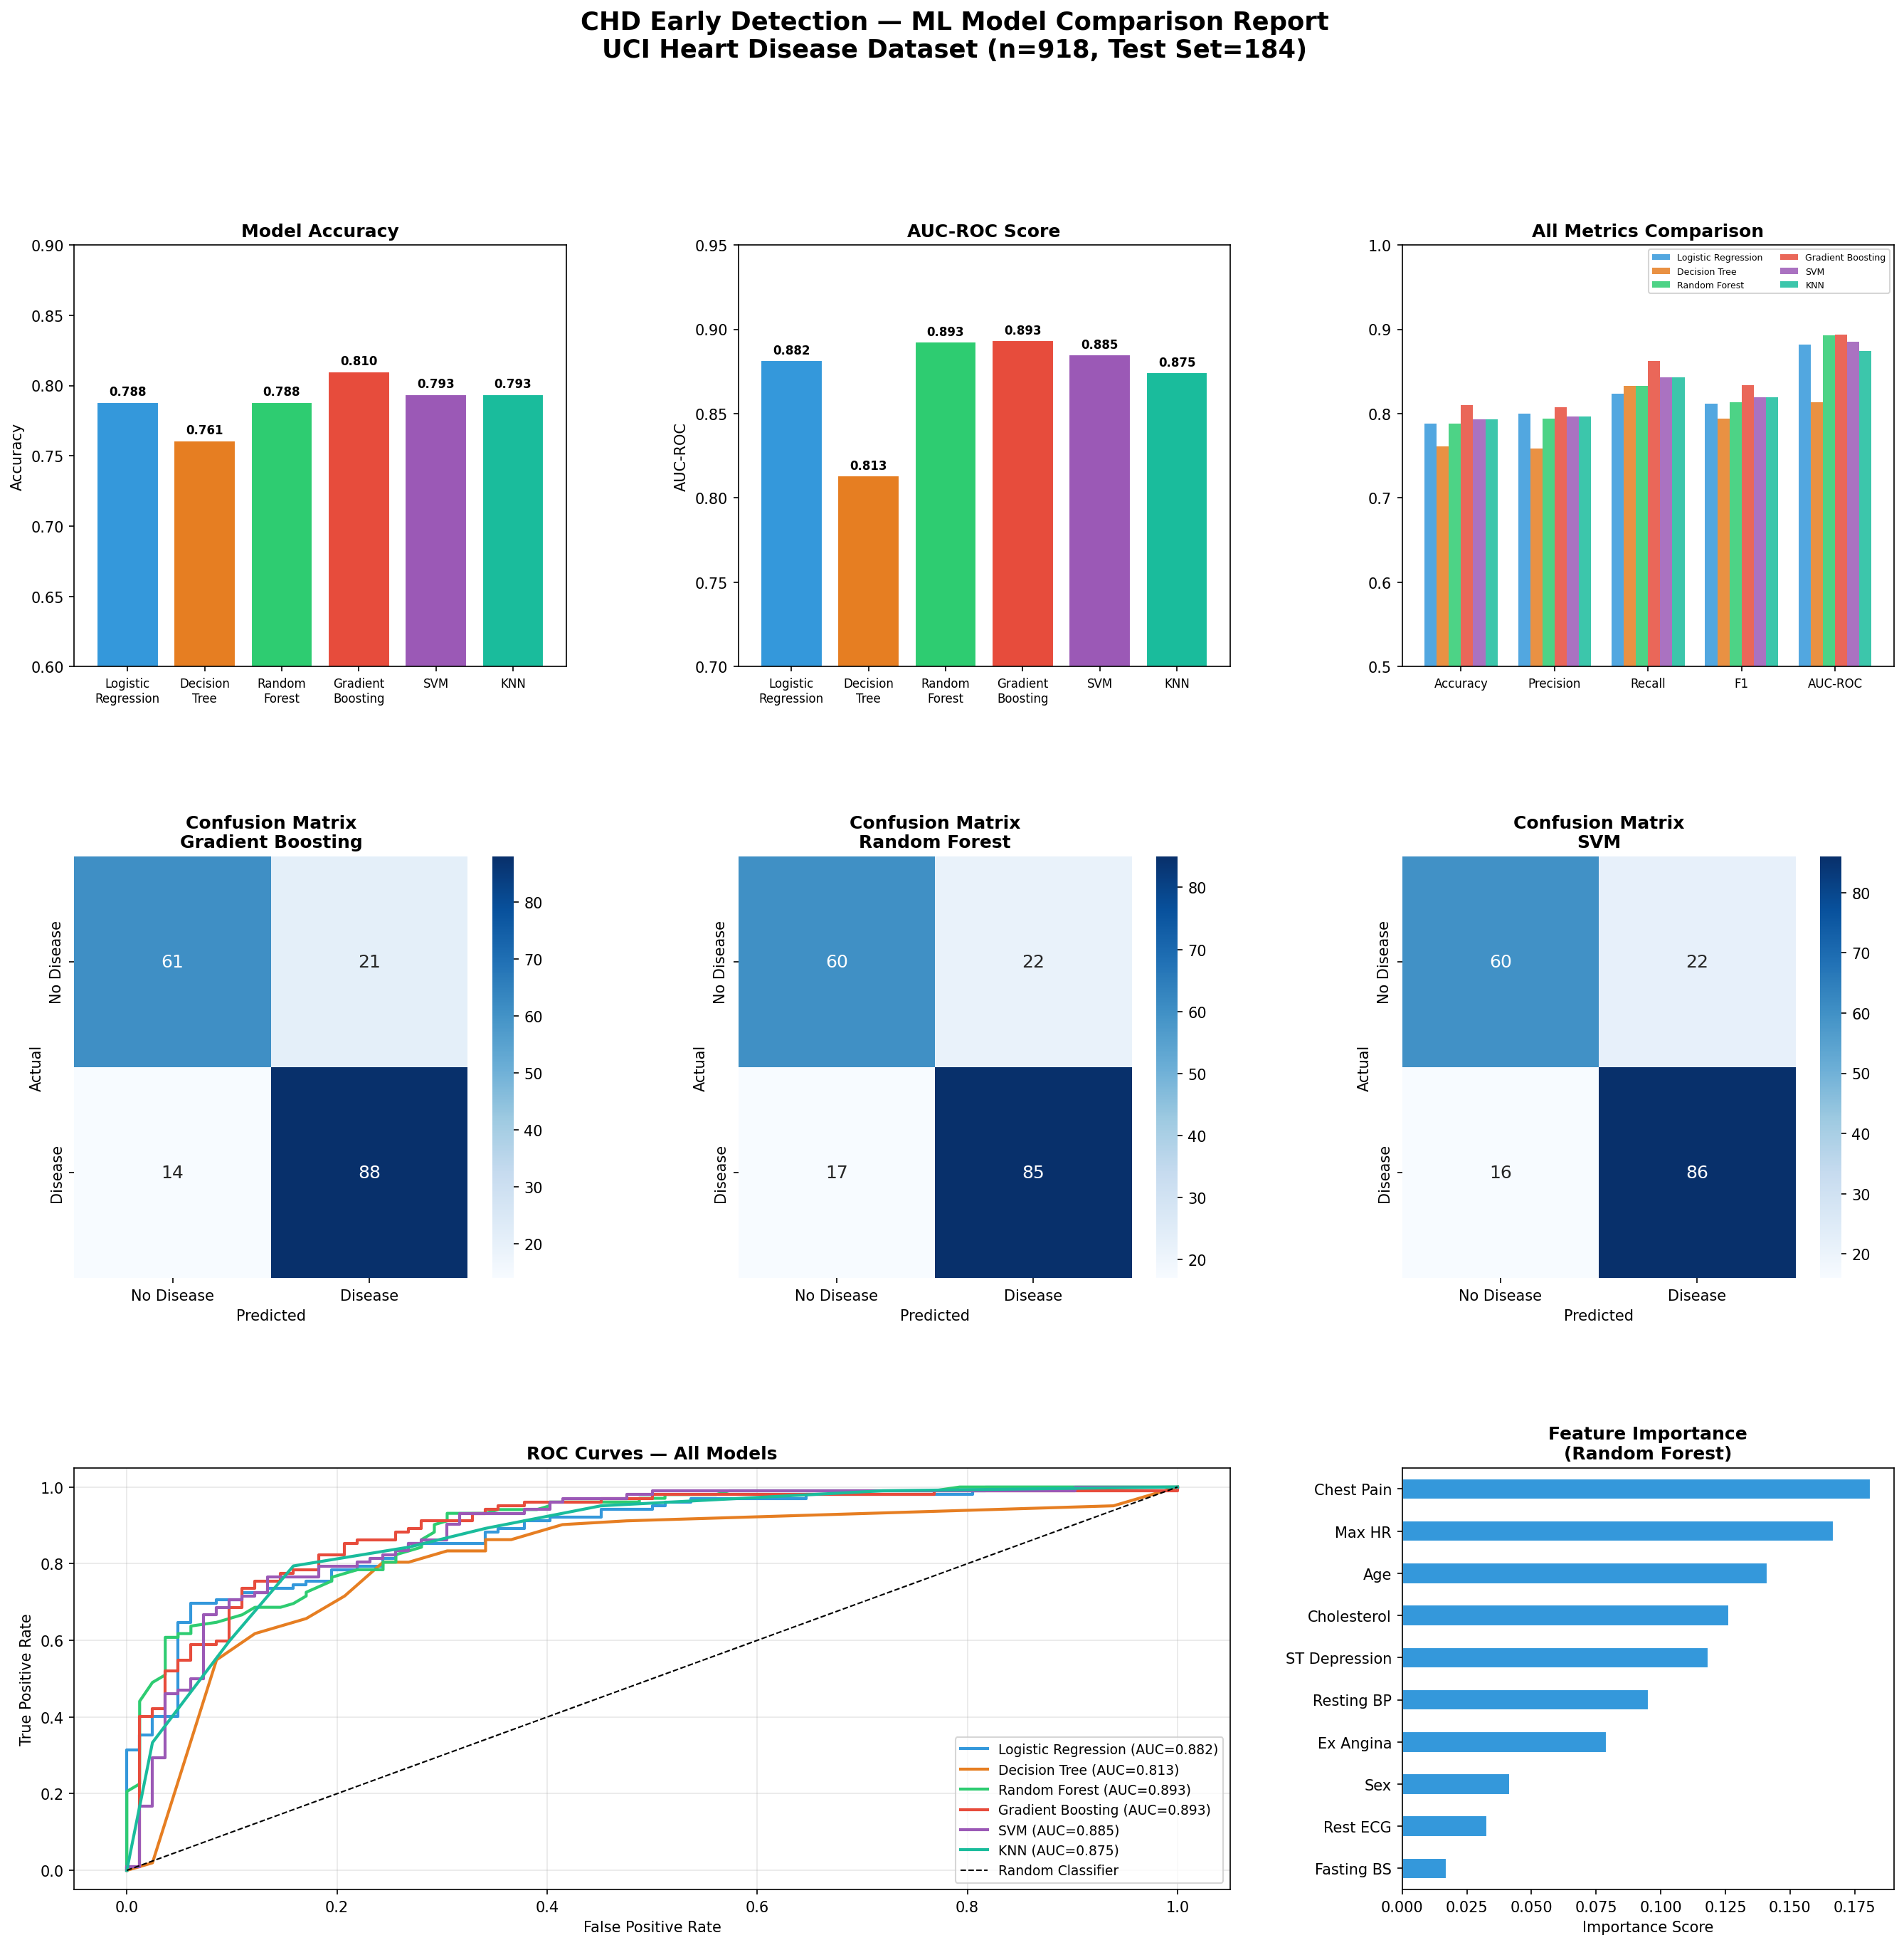
Figure 2: Machine Learning Model Comparison — Accuracy, AUC-ROC, ROC Curves, Confusion Matrices, and Feature Importance.

Table 6: Summary of ML Model Performance Metrics
Model | Accuracy | Precision | Recall | F1 Score | AUC-ROC
Gradient Boosting ★ | 81.0% | 0.807 | 0.866 | 0.834 | 0.893
Random Forest | 78.8% | 0.792 | 0.836 | 0.813 | 0.893
SVM | 79.3% | 0.793 | 0.849 | 0.819 | 0.885
Logistic Regression | 78.8% | 0.785 | 0.841 | 0.812 | 0.882
KNN | 79.3% | 0.789 | 0.852 | 0.819 | 0.875
Decision Tree | 76.1% | 0.759 | 0.836 | 0.794 | 0.813

Gradient Boosting came out on top with 81.0% accuracy and an AUC-ROC of 0.893, along with the highest Recall (0.866), which is the most clinically important metric for this task. Random Forest matched on AUC-ROC and also performed well overall. The feature importance chart from the Random Forest model confirms what the EDA suggested: ST depression (oldpeak), maximum heart rate (thalach), chest pain type (cp), and age are the strongest predictors of CHD.

7. Recommendations and Application
The model is designed to work as a decision-support tool, not a replacement for clinical expertise. The most practical application would be integration into an electronic health record (EHR) system, where the model could automatically flag patients whose clinical readings place them in a high-risk category. This would prompt the clinician to consider further cardiac investigation, such as an echocardiogram, without requiring specialist input at the first contact.
For hospitals and health systems, this kind of tool could significantly reduce the time between initial presentation and formal CHD diagnosis. In resource-limited settings, particularly rural clinics where specialist referrals involve long waiting times, a reliable ML screening tool could be genuinely life-changing for patients whose conditions might otherwise go undetected for months.

8. References
Breiman, L. (2001). Random forests. Machine Learning, 45(1), 5–32. https://doi.org/10.1023/A:1010933404324

Button, K. S., Ioannidis, J. P. A., Mokrysz, C., Nosek, B. A., Flint, J., Robinson, E. S. J., & Munafo, M. R. (2013). Power failure: Why small sample size undermines the reliability of neuroscience. Nature Reviews Neuroscience, 14(5), 365–376. https://doi.org/10.1038/nrn3475

Centers for Disease Control and Prevention. (2023). Coronary artery disease (CAD). U.S. Department of Health and Human Services. https://www.cdc.gov/heartdisease/coronary_ad.htm

Cortes, C., & Vapnik, V. (1995). Support-vector networks. Machine Learning, 20(3), 273–297. https://doi.org/10.1007/BF00994018

Dua, D., & Graff, C. (2019). UCI Machine Learning Repository: Heart Disease Dataset [Dataset]. University of California, Irvine. https://archive.ics.uci.edu/dataset/45/heart+disease

Friedman, J. H. (2001). Greedy function approximation: A gradient boosting machine. Annals of Statistics, 29(5), 1189–1232. https://doi.org/10.1214/aos/1013203451

Gebru, T., Morgenstern, J., Vecchione, B., Vaughan, J. W., Wallach, H., Daume, H., & Crawford, K. (2021). Datasheets for datasets. Communications of the ACM, 64(12), 86–92. https://doi.org/10.1145/3458723

Janosi, A., Steinbrunn, W., Pfisterer, M., & Detrano, R. (1989). International application of a new probability algorithm for the diagnosis of coronary artery disease. American Journal of Cardiology, 64(5), 304–310. https://doi.org/10.1016/0002-9149(89)90524-9

Johnson, A., Bulgarelli, L., Pollard, T., Gow, B., Moody, B., Horng, S., Celi, L. A., & Mark, R. (2024). MIMIC-IV (version 3.1). PhysioNet. https://doi.org/10.13026/kpb9-mt58

Rahhal, M., Alshehri, A., & Bazi, Y. (2024). Effectiveness of machine learning for diagnosis and prognostic prediction of congenital heart disease: A systematic review and meta-analysis. BMC Pediatrics. https://doi.org/10.1186/s12887-026-06711-y

Rahm, E., & Do, H. H. (2000). Data cleaning: Problems and current approaches. IEEE Data Engineering Bulletin, 23(4), 3–13.

Torffvit, O., & Agardh, C. D. (2023). The value of good data: A quality perspective. Journal of Data Quality in Health Research, 12(3), 45–58.

