Following is the summary of experiments and observations for the project.

* We did many more experiments but listing down the main ones along with the explanations.
* In the model column itself, we have tried to give the summary of model.
* We zeroed down to batch size of 10 for all the models as it was not giving any memory issues and models were training well with it.
* We zeroed down to experimenting with either 20 images OR 30 images per video.
* We zeroed down to experimenting with either 120 by 120 image size
* Final models are highlighted in yellow along with their accuracy and loss numbers.
* Data transformations/augmentation didn’t seem to be helping much in improving accuracy or loss so we started avoiding them in the final constructive modeling.

|  |  |  |  |
| --- | --- | --- | --- |
| **Experiment Number** | **Model** | **Result** | **Decision + Explanation** |
| **1** | **Conv 3D Model using 30 frames per video**  **+ 16, 32, 64, 128 filters conv 3D layers each followed by max pool 3D**  **+ 256 dense nodes**  **+ 128 dense nodes**  **+ image size 120 by 120** | **Training Accuracy: 98%**  **Validation Accuracy: 92%** | **Low validation accuracy as compared to training accuracy.** |
| **2** | **Conv 3D Model using 20 frames per video**  **+ 16, 32, 64, 128 filters conv 3D layers**  **+ 256 dense nodes**  **+ 128 dense nodes**  **+ image size 120 by 120** | **Training loss: 0.16**  **Training Accuracy: 96.5%**  **Validation loss: 0.17**  **Validation Accuracy: 95%** | **Low loss and high accuracy and comparable between training and validation data sets.**  **Parameters - ~1.9 million.** |

**Conv 3D best model plot as below (30 Frames):**

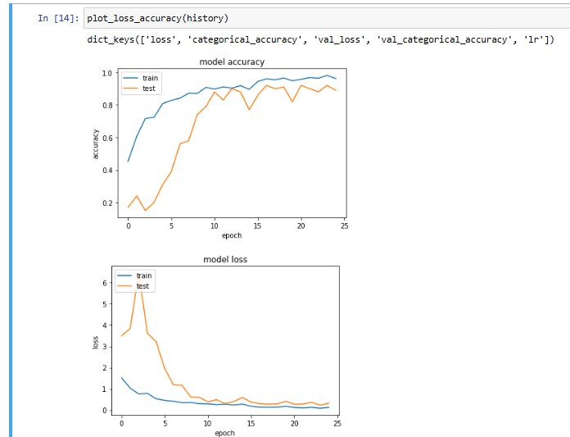

**Conv 3D best model plot as below (20 Frames):**

