**IoT BASED BIOMETRIC ATTENDENCE SYSTEM**

**(USING GOOGLE SPREADSHEETS)**

DESIGN PROJECT REPORT

Submitted by

**SANKER DEV P– TVE17EC042**

**VIPIN CHANDRAN M-TVE17EC061**

**FAIZAL BABU-LTVE17EC065**

Fifth Semester

B.Tech Electronics and Communication Engineering

to the APJ Abdul Kalam Technological University

in partial fullfilment of the requirements for the award of the Degree of

Bachelor in Electronics and Communication Engineering



**Department of Electronics and Communication Engineering**

**College of Engineering**

**Trivandrum**

**2019**

**IoT BASED BIOMETRIC ATTENDENCE SYSTEM**

**(USING GOOGLE SPREADSHEETS)**

DESIGN PROJECT REPORT

Submitted by

**SANKER DEV P– TVE17EC042**

**VIPIN CHANDRAN M-TVE17EC061**

**FAIZAL BABU-LTVE17EC065**

Fifth Semester

B.Tech Electronics and Communication Engineering

to the APJ Abdul Kalam Technological University

in partial fullfilment of the requirements for the award of the Degree of

Bachelor in Electronics and Communication Engineering



**Department of Electronics and Communication Engineering**

**College of Engineering**

**Trivandrum**

**2019**

**DEPARTMENT OF ELECTRONICS AND COMMUNICATION ENGINEERING**

**COLLEGE OF ENGINEERING**

**TRIVANDRUM**



**CERTIFICATE**

This is to certify that this report entitled “**IoT BASED BIOMETRIC ATTENDENCE SYSTEM”** submitted by **SANKER DEV P , VIPIN CHANDRAN M ,FAIZAL BABU** to the APJ Abdul Kalam Technological University in partial fulfillment of the requirements for the award of the Degree of Bachelor in Electronics and Communication Engineering is a bonafide record of the design project work carried out under my/our supervision. This report in this or any other form has not been submitted to any other institute or University for any purpose.

**Prof. Sanil K Daniel Dr Santhosh Kumar S**

*Assistant Professor Professor (****HOD****)*

*Department of ECE Department of ECE*

*CET CET*

**Prof. Jithina T.S Prof. Sasikumar V V**

*Assistant Professor Associate Professor*

*Department of ECE Department of ECE*

*CET CET*

**ACKNOWLEDGEMENT**

As we complete this project, we would like to thank the numerous hands who helped us, wholeheartedly. First and foremost, we thank the Almighty, without whose blessings we could have never reached this far. We express our deepest gratitude to our guide on this project **Professor Sanil K Daniel**, Department of Electronics and Communication Engineering for all his help and invaluable advice, support and constant Encouragement. We offer our thanks to **Professor Sasikumar**, **Professor Jithina T.S** and **Ms. Supriya S.S** for their constant support. We take this opportunity to express our profound gratitude to our Head of the Department, **Dr Santhosh Kumar S** whose encouragement was a great source of inspiration. We would like to thank all the teachers of the Department for their help on various areas of this project. We would also like to thank our friends and family for their continued support and inspiration.

**ABSTRACT**

Biometric student attendance system increases the efficiency of the process of taking student attendance. This project presents a simple and portable approach to student attendance in the form of an Internet of Things (IOT) based system that records the attendance using fingerprint based biometric scanner and stores them securely over cloud. This system aims to automate the cumbersome process of manually taking and storing student attendance records. It will also prevent proxy attendance, thus increasing the reliability of attendance records. The records are securely stored and can be reliably retrieved whenever required by the teacher.

**CONTENTS**

|  |  |  |
| --- | --- | --- |
| **Serial No:**  **(Main Heading)** | **Name** | **Page No:** |
| 1 | Acknowledgement | 5 |
| 2 | Abstract | 6 |
| 3 | Contents | 7 |
| 4 | List of figures | 8 |
| 5 | List of tables | 9 |
| 6 | 1. Introduction | 10 |
| 7 | 1. Product Design   __2.1 Hardware Design  _____2.1.1 Block Diagram  _____2.1.2 Block Description  _____2.1.3 Circuit Diagram  _____2.1.4 Circuit Description  _____2.1.5 PCB Layout  __2.2 Software Design | 11  12  13  14  15 |
| 8 | 1. Product Implememtation   ____3.1 Hardware Implememtation  ____3.1.2 Algorithm  ____3.2 Software Implementation | 17  19  20 |
| 9 | 1. Result | 25 |
| 10 | 1. Conclusion | 26 |
| 11 | 1. References | 27 |
| 12 | 1. Appendix   ___7.1 NodeMCU  ___7.2 R307  ___7.3 LCD Display  ___7.4 4x4 keypad | 28  29 |

**LIST OF FIGURES**

|  |  |  |
| --- | --- | --- |
| **Figure No:** | **Name** | **Page No:** |
| 1 | Circuit Block Diagram | 11 |
| 2 | Final Circuit | 13 |
| 3 | PCB Layout | 15 |
| 4 | Overall Design Implementation | 18 |
| 5 | Enrollment Procedure | 20 |
| 6 | Overall Circuit Overview | 21 |
| 7 | Pushing Box API | 21 |
| 8 | Arduino IDE CODE | 22 |
| 9 | Block Diagram | 23 |
| 10 | Spreadsheet output | 23 |
| 11 | NodeMCU pinout | 27 |
| 12 | R307 | 28 |
| 13 | LCD display pinout | 29 |

**LIST OF TABLES**

|  |  |  |
| --- | --- | --- |
| **Table No:** | **Name** | **Page No:** |
| 1 | Connections to NodeMCU | 14 |
| 2 | Components used | 17 |
| 3 | NodeMCU technical specifications | 27 |
| 4 | R307 technical specifications | 28 |
| 5 | LCD display dimensions | 29 |

**1. INTRODUCTION**

Attendance plays a major role in educational institutions. The most common means of taking attendance in the classroom is by calling out the roll numbers of students or asking the students to manually sign the attendance sheet, which is passed around during the lecture. The process of manually taking and maintaining the attendance records becomes highly cumbersome. Biometric systems have reached a sufficiently advanced stage wherein they can now be deployed in systems without hampering portability. With the recent development of various cloud based computing and storage systems, data can be securely stored and retrieved whenever required. Primarily, fingerprints and iris images are considered to be the most reliable for use in biometric systems.

Since we need a system to implement and recording our attendance. The “BIOMETRIC ATTENDENDANCE SYSTEM WITH IOT” help to take attendance and send to the office. Biometrics systems essentially consist of recording and comparing biometric characteristics, when a person first uses a biometrics system, his or her identifying features are enrolled as a reference for future comparison. This reference can be stored in laptop/ server for future use. In this project Wi-Fi technology is used for wireless communication.

**2. PRODUCT DESIGN**

**2.1 Hardware Design**

**2.1.1 BLOCK DIAGRAM**

*Figure 1*

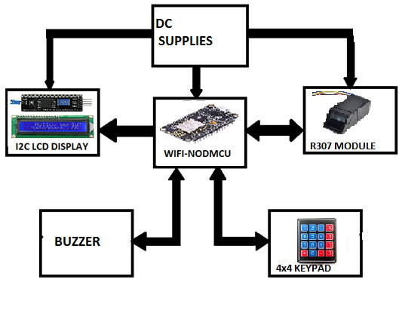

**2.1.2 BLOCK DESCRIPTION**

**WIFI MODULE –ESP12E NODMCU**

NodeMCU is an open source IoT platform. It includes firmware which runs on the ESP8266 Wi-Fi SoC from Espressif Systems, and hardware which is based on the ESP-12 module. The term "NodeMCU" by default refers to the firmware rather than the dev kits. The firmware uses the Lua scripting language. It is based on the eLua project, and built on the Espressif Non-OS SDK for ESP8266. It uses many open source projects, such as lua-cjson, and spiffs.

**FINGER PRINT SENSOR(R307)**

In this project we used fingerprint sensor(R307). The R307 (fingerprint sensor) is a small embedded module that consists of an optical sensor mounted on a small circuit board. The optical sensor scans a fingerprint and the microcontroller and software provides the modules functionality which automatically processes the scanned fingerprint. This module can directly interface with any 3.3V or 5V microcontrollers, but a suitable level converter/serial adapter is required for interfacing with the serial port of a PC.

**I2C LCD DISPLAY**

The I2C 1602 LCD module is a 2 line by 16 character display interfaced to an I2C daughter board. The I2C interface only requires 2 data connections, +5 VDC and GND to operate. The 5x8 matrix is turned to characters as per the value by the microcontroller.

**4x4 KEYPAD**

Keypad is used as an input device to read the key pressed by the user and to process it. 4x4 keypad consists of 4 rows and 4 columns. Switches are placed between the rows and columns. A key press establishes a connection between the corresponding row and column, between which the switch is placed.

**2.1.3 CIRCUIT DIAGRAM**

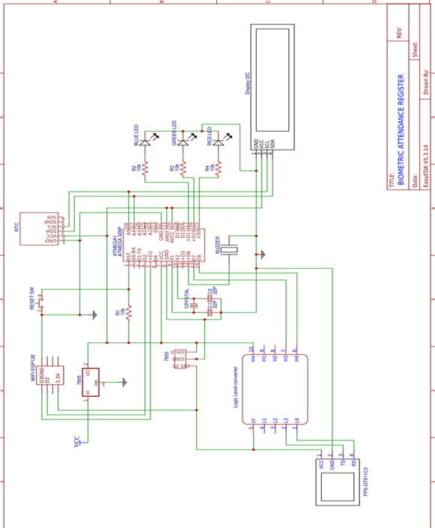

*Figure 2*

**2.1.4 CIRCUIT DESCRIPTION**

*COMPONENTS USED*

* NodeMCU
* R307 Fingerprint sensor
* I2C Module for 16x2 (1602) Alphanumeric LCD
* Breadboard
* 16*2 Alphanumeric LCD
* 4x4 keypad module
* Jumpers

NodeMCU is the microcontroller used here, It includes firmware which runs on the ESP8266 Wi-Fi SoC from Espressif Systems, and hardware which is based on the ESP-12 module.

*Table 1:* **Connections to NodeMCU pins:**

|  |  |
| --- | --- |
| NodeMCU pins | Components Connected |
| D1 | **SCL –I2C Interface** |
| D2 | **SDA-I2C Interface** |
| D3 | **TXD-R307** |
| D4 | **RXD-R307** |
| 3V3 | **VCC-Finger print sensor** |
| Vin | **VCC-I2C Interface** |
| GND | **LCD display,R307,Keypad** |

The above connections are made according to the table and the nodemcu is powered from a pc or any dc battery source after uploading the code to it.

I2C Communication interface enables to save atleast 4 pins on NodeMCU board which has less number of I/O pins.

**2.1.5 PCB LAYOUT**

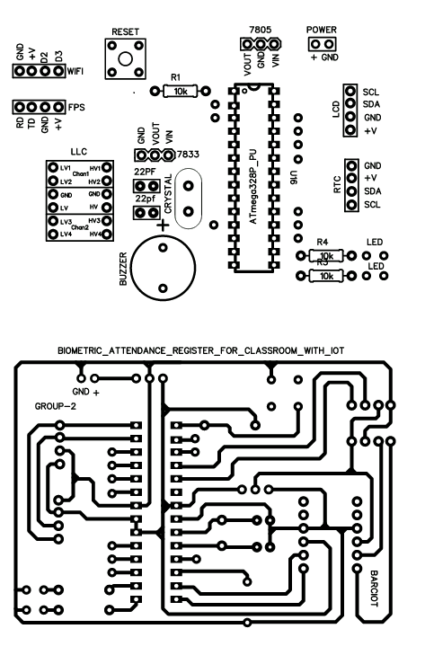*figure 3*

**3. PRODUCT IMPLEMENTATION**

**3.1 Hardware Implementation**

|  |  |
| --- | --- |
| COMPONENTS | SPECIFICATIONS |
| **NodeMCU** | **CPU**: 80 MHz 32-bit  **Dynamic RAM**-128KB  **Flash Memory**-4 MB  **WiFi**-2.4 GHz 8022.11 b/g/n  **Serial I/O**-Micro USB |
| **RC307** | **Power supply-**4.2V to 6V  **Current Consumption-**50mA  **Template Size-**512 Bytes  **Storage Capacity-**1000 |
| **LCD DISPLAY** | **Supply-Voltage Range**: 4.7V to 5.3V  **Current consumption:** 1mA  **Each Character:** 5x8 pixel box |
| **4x4 Keypad** | 8 bit data(hexadecimal) transmitted from keypad module based on the corresponding button pressed |

*Table 2: Components used*

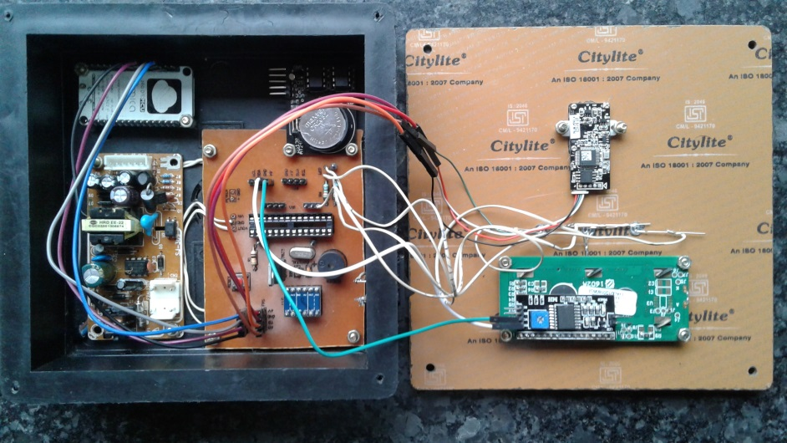 *figure* 4

**FINGERPRINT WORKING**

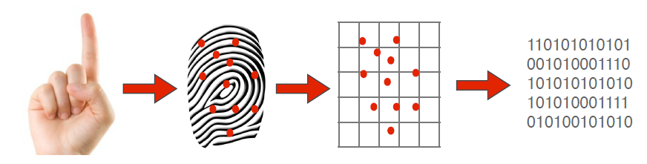

Biometric Finger Print Scanner System Works Very Efficiently And Quickly As You Can Read In Below Described Steps. For Identification Process A Biometric Physiological Finger Scanner Works On Two Basic Principles.

* First, It Takes An Image Of A Finger.
* Then Finger Scanner Save Specific Characteristics Of Every Unique Finger And Saved In The Form Of Biometric Encrypt Key.
* Actually Finger Print Scanner Never Saves Images Of A Finger Only Series Of Binary Code For Verification Purpose.

**3.1.2 ALGORITHM**

1. Start
2. Print “WELCOME”
3. Print “BIOMETRIC ATTENDANCE”
4. Enter password for respective subject
5. Establishing WiFi Connection
6. Searching for sensors
7. Establishing Interface with sensors
8. Then, Start fingerprint scanning
9. Starting of loop
10. If Fingerprint matches, then mark attendance to a[i]
11. Sent attendance in a[i] to wifi and then show date and time.
12. Using Pushing Box API upload it to google sheets
13. Else Show INVALID
14. Prepare an Cummulative at end of the month
15. And share it to all using Google Classroom
16. Remove the access by entering password again
17. End outer loop
18. Stop.

**3.2 Software Implementation**

In this project, we used Arduino c language for programming the IC. Arduino C programming is very simple and easy to use. Its user interface is very convenient for all users. Arduino is the hardware platform used to teach the C programming language as Arduino boards are available worldwide and contain the popular AVR microcontrollers from Atmel.

**3.2.1 FINGERPRINT ENROLMENT**

In the enrolment process, the fingerprint of each student is recorded. The fingerprint of the student is scanned using the fingerprint scanner in the system. Each fingerprint is assigned an ID number. The ID number is stored on the NodeMCU board. 

**3.2.2 FINGERPRINT RECOGNITION AND COMPARISON** *figure 5*

The system, being portable, can be passed around during the lecture from student to student to record attendance. During the fingerprint comparison and recognition process, the student’s fingerprint will be compared with the stored fingerprints in the NodeMCU board.

**3.2.3 VALIDATION OF RECOGONISED FINGER**In the previous process, the fingerprint input is compared with the stored fingerprints. If it matches a fingerprint present in the NodeMCU, then the name or the respective ID number is displayed in the Lcd display and buzzer sounds.

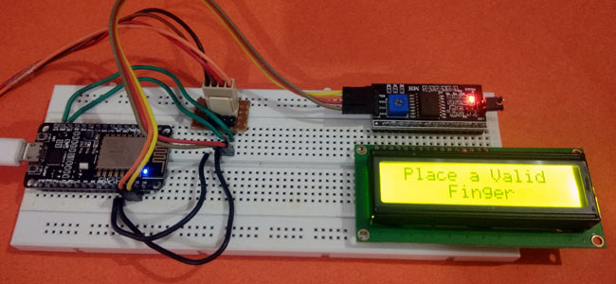

*Figure 6*

**3.2.4 GRANTING ATTENDENCE AND UPLOADING TO GOOGLE SHEETS**

The unique ID number of the student is recognised. The attendance data is logged into Google Spreadsheet by uploading the student’s ID number in it,. For uploading the ID number in Google Spreadsheet, PushingBox API is used. After the attendance is granted, i.e. the ID is stored in Google Spreadsheet, the Fingerprint Comparison and Recognition process starts.

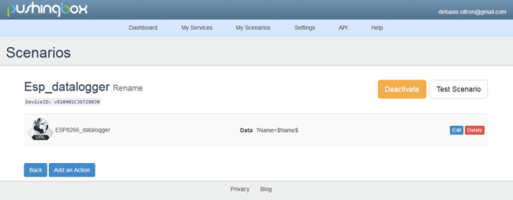

*Figure 7*

*Figure 8*

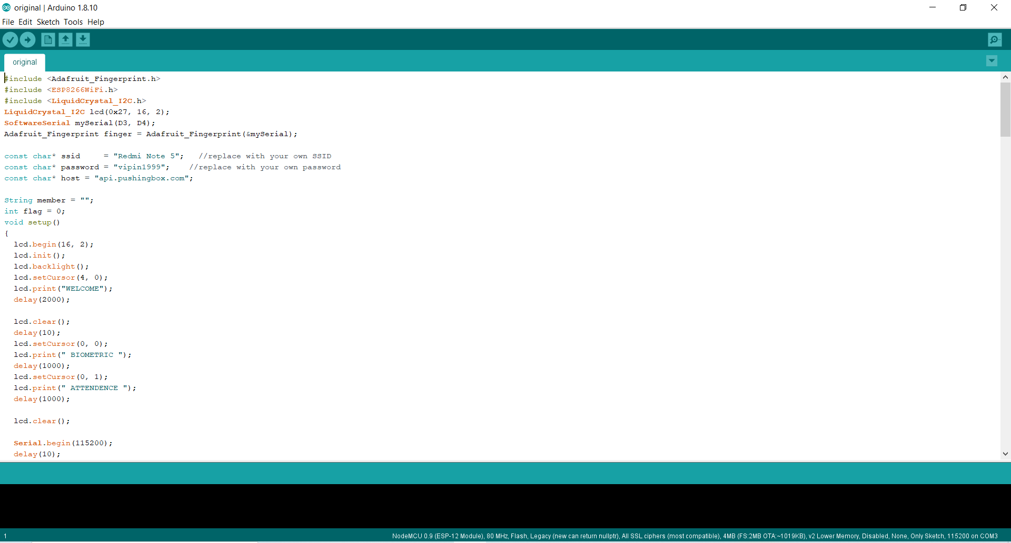

 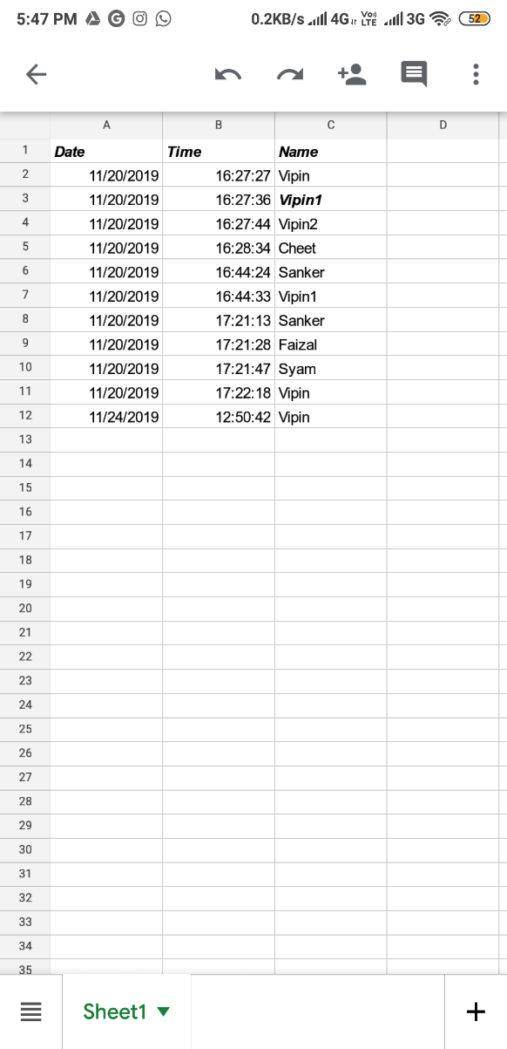

BLOCK DIAGRAM OUTPUT(spreadsheet) *: figure 10*

*Figure 9*

**4.RESULT**

During testing, the system was enrolled with 6 to 7 IDs,passcode was set for subject and when selected a particular passcode the corresponding subject was displayed on the LCD screen. And now the system displays its connections to the provided network and when a person keeps his fingerprint on the sensor the buzzer sounds and the LCD displays the name of the individual and sents it via pushing box API to the googgle spreadsheet created by an email, and this content could be shared via google classroom to all as well as it can be accessed by a link

**5.CONCLUSION**

The traditional process of manually taking and maintaining student attendance is highly inefficient and time consuming. The attendance monitoring system based on biometric authentication has a potential to streamline the whole process. An Internet of Things (IoT) based portable biometric attendance system can prove to be of great value to educational institutions in this regard as it proves to be highly efficient and secure. The cost involved in making this system is quite less, when compared to conventional biometric attendance system. The use of cloud computing to store the attendance records makes all the data easy to access and retrieve as end when required by the teachers. The use of fingerprint scanner ensures the reliability of the attendance record. The system, due to its lack of complexity, proves to be easy to use and user friendly.

**6.REFERENCES**

[1] Prashik S. Bhagat, Prof. D. S. Shilwant, Prof. S. P. Kharde, Praful S. Bhagat, Abhijit S. Andure, Prof. Amol A. Shirsath, “Iris based attendance system”, International Journal of Advanced Research in Computer Engineering & Technology (IJARCET), Volume 4 Issue 8, August 2015.

[2] Sagar Wale, S.A. Patil, "Indigenous Development Of Automated Wireless Fingerprint Attendance System",INTERNATIONAL JOURNAL OF SCIENTIFIC & TECHNOLOGY RESEARCH VOLUME 3, ISSUE 8, AUGUST 2014.

[3] https://iotdesignpro.com/projects/iot-based-smart-attendance-system-project-using-nodemcu

[4] Deepak Ranjan Nayak. "A Novel Architecture for Embedded Biometric Authentication System", 2008 Second UKSIM European Symposium on Computer Modeling and Simulation, 09/2008.

[5] Pradip Patil,Sumit Sharma,R. B. Gajbhiye, "A Study- Impact of Internet of Things (IOT) For Providing Services for Smart City Development", International Journal of Advance Research in Computer Science and Management Studies, Volume 3, Issue 6, June 2015.

**7.APPENDIX**

**Datasheets**

**7.1 NodeMCU**

NodeMCU is an open source IoT platform. It includes firmware which runs on the ESP8266 Wi-Fi SoC from Espressif Systems, and hardware which is based on the ESP-12 module. The term "NodeMCU" by default refers to the firmware rather than the dev kits. The firmware uses the Lua scripting language.

**Image and Pinout Diagram** 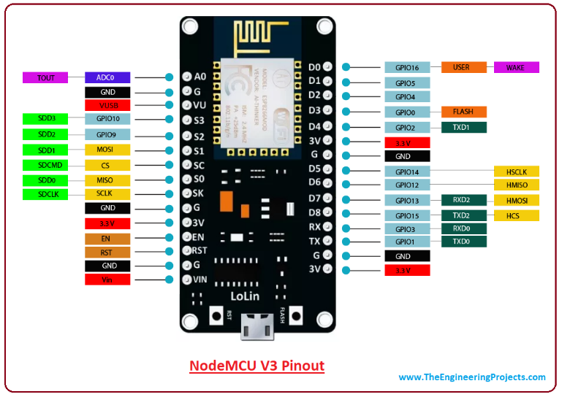 *figure 11*

**NodeMCU Technical Specifications**

|  |  |
| --- | --- |
| **Developer** | **ESP8266 Open source Community** |
| Type | Single-Board Micrcontroller |
| OS | XTOS |
| CPU | ESP8266 |
| Memory | 128K Bytes |
| Storage | 4M Bytes |
| Power | USB |
| Power Voltage | 3V,5V |
| Code | Arduino Cpp |
| IDE used | Arduino IDE |
| GPIO | 10 |
|  |  |

*Table 3*

**7.2 FINGERPRINT SENSOR(R307)**

In this project we used fingerprint sensor(R307). The R307 (fingerprint sensor) is a small embedded module that consists of an optical sensor mounted on a small circuit board. The optical sensor scans a fingerprint and the microcontroller and software provides the modules functionality which automatically processes the scanned fingerprint.

PIN OUT DIAGRAM

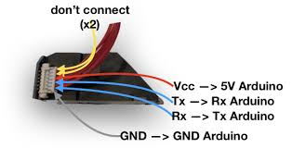*figure 12*

**FINGERPRINT SENSOR PIN CONFIGURATION**

|  |  |  |
| --- | --- | --- |
| **PIN NO** | **PIN NAME** | **DESCRIPTION** |
| 1 | 5V | Power input (4.2V-6V) |
| 2 | GND | Signal Ground.Connected to Power Ground |
| 3 | TXD | Data output TTL logical level |
| 4 | RXD | Data input TTL logical level |
| 5 | TOUCH | Finger detection signal(maximum output current 50mA) |
| 6 | 3.3V | Finger detection power(DC3.3-5V about 5uA) |

*Table 4*

**7.3 LCD DISPLAY**

The I2C 1602 LCD module is a 2 line by 16 character display interfaced to an I2C daughter board. The I2C interface only requires 2 data connections, +5 VDC and GND to operate. The 5x8 matrix is turned to characters as per the value by the microcontroller.

|  |  |
| --- | --- |
| **ITEM** | **DIMENSION** |
| No of characters | 16 characters x 2lines |
| Module Dimension | 80.0x36.0x13.2(MAX) |
| Active Area | 56.2x11.5 |
| Dot Pitch | 0.60x0.70 |
| LCD Type | STN,positive |
| Backlight Type | LED |

*Table 5*

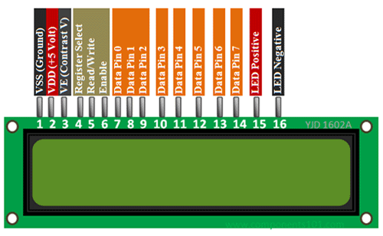

*Figure13*

**7.4 4x4 KEYPAD MODULE**

Keypad is used as an input device to read the key pressed by the user and to process it. 4x4 keypad consists of 4 rows and 4 columns. Switches are placed between the rows and columns. A key press establishes a connection between the corresponding row and column, between which the switch is placed.