Discipline of Information Technology, Mathematics and Statistics
College of Science, Health, Engineering and Education (SHEE)

ICT374 MAJOR ASSIGNMENT ONE
CHECK LIST

Surname: Rana

Given Names: Vishnu

Student Number: 32879349

Tutor’s Name: Robert Hammerstrand

Assignment Due Date: 20/09/2019 Date Submitted: 20/09/2019

Your assignment should meet the following requirements. Please confirm this (by ticking boxes) before submitting your assignment.

- I have read and understood the Documentation Requirements
- This assignment submission is compliant to the Documentation Requirements.
- I have included all relevant Linux source code, executables and test files in the tar archive. The file names are chosen according to the assignment specification.
- I have kept another copy of this assignment and associated programs and files in a safe place.

The unit coordinator may choose to use your submission as sample solutions to be viewed by other students, but only with your permission. Please indicate whether you give permission for this to be done.

- Yes, I am willing to have my submission without change be made public as a sample solution.
- Yes, I am willing to have my submission be made public as a sample solution, as long as my submission is edited to remove all mentions of my identity.
- No, I am not willing to have my submission made public.

Question 1 (20%): Comparing the Cost of Output with Three I/O Models:
The textbook discussed three I/O modes: Programmed I/O, Interrupt-driven I/O, and DMA. Answer the following questions:
- What are the main differences between the three I/O models and what are their strength and weakness?

Programmed I/O
Programmed I/O is the most simple technique for exchanging data or communication b/w the CPU and any other external device. Data is sent and received by the processor and the I/O module. The processor gives complete control to the I/O operation i.e. sensing device status, sending READ/WRITE command. Once the processor issues a command to the I/O module, it then waits for the operation to execute and complete. However, the processor confirms the status of the operation till the I/O module is executed completely.
Strengths:
- Programmed I/O is simple to implement.
- Requires very little hardware support.
Weakness:
- Longer wait time.
- Ties up the CPU for longer time with no necessary need.

Interrupt Driven:
Interrupt I/O is a way of controlling I/O jobs where the external device/peripheral/ command line sends a signal about the due work. Hence, it causes an interrupt to be set. So, in interrupts have a priority level in the processor. Therefore, it requires more complex system and software, however, is a lot more efficient than programmed I/O in terms of efficiently using computer’s time and processing capacity.
Strength:
- It is fast because the I/O devices only interrupt when in ready state.
- It is efficient because it lets the CPU perform other tasks while it is waiting for an interrupt.
Weakness:
- CPU spends most of the time in a loop, waiting fir the device to become ready, called busy waiting.
- Data transfer b/w a fast and slow memory unit is essentially, limited by the speed of CPU.
- Requires an interrupt for every character read/write. Interrupting a running process is can be expensive operation.

Direct Memory Access (DMA)
DMA is a technique of transferring data within main memory and external device w/o passing it through the CPU. DMA improves the processing capacity of the operating system because it takes automates the task of transferring data from the processor and let it perform other tasks.
Strength:
- Allows the peripheral devices to READ/WRITE without going through the CPU.
- Frees the processor from transferring data, hence, allows faster processing since, the processor can be doing something else.

Weakness:
- When peripheral device wants to READ/WRITE it makes the CPU wait. This is called the cycle stealing.

Key Difference:

Programmed I/O | Interrupt-driven I/O | Direct Memory Access
Each data item transfer is initiated by an instruction in the program. Requires constant monitoring of the CPU and sometimes unnecessary. | This approach avoids keeping the processor busy unnecessarily, however, the processor only transfers data when interrupted. Otherwise, continues performing its own tasks. | Direct Memory Access (DMA) allows the peripherals directly communicate with one another by using the memory bus. Hence, completely removes the intervention of the CPU.

- Assuming that an application needs to output 1000 words from the internal memory to the hard disk, calculate the following values for each I/O model:
  - How many times the processor is interrupted?
  - How many times the internal memory is read by the processor for those 1000 words?
  - How many times the disk controller is read by the processor?
  - How many times the disk controller is written to by the processor?
Draw a table to contain your answers.
 | Programmed I/O | Interrupt-Driven I/O | Direct Memory Access
Processor is interrupted | 0 | >1000 | 1
Memory is read | >1000 | >1000 | 0
Disk control is read | >1000 | 1000 | 1
Disk control is written | 1000 | 1000 | 1000

Justification:

This question is bit difficult to answer since we do not have any information about the operating system itself like the word size.

Under programmed I/O a processor will never be interrupted. However, it’s difficult to be specific, the number of times the memory is read or the disk control is read.
With a programmed I/O the memory will be read at least 1000 times, at least one time for each word. The register reads the data bit by bit. Hence, the disk control is read and written 1000 times.

An interrupt-driven I/O model heavily relies upon the other operation of the operating systems and interrupts which might have a higher priority. However, each operation will be attempted at least 1000 times, once for each word. The processor will be interrupted at the end of each transferred word, but may also be interrupted by other processes or users.
The memory will be read at least 1000 times. If it is assumed that no other user or process requires use of the I/O device during the 1000 word transfer, then the CPU will query the disk controller then wait for the interrupt then as long as no errors occur will write to it once for each word.

Direct memory access is the least CPU intensive. If no other process uses system bus and each transfer is completed within the time slice allocated to that process. The CPU will assign disk controller with the starting address in the memory and the length of each letter. Hence, will be interrupted on completion, disk will be read only one time and writing the disk controller 1000 times.

2. (10 marks) Based on the information generated from the above program, produce a memory map table showing the layout of literals, initialised global variables, uninitialized global variables, formal parameters of each function, local variables, dynamically allocated variables, functions, environment and command line arguments in the memory when the program runs at label L in function f2.

The memory map table must show the addresses of each variable, literal, and function and their sizes. It should also show the start
and end addresses of the environment and the command line arguments and their sizes.

The memory map table must contain at least the following columns:
1. The start address of an entity such as a variable or a function
2. The length of the storage space of the entity in bytes
3. The name of the entity, such as global_pointer1 or Hello, world!
4. The nature of the entity, such as function, or uninitialized global variable
5. The memory section, e.g. environment, command line arguments, code (or text), global initialised data, global uninitialed data, stack, heap etc.

In addition, you must use seven different background colours to highlight the following seven memory sections as indicated below::
[Green] initialised global variables (including constants and literals)
[Red] uninitialised global variables
[Blue] stack (containing the local variables and returning addresses of function calls)
[Magenta] heap (containing the dynamically allocated memories)
[Yellow] code (functions)
[Cyan] process environment
[White] command line arguments
Please also note that in your memory table, the memory addresses must be strictly sequential, from the highest address to the lowest address to reflect how different components of a running program are layout in the virtual memory. Your memory table will not be accepted if the addresses are not lined up sequentially in the table. If you find that components from one section are split in more than one continuous area of memory, it is a sure indication that there is something wrong with your memory map and you should find out what went wrong and fix it.

Source code listing:

/** name; memory.c */

#include <stdlib.h>
#include <stdio.h>
#include <math.h>
#include <string.h>

extern char **environ;

int global_x = 10;
// initialised global int variable

int global_y;
// un-initialised global int variable;

char global_array1[] = "Hello, world!";
// initialised global array

char global_array2[10];
// un-initialised

/*lobal_array2 = */
char *global_pointer1 = "bye!";
// global pointer to a string literal

char *global_pointer2;
// un-initialised global pointer

float global_float = 100.1;
// initialised float global variable

double global_double;
// un-initialised global double

int f2(int x)
{
//declaring variables
char *f2_p;
int f2_x = 21;

//allocating memory dynamicly
f2_p = malloc(1000);

printf("The address of \n x = %p \n", &x);
printf("The addresses of \n f2_p = %p, \n f2_x = %p \n", &f2_p, &f2_x);
printf("The address of the dynamically allocated memory \n f2_p = %p \n", &f2_p);

L: f2_x = 10;
return f2_x;
}

void f1(int x1, int x2, float x3, char x4, double x5, int x6)
{

//declaring variables
int f1_x = 10;
int f1_y;

char *f1_p1 = "This is inside f1";
// pointer to another string literal

char *f1_p2;

f1_p2 = malloc(100);
// dynamically allocated memory

printf("The addresses of \n x1 = %p, \n x2 = %p, \n x3 = %p, \n x4 = %p, \n x5 = %p, \n x6 = %p \n", &x1, &x2, &x3, &x4, &x5, &x6);

printf("The addresses of \n f1_x = %p,\n f1_y = %p,\n f1_p1 = %p,\n f1_p2 = %p \n ", &f1_x, &f1_y, &f1_p1, &f1_p2);

printf("The address of the string literal (This is inside f1) is at \n f1_p1 = %p \n", f1_p1);
printf("The address of the string (dynamic) \n f1_p2 %p\n", f1_p2);

f1_y = f2(10);

}

int main(int argc, char *argv[])
{

printf("My OS bit size: %lu \n", sizeof(void *) * 8);

printf("The addresses of \n argc = %p \n ", &argc);

printf("The starting address of \n 1st argument argv = %p , \n last argument address argv = %p of the command line arguments of this process \n ", &argv[0], &argv[argc-1] );

//getting the size of environment variable
int count = 0;
for (environ= environ; *environ != 0; environ++)
{
count++;
}

printf("The size of environ variable processor is : %d bytes \n", (count*8) );

printf("The starting address environ = %p \n The Ending address environ = %p of the environment of this process (values and variables) \n ", &environ[0], &environ[count] );

printf("The starting addresses of function main = %p \n function f1 = %p \n function f2 = %p \n", &main, &f1, &f2);

printf("The addresses \n global_x = %p \n global_y = %p \n global_array1 = %p \n global_array2 = %p \n global_pointer1 = %p \n global_pointer2 = %p \n global_float = %p \n global_double = %p \n", &global_x, &global_y, &global_array1, &global_array2, &global_pointer1, &global_pointer2, &global_float, &global_double);

printf("The addresses of string literals (Hello, world!) is at global_array = %p \n", &global_array1);

printf("The addresses of string literals (bye!) is at global_pointer1 = %p \n ", &global_pointer1);

f1(12,-5,33.7,'A',1.896e-10,100);

exit(0);
}

Variable Name | Start Address | End Address | Memory Type | Size (byte)
Command Line Argument
Argc | 0xbfe81640 |  | Command Line argument | 4
argv | 0xbfe816d4 (index 0) | 0xbfe816d4 (index 0 – one argument only) | Command Line argument | 8
environment Variables
Environ | 0xbfe81718 | 0xbfe81754 | Environment variable | 12*10= 120
Uninitialized Global variable
global_double | 0x45c060 |  | Uninitialized Global variable | 8
global_array2 | 0x45c050 |  | Uninitialized Global variable | 10
global_y | 0x45c04c |  | Uninitialized Global variable | 4
global_pointer2 | 0x45c048 |  | Uninitialized Global variable | 4
Initialized Global variable
global_pointer1 | 0x45c03c |  | Init Global variable | 4
global_float | 0x45c038 |  | Init Global variable | 4
global_array1 | 0x45c028 |  | Init Global variable | 14
global_x | 0x45c024 |  | Init Global variable | 4
Functions
Main | 0x45930c |  | Code process | 737
f1 | 0x45923a |  | Code process | 380
f2 | 0x4591b9 |  | Code process | 198
Formal Parameters
X | 0xbfe815a0 |  | Stack | 4
X6 | 0xbfe815f8 |  | Stack | 4
X3 | 0xbfe815e8 |  | Stack | 4
X2 | 0xbfe815e4 |  | Stack | 8
X1 | 0xbfe815e0 |  | Stack | 1
X4 | 0xbfe815bc |  | Stack | 8
X5 | 0xbfe815b0 |  | Stack | 4
Local Variable
f1_x | 0xbfe815cc |  | Stack | 4
f1_y | 0xbfe815c8 |  | Stack | 4
f1_P1 | 0xbfe815c4 |  | Stack | 8
f2_x | 0xbfe81588 |  | Stack | 4
Dynamic memory allocation (Local Variables)
f1_p2 | 0x11d6170 |  | Heap | 800
f2_p | 0xbfe8158c |  | Heap | 8000

(5 marks) Based on the experiment and analysis you have carried out in 1 and 2 above, answer the following questions:
- what is the size of the virtual address space of that process?
(Highest address i.e. 0xbfe81640 = 3219658304 – Lowest address i.e. 0xbfe8158c = 3219658124). So, 3219658304 - 3219658124 = 180 bytes.
- how does the operating system on your machine layouts the following process components in the virtual address space: command line arguments, environment, literals, initialised global variables, uninitialised global variables, functions, formal parameters and local variables of a function, and dynamically allocated variables (or memories)?
The multitasking OS runs in a virtual address space. When a process runs, the task is executed in two spaces called Kernel space and user space on the system. The two processing spaces implicitly interfere with each other and the processing of the program proceeds.

Kernel Space:
The kernel space can be accessed by user processes only through the use of system calls.

User Space:

It is only for supporting the computing capacity assigned to a user. This space can be classified as various sub-parts i.e. stack, heap, BSS, data and text.
So, visually virtual memory looks like the following image:
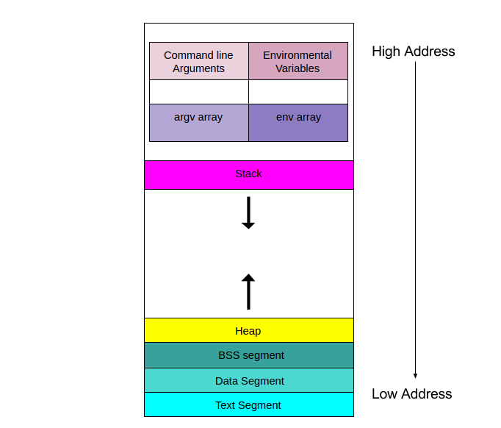
Stack:
This area is for storing all the data required by a function call. Like the arguments (parameter values), return address back to the call function and space for the local variables of the function.
Heap:
This is the segment where dynamic memory allocation happens. In C language which is managed by malloc, new and free.
BSS (Block started by Symbol):
It contains the uninitialised data segment i.e. initialized to arithmetic 0 before the program starts to execute. Primarily consists of the global variables.

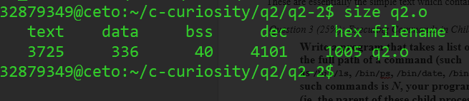
Data segment:
This segment of memory contains the global variables which are initialised by the developer during production. This segment is read-only, since the values of the variables can be altered at run-time.
Text segment:
These are essentially the simple text which contains the executable instructions for a program.

Question 3 (25%): Executing Commands in Child Processes
Write a program that takes a list of command line arguments, each of which is the full path of a command (such as /bin/ls, /bin/ps, /bin/date, /bin/who, /bin/uname etc). Assume the number of such commands is N, your program would then create N direct child processes (ie, the parent of these child processes is the same original process), each of which executing one of the N commands. You should make sure that these N commands are executed concurrently, not sequentially one after the other. The parent process should be waiting for each child process to terminate. When a child process terminates, the parent process should print one line on the standard output stating that the relevant command has completed successfully or not successfully (such as "Command /bin/who has completed successfully", or "Command /bin/who has not completed successfully"). Once all of its child processes have terminated, the parent process should print "All done, bye-bye!" before it itself terminates.

Source code listing

The Linux executable, source code for the question along with the test files and output screenshots are attached.
The following code checks if the number of command line arguments are more than one because the first argument for executing a C program is the typical ./a.out or the executable name. The program creates an array of child processes which is equal to the number of command line arguments passed. After this, the program checks for the occurrence for the ‘/’ in the command and pass the entered command to the execl function which replaces an existing C function with another function. The program has another loop for managing the parent which waits for the child process to execute. It uses the macros WIFEXITED() which returns 1 if the child process executes normally, otherwise 0.

The source code for the program is listed:

#include <stdio.h>
#include <stdlib.h>
#include <unistd.h>
#include <sys/wait.h>
#include <sys/types.h>
#include <string.h>

int main(int argc, char *argv[]){

/**
* the program needs at least one argument to execute
*/
if(argc > 1){
// a collection of number of arguments passed to make the child concurrent
pid_t pid[argc];

char *commandName; // stores the command name
int status; // gives the status

for(int i = 1 ; i < argc; i++){

pid[i-1] = fork();

if(pid[i-1] < 0){

perror("fork unsuccessful ");

exit(1);

} else {

if(pid[i-1] == 0){

commandName = strchr(argv[i], '/'); // find the occurrence of '/'

// execl (path, commandName, NULL)

execl(argv[i], commandName, (char*)0);

perror("execl failed...\n");

exit(1);
}
}

printf("%s \n", argv[i]);
}

// for loop for controlling the parent process for concurrency
for(int i=1; i<argc; i++){

wait((int*)0);

// testing
printf("Command %s has finished executing \n", argv[i]);

sleep(2);

if(WIFEXITED(status)){

const int EXIT_STATUS = WEXITSTATUS(status);
// testing
printf("exit status for the child was %d \n", EXIT_STATUS);
}
}
}
else {
printf("No path entered");
}

printf("All done bye-bye \n");

return 0;
}

Testing for question 3:

Note: The output listing for each of the test case discussed is attached in the folder q3 of the zip file.

Test case : program compilation:
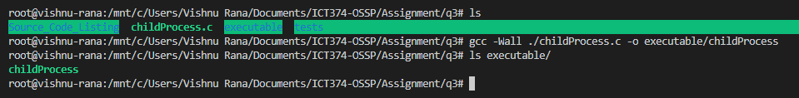

Success: The program successfully compiled and an executable file was created in the executable folder.

Test case : Executing the program with no command line arguments:
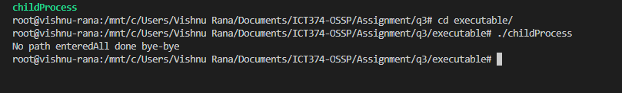

Success: The program needs at least some command to execute in the child process.

Test case: Executing the program with only one valid arguments:
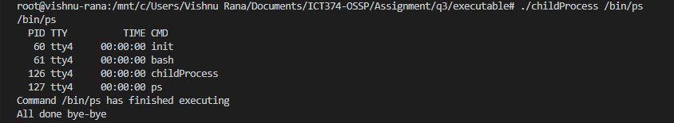

Success: The command is executed in the child process as no error status is reported on the console.

Test case: (testing for concurrency) executing multiple commands inside the child process:
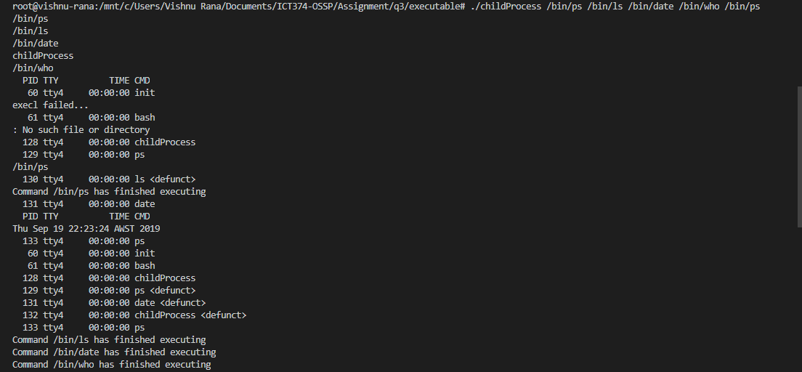
Success: All the commands are executed asynchronously as the invalid command failed at index 5 failed before the valid ones executed.

Test case: Testing for all invalid command line arguments
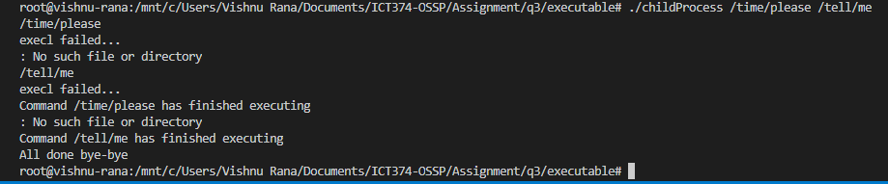
Success: All the commands of the executed in the child process with “All done bye-bye”.

Question 4 (25%): Reporting Information of Files
Write a C program, myls.c, that is similar to the standard Unix utility ls -l (but with much less functionality). Specifically, it takes a list of command line arguments, treating each command line argument as a file name. It then reports the following information for each file:
- user name of the owner owner (hints: Stevens & Rago, 6.2.);
- group name of the group owner; (hints: Stevens & Rago, 6.4.);
- the type of file;
- full access permissions, reported in the format used by the ls program;
- the size of the file;
- I-node number;
- the device number of the device in which the file is stored, including both major number and minor number (hints: Stevens & Rago, 4.23.);
- the number of links;
- last access time, converted to the format used by the ls program (hint: Stevens & Rago, 6.10.);
- last modification time, converted to the format used by the ls program;
- last time file status changed, converted to the format used by the ls program;
brief explanation:
The following program simulates the ls -l command uses a long listing format i.e. provides the user with the information about all the files in the current directory by default. The program is completely modular, readable and easy to follow as it re-uses the same pattern to get information from all the functions and print to console. The program achieves all the 11 subparts of the question. Appropriate system calls have been made for fetching the information about the directory/files. All of them have been mentioned in the source code listing and the testing for the program.

Source code listing:

#include <stdio.h>
#include <string.h>
#include <sys/types.h>
#include <sys/stat.h>
#include <unistd.h>
#include <time.h>
#include <pwd.h>
#include <grp.h>
#include <sys/sysmacros.h>
#define BUF_SIZE 256
/**
* The function returns the time credentials
* of the file/dir.
*/
char* printTime(time_t time, char *buff){
struct tm *timeinfo;
timeinfo = localtime(&time);
char * st = buff;
// the function strftime formats the broken-down time tm
// according to the format specs.
// %b -> abbreviated month name
// %d -> day of the month ranging from 1 - 31
strftime(buff, 8, "%b %d\t", timeinfo);
buff = buff +7;
// %R -> 24 hour notation %H:%M
strftime(buff, 90, "%R", timeinfo);

return st;
}

/**
* The function returns the group name
*/
char* getGroupName(char *buff, gid_t gid){
struct group *grp;
// the function getgrgid returns a pointer to a structure containing
// the group database that matches the group ID gid
grp = getgrgid(gid);
strcpy(buff, grp->gr_name);
return buff;
}

/**
* The function returns the username
*/

char* getUserName(char *buff, uid_t uid){
struct passwd * pwd;
//getpwuid function searches for a matching uid in the user Database.
pwd = getpwuid(uid);
strcpy(buff, pwd->pw_name);
return buff;
}

/**
* The function is essentially a switch case
* which returns the file type.
*/
char* getFileType(int mask){
// bitwise AND for considering the bits involved in the file type
int type = mask & S_IFMT;
switch(type){
case S_IFSOCK : return "socket";
case S_IFLNK : return "symbolic link";
case S_IFREG : return "regular file";
case S_IFBLK : return "block device";
case S_IFDIR : return "directory";
case S_IFCHR : return "char device";
case S_IFIFO : return "FIFO";
}
}

struct permMask{
// permissions
char permission;
// mask
short mask;
// targeted index for mapping
int targetIndex;
};

char* getFilePermissions(char * ret, int mask){
//No permissions
const int NONE = 00;

//mapping of output character, file permission mask and output index
//for each file permission
const struct permMask masks[] = {
{'r', 04, 0}, {'w', 02, 1}, {'x', 01, 2}
};
const int numMasks = 3;
strcpy(ret, "---");
//For each mask, check if its target bit is set, and assign the output character if it is
for (int i=0; i < numMasks; i++){
//target bit check
if ( (mask & masks[i].mask) == masks[i].mask ){
//assign output character
ret[masks[i].targetIndex] = masks[i].permission;
}
}
return ret;
}

/**
* @param buffer - String of at least size 10. Will be filled with file
* permission info. End of string will be set to null.
*/
char * getAccessPermissions(char * buffer, int mask){
//get permission bits from mode mask
int permissions = mask & 0777;
//mask out all user permissions (last three bits of permissions mask)
int all_permissions = (permissions & 07);
//mask out owner permissions (first three bits of mask)
int owner_permissions = (permissions & 0700) >> 06;
//mask out group permissions (middle three bits of mask)
int group_permissions = (permissions & 070) >> 03;
//convert bits to string representation at correct buffer indexes.
getFilePermissions(buffer, owner_permissions);
getFilePermissions(buffer + 3, group_permissions);
getFilePermissions(buffer + 6, all_permissions);

return buffer;
}

int main(int argc, char* *argv){
struct stat buf;
char buff[100];
int i, res;
for(i = 1; i<argc; i++){
res = stat(argv[i], &buf);
printf("%d\n", res);
if(res != -1){
printf("username : %s \n", getUserName(buff, buf.st_uid));
printf("groupname : %s \n", getGroupName(buff, buf.st_gid));
printf("size : %ld\n", buf.st_size);
printf("type : %s\n", getFileType(buf.st_mode));
printf("permissions : %s\n", getAccessPermissions(buff, buf.st_mode));
printf("INode Info : %ld\n", buf.st_ino);
printf("Number of Links : %ld\n", buf.st_nlink);
printf("Device major version : %d\n", major(buf.st_rdev));
printf("Device minor version: %d\n", minor(buf.st_rdev));
printf("accessed time : %s\n", printTime(buf.st_atime, buff));
printf("modified time : %s\n", printTime(buf.st_mtime, buff));
printf("created time : %s\n", printTime(buf.st_ctime, buff));
}
else{
printf("no such file\n");
}
}
return 0;
}

Tests:

Test : program compilation:
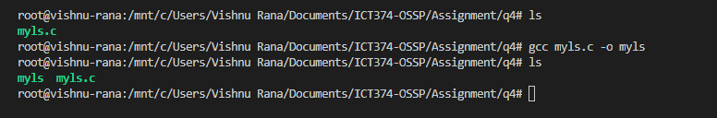
Success: program compiles and an executable is created in the direcory
Test : create a file and check if the program give all the details about the newly created.
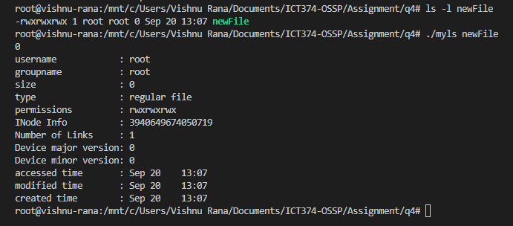
Success: The program prints all the information about the file in detail.
Snapshot for the verification of other file credentials:
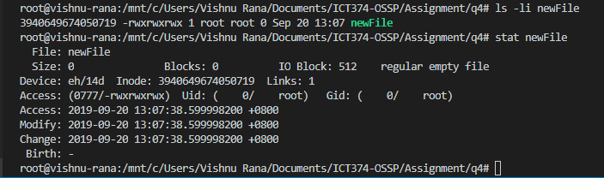
ls -li command with newFile gives the inode number for the file i.e. 3940649674050719 which is matched by the i-node number printed by the program the following outputs are attached in the q4_output.txt file.
After this command, the stat newFile prints all the details of the file like the Number of links, I-node (again), gid, uid and the permissions followed by the last access, modified and change date with times.
Another test documentation is there for the hidden folder (.)
The program successfully identifies the type of file to be a Directory and prints all the required information on the terminal.
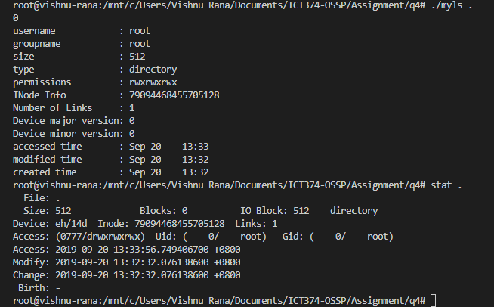
Hence, the program successfully implements all the eleven sub-parts of the question i.e.:
- user name of the owner owner
- group name of the group owner;
- the type of file;
- full access permissions, reported in the format used by the ls program;
- the size of the file;
- I-node number;
- the device number of the device in which the file is stored, including both major number and minor number
- the number of links;
- last access time, converted to the format used by the ls program
- last modification time, converted to the format used by the ls program;
- last time file status changed, converted to the format used by the ls program.

Limitation:
When the program is entered without passing any command line arguments. The program does not report the information about the current directory.
Screenshot:

