Name : Vivek Maliye (Class ID: 25)

**CODE**

1. **import** re  
password = input(**"type the password that has 6 to 12 characters"**)  
**if** len(password) >= 6 **and** len(password) <= 12 **and** re.search(**"[$#@!]"**,password) **and** re.search(**"[A-Z]"**,password) **and** re.search(**"[a-z]"**,password) **and** re.search(**"[0-9]"**,password):  
 print(**"password is valid"**)  
**else**:  
 print(**"password is not valid"**)

2. a = input(**"ENTER YOUR SENTENCE"**)  
d = a.split(**" "**)  
print(d)  
**if** len(d)%2 == 0:  
 print(**"Middle words are"**)  
 print( d[int(len(d)/2)], d[int(len(d)/2 - 1)] )  
**else**:  
 print(**"Middle word is"**)  
 print(d[int(len(d)//2)])  
**def** revSen(Sentence):  
 words = Sentence.split(**" "**)  
 newWords = [word[::-1] **for** word **in** words]  
 newSentence = **" "**.join(newWords)  
 **return** newSentence  
**def** Lar_word(Sentence):  
 pool = Sentence.split()  
 pool.sort(key=len)  
 **return** pool[-1]  
Sentence = input(**"Enter anything"**)  
print(**"Reverse:"**,revSen(Sentence))  
print(**"Largest Word:"**,Lar_word(Sentence))

3. **def** trip(t, n):  
 temp = **False  
 for** a **in** range(0, n - 2):  
  
 **for** b **in** range(a + 1, n - 1):  
  
 **for** c **in** range(b + 1, n):  
  
 **if** (t[a] + t[b] + t[c] == 0):  
 print( t[a], t[b], t[c])  
 temp = **True  
  
 if** (temp == **False**):  
 print(**" No triplets found "**)  
  
  
t = [int(x) **for** x **in** input().split()]  
n = len(t)  
trip(t, n)

4. web = set([**"rahul"**, **"vivek"**, **"saidu"**, **"venky"**])  
pyth = set([**"vivek"**, **"avinash"**, **"smaran"**])  
print(**"Students in both web and python"**)  
print (web.intersection(pyth))  
inters = web.intersection(pyth)  
only_web = web.difference(inters)  
only_pyth = pyth.difference(inters)  
print(**"Students not common in both classes"**)  
no_inters = only_pyth | only_web  
print(no_inters)

OUTPUT

1. 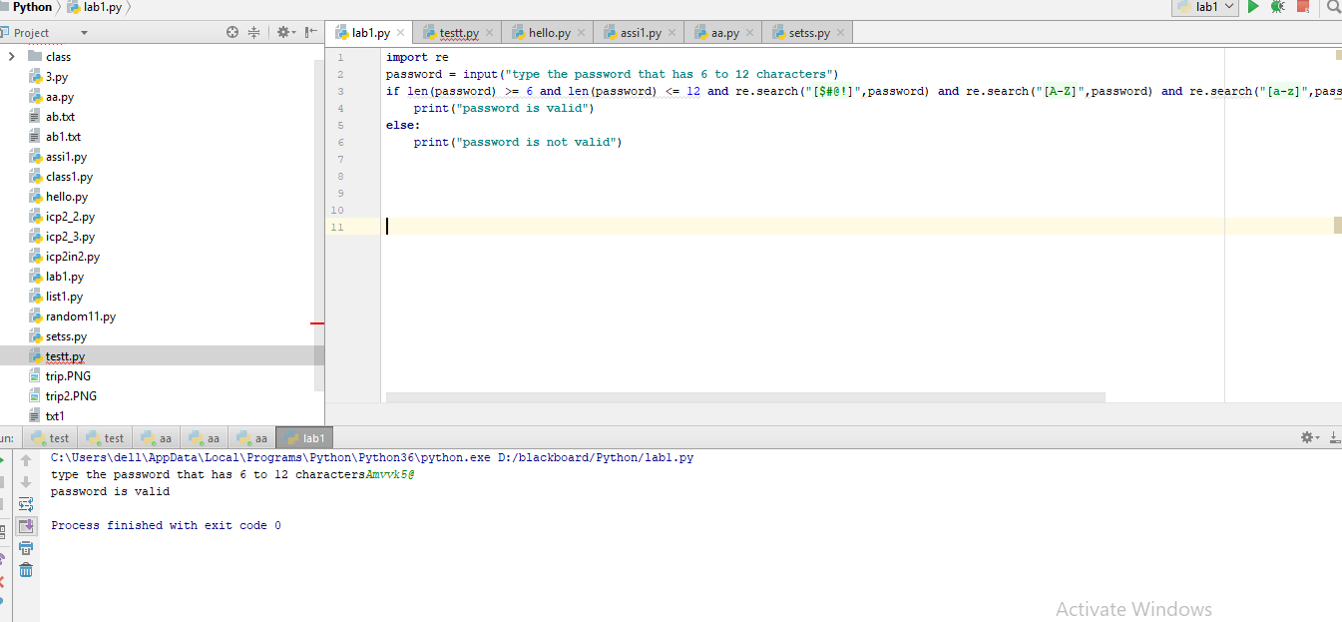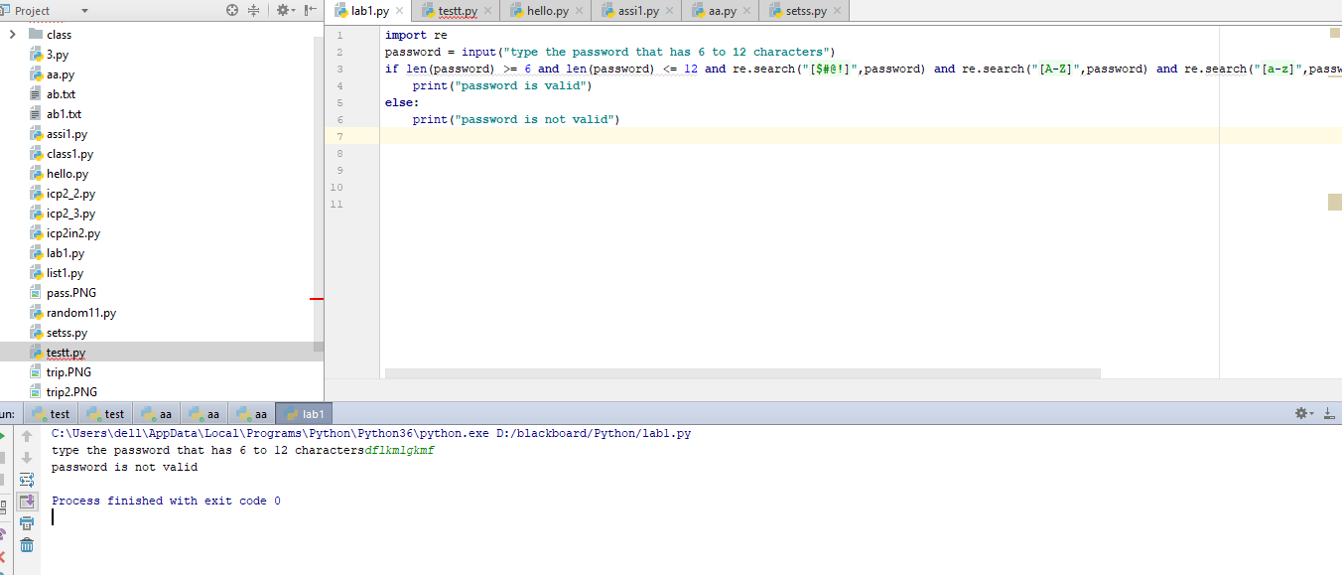

2. 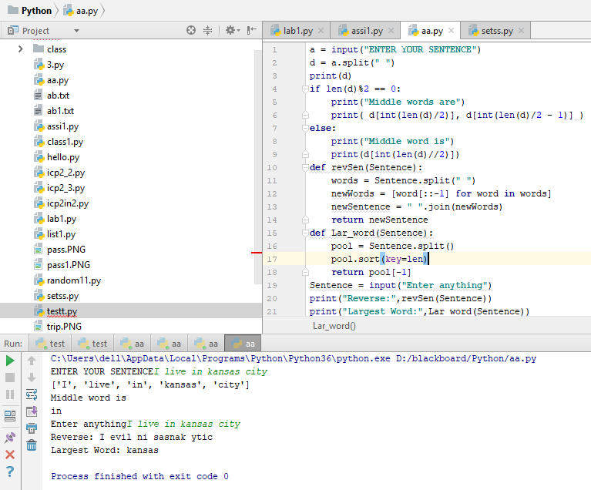

3.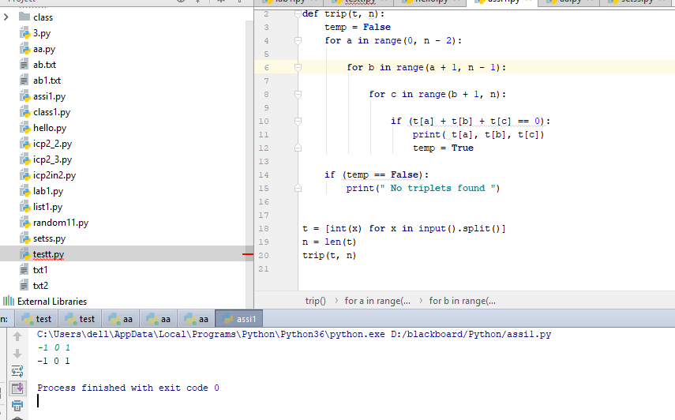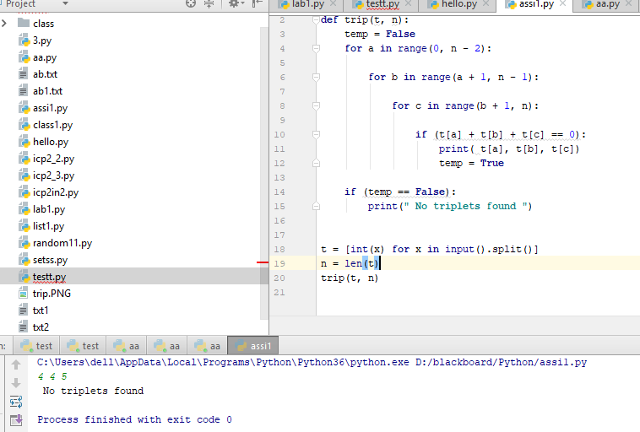

4.