Data Modeling (DML) Layer

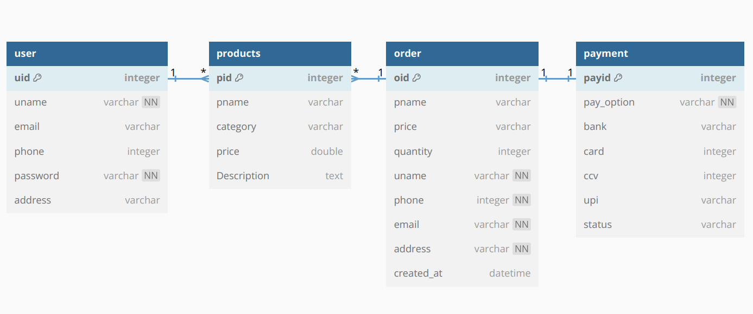

Entity Relationship (ER) Diagram

