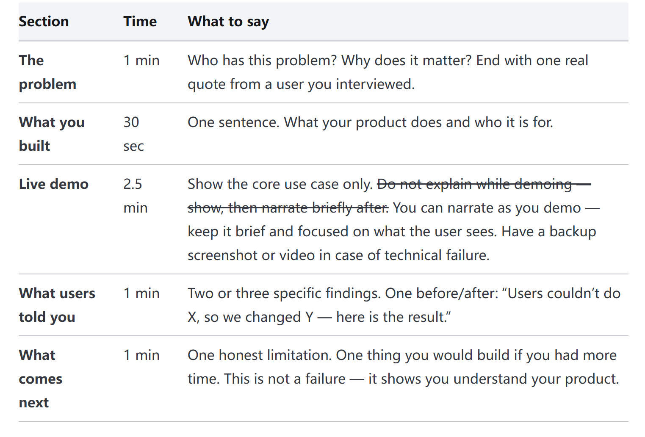
1. The Problem
As the figure shows, personalized skincare is growing fast. But while the market is expanding, the way people choose products is still often quite blind. Many users still rely on influencers, online reviews, friends’ recommendations, or simple labels like oily, dry, or sensitive skin. These sources can be useful, but they are too general.
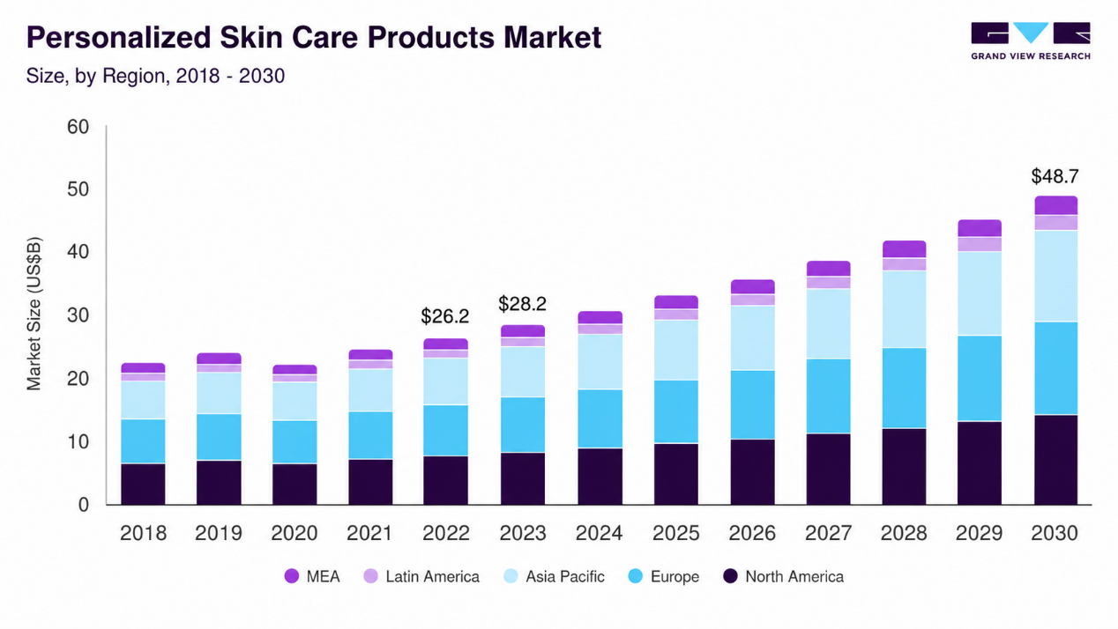
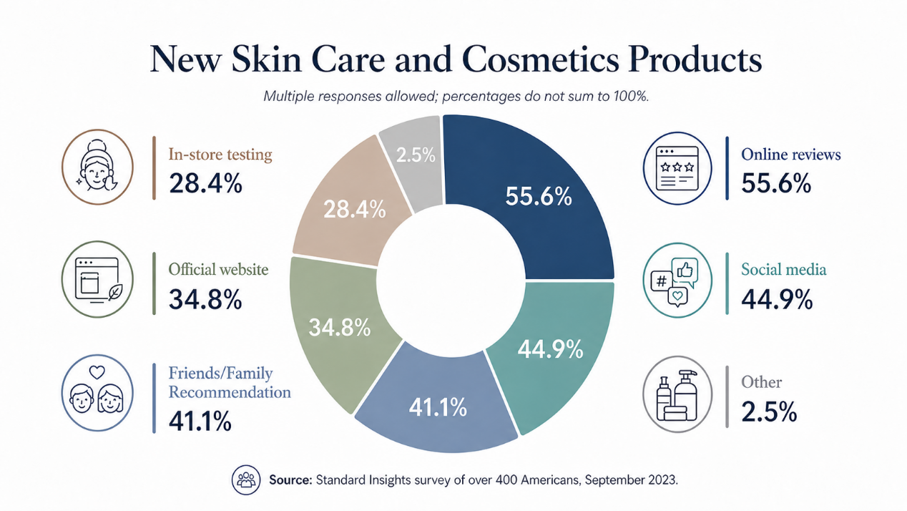
For example, my friend and I both have oily skin. But my friend may also have uneven texture and redness, while I may have dehydration. This means that same skin type, different skincare needs. One user told us, “I know I have skin concerns, but I don’t really know what my skin needs or which ingredients I should choose.” That is the real problem. There are already many skincare products on the market, but users do not know which one is truly right for their own skin.

2. What you built
Lumière Beauty is an AI-powered skin analysis platform for skincare users who want personalized guidance on their skin condition, lifestyle habits and even ingredients.
3. Live demo
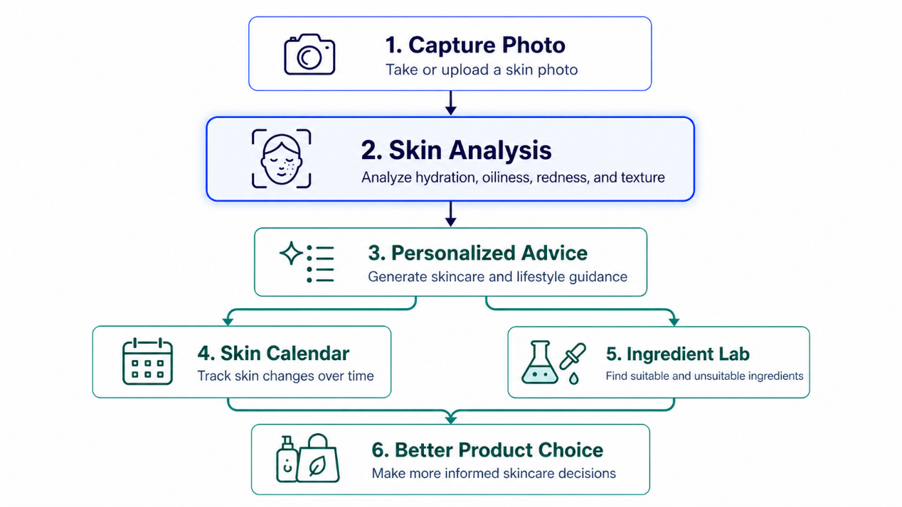
4. What users told you
First, users wanted the skin analysis to feel more accurate and reliable. In the early version, users could only upload a photo, and the results were sometimes inaccurate because of poor lighting or image quality. So, we added real-time camera capture to make the scan faster, clearer, and convenient.
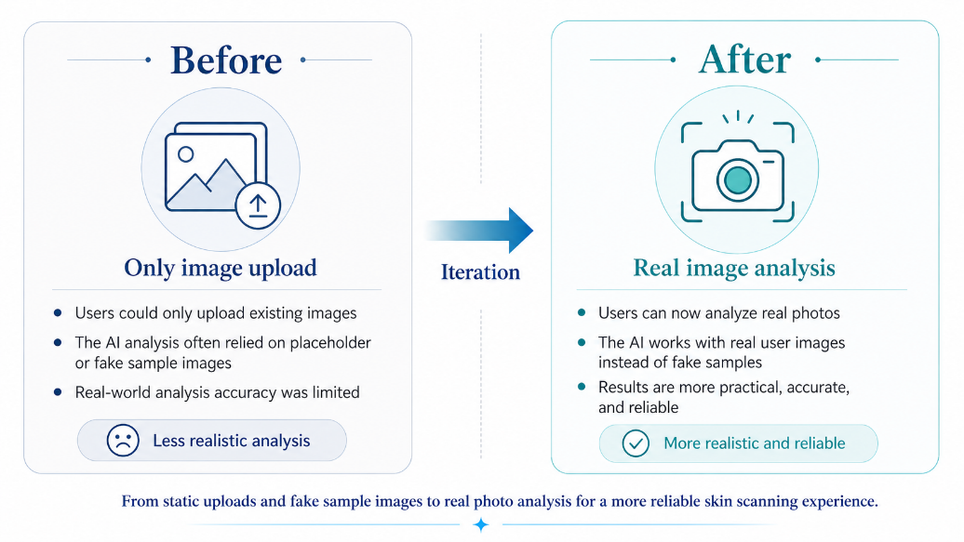
Second, users told us that a skin result alone was not enough. In the first version, we only showed the analysis, so users knew their skin condition but did not know what to do next. Then we added product recommendations in the second version, and in the third version, we made the guidance more complete, including lifestyle advice.
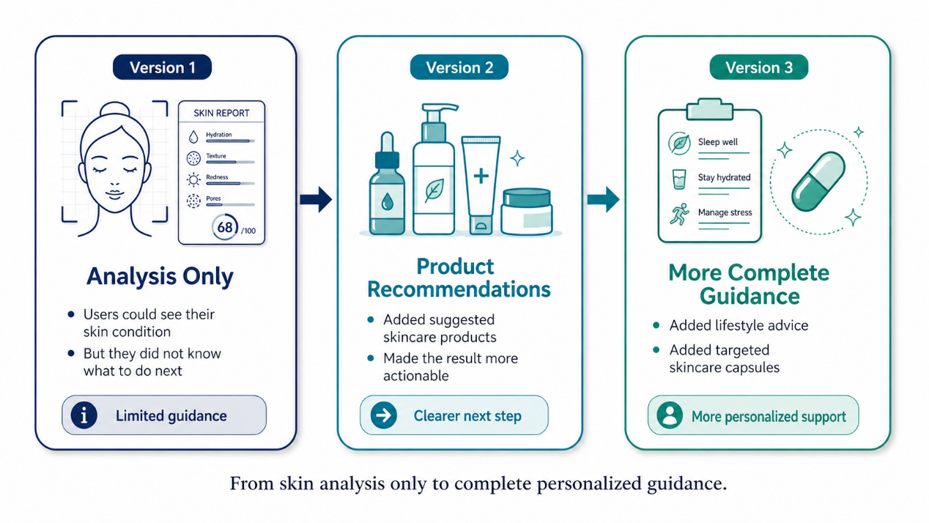

5. What comes next
One limitation is that one photo only captures one moment. It can show how the skin looks today, but it cannot show the full journey of how the skin changes over time.
That is why our next step is to further develop the Skin Calendar. In the future, it will not just record results. It will track skin history, compare changes, and use long-term data to give more personalized advice.
So, Lumière will grow from a one-time skin analysis tool into a long-term skincare management platform.
