# GIT Tutorial

GIT

* It is application/software
* Distributed version control system.

**Distributed vs Centralized**

Distributed version control means track the version in the central and in the local systems also.

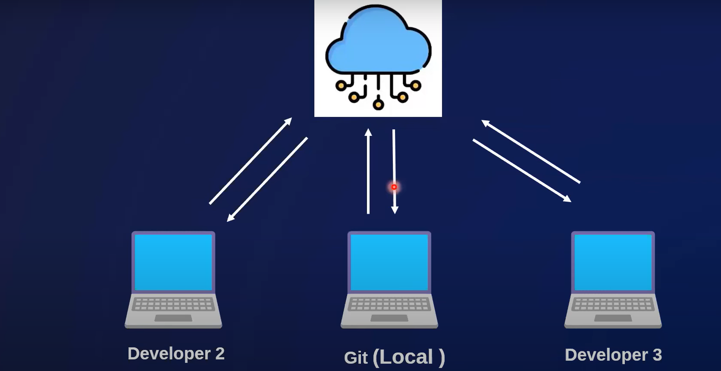



**Centralized:**

Centralized means track the versions in only central system NOT in local systems.



# GIT vs GIT Hub

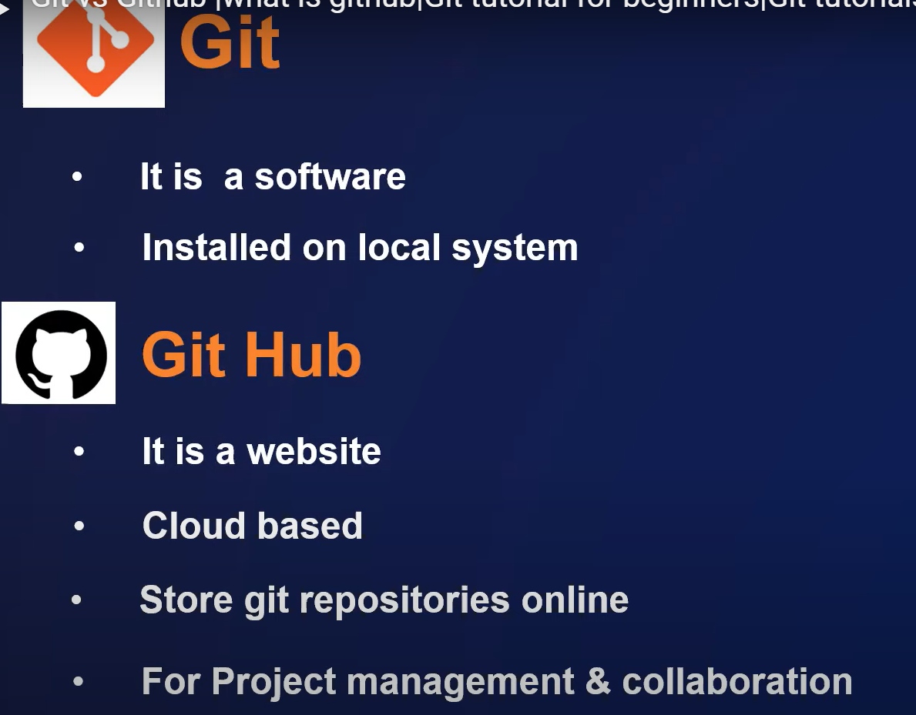

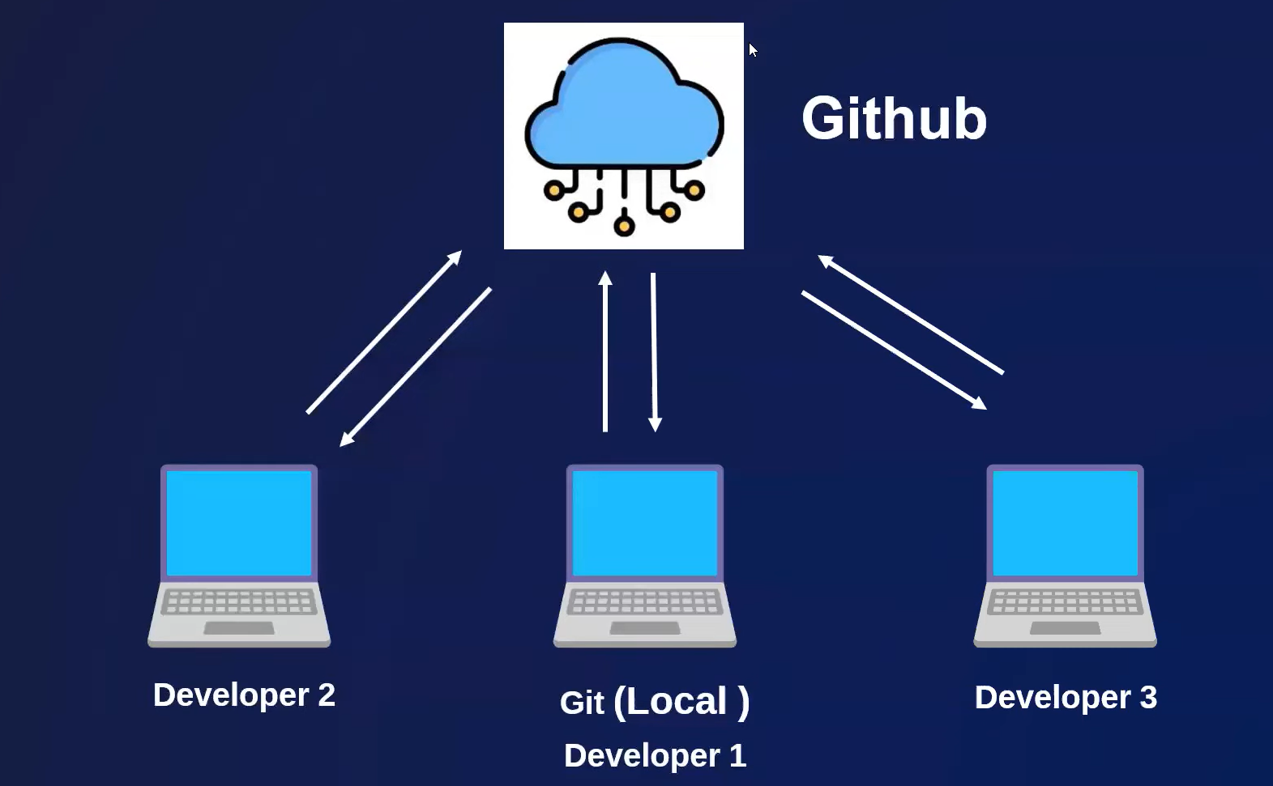

# How to install GIT

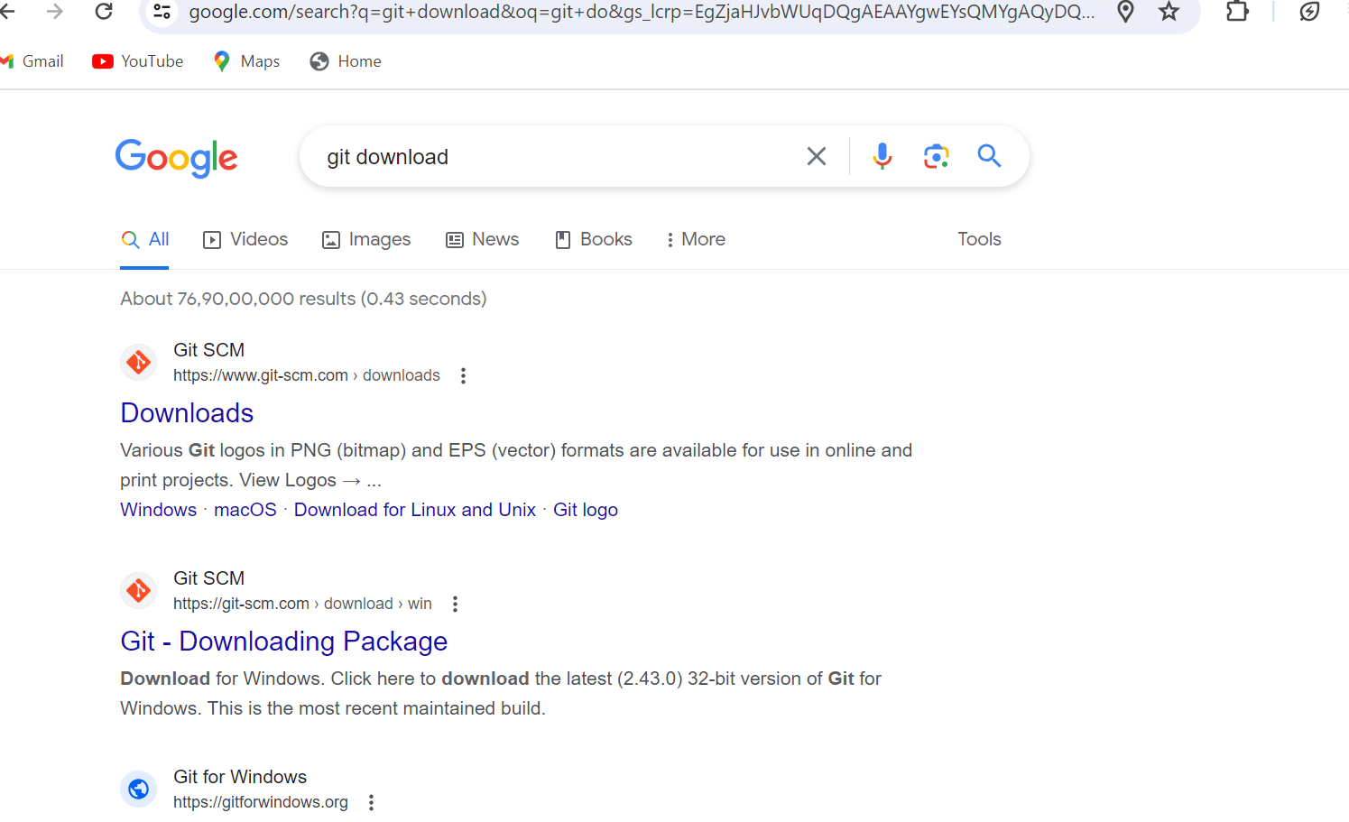

# Create Git Hub Account

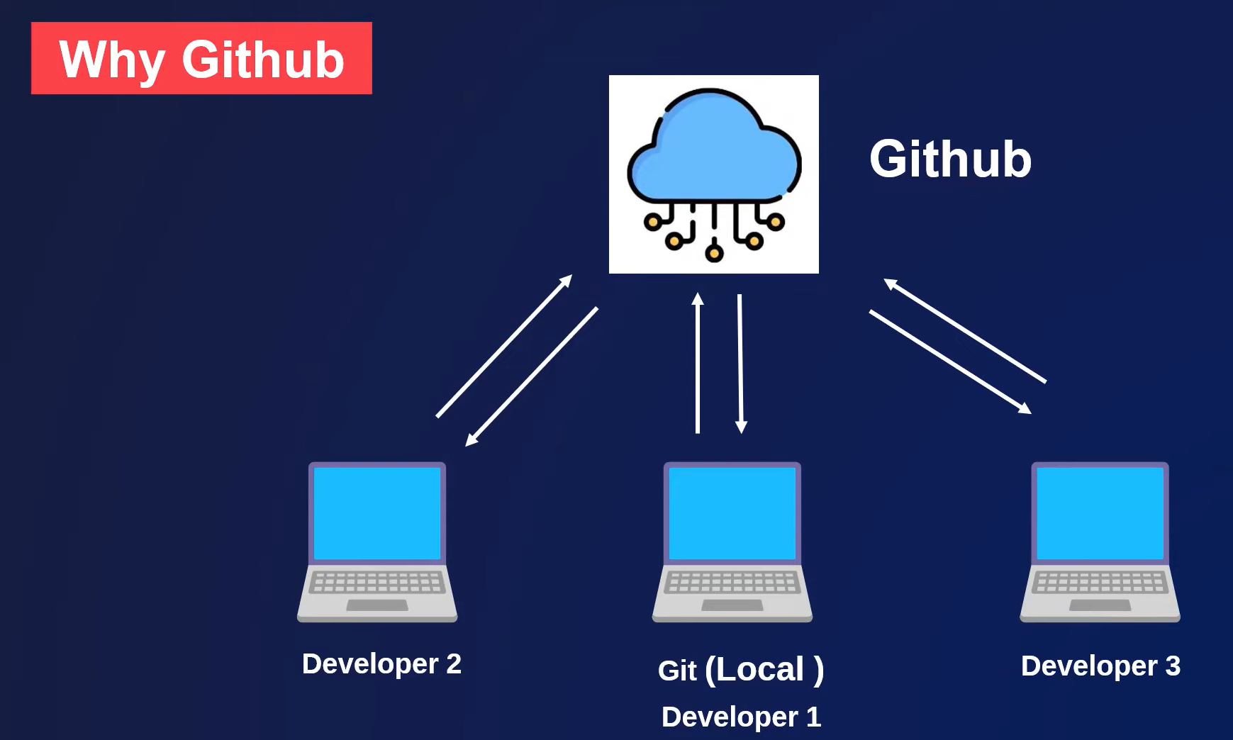

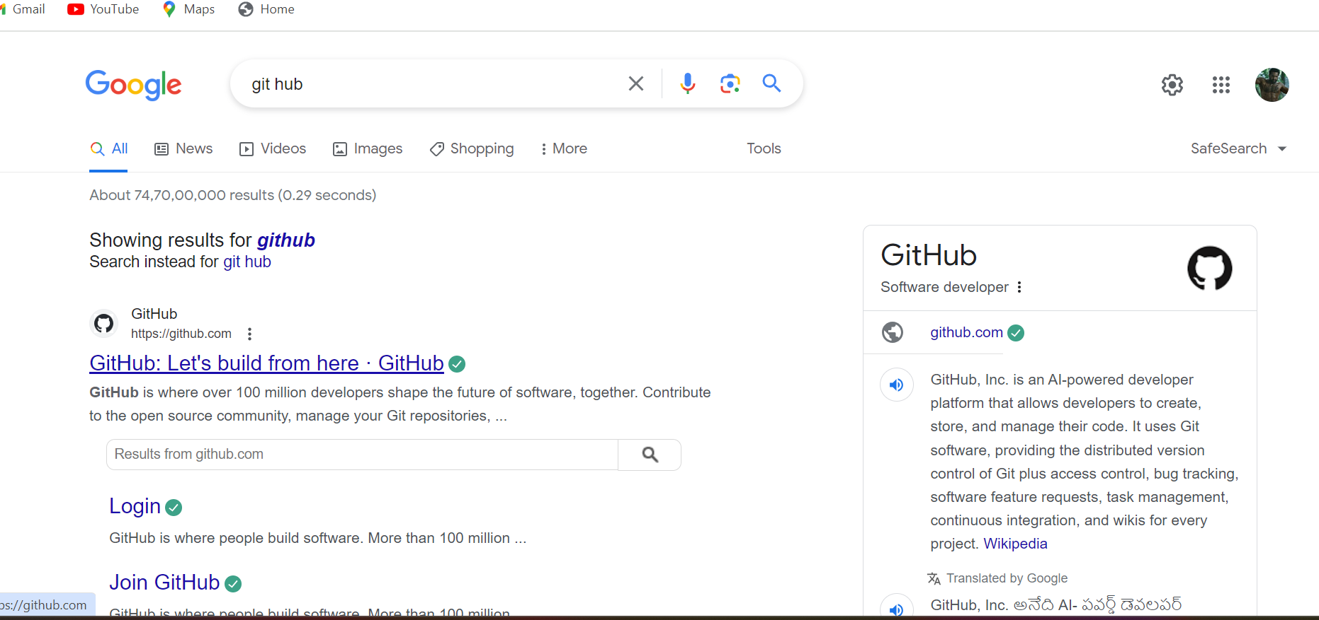

# Git Configuration

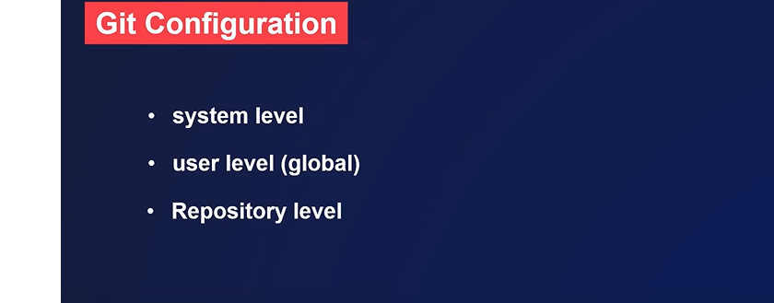

For checking system git config use this command: git config –system --list



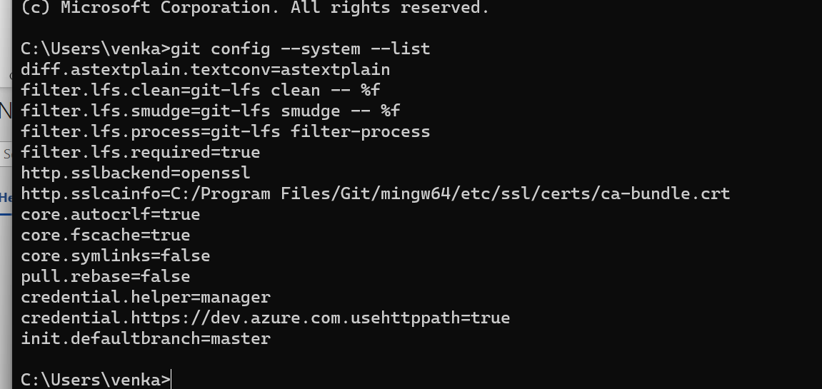



For checking Global(user) git config use this command: git config –global –list





If you want all config like system+ global then use this command: git config –list

If you want to use git then you should config the git with username and gmail(gmail use your organization mail)

Set the username commad: **git config –global user.name “venkat”**

Set the mail command: **git config –global user.email “mvkcode27@gmail.com”**

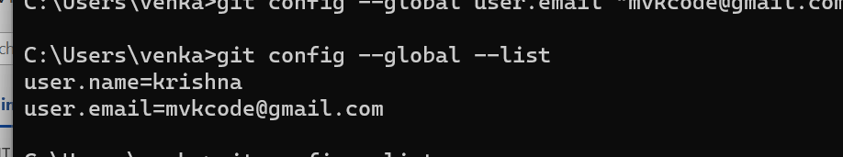



# Git Workflow

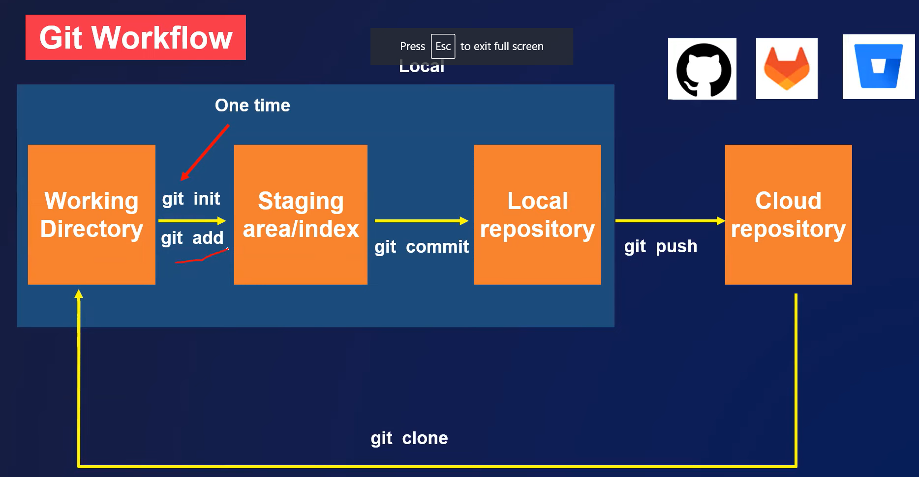

# Git project example with basic commands

* Create git repository
* Basic commands

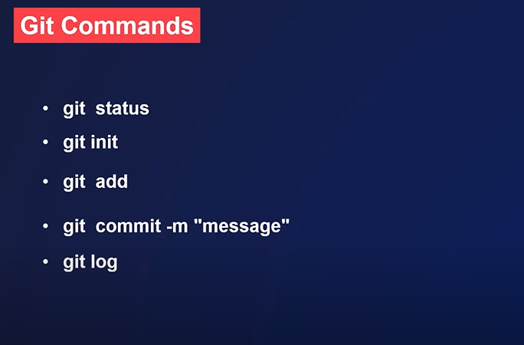

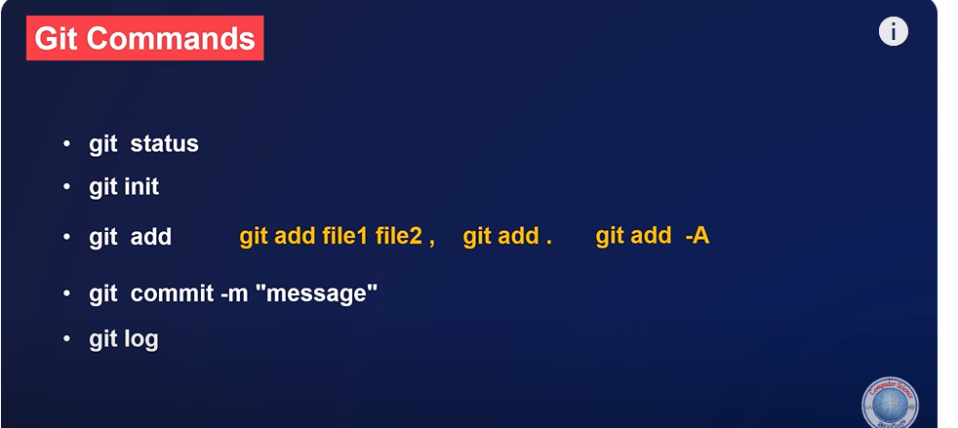Git add. And git add -A both uses for adding new files into git.

Difference between **git add.** And **git add -A**

# How to upload a project in Git hub

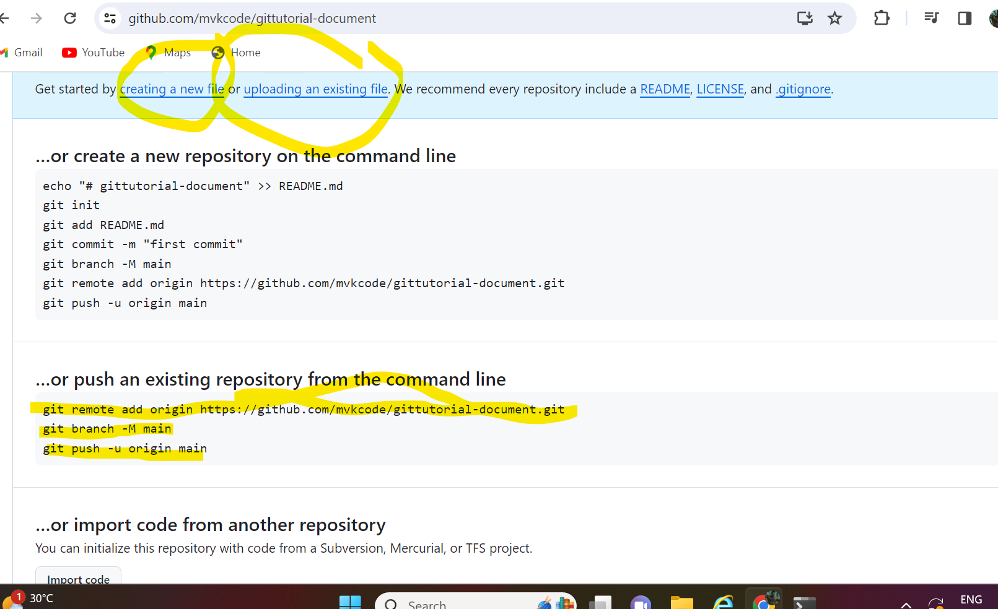

To link the local repository to remote use this : git remote add origin https://github.com/mvkcode/gittutorial-document.git

To rename the local repository branch use this : git branch -M main

To push the content from local to remote use this: git push origin main



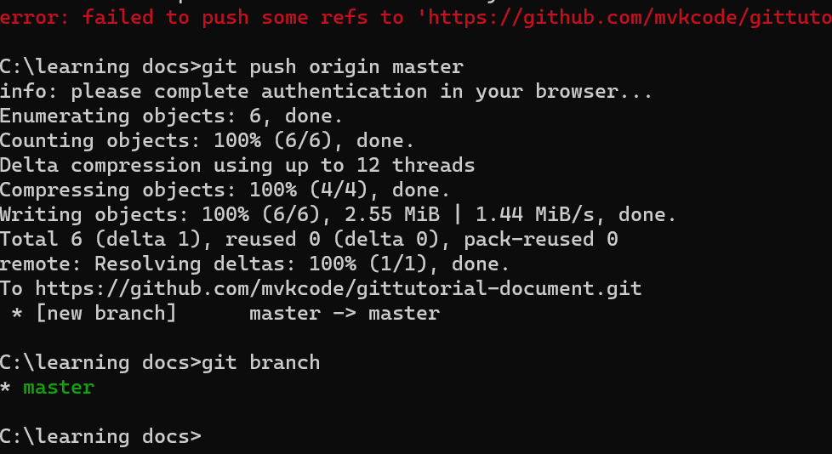

# How to create access token in Git Hub