Amazon RDS for MySQL

Amazon Relational Database Service (Amazon RDS) is a web service that makes it easier to set up, operate, and scale a relational database in the cloud.

It provides cost-efficient, resizable capacity for an industry-standard relational database and manages common database administration tasks.

MySQL is the world's most popular open source [relational database](https://aws.amazon.com/relational-database/).

Amazon RDS makes it easy to set up, operate, and scale MySQL deployments [in the cloud](https://aws.amazon.com/what-is-cloud-computing/).

With Amazon RDS, you can deploy scalable MySQL deployments in minutes with cost-efficient and resizable hardware capacity.

Amazon RDS frees you up to focus on application development by managing time-consuming database administration tasks including backups, software patching, monitoring, scaling and replication.

Features

* Easy, Managed Deployments
* Fast, Predictable Performance
* Availability & Reliability
* Backup & Recovery
* Isolation and Security

Create and Connect to a MySQL Database

**Step 1: Create a MySQL DB Instance**

**Select RDS from Database**

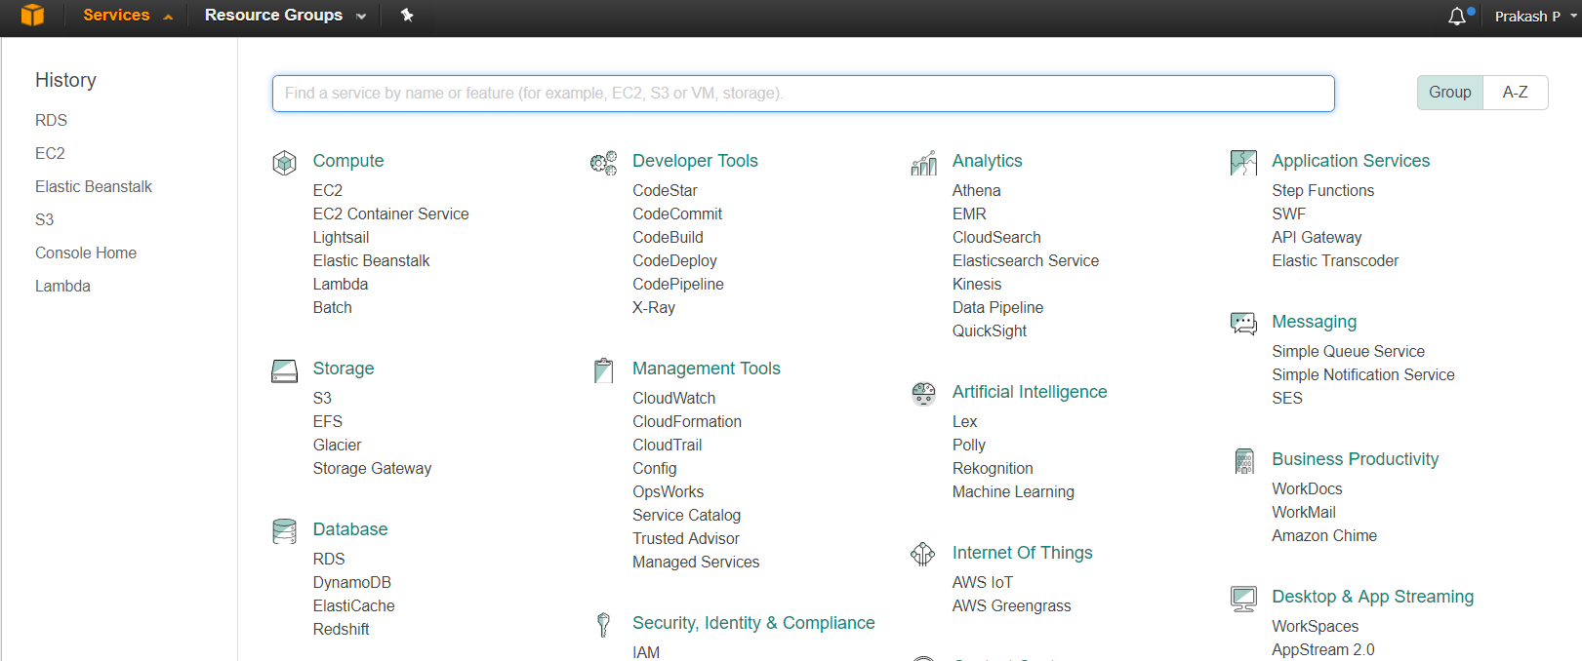

**Select Get Started Now**

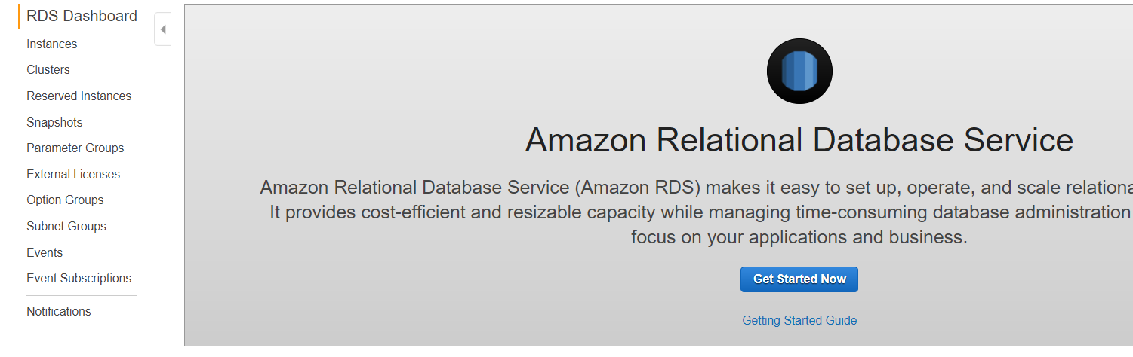

**Step 2: Check Free tier eligible only and then select MySQL**

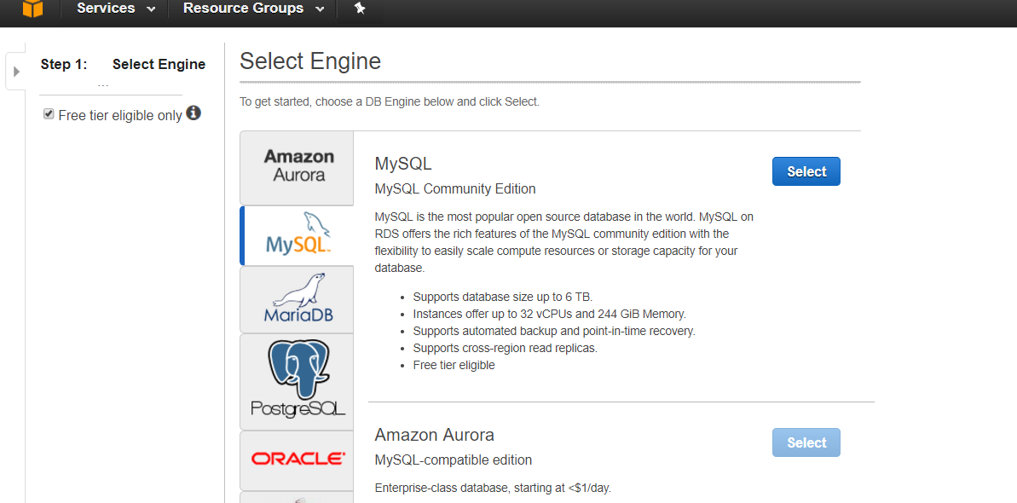

**Step 2.1 - Specify DB Details**

|  |
| --- |
| **Select DB Instance Class from Instance Specifications** |
| |  | | --- | | **Settings 🡪 DB instance identifier, Master User name and Password.** | |  | |  | |
|  |

**Step 2.2 Configure Advanced Settings 🡪 Launch DB Instance**

**DB instance will be launched successfully.**

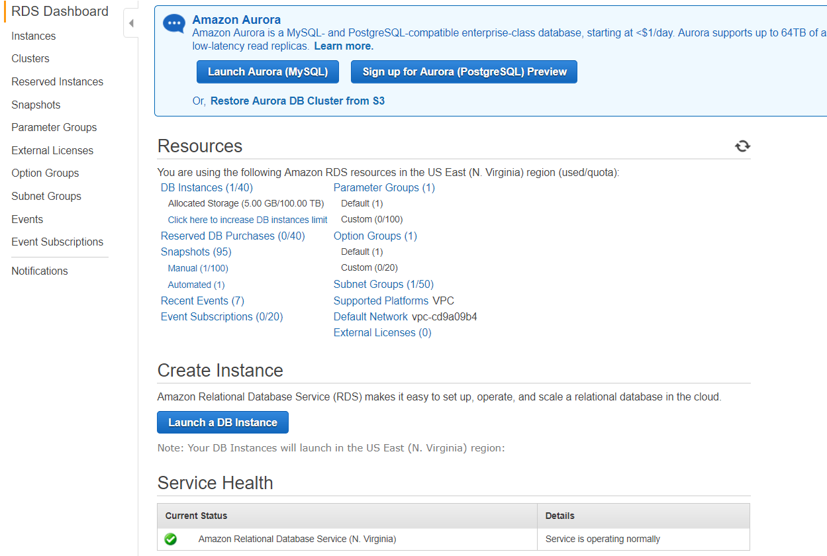

**Step 3: I hope you downloaded, MySQL Client.**

**Step 4: Connect to the MySQL Database**

**Step 4.1 : Launch the MySQL Workbench application and go to Database > Connect to Database**

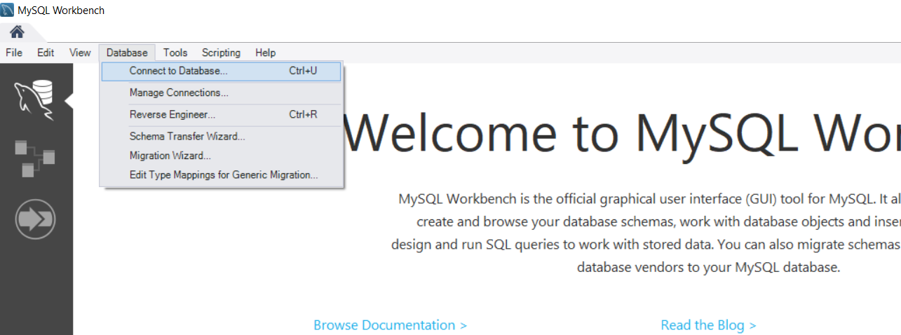

**Step 4.2: Enter the following details.**

* Hostname: You can find your hostname on the Amazon RDS console as shown in the screenshot to the right.
* Port: The default value should be 3306.
* Username: Type in the username you created for the Amazon RDS database.  Our example was “ awsusernpp.'
* Password: Click *Store in Vault* and enter the password you used while creating the Amazon RDS database.

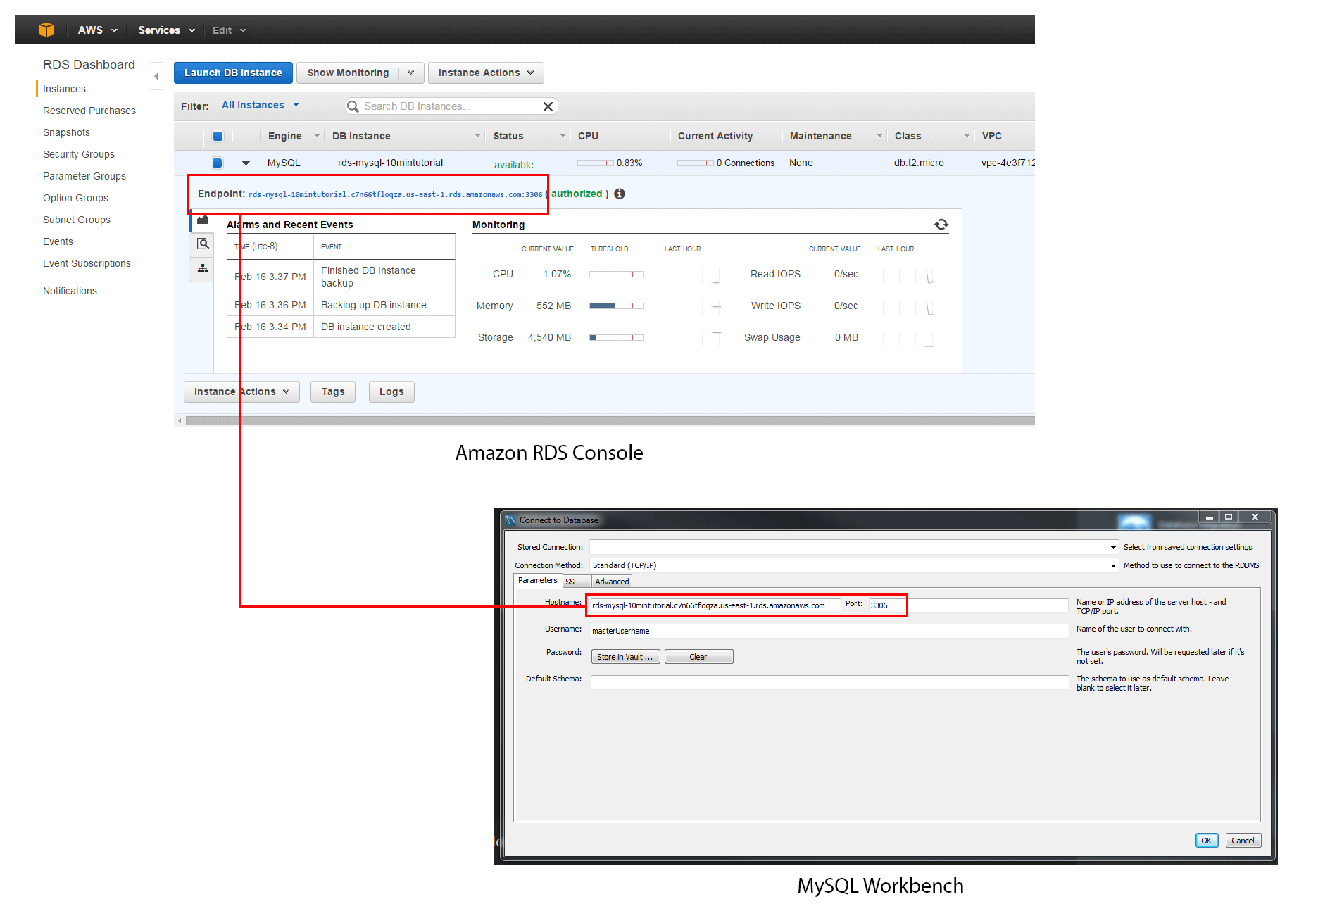

**Step 4.3: It will open the MySQL Workbench client .**

**Step 5: User can able to create a schema and perform any kind of a data management activities.**