1. PROJECT TITLE: QDCNN-Fuzzy-DMN:A Hybrid deep learning for honeypot identification
2. HARDWARE REQUIREMENTS
OS-Windows 10
RAM-8GB
ROM-More than 100 GB
GPU-Yes
CPU-1.7 GHz

3. SOFTWARE REQUIREMENTS
Software name(Python): Version: 3.9.11
(Download link: https://www.python.org/downloads/release/python-3911/)
Click -> Windows installer (64-bit).
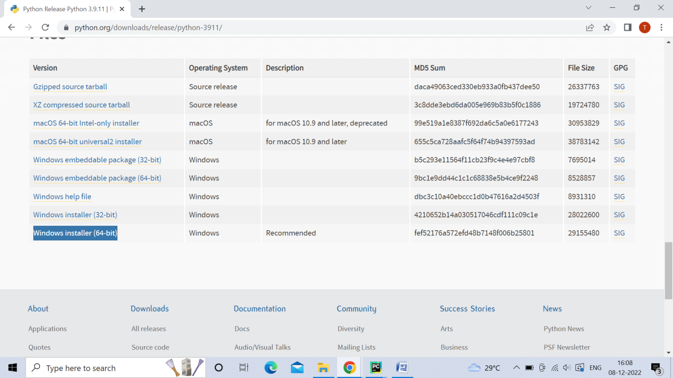

Software name: PyCharm: Version: 2020.3.3
(Download link: https://www.jetbrains.com/pycharm/download/other.html)
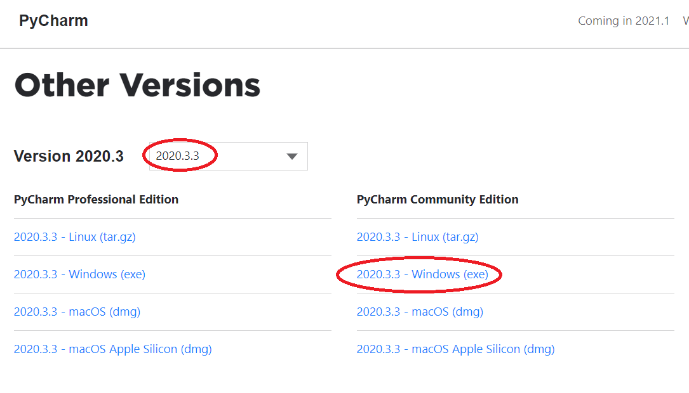
(For installation procedure, please refer the doc “steps to install python.doc”)

4. HOW TO RUN
Step 1: Loading the project in PYCHARM
- Open pycharm
- Go to File, select Open browse the project from your drive and select it. So that the project will get loaded into the Pycharm.
- For the first time, Pycharm will take some time to load the settings.
- Please wait if any process is loading on the bottom of the screen.
- Check the Project Interpreter (File -> Settings -> Project: code -> Project Interpreter).
If this location “(C:\Users\---\AppData\Local\Programs\Python\Python39-64\python.exe) is not presented, then add this ‘python.exe’ from the installed location.
- In Pycharm Terminal(bottom left), type the comment “pip install -r requirements.txt”
Step 2: Run the program and getting the results
- From 'current project folder' window in pycharm, Open ‘code-> Main->GUI.py’ and click run button
- In GUI window,
1)Select Dataset,Select (Training data%(eg:50,60,70,80,90) or K-fold(eg:5,6,7,8,9))
2) Click START, after some time the result will be displayed
[Expected Execution time expected: 20-30 minutes]
- Step 3: Generate the graphs plotted in the paper
- From 'current project folder' window in pycharm, open ‘code -> Main->plot_ca.py,plot_pa.py, and click run button.

5. IMPORTANT PYTHON FILE AND DESCRIPTION:
Main-> GUI.py: User Interface, code starts here
Main-> Run.py: Main code
Main-> Performance_Analysis.py: performance analysis code

Main-> plot_ca.py,plot_pa.py: displays graphs in paper.

