Project 06: Titanic Data Visualization

Summary

I choose the titanic data set because of my prior experience with data in my previous projects. This contains demographics and passenger information from 891 of the 2224 passengers and crew on board of Titanic. I have analyzed the dataset to answer the question based on different combinations. What factors made passengers more likely to survive?

Design

While exploring the data set I believed that there could be lot of factors that could have helped Passengers more likely to survive. I have represented some of these factors visually using dimple.js. I choose three different charts to depict these factors.

After using the other charts like pie and line in my initial submission. It looks like they were not clear to the user. I felt that bar chart is sufficient to depict the characteristics clearly for this case.

- Bar Chart to show passengers who survived based on Class and Gender. It clearly depicts that 80% of female passengers who boarded in Class 2 have survived more.

* Choose pink and blue to differentiate between the genders.

- Bar Chart to show passengers who survived based on Age and Class. It clearly depicts that 72% of passengers who are between the age of 40-60 and in First class survived more.

* Choose green palette as per the recommendation by previous reviewer. Darker green depicts the first class, and lighter green depicts the second and third class.

- Bar Chart to show passengers who survived based on Age and Embarked from. It shows that 80% of the passengers in the age group of 60-80 have survived

* Choose default colors as there is no proper way to know which color is the correct for embarked from as we have just a character.

Feedback 1

- Font size within the chart title and the html in the page were not matching.

- Rename the PClass label to Class.

Feedback 2

- Age attribute is not ordered in line chart.

Feedback 3

- Show First class, Second class, Third class instead of showing 1,2,3

- Align Legend title with the chart title

Reviewer feedback

- once percentages are used, the first chart can be removed as you will be able to see likelihood in the 2nd and 3rd plots (also pie charts are not that good for comparisons as you can see that it is difficult to tell the difference between first and third class)

- arrange the legend in sequential order (1st, 2nd, 3rd)

- if class is used for color (not necessary for sex), use a sequential color (light green, green, dark green for example) so that the differences are intuitive

- last I would use age buckets rather than age as it's difficult to extract much meaning from the 3rd plot (the survival rates should be more clear this way)

Resources

dimple.js

Data Files

- data/titanic_data.csv

Initial Charts before implementing feedback.

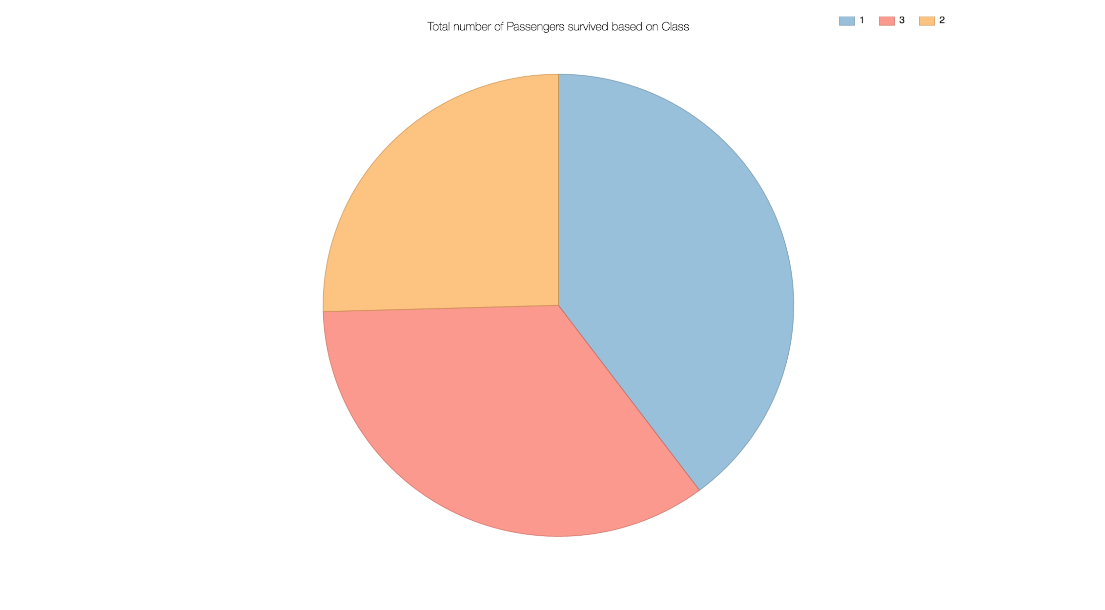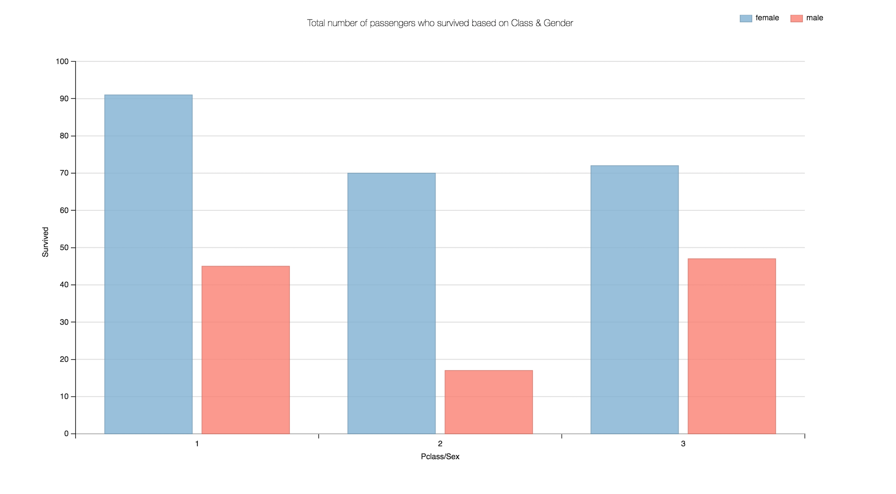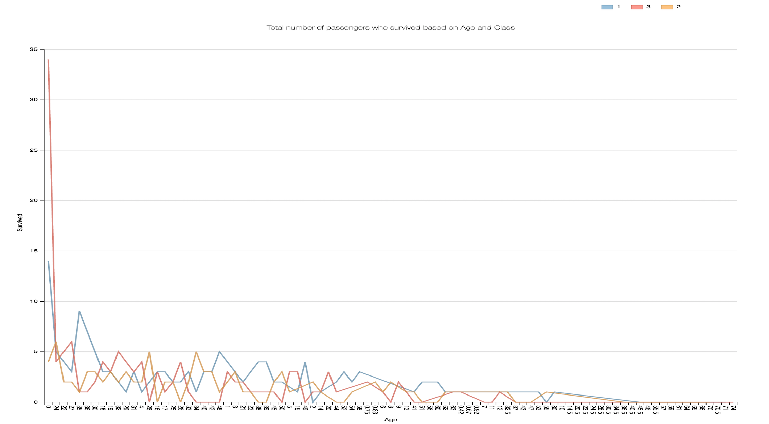

Charts after Implementing feedback.

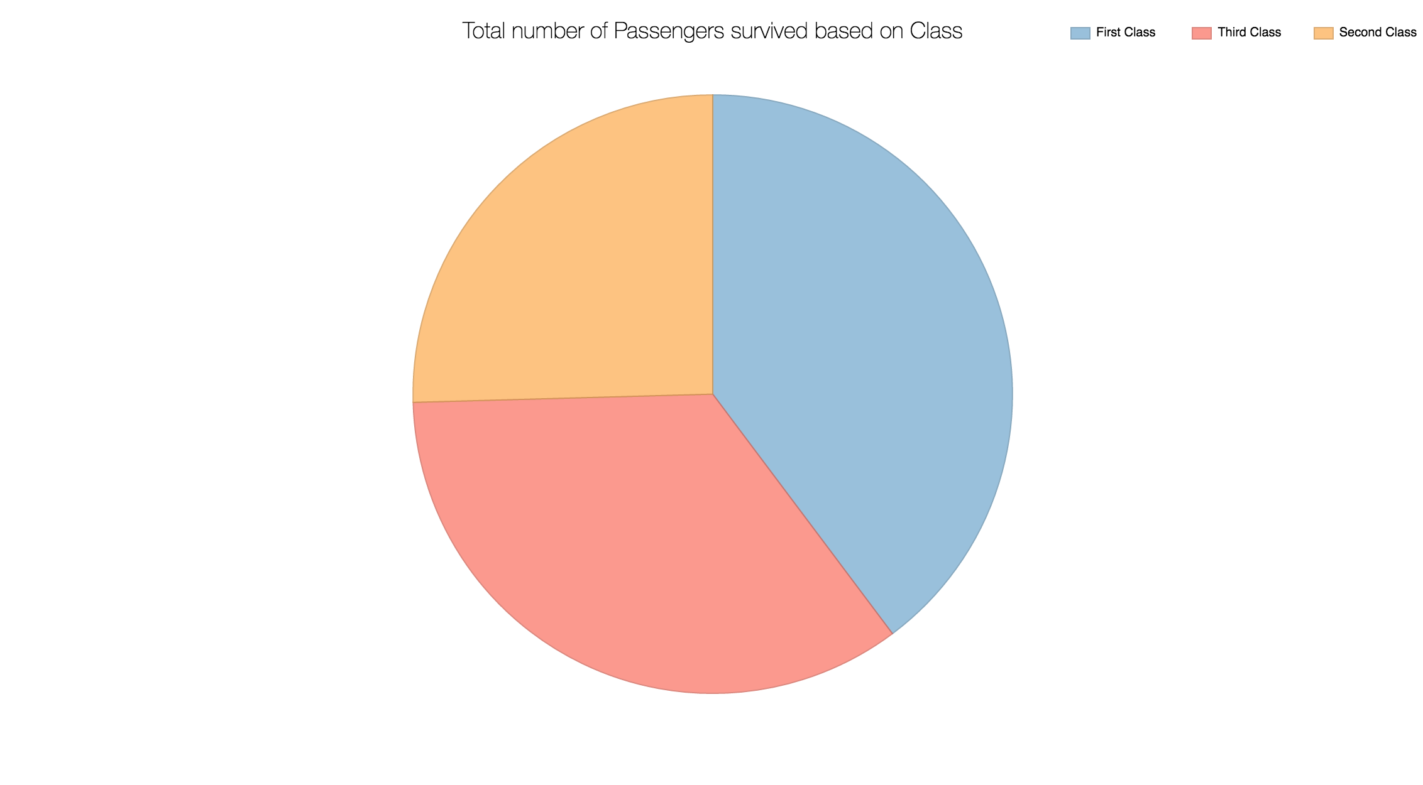

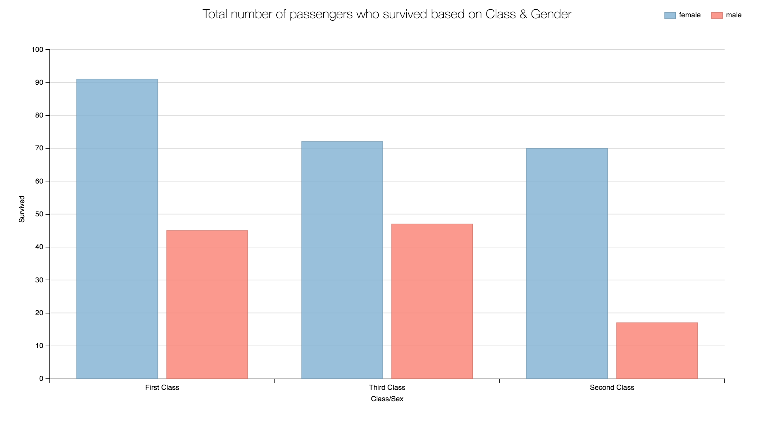

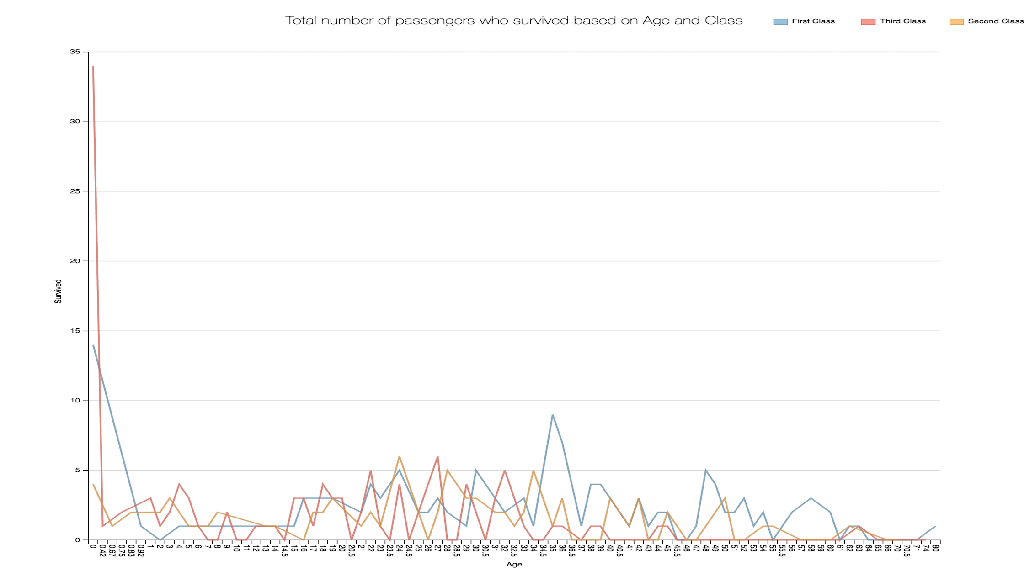

Charts after Implementing Review comments.

