AWS introduces a new approach for centralizing software license management inside organization.

AWS Marketplace buyers can now manage entitlements for product licenses procured in AWS Marketplace within AWS License Manager. Managed entitlements for AWS Marketplace help buyers automatically create licenses corresponding to product subscriptions across its catalog of more than 8,000 offerings. This gives buyers account-level visibility to their licenses procured in AWS Marketplace and gives buyers the ability to manage and distribute access rights (or entitlements) to those licenses. In this blog post, Taylor and I will show you how to use this feature to centrally procure software licenses and distribute license entitlements across Amazon Machine Image (AMI), Containers, and Machine Learning products across your organization.  
To get started, identify the account you want to use for centralized procurement and distribution. We suggest using your management account. Using that account ensures that buyers who have used AWS Organizations to enable all features can benefit from the additional governance capabilities.

Prerequisites

In an all-features-enabled organization, using your management account, you must complete a one-time setup action. This action establishes a trust relationship with AWS Marketplace. This trust relationship allows your organization to take advantage of entitlement distribution for AWS Marketplace AMI, Containers, and Machine Learning products. It does this by enabling AWS Marketplace to create Service Linked Roles to accept and activate granted licenses on behalf of your member accounts.  
To perform this setup, log in to the AWS Marketplace Console. On the left sidebar, choose Settings, and then choose the radio button next to Enable Trusted access across your organization. Choose Create integration. Refer to the following screenshot, which shows the Settings page with Enable Trusted access selected.

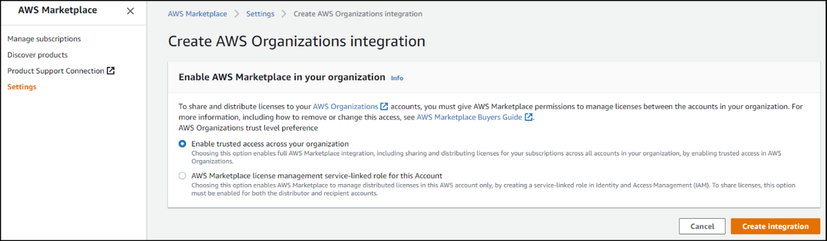

The user can also enable Trusted access using the EnableAWSServiceAccessAPI in AWS Command Line Interface (CLI).

Distributing entitlements

User can distribute access to AWS Marketplace AMI, Containers, or Machine Learning product purchases. AWS Marketplace issues a license within AWS License Manager for both existing and new purchases. This license represents your right to use a product in the specified account.  
You can access and view your licenses two ways.  
Follow the links from the AWS Marketplace website banner or the AWS Marketplace Console banner.  
Go to the AWS License Manager Console.  
AWS Marketplace will prompt you to visit the AWS License Manager console in three situations:

* After the user have completed a subscription through the website
* When the user is viewing subscription details through the console
* When the user visits a product listing for a product that you are already entitled to use.

Viewing your entitlements

The Granted licenses section of the AWS License Manager Console displays your AWS Marketplace product licenses. The Granted licenses page displays a holistic view of the licenses that have been created for your AWS Marketplace purchases. It also displays licenses purchased through sellers who have enabled license creation and distribution through AWS License Manager.  
To view your licenses:  
Navigate to the AWS License Manager Console. First-time users must accept the AWS License Manager Service Linked Role.  
In the left sidebar, choose Granted licenses.  
The following screenshot shows my AWS managed licenses page, including a list of my licenses and detail fields such as product name, issuer, and license status.

On the AWS managed licenses page, you can choose a specific license to see its details and perform entitlement distribution. At launch, the entitlement distribution functionality is supported for AWS Marketplace AMI, Containers, and Machine Learning products.

Granting an entitlement

Only your central procurement account holding the purchased license is able to grant entitlements to recipients. Recipients are not able to subsequently grant the entitlements to other accounts. AWS Marketplace entitlements can only be granted to accounts within the license holder’s AWS Organization.  
To grant an entitlement to a user, do the following:

* From the Granted licenses page, select the license for which you want to grant an entitlement. I chose the license for WordPress Certified by Bitnami and Automattic.
* In this product’s license details, a container is labeled Grants. To start the entitlement distribution process, in the top right corner, choose the Create grant button.
* Enter a Grant name. In the Recipient field, enter the recipient’s 12-digit AWS account ID. The grant recipient must be within your AWS Organization. The following screenshot shows the entitlement I want to grant to my colleague. It shows the grant’s license ID, the grantee’s name of Hugh Grant, and my AWS Account ID of 123456543213.
* Review your grant details. To create the grant, choose the Create grant button. Once created, grants will display in the Grants container in license detail page. You can create multiple grants on a license and manage them independently. To view their entitlements, recipients can follow the steps described in Viewing your entitlements. Recipients can choose the link that corresponds to the license details for their granted license. To start using the product, in the upper right, they can choose the Accept and activate button.