Mark Lese
Dustin Wolf

Jot Requirements - DRAFT

September 22, 2013

ACS560 – Dr. Chen

Change History
By | Date | Description
M. Lese | 09/22/2013 | Initial

Table of Contents
1 Introduction 1
2 Glossary 1
3 Requirements 1
3.1 Functional Requirements 1
3.1.1 User Management 1
3.1.2 Entity Management 1
3.2 Non-functional Requirements 2
3.2.1 System 2
3.2.2 Encryption 2
3.2.3 User Management 2
4 System Architecture 3
Appendix A 5

Introduction
Jot is a media storage application to store images, videos, text files and other notes into a cloud database system and to help manage the various media. The idea of this is to allow users to take pictures of notes or diagrams, upload a document, send a quick message, video tape a quick snippet of a lecture, or even record an audio clip. Jot allows the user to send data to another registered user.

Glossary
Client – A device, PC, phone, etc., that is used to communicate with the server.
Cloud – An abstract storage area available to user via various means.
Data – Any piece of information the user wishes to store on the cloud server. This data may be a text document or media.
Entity – A collection of data sent to or retrieved from the server.
Media – An image, video, or audio recording.
Registered User – A user that has successfully registered with the server.
Server – The system that holds the user’s data and communicates with the clients.
Share – When one user allows access to his data to some other registered user.
Title – A simple text given to an entity that is unique to other entities owned by the user.

Requirements
This section outlines the functional and non-functional requirements of Jot. Each requirement shall be denoted by [Rn] where n is the requirement number. These requirement notations shall be used during validation to ensure all requirements are met.

Functional Requirements
This section defines Jot’s provided services.

User Management
[R1] Jot shall provide a user the means to register with the server using a username and password.
[R2] Jot shall allow a registered user to logon with a username and password prior to interaction with other parts of the system.
[R3] Jot shall allow a registered user to delete her account.

Entity Management
A user in this section is assumed to be a logged-on user.
[R4] Jot shall provide a means for the user to select and gather data to group into an entity.
[R5] Jot shall allow a user to store an entity to the cloud keyed by a title.
[R6] Jot shall allow a user to share an entity or parts of an entity with another registered user.
[R7] Jot shall allow a user to retrieve and view his entity or parts of his entity.
[R8] Jot shall allow retrieval of media by type or storage date.
[R9] Jot shall allow a user to edit the entity, such as its annotation or contents.
[R10] Jot shall allow a user to retrieve and view other users’ shared entities.
[R11] Jot shall allow a user to delete an entity or parts of an entity.

Non-functional Requirements
This section defines the constraints Jot shall adhere to.

System
[R12] Jot’s server shall be a Linux-based server (see Appendix A at the end of this document).
[R13] The server-side software shall be written in PHP.
[R14] The server shall provide database storage for entities and user information.
[R15] The database shall be configured to allow for transactional operation.
[R16] The client application shall be available for a Windows PC, Android device, or iOS device.
[R17] The client shall be written in a language that is not PHP.

Encryption
[R18] Since the system may handle personal data, Jot shall encrypt all communications between the client and server.

User Management
[R19] Only registered users shall store or retrieve data from the server.
[R20] Registered users accounts shall be secured by a user-defined username and password.
[R21] User’s passwords shall be encrypted in the database.
[R22] Users shall be allowed to store no more than a maximum amount of data per his account; configurable within the system.

System Architecture
This section shows an expected high-level system diagram in Figure 4-1. The client side shows the Android and iOS devices along with a Windows PC. The server side shows the PHP web services hosted on a Linux OS. The server also shows the likely MySQL database for storage.

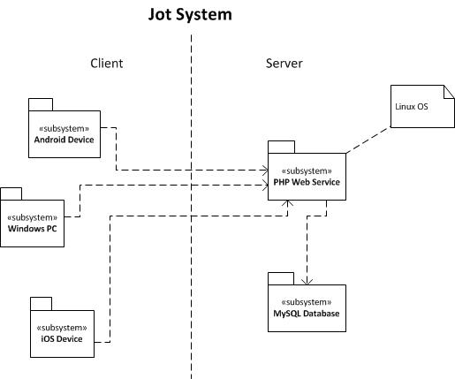
Figure 4-1

On the following page, Figure 4-2 shows a client prototype (subject to change) of the initial page presented to the user.

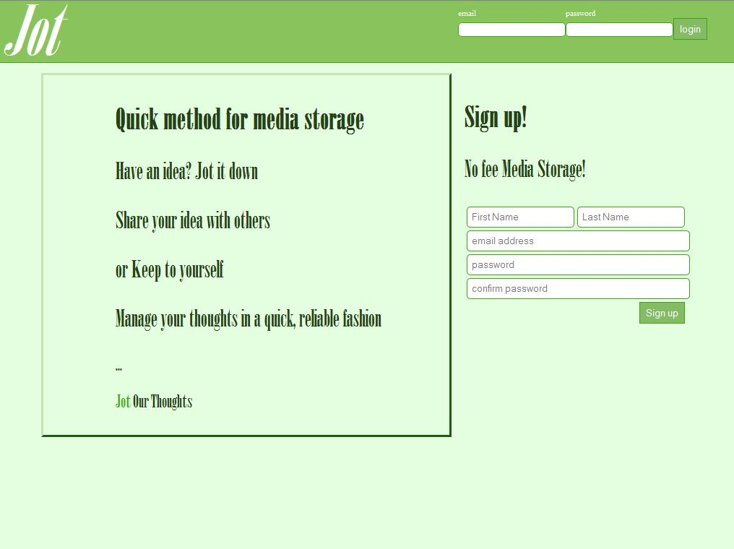
Figure 4-1

Appendix A

Figure A-1 shows a Raspberry Pi module. This device, chosen for its novelty, is easily configured to run Debian Linux OS. The OS and all applications reside on a 16GB SD memory card. This is of sufficient size for the class project, but not practical for a “full production” system due to its limited memory.

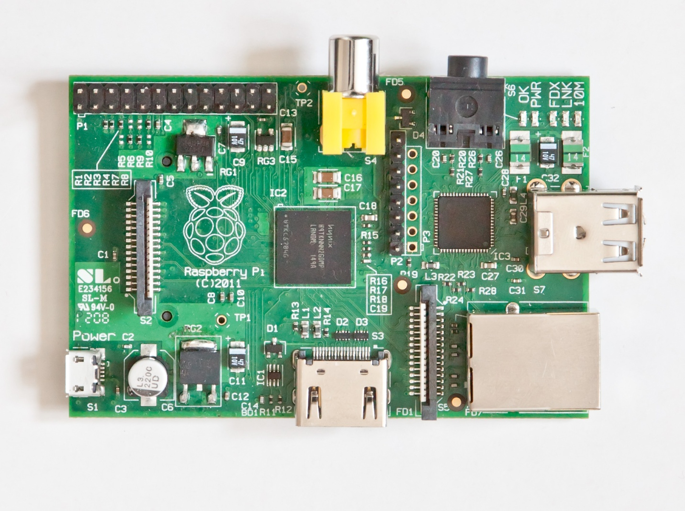
Figure A-1

