Concurrent and Distributed Programming (PCD)

Session 6: Petri Nets

Miguel Angel Vico Moya

Creating the Petri net
To create the Petri net of figure 3 on page 14 of the paper (indicated in the session), we use the WoPeD tool (Workflow Petri Nets Designer).

In this case, we only need define places and transitions. To define a place, we click to button of interface of WoPeD that have a circle drawn and then click in any place of working window. To define a transition, we do the same process but with the button that have a square drawn.

We need to join each transition with places to complete the Petri net design.

The result of the Petri net in WoPeD is follows:
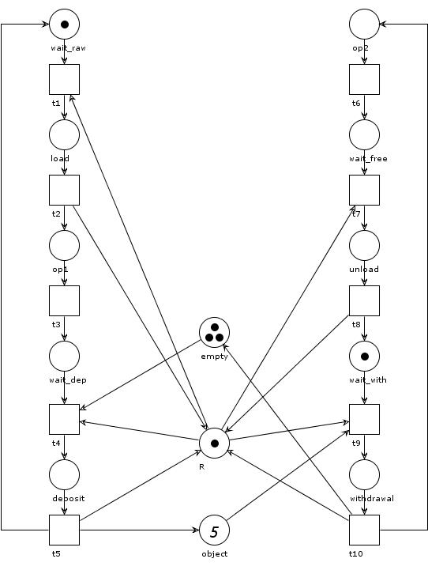

Analyzing the Petri net

To do the analysis of the Petri net we can use the “Semantical analysis” button of WoPeD. It will open an area with two tabs, if we click in the “Expert” tab we can see something like this:

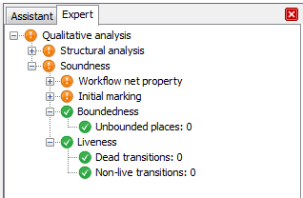

In this image, we can see how our Petri net satisfies the Boundedness (there are not places with infinite tokens) and Liveness (there are not transitions that produce deadlocks) properties.

To analyze the size of the Reachability Graph, we need to click the button right of the “Semantical analysis”, that have an omega (Greek letter) drawn. Then, it open a window that shows the reachability graph and in the bottom of this window we can see the number of vertices and edges of this graph.

