Zoundtracker: Indoor tests

Test 1

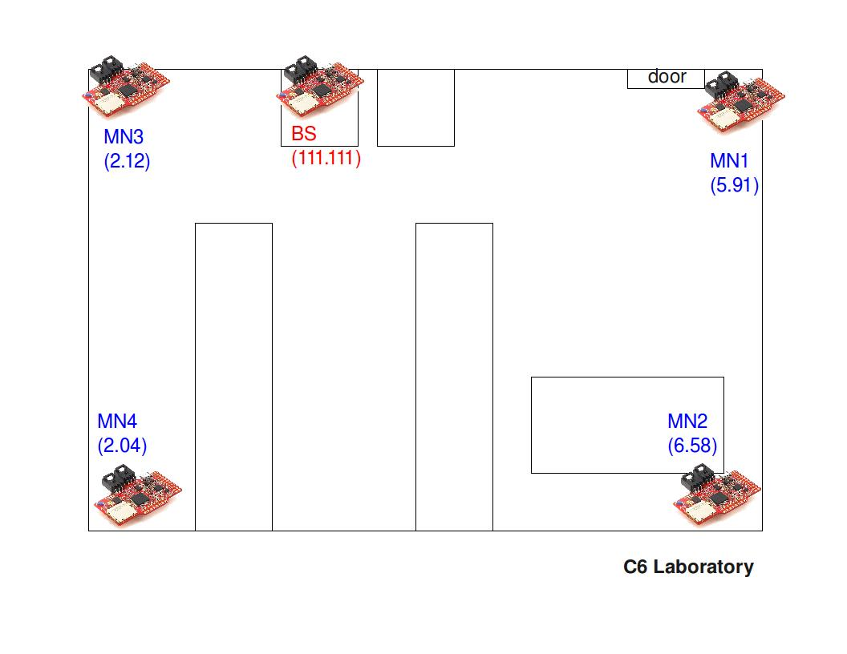
- Deployment map
- Report

Start time: 13:55h
Number of MNs: 4
Base-station conditions:
With antenna
Application’s frequency execution: 10 Hz

Duration: 30 minutes
File sending period: 1 minute
Sample period: 6 seconds
Protocol: Mesh
Base-station’s log file: filename
- Results

MN 6.58:
Packets sent: 30
Packets acknowledged: 28
Packet loss rate: 6.66 %

MN 5.91:
Packets sent: 30
Packets acknowledged: 28
Packet loss rate: 6.66 %

MN 2.04:
Packets sent: 30
Packets acknowledged: 29
Packet loss rate: 3.33 %

MN 2.12:
Packets sent: 30
Packets acknowledged: 30
Packet loss rate: 0 %

Test 2

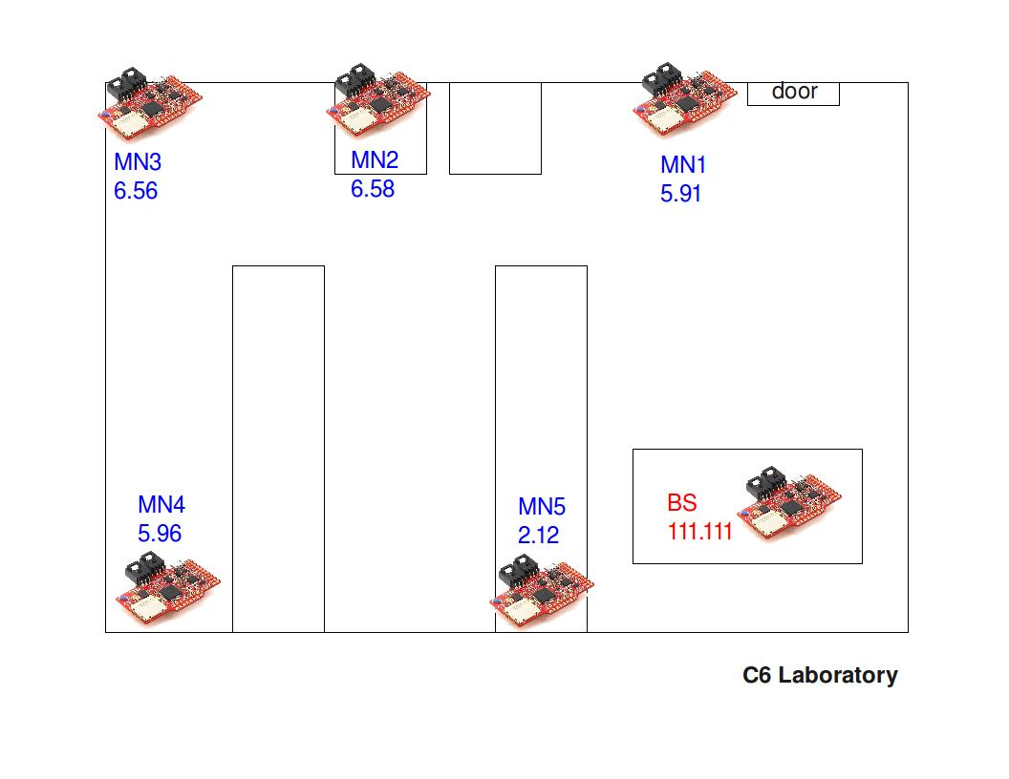
  - Deployment map
  - Report

Start time: 19:20h
Number of MNs: 5
Base-station conditions:
Without antenna
Application’s frequency execution: 10 Hz

Duration: XX minutes
File sending period: 1 minute and 40 seconds
Sample period: 10 seconds
Protocol: Mesh
Base-station’s log file: filename

- Results

MN 5.91:
Packets sent: xx
Packets acknowledged: xx

MN 2.12:
Packets sent: xx
Packets acknowledged: xx

MN 6.58:
Packets sent: xx
Packets acknowledged: xx

MN 6.56:
Packets sent: xx
Packets acknowledged: xx

MN 5.96:
Packets sent: xx
Packets acknowledged: xx

Test 3

  - Deployment map

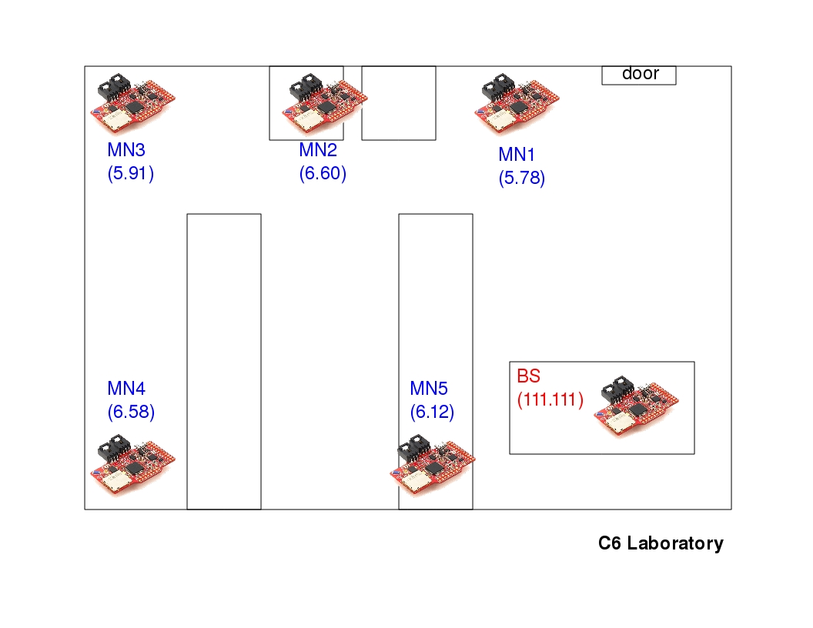

  - Report

Start time: 19:56h
Number of MNs: 5
Base-station conditions:
Without antenna
Application’s frequency execution: 5 Hz

Duration: 2 days and 12 hours
File sending period: 10 minutes
Sample period: 1 minute
Protocol: Mesh
Base-station’s log file: filename
  - Results

MN 5.78:
Packets sent: 193
Packets acknowledged: 190
Packet loss rate: 1.55 %

MN 6.12:
Packets sent: 1811
Packets acknowledged: 1802
Packet loss rate: 0.49 %

MN 6.60:
Packets sent: 1817
Packets acknowledged: 1814
Packet loss rate: 0.16 %

MN 5.91:
Packets sent: 1805
Packets acknowledged: 1805
Packet loss rate: 0 %

MN 6.58:
Packets sent: 1825
Packets acknowledged: 1809
Packet loss rate: 0.87 %

