Test 1

- Scenario: Campus Nord UPC (street between C1 and C6 buildings)
- Goal: Calculate the packet loss rate of each Mobile Node
- Conditions:
  - Using two Mobile Nodes and a Basestation with a 5dB antenna
  - Nodes in line of sight between them
  - Elapsed time: 20 minutes
  - Net protocol: Rime/Mesh
  - Message period: 1 minute
- Results:
1. Mobile Node #1.1:
Distance: 43,5 m
Hops: 1
Packet loss rate: 5 %

2. Mobile Node #1.2:
Distance: 138,06 m
Hops: 1
Packet loss rate: 28 %

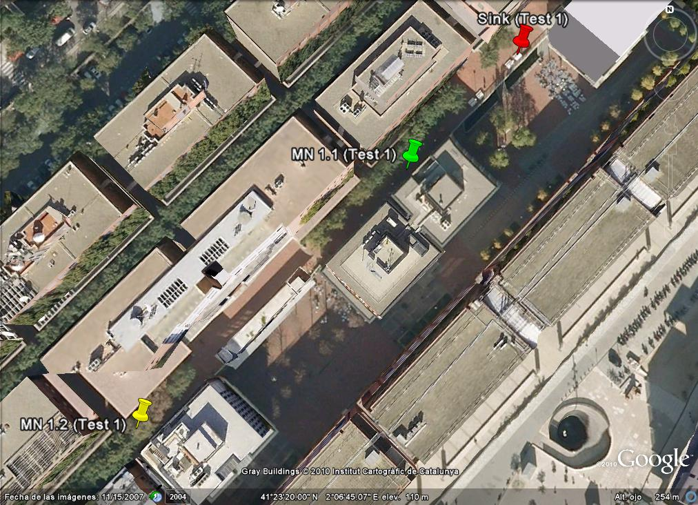

Test 2

- Scenario: Campus Nord UPC (street between C1 and C6 buildings)
- Goal: Calculate the packet loss rate of each Mobile Node
- Conditions:
  - Using two Mobile Nodes and a Basestation with a 5dB antenna
  - Nodes in line of sight between them
  - Elapsed time: 20 minutes
  - Net protocol: Rime/Mesh
  - Message period: 1 minute
- Results:
1. Mobile Node #1.1:
Distance: 153,02 m
Hops: 1
Packet loss rate: 13,64 %

2. Mobile Node #1.2:
Distance: 43,5 m
Hops: 1
Packet loss rate: 0 %

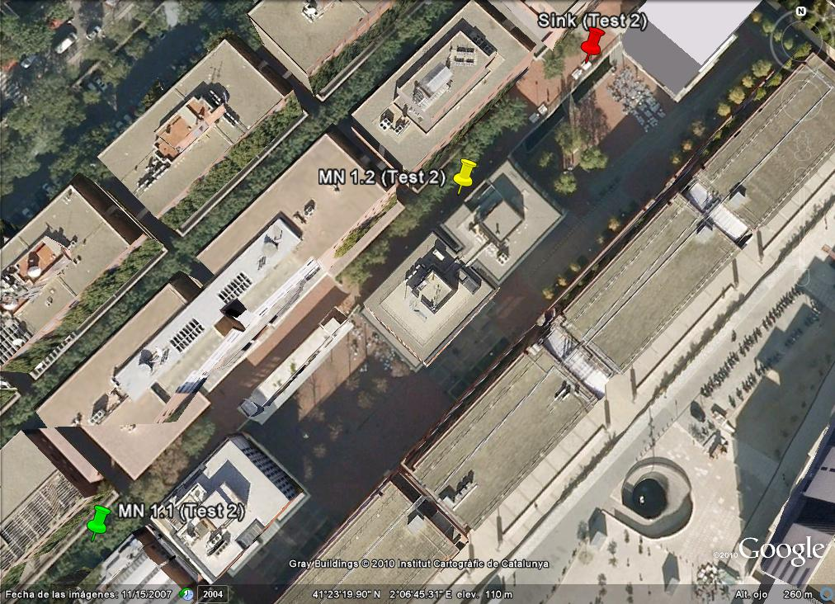

Test 3
- Scenario: Campus Nord UPC (street between C1 and C6 buildings)
- Goal: Calculate the packet loss rate of each Mobile Node
- Conditions:
  - Using two Mobile Nodes and a Basestation with a 5dB antenna
  - Nodes in line of sight between them
  - Elapsed time: 20 minutes
  - Net protocol: Rime/Mesh
  - Message period: 1 minute
- Results:
1. Mobile Node #1.1:
Distance: 69,31 m
Hops: 1
Packet loss rate: 5 %

2. Mobile Node #1.2:
Distance: 83,49 m
Hops: 1
Packet loss rate: 0 %

