Test 1

- Scenario: Diagonal Avenue (Palau Reial metro station, Campus Nord side)
- Goal: Calculate the packet loss rate of each Mobile Node
- Conditions:
  - Using two Mobile Nodes and a Basestation with a 5dB antenna
  - Nodes in line of sight between them
  - Elapsed time: 30 minutes
  - Net protocol: Rime/Mesh
  - Message period: 1 minute
- Results:
1. Mobile Node #1:
Distance: 112 m
Hops: 1
Packet loss rate: 9,1 %

2. Mobile Node #2:
Distance: 182 m
Hops: 1
Packet loss rate: 12,5 %
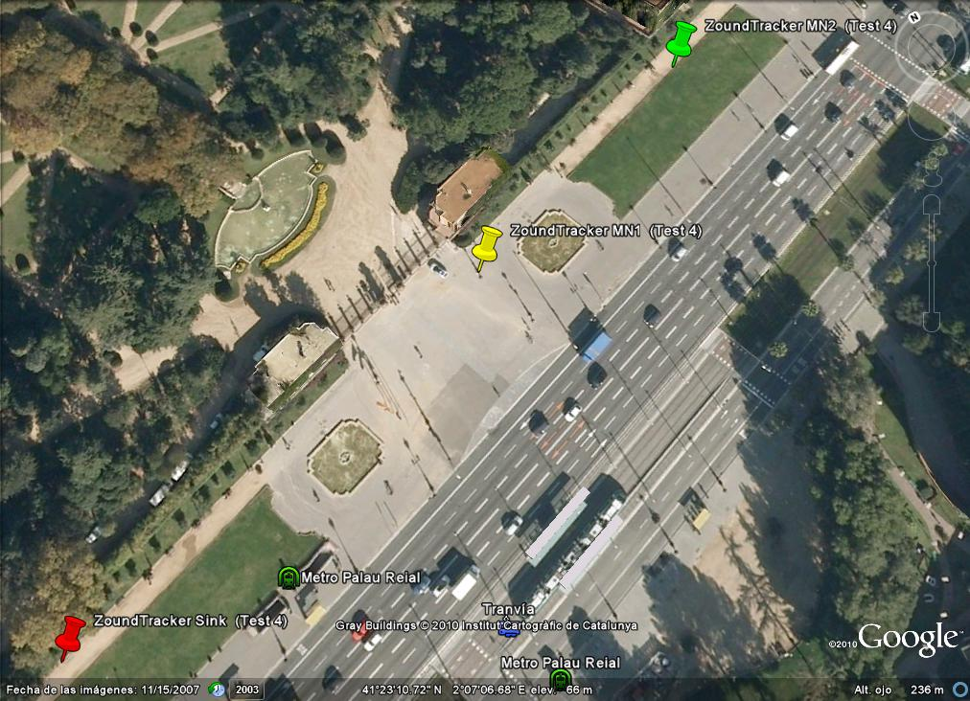

Test 2

- Scenario: Diagonal Avenue (Palau Reial metro station, Campus Sud side across Diagonal Avenue)
- Goal: Calculate the packet loss rate of each Mobile Node
- Conditions:
  - Using two Mobile Nodes and a Basestation with a 5dB antenna
  - Nodes in line of sight between them
  - Elapsed time: 30 minutes
  - Net protocol: Rime/Mesh
  - Message period: 1 minute
- Results:
1. Mobile Node #1
Distance: 76 m
Hops: 1
Packet loss rate: 30,3 %

2 Mobile Node #2
Distance: 127 m
Hops: 1
Packet loss rate: 21,8 %

