Test 4

  - Deployment map
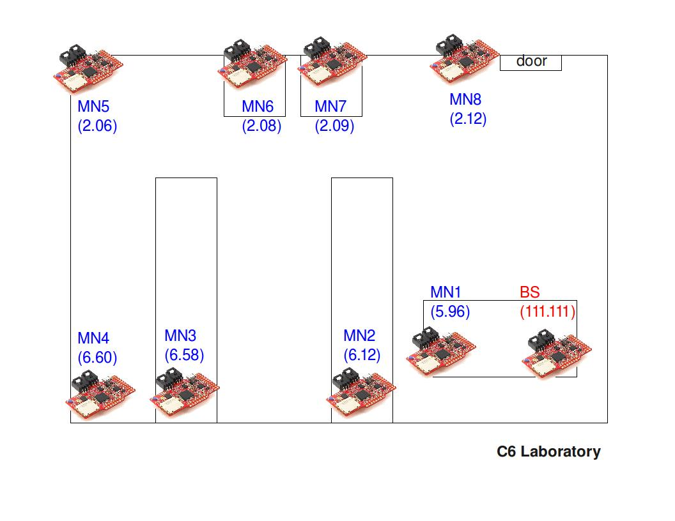
  - Report

Start time: 18:36h
Number of MNs: 8
Base-station conditions:
Without antenna

Duration: 2 days and 12 hours
(1 day and 12 hours storing files to reach 60 stored files)
File sending period: 10 minutes
Sample period: 1 minute
Protocol: Mesh
Base-station’s log file: serialdump-20110513-1836

  - Results

Initially all Mobile Nodes had 60 stored files (40 bytes/stored file). Data flow sent by all Mobile Nodes to the Base-station, converge over the third sending period. Every Mobile Node send a “burst” of files on every period. The following tables describe the number of hops and the number of files received by the Basestation on every burst.

The Basestation didn’t receive any file from Mobile Node 2.12 (dead node).
The “-“ symbol on a field of the next tables means that the Mobile Node has died.

Burst 1

Node ID | Files acknowledged | Hops
5.96 | 59 | 1
6.12 | 2 | 1
6.58 | 34 | 2
6.60 | 60 | 2
2.06 | 60 | 2
2.08 | 59 | 1
2.09 | 60 | 1
2.12 | - | -

Burst 2

Node ID | Files acknowledged | Hops
5.96 | 1 | 1
6.12 | 59 | 1
6.58 | 26 | 2
6.60 | 1 | 2
2.06 | 1 | 2
2.08 | 1 | 1
2.09 | 1 | 1
2.12 | - | -
Burst 3

Node ID | Files acknowledged | Hops
5.96 | 1 | 1
6.12 | 1 | 1
6.58 | 1 | 2
6.60 | 1 | 2
2.06 | 1 | 2
2.08 | 1 | 1
2.09 | 1 | 1
2.12 | - | -

