Test 4

  - Deployment map
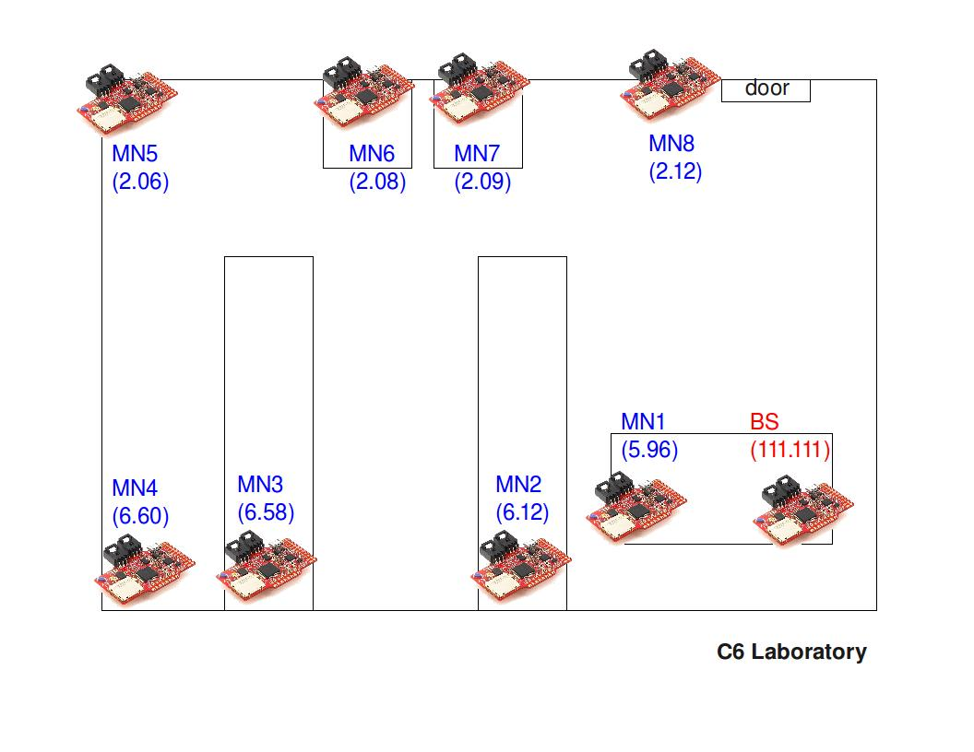
  - Report

Start time: 19:56h
Number of MNs: 5
Base-station conditions:
Without antenna
Application’s frequency execution: 5 Hz

Duration: 2 days and 12 hours
File sending period: 10 minutes
Sample period: 1 minute
Protocol: Mesh
Base-station’s log file: serialdump-20110311-1956
  - Results

MN 5.78:
Packets sent: 193
Packets acknowledged: 190
Packet loss rate: 1.55 %

MN 6.12:
Packets sent: 1811
Packets acknowledged: 1802
Packet loss rate: 0.49 %

MN 6.60:
Packets sent: 1817
Packets acknowledged: 1814
Packet loss rate: 0.16 %

MN 5.91:
Packets sent: 1805
Packets acknowledged: 1805
Packet loss rate: 0 %

MN 6.58:
Packets sent: 1825
Packets acknowledged: 1809
Packet loss rate: 0.87 %

