Test 1

- Scenario: Campus Nord UPC (street between C1 and C6 buildings)

- Goal: Calculate the maximum distance between two nodes in a low noise level environment (buildings)

- Conditions:
1. Using one Mobile Node and a Basestation with a 5dB antenna
2. Nodes in line of sight between them
3. Net protocol: Rime/Mesh
4. Message period: 1 minute

- Results:
1. Mobile Node #1
Distance: ~72,6 m
2. Mobile Node #2
Distance: ~162 m

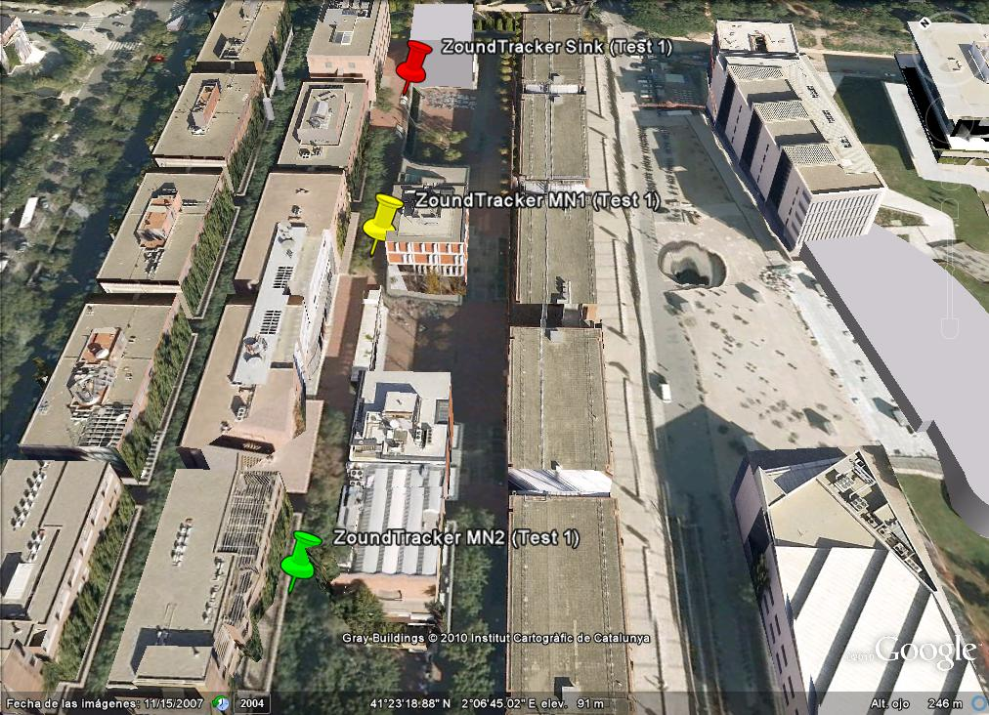

Test 2

- Scenario: Diagonal Avenue (crossroad in front of Physic and Chemistry faculties)

- Goal: Calculate the maximum distance between two nodes in a medium noise level environment (buildings and cars)

- Conditions:
1. Using one Mobile Node and a Basestation with a 5dB antenna
2. Nodes in line of sight between them
3. Net protocol: Rime/Mesh
4. Message period: 1 minute

- Results:
1. Mobile Node #1:
Location: #1
Distance: ~56 m

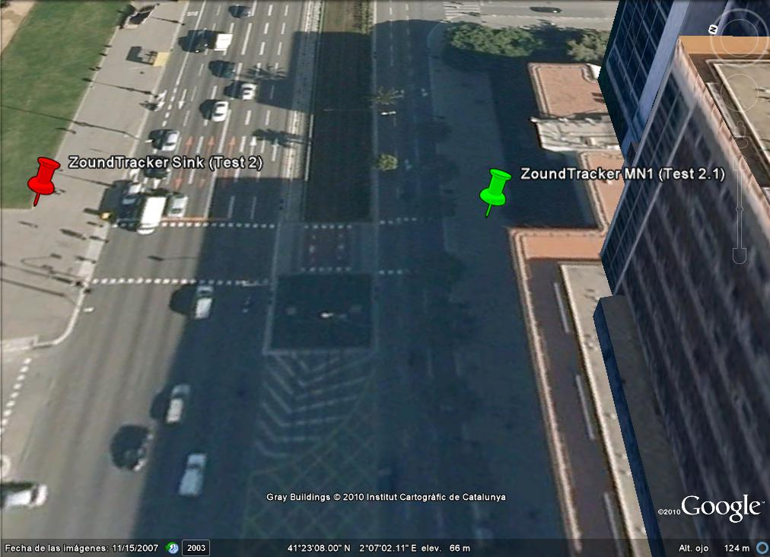

Location: #2
Distance: ~76,6 m

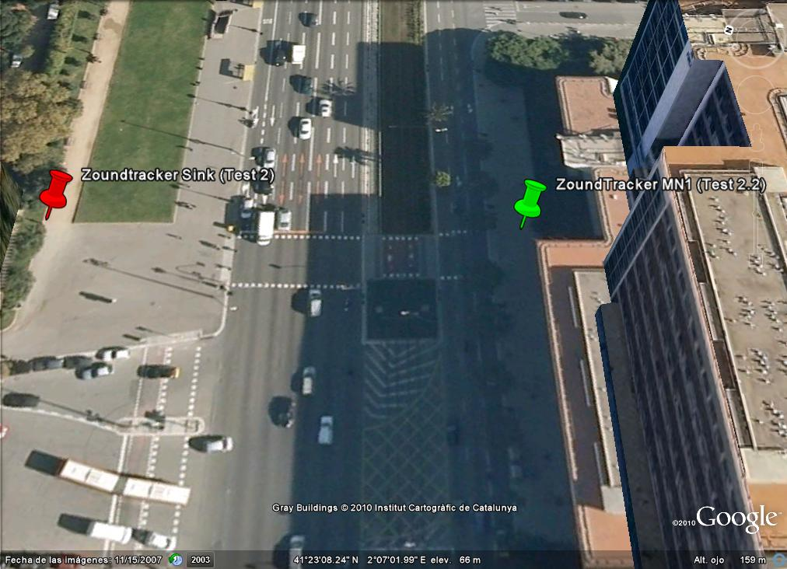
Location: #3
Distance: ~107 m

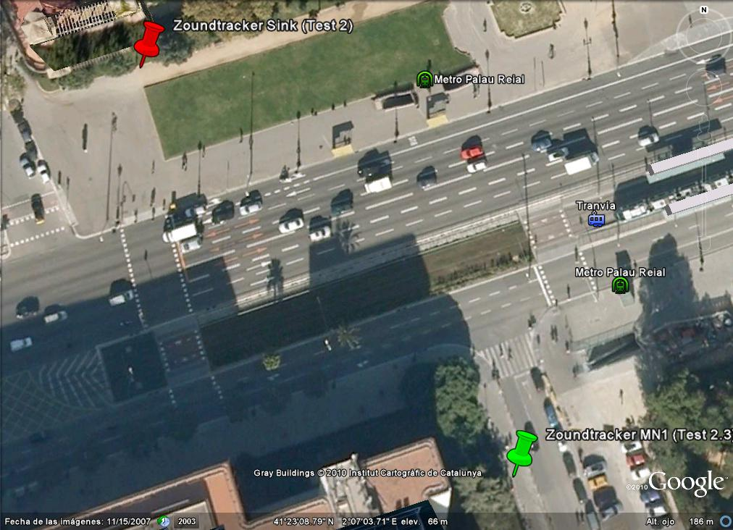
Test 3

- Scenario: Diagonal Avenue (Palau Reial metro station, Campus Sud side)

- Goal: Calculate the maximum distance between two nodes in a high noise level environment (buildings, cars, tram and metro)

- Conditions:
1. Using one Mobile Node and a Basestation with a 5dB antenna
2. Nodes in line of sight between them
3. Net protocol: Rime/Mesh
4. Message period: 1 minute

- Results:
1. Mobile Node #1:
Distance: ~83 m

