Zoundtracker: Indoor tests

Test 1

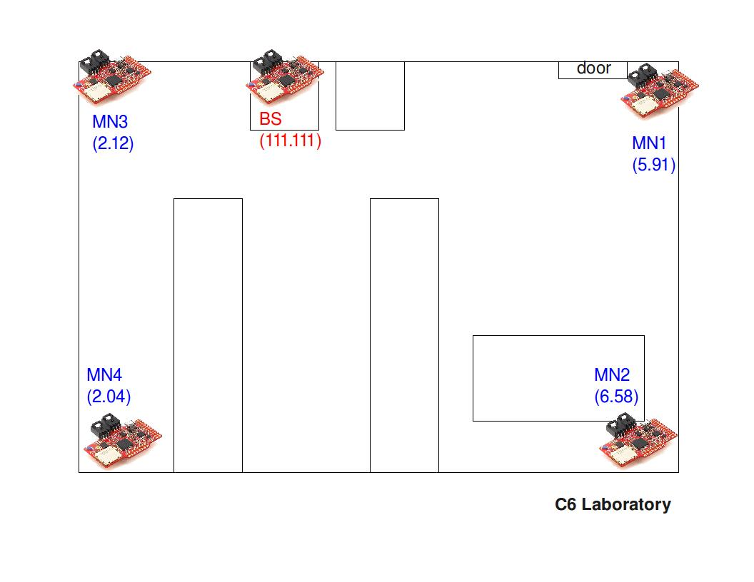
- Deployment map
- Report

- Start time: 13:55h
- Number of MNs: 4
- Base-station: With antenna
- Duration: 30 minutes
- File sending period: 1 minute
- Sample period: 6 seconds
- Protocol: Mesh
- Base-station’s log file: filename

- Results

- MN 6.58
  - Packets sent: 30
  - Packets acknowledged: 28
- MN 5.91
  - Packets sent: 30
  - Packets acknowledged: 28
- MN 2.04
  - Packets sent: 30
  - Packets acknowledged: 29
- MN 2.12
  - Packets sent: 30
  - Packets acknowledged: 30

Test 2

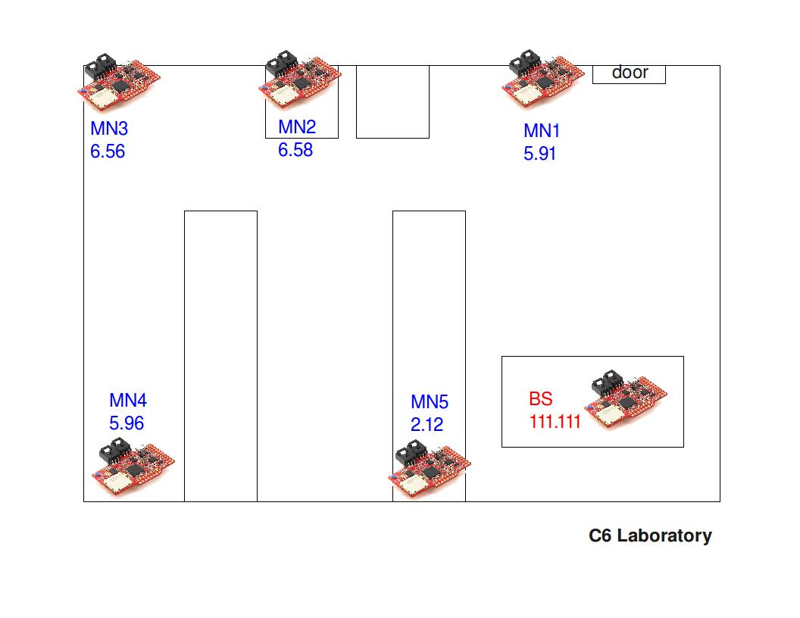
  - Deployment map
  - Report

- Start time: 19:20h
- Number of MNs: 5
- Base-station: Without antenna
- Duration: XX minutes
- File sending period: 1 minute and 40 seconds
- Sample period: 10 seconds
- Protocol: Mesh
- Base-station’s log file: filename

- Results

- MN 5.91
  - Packets sent: xx
  - Packets acknowledged: xx
- MN 2.12
  - Packets sent: xx
  - Packets acknowledged: xx
- MN 6.58
  - Packets sent: xx
  - Packets acknowledged: xx
- MN 6.56
  - Packets sent: xx
  - Packets acknowledged: xx
- MN 5.96
  - Packets sent: xx
  - Packets acknowledged: xx

Test 3

  - Deployment map

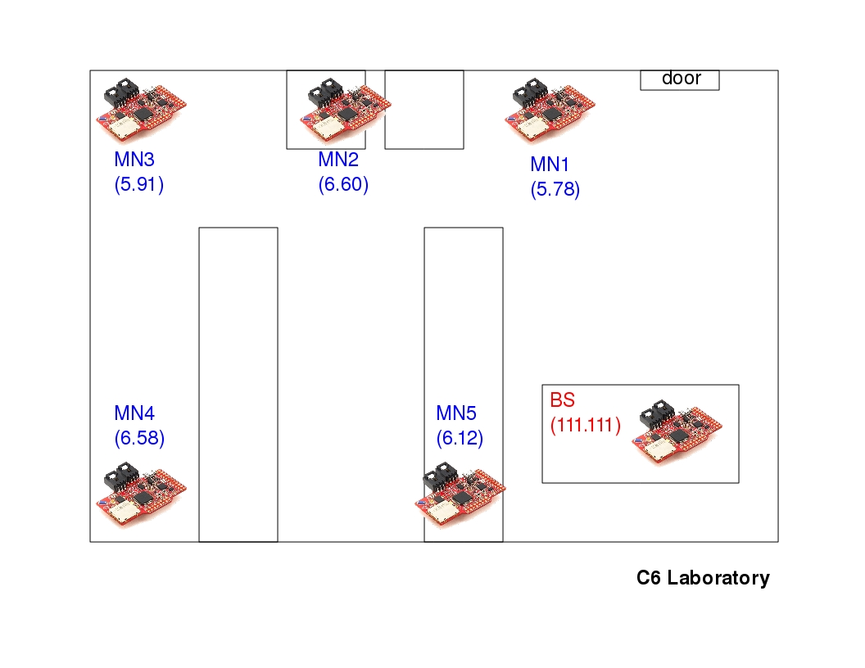

  - Report

- Start time: 19:56h
- Number of MNs: 5
- Base-station: Without antenna
- Duration: 2 days and 12 hours
- File sending period: 10 minutes
- Sample period: 1 minute
- Protocol: Mesh
- Base-station’s log file: filename

  - Results

- MN 5.78
  - Packets sent: 193
  - Packets acknowledged: 190
  - Packet loss rate: 1.55 %
- MN 6.12
  - Packets sent: 1811
  - Packets acknowledged: 1802
  - Packet loss rate: 0.49 %
- MN 6.60
  - Packets sent: 1817
  - Packets acknowledged: 1814
  - Packet loss rate: 0.16 %
- MN 5.91
  - Packets sent: 1805
  - Packets acknowledged: 1805
  - Packet loss rate: 0 %
- MN 6.58
  - Packets sent: 1825
  - Packets acknowledged: 1809
  - Packet loss rate: 0.87 %

