Zoundtracker: Outdoor tests

0. Test conditions

Node’s configuration:
a) In line of sight between them
b) Antenna pointing to the sky

Noise sources:
a) Tram
b) Metro train
c) Cars (includes buses)
d) Wi-Fi networks (2.4 GHz)

(!) Wi-Fi networks don’t interfere with nodes. Actually nodes are working on a different channel than Wi-Fi networks.

1. Test scenarios

a) Low noise level environment: buildings (Campus Nord UPC: street between C1 and C6 buildings)
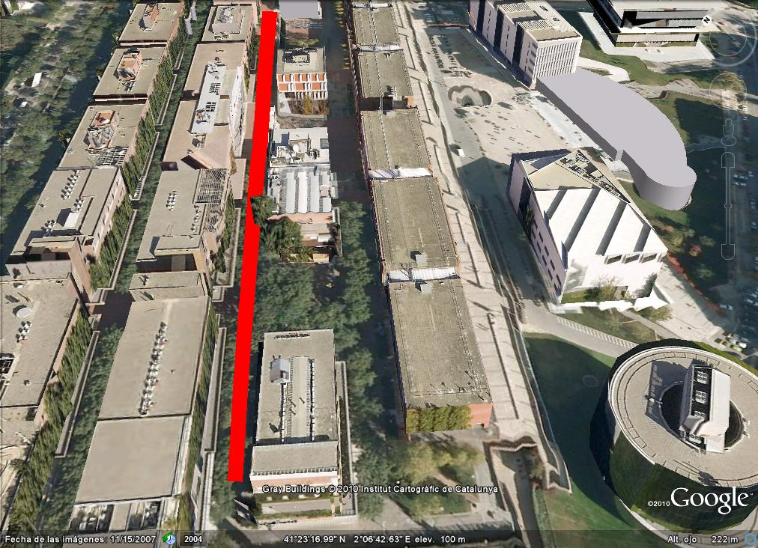

b) Medium noise level environment: buildings and cars (Diagonal Avenue: crossroad in front of Physic and Chemistry faculties)

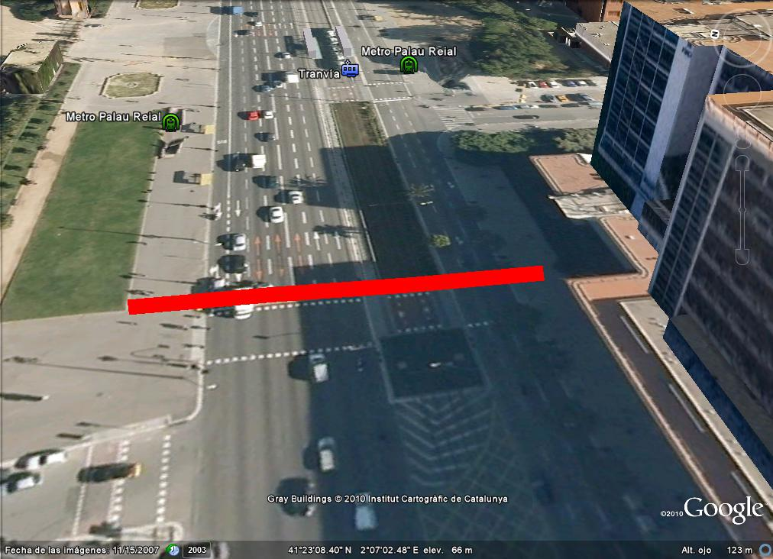

c) High noise level environment: buildings, cars, tram and metro train (Diagonal Avenue: Palau Reial metro station, Campus Sud side)

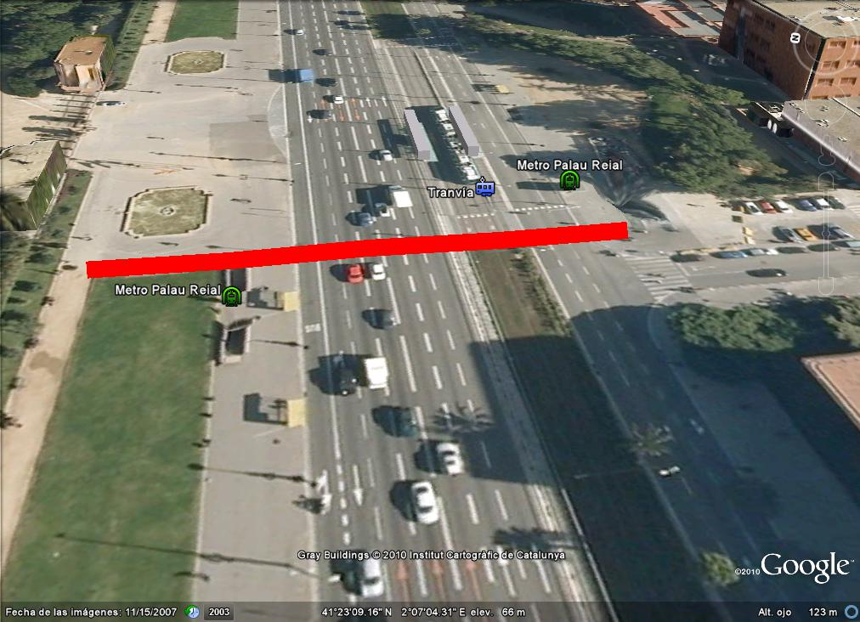

2. Pending tests

(!) Final location: Diagonal Mar shopping center

3. Finished tests

Test 1 (18 - 02 - 2011)

- Scenario: Campus Nord UPC (street between C1 and C6 buildings)

- Goal: Calculate the maximum distance between two nodes in a low noise level environment (buildings)

- Conditions:
1. Using one Mobile Node and a Basestation with a 5dB antenna
2. Nodes in line of sight between them
3. Net protocol: Rime/Mesh
4. Message period: 1 minute

- Results:
1. Mobile Node #1
Distance: ~72,6 m
2. Mobile Node #2
Distance: ~162 m

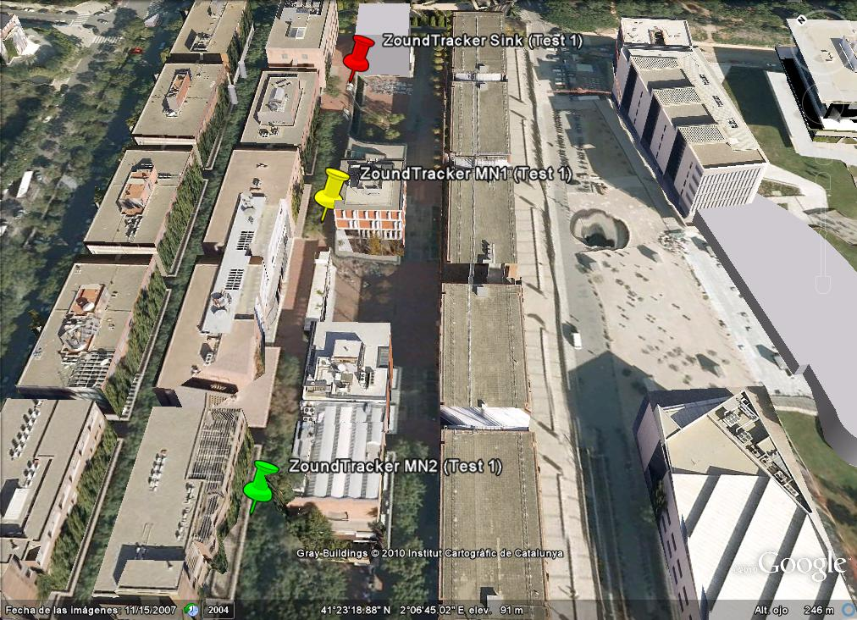

Test 2 (18 - 02 - 2011)

Scenario: Diagonal Avenue (crossroad in front of Physic and Chemistry faculties)

Goal: Calculate the maximum distance between two nodes in a medium noise level environment (buildings and cars)

Conditions:
1. Using one Mobile Node and a Basestation with a 5dB antenna
2. Nodes in line of sight between them
3. Net protocol: Rime/Mesh
4. Message period: 1 minute

Results:
1. Mobile Node #1:
Location: #1
Distance: ~56 m
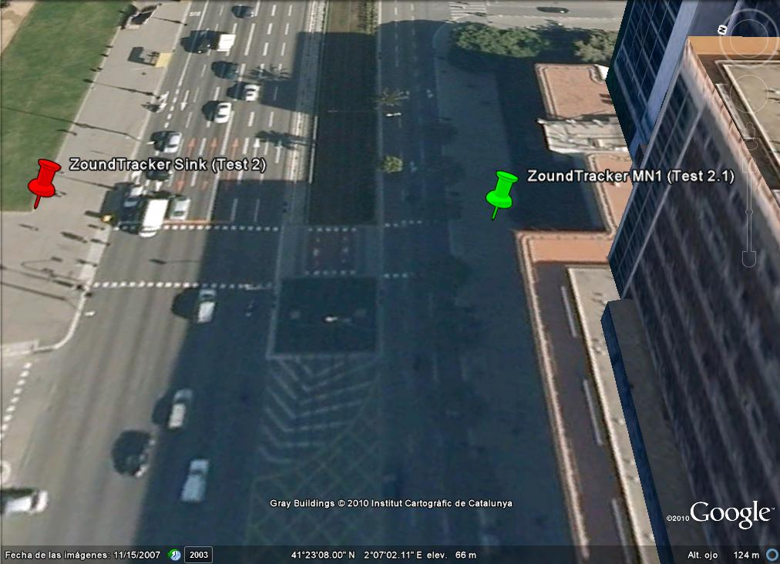
Location: #2
Distance: ~76,6 m
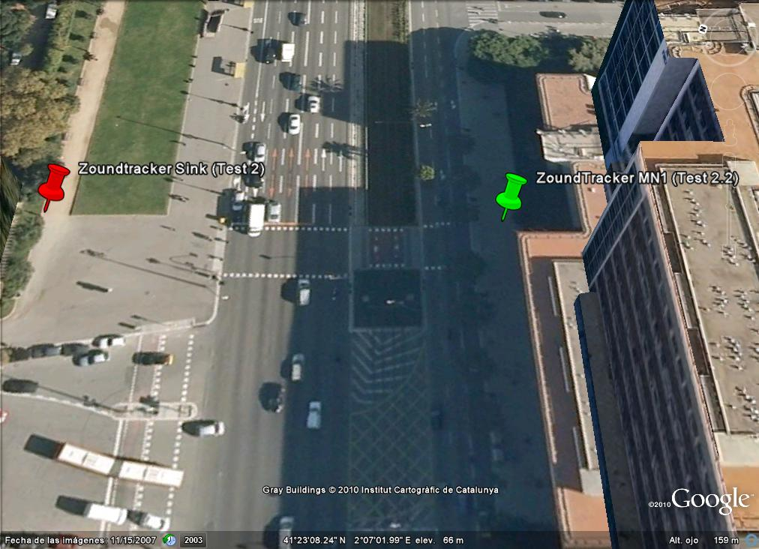

Location: #3
Distance: ~107 m
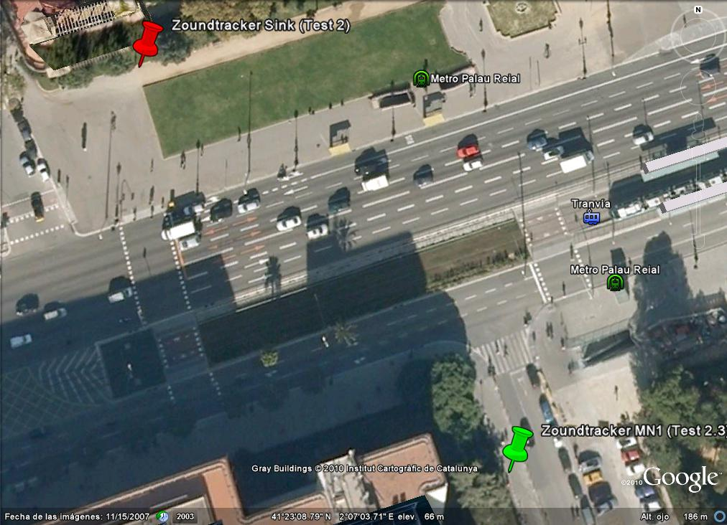

Test 3 (18 - 02 - 2011)

Scenario: Diagonal Avenue (Palau Reial metro station, Campus Sud side)

Goal: Calculate the maximum distance between two nodes in a high noise level environment (buildings, cars, tram and metro)

Conditions:
1. Using one Mobile Node and a Basestation with a 5dB antenna
2. Nodes in line of sight between them
3. Net protocol: Rime/Mesh
4. Message period: 1 minute

Results:
1. Mobile Node #1:
Distance: ~83 m

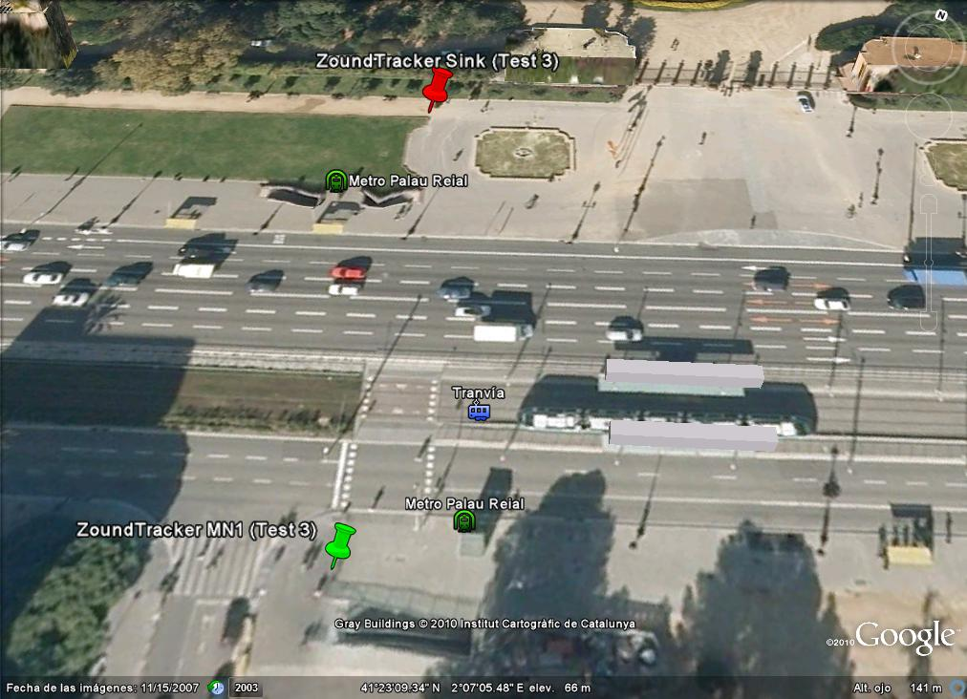

Test 4 (25 - 02 - 2011)

- Scenario: Diagonal Avenue (Palau Reial metro station, Campus Nord side)

- Goal: Calculate the packet loss rate of each Mobile Node

- Conditions:
  - Using two Mobile Nodes and a Basestation with a 5dB antenna
  - Nodes in line of sight between them
  - Elapsed time: 30 minutes
  - Net protocol: Rime/Mesh
  - Message period: 1 minute

- Results:
1. Mobile Node #1:
Distance: 112 m
Hops: 1
Packet loss rate: 9,1 %

2. Mobile Node #2:
Distance: 182 m
Hops: 1
Packet loss rate: 12,5 %

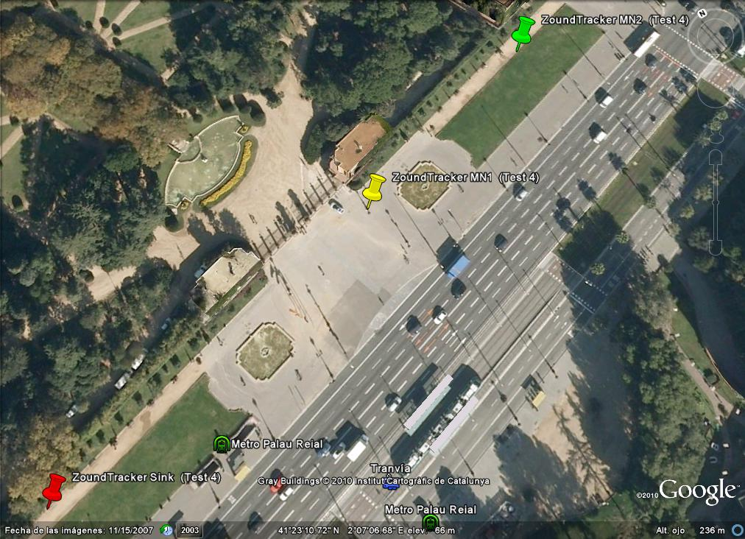

Test 5 (25 - 02 - 2011)

- Scenario: Diagonal Avenue (Palau Reial metro station, Campus Sud side across Diagonal Avenue)

- Goal: Calculate the packet loss rate of each Mobile Node

- Conditions:
  - Using two Mobile Nodes and a Basestation with a 5dB antenna
  - Nodes in line of sight between them
  - Elapsed time: 30 minutes
  - Net protocol: Rime/Mesh
  - Message period: 1 minute

- Results:
1. Mobile Node #1
Distance: 76 m
Hops: 1
Packet loss rate: 30,3 %

2 Mobile Node #2
Distance: 127 m
Hops: 1
Packet loss rate: 21,8 %

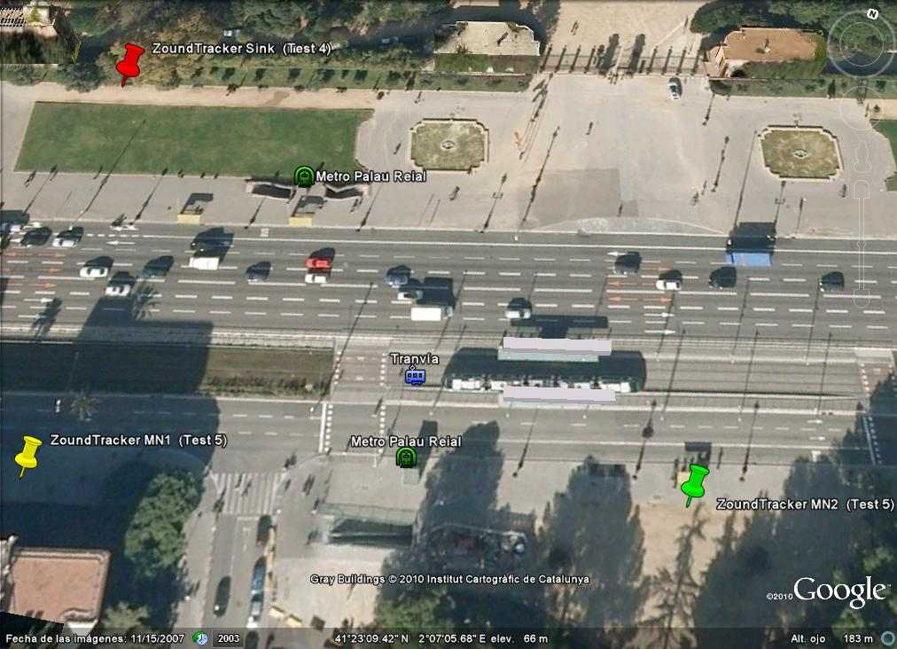

Test 6 (02 - 03 - 2011)

- Scenario: Campus Nord UPC (street between A1 and C6 buildings)

- Goal: Calculate the packet loss rate of each Mobile Node

- Conditions:
  - Using two Mobile Nodes and a Basestation with a 5dB antenna
  - Nodes in line of sight between them
  - Elapsed time: 40 minutes
  - Net protocol: Rime/Mesh
  - Message period: 30 seconds

- Results:
1. Mobile Node #1:
Distance: 62 m
Hops: 1
Packet loss rate: 33,8 %

2. Mobile Node #2:
Distance: 162 m
Hops: 1
Packet loss rate: 28,8 %

