**Zoundtracker: Indoor tests**

**Pending tests**

Prueba 1

* Escenario: Laboratorio
* Objetivo: Validar el funcionamiento “indoor” de la aplicación
* Condiciones:
  1. Utilizar los tiempos finales (para toma de datos, envío de ficheros,…).
  2. Durante 24 horas seguidas
  3. Almacenar los datos de la Basestation en un fichero (utilizando la aplicación para Linux “minicom” o similares).

**Finished tests**

**Test 1**

1. Deployment map
2. 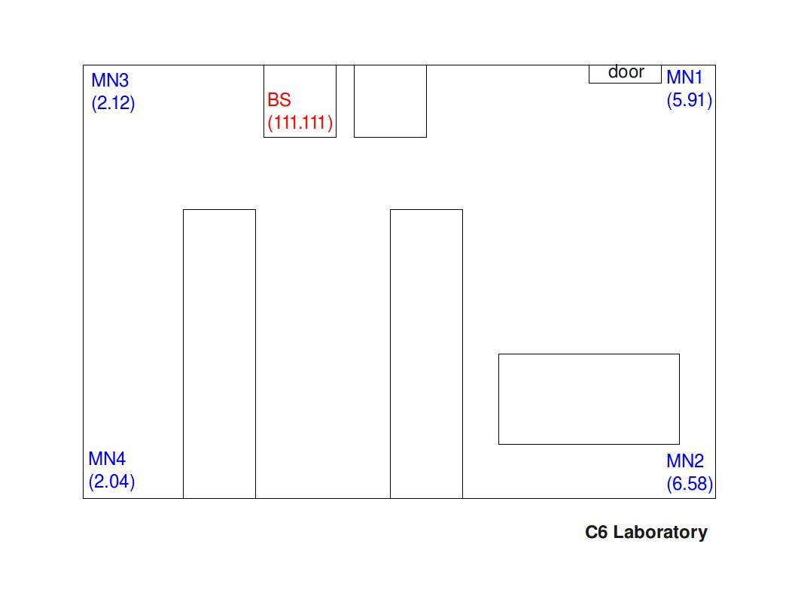Report

* Start time: 13:55h
* Number of MNs: 4
* Base-station: With antenna
* Duration: 30 minutes
* File sending period: 1 minute
* Sample period: 6 seconds
* Protocol: Mesh
* Base-station’s log file: filename

1. Results

* MN 6.58
  + Packets sent: 30
  + Packets acknowledged: 28
* MN 5.91
  + Packets sent: 30
  + Packets acknowledged: 28
* MN 2.04
  + Packets sent: 30
  + Packets acknowledged: 29
* MN 2.12
  + Packets sent: 30
  + Packets acknowledged: 30

**Test 2**

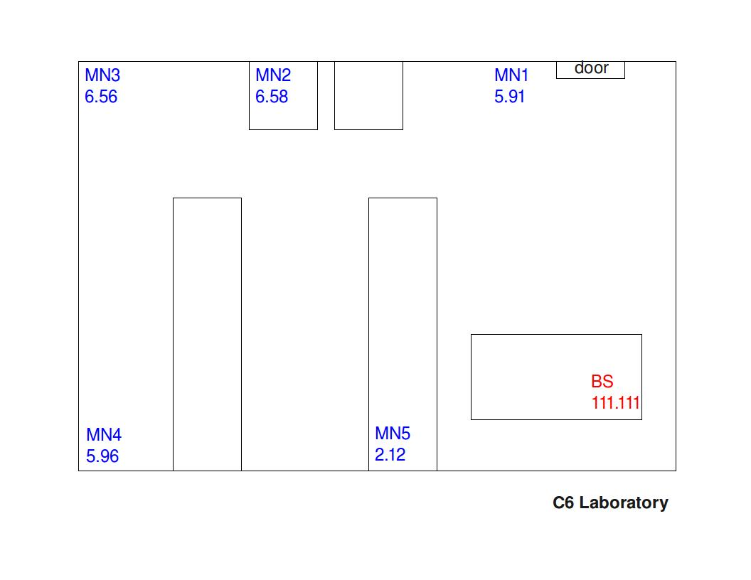

* 1. Deployment map
  2. Report
* Start time: 19:20
* Number of MNs: 5
* Base-station: Without antenna
* Duration: XX minutes
* File sending period: 1 minute and 40 seconds
* Sample period: 10 seconds
* Protocol: Mesh
* Base-station’s log file: filename

1. Results

* MN 5.91
  + Packets sent: xx
  + Packets acknowledged: xx
* MN 2.12
  + Packets sent: xx
  + Packets acknowledged: xx
* MN 6.58
  + Packets sent: xx
  + Packets acknowledged: xx
* MN 6.56
  + Packets sent: xx
  + Packets acknowledged: xx
* MN 5.96
  + Packets sent: xx
  + Packets acknowledged: xx

**Test 3**

* 1. Deployment map

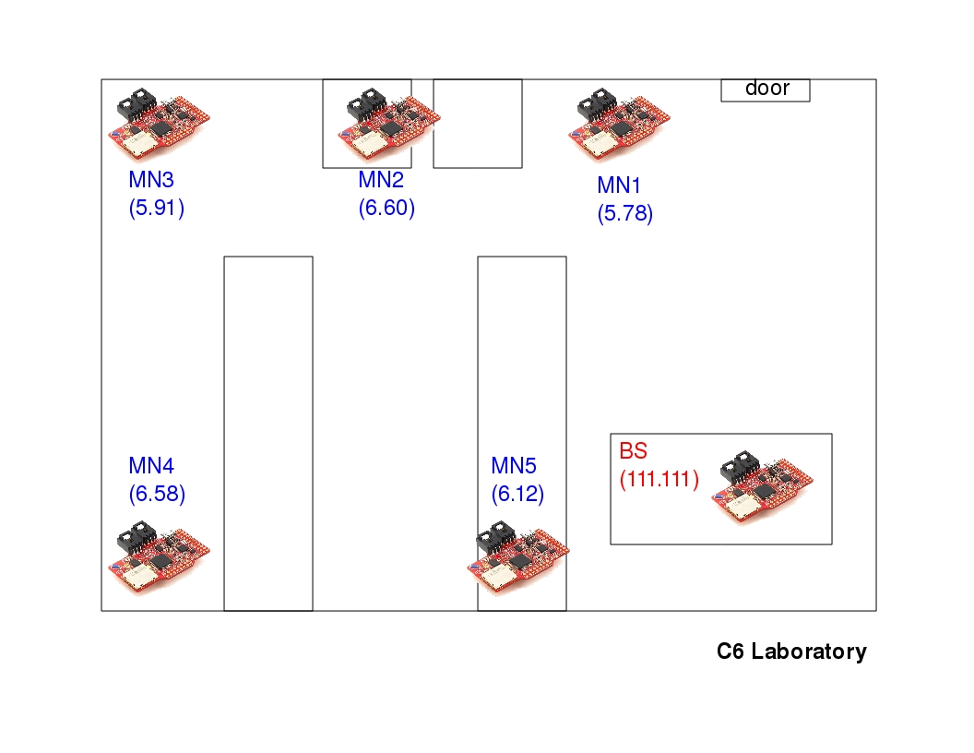

* 1. Informe
* Start time: 19:20
* Number of MNs: 5
* Base-station: Without antenna
* Duration: 2 days and 12 hours
* File sending period: 10 minutes
* Sample period: 1 minute
* Protocol: Mesh
* Base-station’s log file: filename
  1. Results
* MN 5.78
  + Packets sent: xx
  + Packets acknowledged: xx
* MN 6.12
  + Packets sent: xx
  + Packets acknowledged: xx
* MN 6.60
  + Packets sent: xx
  + Packets acknowledged: xx
* MN 5.91
  + Packets sent: xx
  + Packets acknowledged: xx
* MN 6.58
  + Packets sent: xx
  + Packets acknowledged: xx