

**MDSAA**

Master Degree Program in

**Data Science and Advanced Analytics**

**Application of Business Intelligence in Employee Demographic and Structure**

A case study at Vodafone Portugal

Álvaro António Matos dos Reis

Project Work

Presented as partial requirement for obtaining a Master’s Degree in Data Science and Advanced Analytics

**NOVA Information Management School**

**Instituto Superior de Estatística e Gestão de Informação**

Universidade Nova de Lisboa

**NOVA Information Management School**

**Instituto Superior de Estatística e Gestão de Informação**  
Universidade Nova de Lisboa

**APPLICATION OF BUSINESS INTELLIGENCE IN EMPLOYEE DEMOGRAPHIC AND STRUCTURE ANALYSIS: CASE STUDY OF VODAFONE PORTUGAL**

by

Álvaro António Matos dos Reis

Project Work report presented as partial requirement for obtaining the master’s degree in Advanced Analytics, with a Specialization in Business Analytics

**Supervisor**:

**Co-Supervisor:**

July, 2024

##### Statement of Integrity

I hereby declare having conducted this academic work with integrity. I confirm that I have not used plagiarism or any form of undue use of information or falsification of results along the process leading to its elaboration. I further declare that I have fully acknowledged the Rules of Conduct and Code of Honor from the NOVA Information Management School.

*Lisboa, July 15th, 2024*

##### Abstract

The human resources sector is of fundamental importance for companies and has key indicators to boost the business. In this sense, understanding how the control of the top management team works as well as providing information by functional level and ranges, where employees are allocated. In this sense, understand how the control of the top management team works, as well as providing information by functional level and ranges, where employees are allocated. In this context, the use of dashboards in Human Resources (HR) becomes a powerful tool for data evaluation. Studies such as Johnson et al. (2018), Robbins (2021) and Hernandez (2019) highlight the importance of using business intelligence tools as a strong strategy in the HR sector. Given this, as companies seek competitive advantage in a knowledge-oriented and technology-based economy, technological advances have expanded the potential of BI methodologies in HR management, enabling automated decision-making processes. This study, based on empirical research at Vodafone Portugal, explored how to use dashboards in Human Resources (HR) to evaluate demographic data and organizational structure through a case study highlighting the strategic importance of business intelligence (BI) in HR, using a Kimball Lifecycle methodology. To achieve the objectives of the study, exploratory and empirical approaches were adopted, following eight phases: project planning, business requirements definition, technical architecture design and dimensional modeling, physical design, ETL design and development, BI application development, deployment and maintenance. This project, aimed at evaluating the potential of business intelligence (BI) tools, specifically Power BI, in supporting data-based decision making in the HR department, was developed to meet the specific needs of supervising the conduct of this sector in the HR department. Vodafone Portugal, showed through the creation of custom dashboards and key performance indicators (KPIs) how BI solutions can provide actionable insights into employee demographics and organizational structure, thereby supporting strategic planning and company development. corporate culture.

**Keywords**

Dashboards; Business intelligence; Human resource; Microsoft Power BI; Kimball Lifecycle.

**INDEX**

1. Introduction 1

2. Literature review 3

2.1. HR Analytics 3

2.1.1. The Scientific Mentality in Decision-Making 4

2.1.2. Business Acumen and HR Analytics 5

2.2. Business Intelligence (BI) 5

2.3. Summary of the Chapter 7

3. Methodology 8

3.1. Hypothesis 9

3.2. Questionnaire 10

3.3. limitations 10

4. Empirical Study 11

4.1. Program/Project Planning 11

4.2. Business Requirements Definition 12

4.3. Technical Architecture Design 13

4.4. Dimensional Modelling 13

4.5. Physical Design 16

4.6. ETL Design & Development 19

4.7. BI Application Development 21

4.8. Deployment 23

4.9. Maintenance 24

5. Results and discussion 26

5.1. questionnaire Responses 32

6. Conclusions and future works 36

Bibliographical References 39

Appendix A 44

Appendix B 46

Appendix C 55

##### List of figures

Figure 1 Kimball Lifecycle Diagram (Kiball & Ross, 2013) 9

Figure 2 - Power BI Model 18

Figure 3 - Power BI Model in Second Dashboard 19

Figure 4 - ETL Design & Development Diagram 20

Figure 5 - BI Application Development Diagram 22

Figure 6 – Deployment Diagram 23

Figure 7 - Results of First Dashboard 30

Figure 8 - Results of Second Dashboard 32

##### List of tables

Table 1 - Answers to the First Questionnaire 33

Table 2 - Answers to the Second Questionnaire 34

##### List of Abbreviations and Acronyms

**AAD** Azure Active Directory

**BI** Business Intelligence

**CSV** Comma Separated Values

**DAX** Data Analysis Expressions

**ETL** Extract, Transform and Load

**Fem** Female

**HC** Headcount

**HR** Human Resources

**HRBP** Human Resources Business Partner

**KPI** Key Performance Indicator

**SQL** Structure Query Language

**WDG** Work Done for Group

# Introduction

The role of business intelligence solutions including Power BI in transforming raw data into actionable insights is highlighted. This competence allows organizations like Vodafone Portugal to have a fully developed plan from which they can manage their data. The integration of Power BI is considered in the context of personalized dashboards, as well as key HR KPIs to enhance decision-taking.

In this context, according to Harold Kerzner (2017), currently the process of goal-oriented and data-based decision-making has become central for businesses that wish to generate competitive advantage. One of the most crucial roles that HR departments play in this change is to apply technology to simplify operations and improve productivity, and business intelligence techniques assist in this process.

The general objective of this thesis is to evaluate the transformative potential of business intelligence tools as an application instrument that can be used to assess the origin of workers at the company Vodafone de Portugal and also how employees are distributed in the company's organizational structure and the percentage of women.

To reach the general objective of the research, two dashboards will be developed using the Kimball Lifecycle methodology: first dashboard was developed for Vodafone Portugal's human resources department with the aim of providing insights into demographic information and second is about the company's organizational structure, mainly evaluating the percentage of women among Vodafone's team leaders.

A questionnaire will develop to evaluate the usability of two sound reports, seeking to capture the perception of the main users in relation to the dashboards. The questionnaire contained 13 questions, divided into five categories: general information about the user, frequency of use of the panels, evaluation of the dashboards, suggestions and general evaluation.

In this context, the role of the Human Resources (HR) department at Vodafone Portugal is fundamental to promoting organizational growth, boosting corporate culture and ensuring the well-being of employees. Knowing the origin of workers is essential for the company's resources sector to know how the strategic hiring planning and construction of organizational culture will be carried out. Developing an analysis of the organizational structure based on knowledge of the percentage of women is also vital for the HR sector, as it will show whether there is gender balance in senior management, thus demonstrating the issue of representation.

Firstly, it is imperative to carry out an in-depth analysis of the specificities of Vodafone Portugal. One of these specificities is the issue of demographic assessment of employees, as there are many foreigners living in Portuguese territory and this is reflected in the company's culture.

The secondary objectives are to present the fundamentals and techniques for data extraction using query languages, methods for table relationships, the construction of Key Performance Indicators (KPIs) with Power BI's DAX language, and, finally, the most appropriate techniques for the visual presentation of indicators. This constitutes the technical process of building the business intelligence methodology.

The challenge of this research will be to evaluate the benefits of integrating a Business Intelligence tool in an empirical situation. This study is in line with research by authors such as Jadhav, Shelar & More (2022), Bhosale et al. (2023) and Sousa & Dias (2020) who sought how to evaluate Business Intelligence tools in evaluating performance metrics help in making decisions about human resources management.

According to Sousa & Dias (2020), Business Intelligence tools help companies automate the transmission of information and thus generate a competitive gain over competitors. BI tools have modules for managing large volumes of data, such as data marts, for example, and thus provide automated information through dynamic reports.

Regarding the above, it is important to highlight that the demographic issue can be used as a benchmark for Vodafone with other companies in the telecommunications sector, both inside and outside Portugal. This identification will allow us to know whether the company can retain talent of Portuguese origin and attract foreign employees over time.

In addition to this introduction, this study contains a literature review chapter on business intelligence and human resources, another chapter on research methodology, a chapter on the bases of the empirical study with the two dashboards, another chapter on the results of the empirical study and finally the conclusions.

# Literature review

The objective of this chapter is to present a review of existing literature on human resources analytics, Business Intelligence (BI) in human resources, and the specific use of Power BI to support and improve HR operations. As the central objective of this thesis is based on analyzing Vodafone's employees and organizational structure, it is important to know the contexts in which Business Intelligence tools are applied in different areas of the HR sector. It is essential to have a macro view to understand the micro.

According to Harold Kerzner (2017), currently the goal-oriented and data-based decision-making process has become central for businesses that want to generate competitive advantage. In this context, one of the most crucial roles that HR departments play in this change is applied technology to simplify operations and improve productivity by attracting and retaining good talent.

Based on the previous paragraph, the example of Vodafone Portugal, the main provider of telecommunications services, understands that data is essential for operational efficiency and employee performance. In this context, based on Jadhav, Shelar & More (2022) emphasize that the main role of Human Resources management is to evaluate the functionality of workers and their role in work activity. In companies like Vodafone, knowing the origin of employees and building a multifactorial culture is essential to guarantee the perpetuity of operations, in addition to guaranteeing representation in the organizational structure.

As analyzed in Jadhav, Shelar & More (2022) and Bhosale et al. (2023), the integration of Power BI software with Power BI is a powerful business intelligence tool that has the potential to measure operations within the company and offer information about what actions can be taken through customized dashboards and evaluate whether the developed organizational culture is yielding results.

## HR Analytics

Fitz-enz (2009) defines HR Analytics as people analysis or talent analysis and represents a systematic approach to human management, leveraging data-based methodologies. It involves collecting, analyzing, interpreting and reporting data about employees within organizations. The overall objective is to inform decision-making, meet strategic HR management objectives and maintain a competitive advantage in the rapidly evolving business ecosystem.

According to Minbaeva (2017), HR analytics tools are resources that aim to evaluate data exploration to gain insights into various related work within this sector. This is part of the emergence of data analytics for HR. This demonstrates how human resources analytics is becoming more meaningful within the context of technology and data analytics.

Based on what was exposed in the previous paragraph and the study by Marler and Boudreau (2017), based on HR analytics, many companies moved forward with operations reports and can create or internalize some well-designed and distributed dashboards retrospective reports to business units regularly.

Given this, it can be said that analysis related to human resources is on the rise as an activity that has become more crucial. With HR analysis through HR analysis tools, companies can optimize the use of human resources and make informed decisions, as evidenced in studies by Minbaeva (2017) and Rasmussen and Ulrich (2015).

That said, Lawler, Levenson and Boudreau (2004) show that this type of analysis allows companies to reach maximum levels of efficiency. This is because they can fully exploit the potential of their people. This objective can be achieved in several ways, including using tools provided based on employee performance analysis relevant to hiring and organizational engagement data.

### The Scientific Mentality in Decision-Making

According to Boudreau and Ramstad (2005), the basis of Human Resource Analysis (HR Analysis) is a tireless commitment to promoting a scientific approach within the complex network of decision-making procedures. This paradigm requires a conscious break from historically subjective judgments and emphasizes the use of techniques based on methods rather than evidence.

It is highly disturbing that HR professionals and organizational leaders adopt and apply a scientific methodology, moving from a purely intuitive, evidence-based approach to a method-based approach and utilizing empirical data when developing and updating workforce strategies (American Economic Association, Royal Economic Society and Simon, H. A. (1966)).

This shift to a methods-based rather than evidence-based paradigm is critical to improving the effectiveness of decision-making processes and aligns with a broader organizational trend that is being renewed: a deliberate attempt to establish and maintain an organizational culture deeply rooted in data-driven insights.

### Business Acumen and HR Analytics

According to Minbaeva (2017), a sophisticated business sense is essential for the effective application of science-based human resources (HR) techniques. According to this paradigm, the CEO and HR experts play a crucial and vital role in promoting the use of method-based practices to improve organizational performance.

Business savvy is a crucial component that serves as the foundation for HR Analytics’ successful implementation (Minbaeva, 2017). HR Analytics’ strategic posture is strengthened by the mutually beneficial relationship between data-driven approaches and a deep understanding of the complex dynamics of the business landscape.

This relationship also makes HR Analytics an indispensable tool for achieving organizational objectives. This fusion, characterized by the harmonious convergence of empirical data analysis and a sophisticated grasp of business intricacies, not only amplifies the efficacy of HR practices but also establishes HR Analytics as an indispensable strategic asset in the organizational arsenal, playing a pivotal role in steering the trajectory towards successful goal achievement (Popovič, A., Hackney, R., Coelho, P. S., & Jaklič, J. 2012).

## Business Intelligence (BI)

Convergence with business intelligence (BI) becomes a strategic requirement to improve HR Analytics’ capabilities. Business intelligence, according to Ralph Kimball’s definition in “The Data Warehouse Toolkit,” is the act of turning unprocessed data into information that can be used for business objectives by using technology, procedures, and tools (Sherman, R. 2014). The scope of data analysis is expanded beyond HR-specific data by the integration of HR Analytics with BI, providing insights that align with more general company goals.

This interdisciplinary approach fosters a data-driven culture across the whole organization in addition to improving decision-making across the board. Organizations may make well-informed decisions that affect both human capital management and overall business success thanks to synergistic teamwork. According to the literature, combining BI with HR Analytics offers a comprehensive method of data analysis that links HR activities with more general company goals.

BI solutions is a useful tool for strategic decision making in the field of human resources because this part delivers possibilities to adapt it, so that all changes are related with stated goals of the organization. Hernandez (2019) showed that customized dashboards provide better insight on key metrics related to human resources, analyzing how the role of big data can retain employees retention in a resource-based view.

Now, studies that used the Power BI tool in the HR sector will be shown. The objective is to evaluate how this tool can be applied in different contexts. Ameer and Manner (2020) used Power BI to conduct a study on human resources (HR) management, showing that it is a complex topic in which descriptive analysis is one of its main components, including the analysis of employee turnover, performance analysis, among others.

Pandey and Mehta (2020) evaluated through Power BI how each company makes every effort to extract maximum productivity from its employees to achieve business profitability. However, they encounter a few problems unique to their best employees, and this is often where people analytics comes into play. Daily operations, procedural efficiency and other strategic operational challenges are addressed by HR analytics. As a result, HR analytics considers all components of an organization at a high level, while workforce analytics focuses on personal data such as engagement, job satisfaction, and success. Machine learning approaches and business intelligence tools can be used to predict and evaluate staff turnover and retention. Every modern organization accumulates a huge amount of employee data. The authors used this data to extract insights from it so that the company can make better decisions about how to conduct employee work.

Kakulapati et al. (2020) evaluated how business tools optimize HR analytics, through system development that HR units in organizations. These authors applied the use of Power BI and machine learning techniques to analyze employee information to improve their position in the organization.

Baggyalakshmi et al. (2024) evaluated how users can automate tasks and processes in their Office 365 workflow with Microsoft Flow along with Power BI. The authors state that many organizations depend on several programs that are part of Microsoft Office 365 and through Microsoft Power Automate a wide variety of processes and tasks can be automated by integrating various applications and platforms. Whether in the cloud or on-premises, users can integrate Microsoft Office 365 applications with each other and with a vast library of other programs. This way, any member of the company with rudimentary knowledge of Office 365 can create simple automations to speed up routine tasks in your company. Power BI and Microsoft Power Apps allow power users to create their own unique business processes. This optimizes flows within HR.

## Summary of the Chapter

In all, the literature review focuses on BI in human resources, HRA and PBI for HR. That is a brief review summary. Businesses such as Vodafone Portugal have a significant opportunity for ameliorating the capability of making decisions based on data in their human resource management activities by incorporating Power BI into the same. This is a significant opportunity. A strong opportunity has been brought up here. With the help of Power BI dashboards, internal human resources departments that can tailor to their individual needs will have a better understanding of employee performance as well as effective recruitment and engagement strategies. Consequently, the departments will be in a position to offer better service delivery for its staff. It all happens with the help of business intelligence software.

As for the implementation process, challenges of Power BI deployment reveal how important proper preparation prior to installation and during its execution is. There are many such issues, some of which include security concerns about the data available there, integration problems with the system and user training possibilities.

There are several businesses that may benefit from the direction described by best practices and case studies for those who want to discover the ways in which Power BI creates opportunities within human resources. This direction, however simple these two types of resources may seem to be, can prove helpful for such businesses. Furthermore, the assessment of its effects gives a perceptive and insightful viewpoint on software efficiency.

# Methodology

The objective of this chapter is to explain the methodology used in this research. The chapter will be divided into two sections: the first will explanate about the research hypothesis and second will describe limitations.

This research used Kimball lifecycle methodology apply quantitative and qualitative techniques (Kimball & Ross, 2013). One of the widely used structures and life cycles of a project in the context of the business intelligence area, it is the Kimball life cycle. This cycle dictates the rules of the dimensional drawing term, which is based on 4 steps: configuration of project planning, creation and definition of business requirements, creation of the dimensional model and design of data extraction, transformation, and loading.

The steps of the Kimball life cycle were defined to assist in the creation of systems architectures and infrastructures for business needs. Below is Figure 1 with the summary diagram of Kimball's life cycle.

Figure 1 Kimball Lifecycle Diagram (Kiball & Ross, 2013)

Regarding the quantitative methodology, like the work of Sousa and Dias (2020), similar to the work of Sousa and Dias (2020), in which a sample was made with fictitious data from the company Vodafone on the origin of employees and information on the organizational structure.

From a qualitative point of view, this research was close to the methodology adopted by Sharma, Dashora and Saxena (2022) evaluating niches in the human resources sector using BI tools. Therefore, an iterative and collaborative qualitative approach was used.

## Hypothesis

In this study, the impacts of using Power BI on the expectations of the Human Resources sector were analyzed as a fundamental tool for managers, allowing them to access crucial information quickly, efficiently and visually attractive. This is measured in terms of the following aspects:

Using dashboards in Power BI helps to automate the assessment of the nationalities of Vodafone Portugal employees? It also helps to know how the company's employees are distributed in the organizational structure, the percentage of women and what are the management rates by functional level?

In summary, by centralizing and visualizing data in a dynamic and effective way, dashboards and reports developed in Power BI can allow Vodafone Portugal managers to better identify their employees and create representation in the organizational structure through automated information and to boost the company's success.

This initiative is expected to represent a significant step in the modernization and optimization of information about employees and managers at Vodafone Portugal, empowering leaders with the necessary tools to promote a business culture of excellence, innovation and continuous growth within the organization.

## Questionnaire

A questionnaire will develop to evaluate the usability of the two dashboards that will be developed in the work, the objective was to understand the perception of the main users in relation to the panels. The questionnaire consisted of 13 questions, covering 5 (five) categories: which sought to evaluate general information about the user, frequency of use of the panels, evaluation of the dashboards, suggestions and general evaluation. As there were few users, the questionnaire focused on evaluating each person's perception regarding the use of each panel. The questionnaire will include in Appendix C and the results will be presented in the results and discussions chapter.

## limitations

A limitation of the research is in relation to access to the company's sensitive data, this involves ethics for conducting of the research, as the results with the real sample can only be accessed by members of the company being researched. This limitation would occur in other private law organizations. Another limitation would be a more systematic bibliometric survey in regarding the use of Business Intelligence tools, as the technology used is very new and only very recent articles were found. Cloud database management systems are currently being used and this will certainly impact the use of business intelligence tools, such as Power BI.

Another limitation is in relation to the comparison prior to using the Power BI tool. It is difficult to control to evaluate performance before and after, so it would be necessary to carry out an observational study comparing performance indicators.

# Empirical Study

The objective of this chapter was to highlight the steps of the Kimball Lifecycle methodology used in this research. The steps and methods used will be presented below.

The dynamic panels in this work will be built with Microsoft's Power BI tool using simulated databases due to Vodafone's information security. The simulated samples approximate the day-to-day life of the company's human resources sector.

Initially, the data was collected and processed through queries using SQL (structure query language) and ETL (extract, transform, load) tools in the company's database and later simulated data was generated. Subsequently, the simulated data was loaded into Microsoft Power BI and processed using the Microsoft Power Query M language. Subsequently, fact and dimension tables were generated to make connections between them to generate the dashboards, these connections were made using primary keys.

The relationships between the tables will be of the many-to-one type, that is, a fact table related to dimension tables. This type of relationship will be used in two dashboards. In the first dashboard, a temporal dimension, a demographic dimension and a fact table with general data from Vodafone employees will be built.

The second dashboard is a fact table with general data on Vodafone employees, a time dimension, a bandwidth dimension and another to identify employees in the organizational structure. Details on the construction of the tables and variables will be detailed in the physical design section of this chapter.

## Program/Project Planning

The first step is to define the project to be developed. The objective was to build two dashboards in the human resources area with different objectives: the first was to evaluate the visualization of the nationalities of Vodafone Portugal employees and analysis of cultural diversity within the company. The second involved evaluating gender diversity and organizational structure.

Still on planning, detailed insights were provided on the demographic composition and organizational structure of employees, to facilitate strategic decision-making related to diversity and human resources management.

Still at this stage, it is important to assess risks and mitigations and to do so, it is necessary to implement rigorous data validation and cleaning processes and maintain constant communication with stakeholders to manage scope changes.

Another important point at this stage is the process of technical problems and in this case we sought to ensure that the team has adequate technical skills and access to the necessary support.

## Business Requirements Definition

The objective was to define and document the business requirements for employee nationality and gender diversity dashboards and organizational structure, ensuring that all stakeholder needs are understood and met.

Stakeholders were identified through HR directors and managers, who were interested in obtaining a clear and comprehensive view of the demographic composition and diversity within the company. This is important, as HR teams need tools for detailed analysis of employee data and stakeholders need quick and accurate insights to support strategic decisions. The data will be extracted from the company's database and processed using the SQL language.

This stage has functional and non-functional requirements. The functional requirements were to evaluate the distribution of employee nationalities and show the total headcount in the HR department.

* The non-functional requirements were to show periodically updated data to reflect changes in the company's structure and ensure data security and privacy, in accordance with the company's data protection policies. In this context, the research questions to be answered are: What are the nationalities of Vodafone Portugal employees?
* What is the percentage of foreigners within Vodafone and how many joined in the month of analysis?
* How are employees distributed in the company's organizational structure and the percentage of women?
* What are management ratios and spans of controls by functional level?

## Technical Architecture Design

In this step, the data was first extracted through queries in SQL language in the Oracle DataBase database following the ETL (Extract, Transform, Load) process. The data modeling was based on the dimensional model in which the data structure is organized into fact and dimension tables to optimize query and analysis. The tools used in this stage were the Power BI Data Model and the Tabular Model.

Regarding security, user permissions were defined to access sensitive data in the Azure Active Directory (AAD) tool for authentication and authorization. Regarding data governance, policies and procedures were defined to ensure data quality and compliance through the Azure Data Catalog and Data Governance Framework tools.

## Dimensional Modelling

Regarding the dimensional model, the objective was to develop a dimensional model that supports the business requirements of HR dashboards, ensuring that data is organized efficiently for quick and intuitive analysis.

For the physical design components, the dimensional model was used through the snowflake relationship. The dimension tables were: Employees Dimension, Nationalities Dimension and Time Dimension. The fact tables were: Headcount Fact and Gender Diversity Fact.

In the employees dimension, attributes such as ID, name, department, position and date of admission were included. In the nationalities dimension, the attributes used were ID, country, region and continent. In the time dimension, the attributes were date ID, day, month, year and quarter.

The process chosen was the analysis of demographic data and organizational structure. This focus was defined to meet the need for HR managers to understand the composition of employees in terms of nationality and gender, as well as to support the company's diversity and inclusion goals

The granularity of the model has been defined at the employee level, enabling detailed analysis of specific metrics such as nationality and gender, which are essential for data segmentation and deeper insights. This level of granularity ensures that analyzes can be carried out both individually and on larger aggregates.

Regarding dimension identification, the employees dimension includes attributes such as employee ID, name, department and hire date, to allow a clear view of each employee within the organizational structure. The nationalities dimension contains information on countries, regions and continents, enabling analyzes of cultural diversity. Finally, the time dimension was composed of attributes such as date ID, day, month, year and quarter, allowing trends and comparisons to be monitored over time.

Regarding the definition of facts, the fact tables were designed to capture essential metrics for HR analysis through the Headcount Fact tables that account for the total number of employees, with the ability to segment by gender and nationality, meeting the need of visibility in demographic distribution and gender diversity fact table that stores gender diversity data, essential for analyzes focused on inclusion and gender balance within the company.

The dimensional model developed in this work supports HR dashboards and was implemented in a scheme close to the star model, where fact tables are connected to multiple dimensions, facilitating quick and efficient queries.

Dimensional Modeling was developed according to the Kimball methodology, using four steps to define the ideal data structure for analysis in HR dashboards. This approach allows for clear and efficient organization of data to meet specific analysis requirements.

The analysis of demographic data and organizational structure was selected as the main business process due to its importance for Vodafone Portugal's strategic diversity and inclusion objectives. This process is critical to providing HR managers with detailed insights into the demographic composition and gender balance of the workforce, essential elements of human resources strategy.

First, in the Business Process Selection step, the analysis of demographic data and organizational structure was selected as the main business process due to its importance to Vodafone Portugal's strategic diversity and inclusion objectives. This process is critical to providing HR managers with detailed insights into the demographic composition and gender balance of the workforce, essential elements of human resources strategy. The focus on demographic and diversity data meets the needs of monitoring internal policies, allowing the monitoring of KPIs such as total headcount, gender ratio and cultural diversity among employees.

In the second step, Determining the Level of Granularity, we opted for granularity at the individual employee level, as this depth is necessary for detailed analyzes that allow the segmentation and identification of specific patterns within the company. With this granularity, it is possible to carry out both aggregated and specific analyses, facilitating access to information from total data by department to individual details by nationality and admission date. This approach allows greater flexibility for managers to adjust their queries and visualizations according to the needs of different analyses.

In the third step, Dimensions Identification, the following main dimensions were chosen: the employee dimension, the nationality dimension and the time dimension. The employee dimension includes attributes such as ID, name, department and hire date, allowing each employee to be individually identified, relating them to the department and allowing a complete analysis of the internal structure.

The nationalities dimension adds data about the country, region and continent, allowing a detailed analysis of cultural diversity and compliance with the company's inclusion objectives, making it possible to evaluate the distribution and representation of different cultures. The time dimension, made up of attributes such as date ID, month, year and quarter, facilitates longitudinal analysis, allowing comparisons over time, such as the evolution of the number of employees or diversity over different periods.

Finally, in the Fact Definition step, two main fact tables were defined: the headcount fact table and the gender diversity fact table. The headcount fact table records total employee count and allows filters by gender and nationality, providing a consolidated view for demographic analysis. This fact is crucial for evaluating the total number of employees and understanding the distribution by demographic group.

The gender diversity fact table contains gender diversity percentages, allowing the company to monitor and evaluate gender balance at different levels and sectors, supporting inclusion goals. Fact tables are designed to capture and store essential metrics that align with business objectives, such as gender diversity and headcount by nationality. This allows the metrics most relevant to the company's strategic objectives to be readily available on HR dashboards.

## Physical Design

The objective was to select and install the BI tools that best meet the technical and business requirements for Vodafone Portugal's HR dashboards. This phase must ensure that all software and hardware components are correctly configured to support the development, implementation, and ongoing operation of the dashboards.

The selected products were BI tools such as Power BI Desktop, Power BI Service and Power BI Mobile for visual dashboards; Microsoft Azure Synapse Analytics and Azure Data Factory for Data Warehouse Infrastructure; SQL Server for data storage and processing; Azure Active Directory (AAD) for security and access control; and Azure Data Factory as an ETL (Extract, Transform, Load) tool.

Power BI Desktop is used for developing and designing dashboards, while Power BI Service is the cloud-based platform for sharing, collaborating and publishing dashboards. Power BI together with the Power BI Service offer an intuitive interface, a wide range of visualizations and tight integration with other Microsoft tools such as Azure and Office 365.

Microsoft Azure Synapse Analytics was used for data storage and processing and was chosen due to its high scalability, robust performance and native integration with Power BI. Azure Data Factory was used to integrate and move data between different sources and was chosen to facilitate the orchestration and automation of data flows, ensuring that the data is up to date.

The SQL Server database was used to store structured data due to its optimized performance for SQL queries and support for complex transactions. Azure Active Directory was used to manage user authentication and authorization as it provides role-based access control, ensuring data security.

Azure Data Factory was employed to extract, transform and load data from various sources into the Data Warehouse. This software facilitates the integration of data from different sources, automating the ETL process.

The first step towards implementing the physical design was to download the Power BI Desktop installer from the official Microsoft website and run it. Data connections were then configured to access the data warehouse in Azure Synapse Analytics and update data and credentials.

Subsequently, the Power BI Service was configured by creating an account in the Power BI Service or using an existing corporate account. Workspaces were then created and configured to organize the dashboards and reports in which Power BI Desktop dashboards were published for the Power BI Service.

The other step was to define access and sharing permissions for different users and groups from data gateway settings, if necessary, to allow real-time data updating. Azure Synapse Analytics was then configured by creating an Azure Synapse Analytics instance in the Azure portal.

The next step was to configure dedicated SQL pools to store and process data across database schemas, tables, and indexes to optimize performance. The next step was to implement security and backup policies to protect data with Azure Data Factory. To this end, an Azure Data Factory instance was created in the Azure portal.

Next, data pipelines were defined to extract, transform and load data from various sources through schedules for automatic execution of the data pipelines. After the previous step, it was necessary to monitor the execution of the pipelines to guarantee the integrity and update of the data through the security configuration with Azure Active Directory managing users and groups.

In relation to the components of the physical design, dimensional modeling was used through the snowflake relationship. The dimension tables were: Collaborators Dimension, Nationalities Dimension, Time Dimension. The fact tables were Headcount Fact and Gender Diversity Fact.

In the employees’ dimension, attributes such as ID, name, department, position and date of admission were used. In the nationalities dimension, attributes such as ID, country, region and continent were used. In the time dimension, attributes such as date ID, day, month, year and quarter were used. Below are figures 2 and 3 with the relational models of the two dashboards developed.

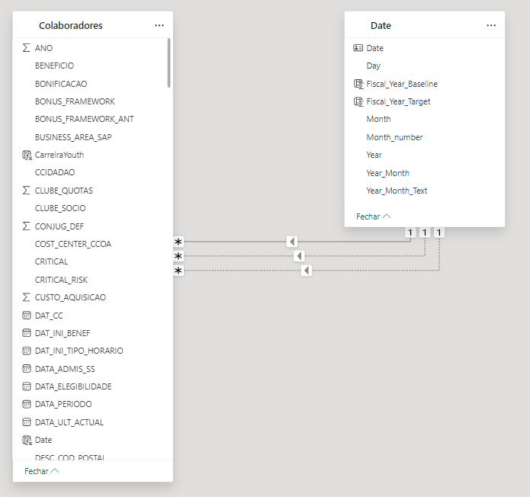

Figure 2 - Power BI Model

Source of author's elaboration based on research data. As can be seen, the relationship is close to a star schema, in which there are one-to-many relationships through a fact table with dimension tables. According to Emany et al. (2016), in the star schema, the fact table is the central table with information that can be repeated and is linked to dimension tables, whose information is unique. Dimension tables contain the attributes or keys.

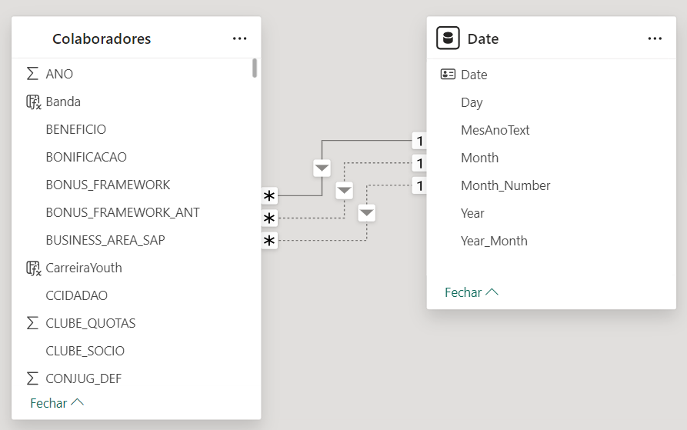

Figure 3 - Power BI Model in Second Dashboard

Source of author's elaboration based on research data. Dimension tables contain the attributes or keys.

## ETL Design & Development

The objective of this stage was to design and develop the ETL pipelines to extract, transform and load the necessary data for Vodafone Portugal's HR dashboards. This process aims to ensure the integrity, quality and availability of data in the Data Warehouse, allowing accurate and timely analysis. The ETL design development follows the diagram in figure 4 below.

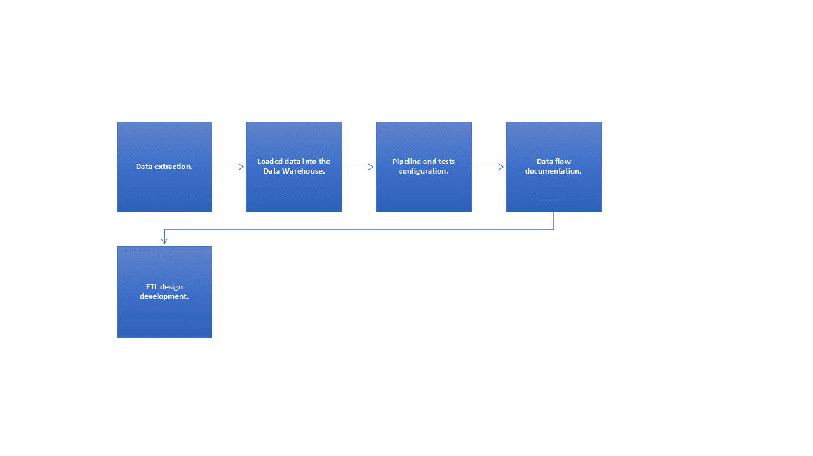

Figure 4 - ETL Design & Development Diagram

Source of author's elaboration based on research data.

The main component used was data extraction to identify and access relevant operational data sources, such as Vodafone Portugal's HR systems, transactional databases, CSV files, among others. To this end, appropriate connectors and APIs were used to extract data efficiently and securely.

After data extraction, transformations were applied to the extracted data to prepare it for analysis, including data cleaning, standardization, enrichment and aggregation as necessary. It was necessary to validate and guarantee the quality of the data during the transformation process.

After the extraction and transformation steps, data was loaded into the Data Warehouse, following the dimensional structures and facts defined in Physical Design. Incremental load techniques were used to optimize performance and minimize downtime in Azure Data Factory.

Subsequently, the pipelines were configured. Data pipelines were created in Azure Data Factory to orchestrate the flow of data from extraction to loading into the Data Warehouse. From there, extraction, transformation and loading activities were defined within the pipelines, such as scheduling and monitoring and schedules were configured for automatic execution of pipelines based on defined load times.

After configuring and automating pipelines, the validation and testing stage was carried out in order to carry out integration tests to ensure that the ETL pipelines are working as expected. This is necessary to validate the accuracy of uploaded data by comparing with original data sources and through exploratory analysis.

The next step was to develop the documentation and maintenance stage to document the data flows, applied transformations and pipeline execution schedules for future reference. The goal was to establish maintenance and support procedures to monitor and adjust pipelines as needed.

The next stage was working with requirements analysis where data and business requirements were reviewed with stakeholders to define ETL needs. Specific data sources and transformation requirements were identified for each dashboard.

After the previous stage, the ETL design was developed through a detailed design of the ETL pipelines, including data mapping, transformations, validations and loading strategies. ETL pipelines were implemented using Azure Data Factory, writing transformation scripts and activity configurations in the Azure portal.

Subsequently, the testing stage was carried out. Integration tests were performed to validate the complete data flow from extraction to loading into the Data Warehouse. Subsequently, the testing stage was carried out. Integration tests were performed to validate the complete data flow from extraction to loading into the Data Warehouse. And after testing, the ETL pipelines were implemented in the production environment, configuring schedules and monitoring for automated execution.

Finally, the training and documentation stage was carried out. The objective was to provide training to the operations team on monitoring and maintaining ETL pipelines and document the design and implementation of ETL pipelines for future support and reference.

## BI Application Development

The objective was to develop and implement dashboards and reports in Power BI that will visualize the Data Warehouse's analytical data, focusing on specific human resources indicators such as nationalities of employees, gender diversity by functional level, headcount, span of control and management ratios from Vodafone Portugal. The BI application development follows the diagram in figure 5 below.

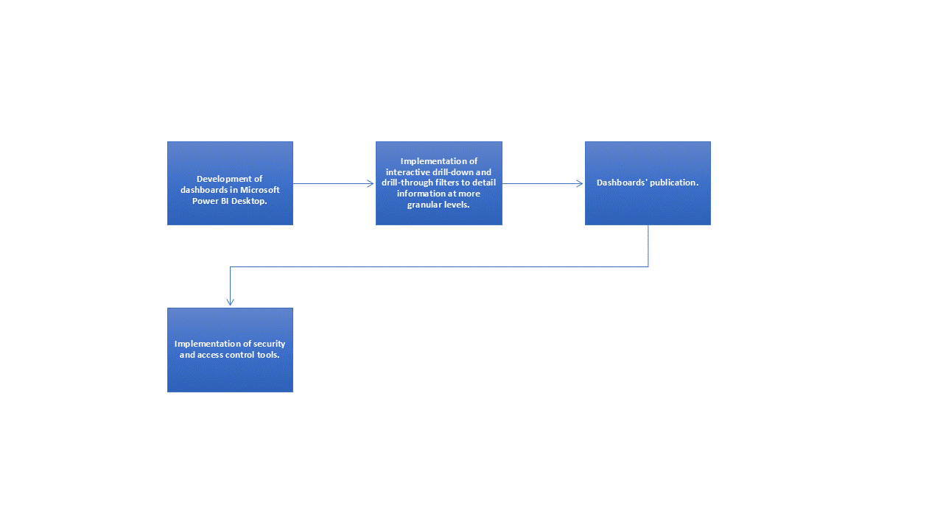

Figure 5 - BI Application Development Diagram

Source of author's elaboration based on research data.

The first stage of BI Application Development was the development of dashboards in Microsoft Power BI Desktop with the aim of generating dashboard visualization. Visualizations such as bar graphs, lines, pie charts, maps, pivot tables, among others, were developed.

At this stage it is important to maintain visual consistency, as it maintains a visual design consistent with Vodafone Portugal's corporate identity. It’s important to use colors, fonts and layouts that are clear and intuitive for users.

Another important point is to implement interactive filters to allow users to explore data from different perspectives and use drill-down and drill-through to detail information at more granular levels.

After completing the steps described in the previous paragraphs, it is important to publish the dashboards and reports developed in Power BI Desktop to the Power BI Service and configure automatic updates to ensure that the data is always up to date. In this case, dashboards in appropriate workspaces in Power BI Service for collaboration and sharing.

Regarding access to dashboards, security and access control tools were implemented to restrict access to sensitive data based on user roles. Access permissions have been defined to ensure that only authorized users can view and interact with the dashboards.

## Deployment

The objective this section was to deploy HR dashboards in Power BI and ETL processes in Azure Data Factory in Vodafone Portugal's production environment, ensuring that all components are correctly configured and ready for use by end users. The deployment step follows the diagram in figure 6 below.

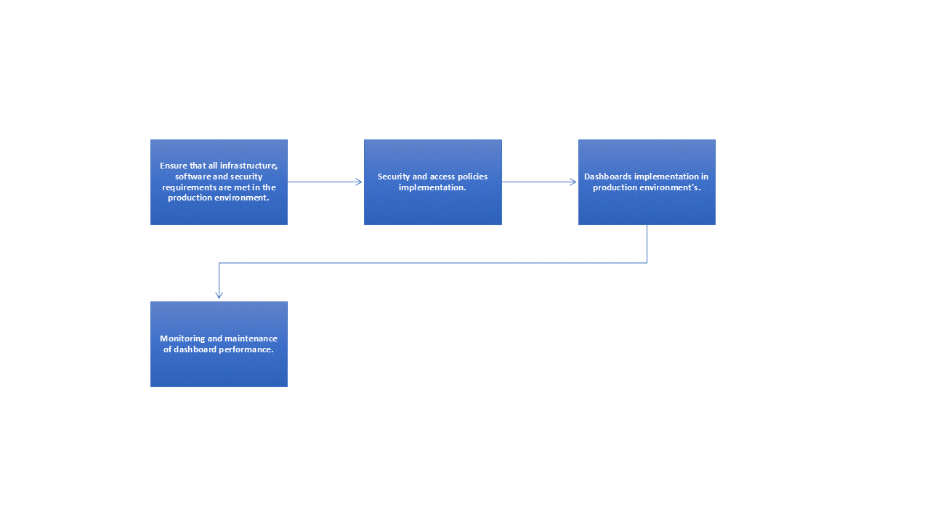

Figure 6 – Deployment Diagram

Source of author's elaboration based on research data.

In relation to the deployment components, the production environment was prepared and prerequisites were validated. The focus was to ensure that all infrastructure, software and security requirements are met in the production environment. Subsequently, storage and processing capacity was validated in Azure Synapse Analytics (formerly Azure SQL Data Warehouse) and Azure Data Factory.

Another important step in the deployment is the security configuration, which was done by implementing security and access policies in Power BI Service and Azure Synapse Analytics using Azure Active Directory (AAD). Also at this stage, Row-Level Security (RLS) was configured to restrict access to sensitive data in the dashboards.

The next step was to deploy dashboards in Microsoft Power BI through publication in the Power BI Service. In this subsection, dashboards and reports developed in Power BI Desktop were published in Power BI Service and workspaces suitable for organization and collaboration were configured.

The next stage was to perform post-deploy testing. They were made functional to ensure that all dashboards are working as expected in the production environment and verifying data integrity and query performance.

The other step was to deploy ETL pipelines in Azure Data Factory by configuring ETL pipelines in Azure Data Factory to extract, transform and load data into Azure Synapse Analytics. Execution schedules were established to keep data updated according to business needs.

In the next stage, the integration testing stage was performed to validate the complete data flow from extraction to loading into the Data Warehouse and monitor and adjust pipelines as necessary to ensure data consistency and accuracy.

The other step taken was training and supporting end users to conduct training sessions for end users on how to access and use the dashboards in Power BI. Guidance was provided on available features and best practices for exploring data.

After the training stage, the continuous support stage was conducted to establish a support channel to resolve doubts and technical problems related to dashboards and ETL processes. Finally, the performance monitoring and maintenance stage was carried out in which a detailed deployment plan was defined, including dates, responsibilities and specific steps for each component (dashboards and ETL) and continuous monitoring of the performance and use of dashboards and ETL pipelines, performing maintenance as necessary.

## Maintenance

The objective of this section was to explain how the process was carried out to maintain the performance, availability and relevance of Vodafone Portugal's HR dashboards over time, ensuring that they continue to provide accurate and useful insights to stakeholders.

Monitoring the performance of dashboards in Power BI Service was defined, evaluating page loading times, query responses and resource usage. Furthermore, it was defined as Identify and resolve performance issues to improve the user experience.

The other stage developed in this maintenance process was data integrity, as it is necessary to monitor the integrity of the data in the Data Warehouse, checking the consistency and accuracy of the information presented in the dashboards. Another aspect of this step was the implementation of automatic verification routines to detect anomalies in the data.

Finally, the updates and tuning stage was performed where software updates and patches were applied to Power BI Service, Azure Synapse Analytics, and Azure Data Factory as needed to maintain security and compatibility. In this case, the data is updated and verified every month so that the data is always in accordance with the company's reality.

# Results and discussion

The objective of this chapter is to discuss the results of the two dashboards developed at Vodafone. Simulated data was used for information security reasons. At this point, today's challenging business environment is vital for the organization to access information and knowledge for better decision making.

The construction of dashboards used techniques and solutions to help managers understand the business situation in the company analyzed.

The rapid advancement of business technologies in recent years has made knowledge an essential asset that dictates the success of a company. The use of correct information in real time is a competitive differentiator in the market. Business intelligence systems provide corporate executives, business managers, and others with operational workers make better, more informed business decisions. The panel evaluates the impact of using Power BI on the decision-making process in organizations in Vodafone's human resources sector.

The first dashboard was developed for Vodafone Portugal's human resources department with the aim of providing insights into demographic information and another into team leader reporting. Minbaeva (2017), Rouhani, Asgari and Mirhosseini (2012) and Mehta (2020).

The second panel is about the company's organizational structure, mainly evaluating the percentage of women among Vodafone's team leaders. Studies such as Sudesh & Shroff & Neha (2020) also address team leaders as an object of research, whose authors evaluated useful BI capabilities and resources to support and improve decision-making for effective actions in senior management.

Given the above, in relation to the first dashboard, the following business questions were asked: what is the current percentage of foreign employees, and how does it compare to the company's target for this fiscal year? How has the headcount of Portuguese and foreign employees evolved over the past fiscal years, and how does it compare to the targets set for future fiscal years? How many new foreign employees have been hired in the current reporting month, and how does this number align with the set targets? What is the distribution of employees by nationality, and how does the current demographic composition align with the company’s diversity goals? How does the demographic distribution of employees correlate with the geographical presence of the company? How does the percentage of foreign employees compare to the baseline year (FY22/23) and future targets?

The second dashboard seeks to answer the following business questions: what is the current number of employees, and how does this compare to the previous month? How is the headcount distributed across business areas, and how does this vary between different salary bands and genders? What are the company’s gender diversity rates, and how do they compare to the previous month? How many employees are on external assignments (assign out) or are interns, and what are the trends in these numbers? What is the distribution of employees across different population types (local, WDG, vertical) and business areas? What are the key management efficiency indicators, such as management ratios and spans of control? How are business areas and the position qualification system mapped within Vodafone Portugal?

In relation to the construction of the two dashboards, information was protected directly from the database (simulated). Demographic information was extracted from Vodafone de Portugal employees. In Power BI, a relational model was developed between tables like the star schema. To generate the indicators, operations were carried out using the DAX (Data Analysis Expressions) language and the codes will be available in the appendix section of this dissertation.

In relation to the results of the first dashboard, about first business question (about the current number of employees, and how does this compare to the previous month) the information was compiled on the nationality of Vodafone de Portugal employees through counting. This question assesses how well the company is meeting its diversity targets in terms of foreign employee representation. The dashboard shows that for the reporting month, the percentage is 2.10%, compared to the targets set for the fiscal years FY23/24 (2.51%) and FY24/25 (2.71%).

The second business question in the first dashboard, about the headcount of Portuguese and foreign employees evolved over the past fiscal years, this question looks at trends in the headcount of both Portuguese and foreign employees over time, providing insights into the company’s progress toward its diversity and inclusion goals. The dashboard highlights the headcount numbers across FY22/23, FY23/24, FY24/25, and the reporting month.

The third business question in the first dashboard, the dashboard lists the headcount for each nationality, with a significant majority being Portuguese (1479 out of 1509 total employees).

The fourth business question in the first dashboard, about the demographic distribution of employees correlate with the geographical presence of the company, whose objective was exploring how the nationalities of employees relate to the company's geographical footprint, which can be seen on the map provided in the dashboard. This helps in understanding whether the company’s workforce reflects its global reach and market presence.

The last business question in the demographic dashboard, about the percentage of foreign employees compare to the baseline year (FY22/23) and future targets, question that sought to infer about the progress in increasing the percentage of foreign employees from the baseline year to the present, and how it aligns with future targets. The dashboard shows a slight decrease in the percentage from FY22/23 (2.21%) to the reporting month (2.10%).

The business questions regarding the demographic dashboard allowed stakeholders to assess the company's progress in meeting its diversity and inclusion objectives, focusing particularly on the representation of foreign employees. The dashboard provides valuable insights into how well the company is aligning workforce composition with its strategic objectives.

The results of the second dashboard were explain show the main indicators of team leaders. In which employability indicators are presented, employability comparisons in relation to the previous month, percentage of female workers. The first business question results (about the current number of employees, and how does this compare to the previous month), this information about the number of employees is displayed in the "Employees" section (1540), with a change of +5 from the previous month.

The result of second business question, about the headcount distributed across business areas, and how does this vary between different salary bands and genders, the distribution is detailed in the central table, with columns for each business area and rows for each salary band. The diversity percentages (Fem. %) are also included. Next, about third business question (about the company’s gender diversity rates, and how do they compare to the previous month), the result was the overall percentage of female employees (F - Female %) is shown as 37%, with a +1% change from the previous month.

The fourth business question, which refers to the employees are on external assignments (assign out) or are interns, and what are the trends in these numbers, it was observed that the numbers for "Assign Out" (1) and "Internships" (3) are presented along with the change from the previous month.

Now, about the fifth business question in the second dashboard (about the distribution of employees across different population types and business areas), the information results are shown at the bottom of the dashboard, indicating the distribution of staff between “HC Local”, “HC Vertical” and “HC WDG”.

The sixth business question addressed in the second dashboard sought answers about the key management efficiency indicators, such as management ratios and spans of control. In this context, OE indicators, such as management ratios and spans of control, are presented in the “Management Ratios” section of the dashboard.

The last business question presented in the second dashboard was regarding business areas and the position qualification system mapped within Vodafone Portugal. Regarding this question, the mapping by business areas is visible in the headcount table, where each area has a specific column. The job qualification system can be inferred from the different salary ranges presented. In summary, below are figures 7 and 8 with the results of the two dashboards respectively.

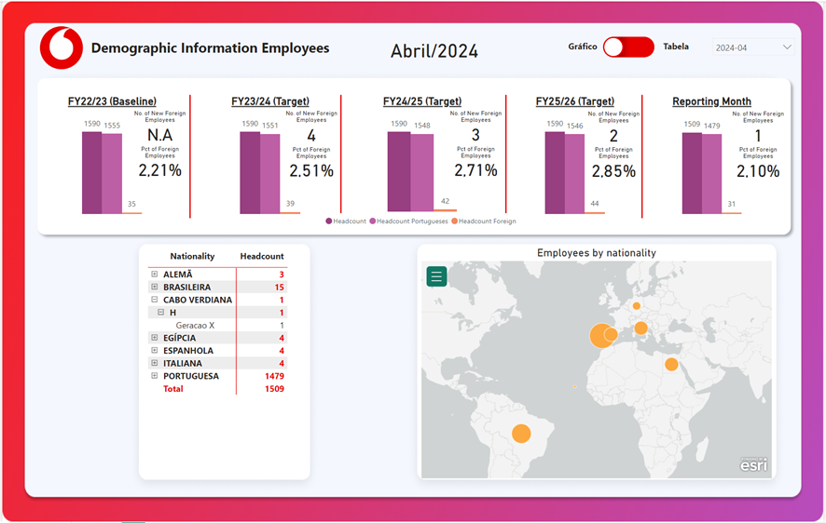

Figure 7 - Results of First Dashboard

Source of author's elaboration based on research data. The colors and design chosen were based on Vodafone.

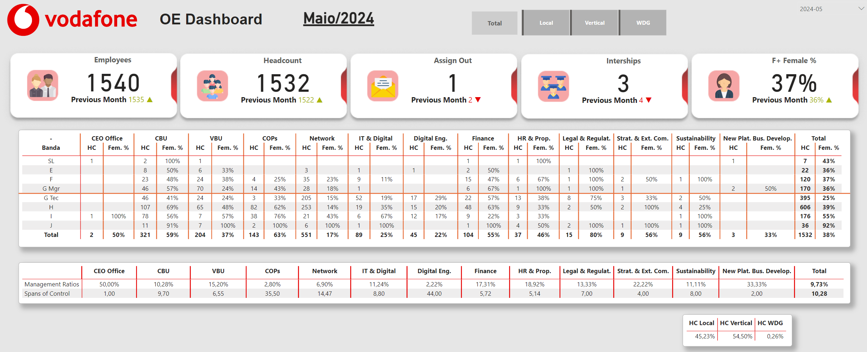

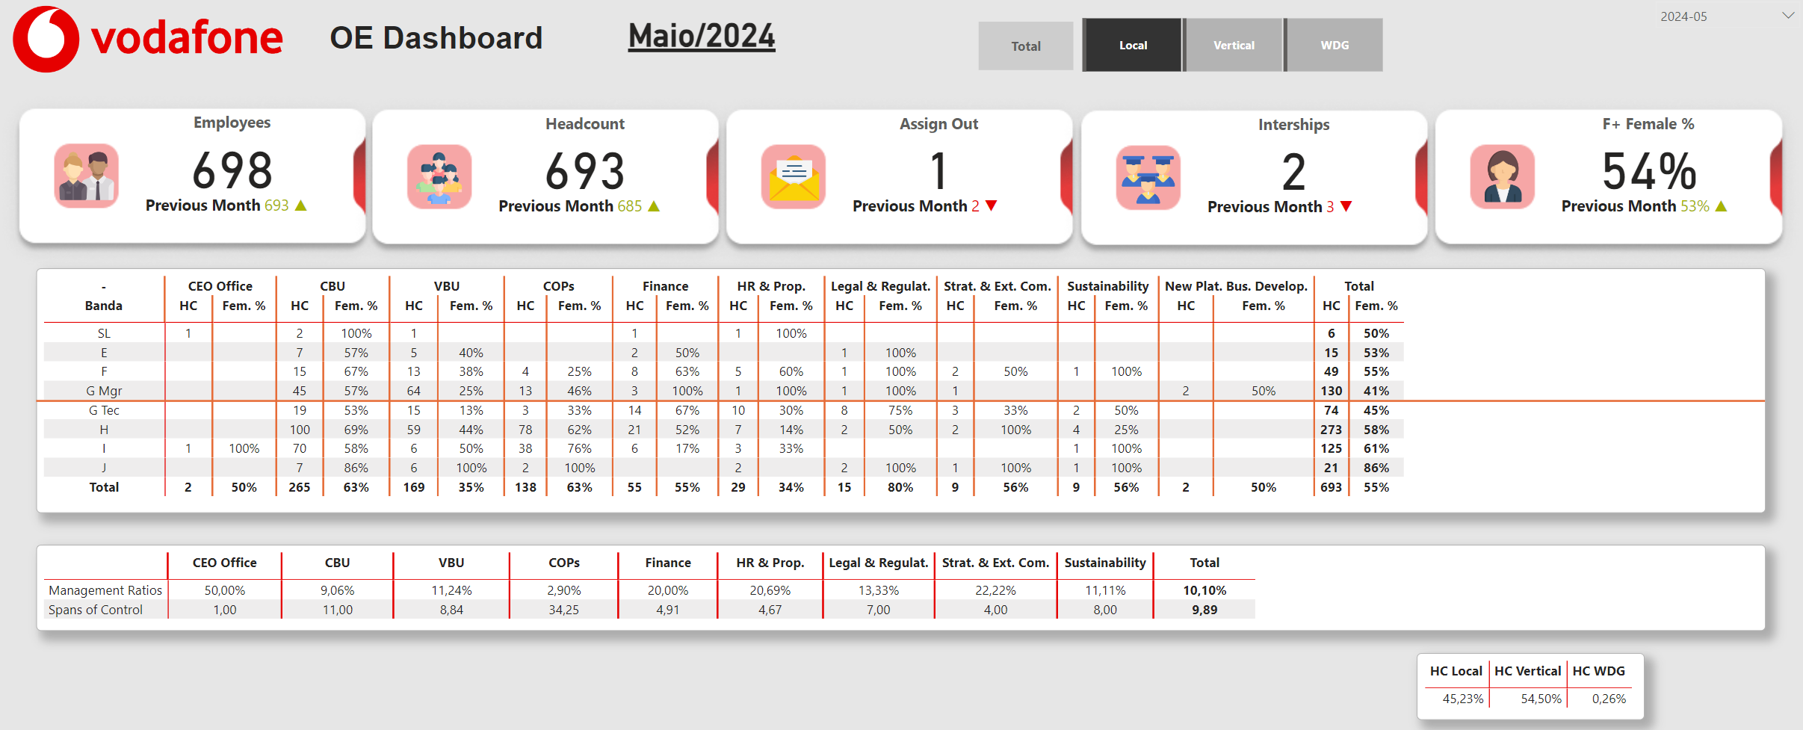

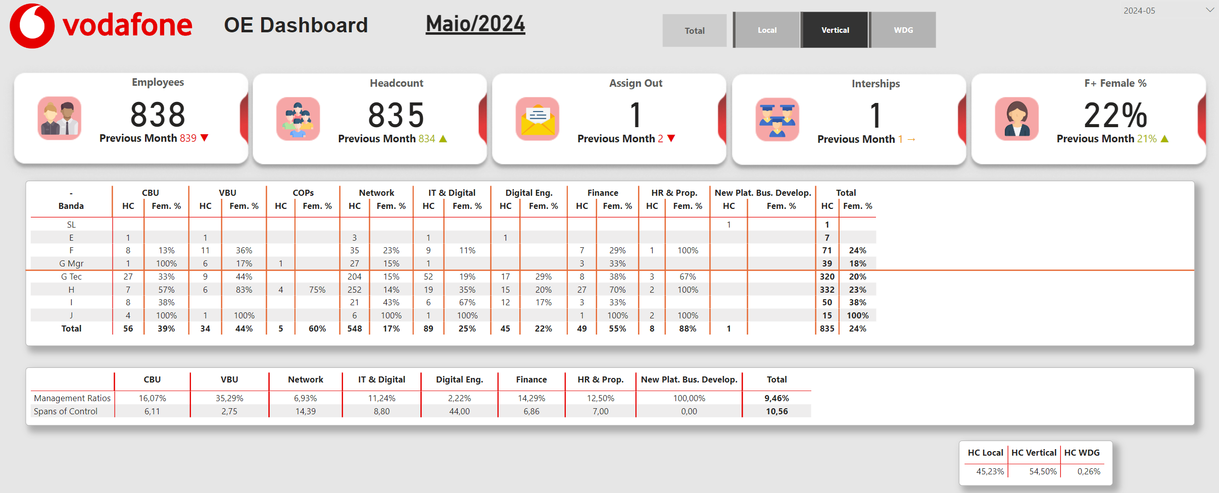

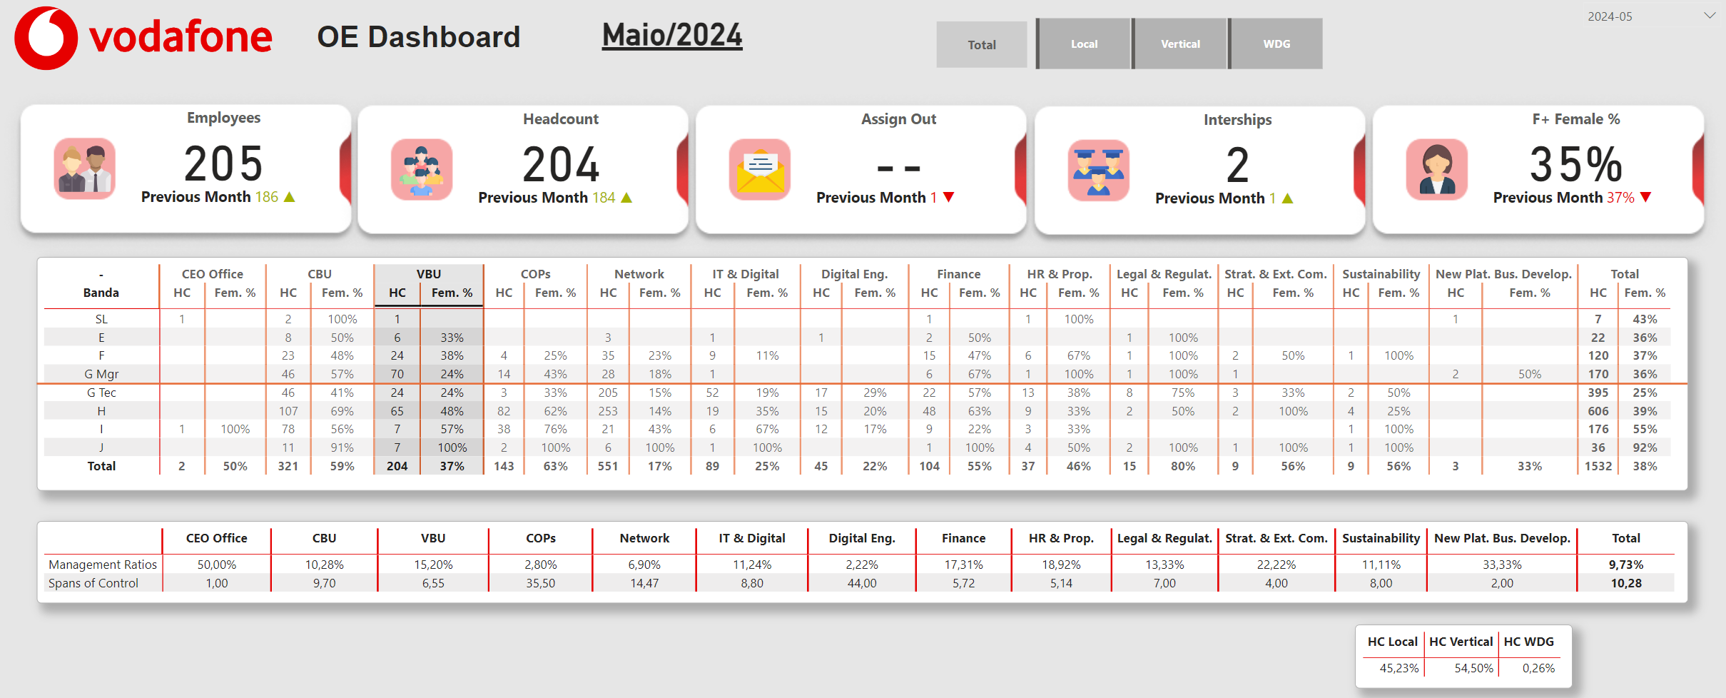

Figure 8 - Results of Second Dashboard

**Figure legend**. Source of author's elaboration based on research data. The colors and design chosen were based on Vodafone. The objective was to provide results based on data on the area's main performance indicators.

## questionnaire Responses

Regarding the questionnaire, two people who used the dashboards constantly responded. The respondent to the demographic dashboard questionnaire was Mgr. Culture, Sustainab. & Foundation in the Property sector. Regarding the dashboard usage section, this employee responds that he used the tool weekly, which took between 5 and 15 minutes, while in the dashboard evaluation section he stated that navigation in the dashboard was very easy. This employee also responded that the layout and organization of the information was completely adequate, that the presented information was useful, that the speed of the dashboard was fast, and agreed that the dashboard is reliable and presents accurate data.

Regarding the suggestions and comments section, the respondent on the demographic panel questionnaire stated that he would like this Dashboard to be replicated in Qlik Sense and he didn’t find problems navigating this panel because information was clean and clear. Finaly, he stated that he was very satisfied with the dashboard in general.

The second respondent, now on the OE questionnaire, had the position of HRBP & OE Lead in the Human Resources department. In the section about dashboard usage, this employee mentioned that they used the tool on a daily basis, spending less than 5 minutes on it. In the dashboard evaluation section, they noted that navigation was very easy. Additionally, the employee expressed that the layout and organization of the information were adequate, the information provided was helpful, the dashboard's performance was quick, and they agreed that it is reliable and delivers accurate data.

In the suggestions and comments section, the HRBP & OE Lead respondent informed that he would like to expand the number of key indicators and get dynamic dashboards. To conclude, this employee responded that he was very satisfied.

The answers to the first questionnaire are below in table 1.

|  |  |
| --- | --- |
| **Questions** | **Responses** |
| **How often do you use the new dashboard?** | Weekly |
| **On average, how much time do you spend using the dashboard in each session?** | Between 5 and 15 minutes |
| **How would you rate the ease of navigation in the dashboard?** | Very easy |
| **Is the layout and organization of the information adequate?** | Completely adequate |
| **Is the presented information useful for your decision-making?** | Useful |
| **How would you rate the loading speed of the dashboard?** | Fast |
| **Is the dashboard reliable and does its present accurate data?** | Strongly agree |
| **How would you rate your overall satisfaction with the dashboard?** | Very satisfied |
| **What additional features would you like to see in the dashboard?** | I would like to this Dashboard be replicated on Qlik Sense |
| **Did you encounter any issues or difficulties while using the dashboard?** | No, I didn´t find any trouble navigating through this dashboard. The information is clean and clear. |
| **Additional comments:** | N/A |

Table 1 - Answers to the First Questionnaire

The answers to the second questionnaire are below in table 2.

|  |  |
| --- | --- |
| **Questions** | **Responses** |
| **How often do you use the new dashboard?** | Daily |
| **On average, how much time do you spend using the dashboard in each session?** | Less than 5 minutes |
| **How would you rate the ease of navigation in the dashboard?** | Very easy |
| **Is the layout and organization of the information adequate?** | Adequate |
| **Is the presented information useful for your decision-making?** | Very useful |
| **How would you rate the loading speed of the dashboard?** | Very fast |
| **Is the dashboard reliable and does its present accurate data?** | Agree |
| **How would you rate your overall satisfaction with the dashboard?** | Very satisfied |
| **What additional features would you like to see in the dashboard?** | Enlarge the number of key Indicators and get dynamic dashboards. |
| **Did you encounter any issues or difficulties while using the dashboard?** | N/A |
| **Additional comments** | N/A |

Table 2 - Answers to the Second Questionnaire

Based on comments and suggestions from questionnaire respondents, some relevant directions were identified for future improvements to Vodafone Portugal's HR dashboards. Firstly, it was suggested that the dashboard be replicated in the Qlik Sense tool. This development will allow us to explore additional dynamic visualization functionalities that may not be present in Power BI, such as greater interactivity and more robust filter customization options, which will enrich the user experience and enable even more detailed analyzes adapted to the needs of different areas.

Another important suggestion was the expansion of indicators and the implementation of more dynamic dashboards. The inclusion of new key indicators (KPIs) and the creation of an interactive platform offer development opportunities that will make the dashboard more useful for different sectors of the HR area. This will enable deeper and more personalized analysis, aligning the dashboard with users' specific requirements.

Furthermore, for future iterations, it is recommended to expand feedback collection to a broader audience, including stakeholders from different areas. This practice could involve discussion groups or feedback sessions with managers and analysts from various areas, which would ensure that dashboards evolve to meet the specific needs of different teams and functions, promoting a more representative and effective tool.

Finally, another relevant next step is the automation and real-time updating of data. Dashboard users could benefit from more frequent information updating, ideally in real time, to ensure that decisions are based on the most current data possible. The implementation of automatic updates, integrated into the company's HR systems, would help to keep data always aligned with current operations, improving the accuracy and relevance of information. These next steps aim to not only respond to specific feedback from users, but also improve the functionality and adaptability of the dashboards, to ensure that they continue to efficiently and strategically meet the needs of Vodafone Portugal's HR area.

# Conclusions and future works

This work sought to analyze the application of dashboards in the HR sector to evaluate demographic data and the company's organizational structure, using a home study of the company Vodafone in Portugal. In this context, authors such as Johnson et al. (2018), Robbins (2021) and Hernandez (2019) also evaluated the importance of applying business intelligence tools in the HR sector.

In the current context of a market economy based on knowledge and technology, companies recognize the growing relevance of precision data analysis in generating competitive advantage and helping to develop better company performance. The growth in progress in information technology has helped to immerse the improvement and potential of the BI methodology applied to Human Resources Management, generating automated tools for better choices. This structural change generates efficiency through the rapid generation and transmission of data-based information. This research sought to evaluate the use of BI tools to evaluate specific subsectors within Vodafone.

Regarding the results of the case study at Vodafone, it was possible to implement the business intelligence methodology in the HR sector to obtain demographic information about the company's employees and also about key indicators for team leaders, mainly regarding gender issues. The entire process was conducted using the Kimball Lifecycle methodology supported by the literature.

Although the results displayed were based on simulated data due to information security, it was possible to visualize the distribution of workers' countries of origin, gender, total number of employees and monthly variation in the number of employees. It was a simplified presentation of how powerful the BI methodology is to evaluate the demographic profile of employees and also the organizational structure.

Considering the specifications presented, this research demonstrates the importance of a solid and efficient data infrastructure for the development of specific and reliable dashboards. The use of simple tools, such as Excel, and the lack of a well-structured data model compromised the quality of the results obtained.

In relation to the limitation in the previous paragraph, the migration to Qlik Sense, the creation of a direct connection to the database and the implementation of a star model are proposed to overcome these limitations. These measures will allow the creation of more dynamic dashboards, with data updated in real time and a more intuitive interface for the user.

Another important limitation was the failure to create a statistical model to assess causality in process improvements through the creation of the two dashboards. For future studies, it would be important to carry out an analysis of the causal relationship between the use of BI tools and their impact on the company's results. To do this, it would be necessary to work with regression models to evaluate, as was done in the study by Soua and Dias (2020).

Additionally, collecting multichannel feedback is critical to ensuring that dashboards meet the needs of all users. By involving different stakeholders in the development process, it is possible to create more personalized and effective tools.

Another important point in the research was evaluating the perception of dashboard users. There was a limitation of only two respondents, but it was possible to obtain their respective perceptions on the usability of the dashboards.

The questionnaires were developed to evaluate the usability of the two dashboards developed in this work, with the aim of understanding the perception of the main users in relation to the panels. The questionnaire had 13 questions divided into five categories: general information about the user, frequency of use of the panels, evaluation of the dashboards, suggestions and general evaluation. The central idea was to individually evaluate each participant's perception of the qualities of each dashboard.

The first responding user, manager of Culture, Sustainability and Foundation in the Properties sector, used the demographic dashboard weekly for around 5 to 15 minutes and evaluated the navigation as very easy, with well-organized and useful information, fast performance and reliable data. This employee suggested replicating the dashboard in Qlik Sense and expressed general satisfaction with possible improvements.

The second respondent, HRBP and OE leader in the Human Resources sector, used the dashboard daily for less than 5 minutes. This last user rated the navigation as very easy, with adequate layout and organization, and fast and reliable performance. He made the suggestion to increase the number of key indicators and make the dashboards more dynamic, concluding with high satisfaction with the tool. Both users were generally satisfied with the features presented in the dashboards.

In summary, by addressing this area of ​​research and understanding the existing gaps, companies will be better prepared to develop BI tools that respond effectively to the needs of the company's department, to better understand their employees and develop better policies for organizational culture, contributing thus for more strategic, representative, informed and efficient management.

# Bibliographical References

Ameer, M.L., Rahul, S.P., & Manne, S. (2020). Human Resource Analytics using Power Bi Visualization Tool. 2020 4th International Conference on Intelligent Computing and Control Systems (ICICCS), 1184-1189.

American Economic Association, Royal Economic Society, & Simon, H. A. (1966). Theories of decision-making in economics and behavioural science (pp. 1-28). Palgrave Macmillan UK.

Antunes, A. L., Cardoso, E., & Barateiro, J. (2022). Incorporation of ontologies in data warehouse/business intelligence systems-a systematic literature review. International Journal of Information Management Data Insights, 2(2), 100131.

Baggyalakshmi, D., Dhanya, R., & Revathi, D. (2024). HR Onboarding Kit. International Academic Journal of Innovative Research.

Ballard, C., Farrell, D. M., Gupta, A., Mazuela, C., & Vohnik, S. (2012). Dimensional Modeling: In a Business Intelligence Environment. IBM Redbooks.

Ballard, C., Herreman, D., Schau, D., Bell, R., Kim, E., & Valencic, A. (1998). Data modeling techniques for data warehousing (p. 25). San Jose: IBM Corporation International Technical Support Organization.

Bernhard Wieder, Maria-Luise Ossimitz. The Impact of Business Intelligence on the Quality of Decision Making – A Mediation Model, Procedia Computer Science, Volume 64, 2015, Pages 1163-1171, ISSN 1877-0509, https://doi.org/10.1016/j.procs.2015.08.599.

Bersin, J. (2015). The datafication of HR. Deloitte University Press.

Boudreau, J. W., & Ramstad, P. M. (2005). Talentship, talent segmentation, and sustainability: A new HR decision science paradigm for a new strategy definition. Human Resource Management, 44(2), 129-136.

Brown, A., et al. (2020). Transforming employee performance analytics with Power BI: A case study. Journal of Business Analytics, 3(2), 123-137.

Chen, H., Chiang, R. H. L., & Storey, V. C. (2012). Business Intelligence and Analytics: From Big Data to Big Impact. MIS Quarterly, 36(4), 1165–1188. https://doi.org/10.2307/41703503.

Chen, Y., et al. (2019). Challenges and considerations in adopting business intelligence in human resources: A case study approach. International Journal of Human Resource Management, 30(1), 162-183.

Collier, K. (2012). Agile analytics: A value-driven approach to business intelligence and data warehousing. Addison-Wesley.

Dahlbom, P., Siikanen, N., Sajasalo, P., & Jarvenpää, M. (2020). Big data and HR analytics in the digital era. Baltic Journal of Management, 15(1), 120-138.

Dipak Kumar Bhattacharyya. (n.d.). HR analytics: understanding theories and applications.

Fitz-enz, J. (2009). The new HR analytics: Predicting the economic value of your company's human capital investments. AMACOM Div American Mgmt Assn.

Hernandez, M. (2019). The impact of customized dashboards on HR analytics. Journal of Organizational Analytics, 6(4), 275-289.

Jadhav, M. D, & Shelar, A.B, & More, S. (2022). HR People Data Analytics Using Power BI Data Visualization Tool. International Journal of Research Publication and Reviews (Vol. 3). Online. www.ijrpr.com

Johnson, R., et al. (2018). Empowering HR with Microsoft Power BI: A case study. Journal of Information Systems and Technology Management, 15(3), 317-330.

Jones, P., & Smith, L. (2019). Quantifying the impact of Power BI on HR efficiency: A case study. International Journal of Human Resource Management, 30(12), 1975-1994.

Kakulapati, V., Kalluri Krishna Chaitanya, Kolli Vamsi Guru Chaitanya and P. Shilhora Akshay. “Predictive analytics of HR - A machine learning approach.” Journal of Statistics and Management Systems 23 (2020): 959 - 969.

Kasemsap, K. (2016). The fundamentals of business intelligence. International Journal of Organizational and Collective Intelligence (IJOCI), 6(2), 12-25.

Kerzner, H.R. (2017) Project Management, Metrics, KPIs, and Dashboards. John Wiley, New York.

Kim, S., et al. (2021). Best practices in implementing Power BI for HR: Lessons learned from successful organizations. Journal of Information Technology Case and Application Research, 23(3), 119-135.

Kimball, R., Reeves, L., Ross, M., & Thornthwaite, W. (1998). The Data Warehouse Lifecycle Toolkit: Expert Methods for Designing, Developing, and Deploying Data Warehouses. Wiley.

Lawler III, E. E., Levenson, A., & Boudreau, J. W. (2004). HR metrics and analytics: Use and impact. Human Resource Management, 43(1), 73-82.

Marler, J. H., & Boudreau, J. W. (2017). An Evidence-Based Review of HR Analytics. The International Journal of Human Resource Management, 28, 3-26. <https://doi.org/10.1080/09585192.2016.1244699>.

Microsoft. (2020). Power BI. Retrieved from <https://powerbi.microsoft.com/>.

Minbaeva, Dana. (2017). Human capital analytics: why aren't we there? Introduction to the special issue. Journal of Organizational Effectiveness: People and Performance. 4. 110-118. 10.1108/JOEPP-04-2017-0035.

Oliveira, B., & Belo, O. (2017). Approaching ETL processes Specification Using a Pattern-Based ontology. In Data Management Technologies and Applications: 5th International Conference, DATA 2016, Colmar, France, July 24-26, 2016, Revised Selected Papers 5 (pp. 65-78). Springer International Publishing.

Opatha, H. H. D. P. J. (2020). HR Analytics: A Literature Review and New Conceptual Model. International Journal of Scientific and Research Publications (IJSRP), 10(06), 130–141. <https://doi.org/10.29322/ijsrp.10.06.2020.p10217>.

Pandey, S., & Mehta, J. (2022). HRPA: Human Resource Prediction Analytics. 2022 Third International Conference on Intelligent Computing Instrumentation and Control Technologies (ICICICT), 721-726.

Popovič, A., Hackney, R., Coelho, P. S., & Jaklič, J. (2012). Towards business intelligence systems success: Effects of maturity and culture on analytical decision making. Decision support systems, 54(1), 729-739.

Rasmussen, T., & Ulrich, D. (2015). Learning from practice: How HR analytics avoids being a management fad. Organizational Dynamics, 44(3), 236-242.

Reddy, P. R., & Lakshmikeerthi, P. (2017). 'HR Analytics'-An Effective Evidence-Based HRM Tool. In International Journal of Business and Management Invention ISSN (Vol. 6). Online. [www.ijbmi.org](https://chat.openai.com/c/www.ijbmi.org).

Robbins, J. (2021). Customization of business intelligence tools for HR: A practical guide. HR Technology Solutions, 45(2), 89-104.

Rouhani, Saeed & Asgari, Sara & Mirhosseini, Vahid. (2012). Review Study: Business Intelligence Concepts and Approaches.

Sidi, Emany & El Merouani, Mohamed & Aoulad Abdelouarit, Dr. El Amin. (2016). Star Schema Advantages on Data Warehouse: Using Bitmap Index and Partitioned Fact Tables. International Journal of Computer Applications. 134. 11-13. 10.5120/ijca2016908108.

Smith, A., & Davenport, T. (2019). The role of business intelligence in transforming HR functions. Harvard Business Review.

Smith, J. (2017). Leveraging business intelligence for employee engagement: A comprehensive guide. Employee Engagement Journal, 2(1), 45-60.

Sousa, J. S., et al. (2020). Business Intelligence for Human Capital Management. International Journal of Business Intelligence Research (Vol. 11).

Wang, L., & Shanks, G. (2018). Business intelligence for recruitment analytics: A systematic literature review. Decision Support Systems, 114, 51-64.

Kimball, R. (1996). The data warehouse toolkit: practical techniques for building dimensional data warehouses. John Wiley & Sons, Inc.

Sherman, R. (2014). Business intelligence guidebook: From data integration to analytics. Newnes.

Song, I. Y., Eder, J., & Nguyen, T. M. (Eds.). (2007). Data Warehousing and Knowledge Discovery: 9th International Conference, DaWaK 2007, Regensburg, Germany, September 3-7, 2007, Proceedings (Vol. 4654). Springer Science & Business Media.

Suomela, L. (2021). Implementing HR analytics: Premises for value creating analytics (Master's thesis).

Youssef, M. W. A. F. (1993). Transaction behaviour in large database environments: A methodological approach (Doctoral dissertation, City, University of London).

Zingde, Sudesh & Shroff, Neha. (2020). The Role of Dashboards in Business Decision Making and Performance Management.

Zulqarnain, R. M., Siddique, I., Asif, M., Ahmad, H., Askar, S., & Gurmani, S. H. (2023). Extension of correlation coefficient based TOPSIS technique for interval-valued Pythagorean fuzzy soft set: A case study in extract, transform, and load techniques. Plos one, 18(10), e0287032.

# Appendix A

Colunas criadas na tabela Rc_comp1Dummy:

CarreiraYouth =

IF(

    RC_COMP1Dummy[N_UNI_HEAD] = "ESTAGIÁRIO",

    "Estagiário",

    IF(

        ((RC_COMP1Dummy[N_UNI_HEAD] = "TECHNICAL" || RC_COMP1Dummy[N_UNI_HEAD] = "ENGINEERS") && RC_COMP1Dummy[Id_est_carreira] = "Graduates") || RC_COMP1Dummy[Id_est_carreira] = "Graduates",

        "Graduates",

        BLANK()

    )

)

Date = DATE(RC_COMP1Dummy[ANO], RC_COMP1Dummy[MES], 1)

País =

SWITCH(TRUE(),

    RC_COMP1Dummy[Nacionalidade] = "PORTUGUESA", "Portugal",

    RC_COMP1Dummy[Nacionalidade] = "BRASILEIRA", "Brasil",

    RC_COMP1Dummy[Nacionalidade] = "ALEMÃ", "Alemanha",

    RC_COMP1Dummy[Nacionalidade] = "ITALIANA", "Itália",

    RC_COMP1Dummy[Nacionalidade] = "ANGOLANA", "Angola",

    RC_COMP1Dummy[Nacionalidade] = "EGÍPCIA", "Egito",

    RC_COMP1Dummy[Nacionalidade] = "ESPANHOLA", "Espanha",

    RC_COMP1Dummy[Nacionalidade] = "BIEOLORRÚSSA", "Bielorrússia",

    RC_COMP1Dummy[Nacionalidade] = "CABO VERDIANA", "Cabo Verde",

    RC_COMP1Dummy[Nacionalidade] = "CHILE", "Chile",

    RC_COMP1Dummy[Nacionalidade] = "CUBANO", "Cuba",

    RC_COMP1Dummy[Nacionalidade] = "PERUANA", "Peru",

    RC_COMP1Dummy[Nacionalidade] = "ROMENA", "Romênia",

    RC_COMP1Dummy[Nacionalidade] = "TANZANIANO", "Tanzânia",

    RC_COMP1Dummy[Nacionalidade] = "TURQUIA", "Turquia",

    RC_COMP1Dummy[Nacionalidade] = "UCRANIANA", "Ucrânia",

    RC_COMP1Dummy[Nacionalidade] = "VENUZUELANA", "Venezuela",

    BLANK()

)

Metricas criadas:

Count of Employees = CALCULATE(DISTINCTCOUNT(RC_COMP1Dummy[NIF]),

    RC_COMP1Dummy[ID_EST_CARREIRA] <> "Assign out"

    && RC_COMP1Dummy[CarreiraYouth] <> "Estagiário" )

Numero de Novos Colaboradores Estrangeiros =

    CALCULATE(

        [Count of Employees],

        FILTER(

            RC_COMP1Dummy,

            RC_COMP1Dummy[DT_FS_ACTIV] >= RC_COMP1Dummy[Date] &&

            RC_COMP1Dummy[NACIONALIDADE] <> "PORTUGUESA"

        )

    )

Headcount % de Foreign = [Headcount Foreign]/[Headcount Portugueses]

Headcount =

VAR MaxDateOneMonthAgo =

    CALCULATE (

        MAX ( 'Date'[Date] ),

        FILTER ( 'Date', DATEDIFF ( 'Date'[Date], TODAY (), MONTH ) = 1 )

Var sem_filtro =

CALCULATE(

        [Count of Employees], RC_COMP1Dummy[MES] = MONTH(MaxDateOneMonthAgo) && MONTH(RC_COMP1Dummy[DT_SAID]) <> MONTH(MaxDateOneMonthAgo))

Var filtro = CALCULATE(

    [Count of Employees],

    (MONTH(RC_COMP1Dummy[DT_SAID]) <> RC_COMP1Dummy[MES])

    )

Return

IF(

    mes=1,

    filtro,

    sem_filtro

)

# Appendix B

CountAssignOut =

CALCULATE(

    DISTINCTCOUNT(RC_COMP1DummyOEDashboard[NIF]),

    (RC_COMP1DummyOEDashboard[id_est_carreira] IN {"Assign out", "CPC"}),

    RC_COMP1DummyOEDashboard[DT_FS_ACTIV] <= MAX('Date'[Date]),

    (RC_COMP1DummyOEDashboard[DT_SAID] > MAX('Date'[Date]) || ISBLANK(RC_COMP1DummyOEDashboard[DT_SAID])),

    RC_COMP1DummyOEDashboard[CarreiraYouth] <> "Estagiário"

)

AssignOut previous month =

    CALCULATE([CountAssignOut],

    USERELATIONSHIP(RC_COMP1DummyOEDashboard[Date],'Date'[Date]),

    PREVIOUSMONTH('Date'[Date])

)

assign out Icon Measure =

VAR CurrentMonthHDC = [CountAssignOut]

VAR PreviousMonthHDC = [AssignOut previous month]

RETURN

    IF(

        ISBLANK(PreviousMonthHDC),

        BLANK(),

        IF(

            CurrentMonthHDC > PreviousMonthHDC,

            "#A8B400",   // Positive growth

            IF(

                CurrentMonthHDC < PreviousMonthHDC,

                "#E60000",  // Negative growth

                "#EB9700"    // No change

            )

        )

    )

Assign out Icon =

VAR CurrentMonthHDC = [CountAssignOut]

VAR PreviousMonthHDC = [AssignOut previous month]

RETURN

    IF(

        ISBLANK(PreviousMonthHDC),

        BLANK(),

        IF(

            CurrentMonthHDC > PreviousMonthHDC,

            "▲",   // Up arrow for positive growth

            IF(

                CurrentMonthHDC < PreviousMonthHDC,

                "▼",  // Down arrow for negative growth

                "→"   // Right arrow for no change

            )

        )

    )

Count of Employees = CALCULATE(DISTINCTCOUNT(RC_COMP1DummyOEDashboard[NIF]),

    RC_COMP1DummyOEDashboard[ID_EST_CARREIRA] <> "Assign out"

    && RC_COMP1DummyOEDashboard[CarreiraYouth] <> "Estagiário" )

Employees Icon =

VAR CurrentMonthHDC = [Count of Employees]

VAR PreviousMonthHDC = [Employees Previous Month]

RETURN

    IF(

        ISBLANK(PreviousMonthHDC),

        BLANK(),

        IF(

            CurrentMonthHDC > PreviousMonthHDC,

            "▲",   // Up arrow for positive growth

            IF(

                CurrentMonthHDC < PreviousMonthHDC,

                "▼",  // Down arrow for negative growth

                "→"   // Right arrow for no change

            )

        )

    )

-------

Employees Icon Measure =

VAR CurrentMonthHDC = [Count of Employees]

VAR PreviousMonthHDC = [Employees Previous Month]

RETURN

    IF(

        ISBLANK(PreviousMonthHDC),

        BLANK(),

        IF(

            CurrentMonthHDC > PreviousMonthHDC,

            "#A8B400",   // Positive growth

            IF(

                CurrentMonthHDC < PreviousMonthHDC,

                "#E60000",  // Negative growth

                "#EB9700"    // No change

            )

        )

    )

Employees Previous Month =

CALCULATE(

    [Count of Employees],

    USERELATIONSHIP(RC_COMP1DummyOEDashboard[Date],'Date'[Date]),

    PREVIOUSMONTH('Date'[Date])

)

Count of Estagiarios =

CALCULATE(

    DISTINCTCOUNT(RC_COMP1DummyOEDashboard[NIF]),

    RC_COMP1DummyOEDashboard[CarreiraYouth]= "Estagiário",

    RC_COMP1DummyOEDashboard[ID_EST_CARREIRA] <> "Assign out"

)

Estagiarios Icon =

VAR CurrentMonthHDC = [Count of Estagiarios]

VAR PreviousMonthHDC = [Internships Previous Month]

RETURN

    IF(

        ISBLANK(PreviousMonthHDC),

        BLANK(),

        IF(

            CurrentMonthHDC > PreviousMonthHDC,

            "▲",   // Up arrow for positive growth

            IF(

                CurrentMonthHDC < PreviousMonthHDC,

                "▼",  // Down arrow for negative growth

                "→"   // Right arrow for no change

            )

        )

    )

Estagiarios Icon Measure =

VAR CurrentMonthHDC = [Count of Estagiarios]

VAR PreviousMonthHDC = [Internships Previous Month]

RETURN

    IF(

        ISBLANK(PreviousMonthHDC),

        BLANK(),

        IF(

            CurrentMonthHDC > PreviousMonthHDC,

            "#A8B400",   // Positive growth

            IF(

                CurrentMonthHDC < PreviousMonthHDC,

                "#E60000",  // Negative growth

                "#EB9700"    // No change

            )

        )

    )

Internships Previous Month =

    CALCULATE(

        DISTINCTCOUNT(RC_COMP1DummyOEDashboard[NIF]),

        RC_COMP1DummyOEDashboard[CarreiraYouth] = "Estagiário",

        RC_COMP1DummyOEDashboard[ID_EST_CARREIRA] <> "Assign out",  // Adicionei a vírgula faltante

        USERELATIONSHIP(RC_COMP1DummyOEDashboard[Date], 'Date'[Date]),

        PREVIOUSMONTH('Date'[Date])

    )

F+ % Icon =

VAR CurrentMonthHDC = [F+ Female %]

VAR PreviousMonthHDC = [F+ Female % Previous Month]

RETURN

    IF(

        ISBLANK(PreviousMonthHDC),

        BLANK(),

        IF(

            CurrentMonthHDC > PreviousMonthHDC,

            "▲",   // Up arrow for positive growth

            IF(

                CurrentMonthHDC < PreviousMonthHDC,

                "▼",  // Down arrow for negative growth

                "→"   // Right arrow for no change

            )

        )

    )

F+ % Icon Measure =

VAR CurrentMonthHDC = [F+ Female %]

VAR PreviousMonthHDC = [F+ Female % Previous Month]

RETURN

    IF(

        ISBLANK(PreviousMonthHDC),

        BLANK(),

        IF(

            CurrentMonthHDC > PreviousMonthHDC,

            "#A8B400",   // Positive growth

            IF(

                CurrentMonthHDC < PreviousMonthHDC,

                "#E60000",  // Negative growth

                "#EB9700"    // No change

            )

        )

    )

F+ Female % =

    DIVIDE(

    CALCULATE([Headcount],

    RC_COMP1DummyOEDashboard[Banda] IN {"SL", "E", "F"}

    && RC_COMP1DummyOEDashboard[ID_SEXO]="M"

    ),

    CALCULATE([Headcount],

    RC_COMP1DummyOEDashboard[Banda] IN {"SL", "E", "F"}

    )

)

F+ Female % Previous Month =

    CALCULATE(

        DIVIDE(

            CALCULATE(

                [Headcount],

                RC_COMP1DummyOEDashboard[Banda] IN {"SL", "E", "F"},

                RC_COMP1DummyOEDashboard[ID_SEXO]="M"   // corrected from "M" to "F"

            ),

            CALCULATE(

                [Headcount],

                RC_COMP1DummyOEDashboard[Banda] IN {"SL", "E", "F"}

            )

        ),

        USERELATIONSHIP(RC_COMP1DummyOEDashboard[Date], 'Date'[Date]),

        PREVIOUSMONTH('Date'[Date])

    )

headcount = CALCULATE([Count of Employees],

    RC_COMP1DummyOEDashboard[DT_FS_ACTIV] <= MAX('Date'[Date])

    && (RC_COMP1DummyOEDashboard[DT_SAID] > MAX('Date'[Date]) || ISBLANK(RC_COMP1DummyOEDashboard[DT_SAID]))

    )

Reporting Month Female % =

DIVIDE(

    CALCULATE(

        [Count of Employees],

        FILTER(

            RC_COMP1DummyOEDashboard,

            (

                RC_COMP1DummyOEDashboard[DT_FS_ACTIV] <= MAX('Date'[Date])

                && (RC_COMP1DummyOEDashboard[DT_SAID] > MAX('Date'[Date]) || ISBLANK(RC_COMP1DummyOEDashboard[DT_SAID]))

                && RC_COMP1DummyOEDashboard[ID_SEXO] = "M"

            )

        )

    ),

    [Count of Employees]

)

Headcount Previous Month =

CALCULATE(

    [Headcount],

    USERELATIONSHIP(RC_COMP1DummyOEDashboard[Date],'Date'[Date]),

    PREVIOUSMONTH('Date'[Date])

)

Headcount Icon =

VAR CurrentMonthHDC = [Headcount]

VAR PreviousMonthHDC = [Headcount Previous Month]

RETURN

    IF(

        ISBLANK(PreviousMonthHDC),

        BLANK(),

        IF(

            CurrentMonthHDC > PreviousMonthHDC,

            "▲",   // Up arrow for positive growth

            IF(

                CurrentMonthHDC < PreviousMonthHDC,

                "▼",  // Down arrow for negative growth

                "→"   // Right arrow for no change

            )

        )

    )

Headcount Icon Measure =

VAR CurrentMonthHDC = [Headcount]

VAR PreviousMonthHDC = [Headcount Previous Month]

RETURN

    IF(

        ISBLANK(PreviousMonthHDC),

        BLANK(),

        IF(

            CurrentMonthHDC > PreviousMonthHDC,

            "#A8B400",   // Positive growth

            IF(

                CurrentMonthHDC < PreviousMonthHDC,

                "#E60000",  // Negative growth

                "#EB9700"    // No change

            )

        )

    )

Headcount % Local =

DIVIDE(

    CALCULATE(

    CALCULATE([Headcount],

    RC_COMP1DummyOEDashboard[TIPO_ESTRUT_ORG]="Local"

    )),

    [Headcount]

    )

Headcount % Vertical =

DIVIDE(

    CALCULATE(

    CALCULATE([Headcount],

    RC_COMP1DummyOEDashboard[TIPO_ESTRUT_ORG]="Vertical"

    )),

    [Headcount]

    )

Headcount % WDG =

DIVIDE(

    CALCULATE(

    CALCULATE([Headcount],

    RC_COMP1DummyOEDashboard[TIPO_ESTRUT_ORG]="WDG"

    )),

    [Headcount]

    )

Management Ratios =

   DIVIDE(

      CALCULATE(

         [Headcount],

         'RC_COMP1DummyOEDashboard'[id_job_grade] IN {"SL", "E", "F"}

      ),

     [Headcount]

   )

Spans of Control =

DIVIDE(

CALCULATE(

   [Headcount]-1

   ),

   CALCULATE(

   [Headcount],

   'RC_COMP1DummyOEDashboard'[ID_JOB_GRADE] IN {"SL", "E", "F", "G Mrg"}

   )

)

Tabela date:

Date =

ADDCOLUMNS(

    CALENDARAUTO(),

    "Year", YEAR([Date]),

    "Month", FORMAT([Date], "mmmm"),

    "Month Number", MONTH([Date]),

    "Day", DAY([Date]),

    "Year Month", FORMAT([Date], "YYYY-MM"),

    "MonthYearText", UPPER(LEFT(FORMAT([Date], "mmmm"), 1)) & LOWER(SUBSTITUTE(FORMAT([Date], "mmmm"), LEFT(FORMAT([Date], "mmmm"), 1), "")) & "/" & YEAR([Date]),

    "FiscalYear", IF(MONTH([Date]) >= 4, YEAR([Date]) & "/" & YEAR([Date]) + 1, YEAR([Date]) - 1 & "/" & YEAR([Date])),

    "Semester", IF(AND(MONTH([Date]) >= 4, MONTH([Date]) <= 9), "1st Semester", "2nd Semester"),

    "Trimester",

        IF(

            AND(

                MONTH([Date]) >= 4,

                MONTH([Date]) <= 6

            ),

            "1st Trimester",

            IF(

                AND(

                    MONTH([Date]) >= 7,

                    MONTH([Date]) <= 9

                ),

                "2nd Trimester",

                IF(

                    AND(

                        MONTH([Date]) >= 10,

                        MONTH([Date]) <= 12

                    ),

                    "3rd Trimester",

                    "4th Trimester"

                )

            )

        )

)

**Colunas Calculadas:**

Date = DATE(RC_COMP1DummyOEDashboard[ANO], RC_COMP1DummyOEDashboard[Mes], 1)

CarreiraYouth =

IF(

    RC_COMP1DummyOEDashboard[N_UNI_HEAD] = "ESTAGIÁRIO",

    "Estagiário",

    IF(

        ((RC_COMP1DummyOEDashboard[N_UNI_HEAD] = "TECHNICAL" || RC_COMP1DummyOEDashboard[N_UNI_HEAD] = "ENGINEERS") && RC_COMP1DummyOEDashboard[Id_est_carreira] = "Graduates") || RC_COMP1DummyOEDashboard[Id_est_carreira] = "Graduates",

        "Graduates",

        BLANK()

    )

)

Banda = SWITCH(

        TRUE(),

        RC_COMP1DummyOEDashboard[ID_job_grade] = "SL", "SL",

        'RC_COMP1DummyOEDashboard'[ID_job_grade] = "F", "F",

        'RC_COMP1DummyOEDashboard'[ID_job_grade] = "E", "E",

        'RC_COMP1DummyOEDashboard'[ID_job_grade] = "I", "I",

        'RC_COMP1DummyOEDashboard'[ID_job_grade] = "J", "J",

        'RC_COMP1DummyOEDashboard'[ID_job_grade] = "H", "H",

        'RC_COMP1DummyOEDashboard'[ID_job_grade] = "G" && (

            'RC_COMP1DummyOEDashboard'[n_uni_head] = "ENGINEERS" ||

            'RC_COMP1DummyOEDashboard'[n_uni_head] = "ESTAGIÁRIO" ||

            'RC_COMP1DummyOEDashboard'[n_uni_head] = "PRODUCT MANAGERS" ||

            'RC_COMP1DummyOEDashboard'[n_uni_head] = "TEAM LEADER" ||

            'RC_COMP1DummyOEDashboard'[n_uni_head] = "TECHNICAL"

        ), "G Tec",

        'RC_COMP1DummyOEDashboard'[ID_job_grade] = "G", "G Mgr",

        'RC_COMP1DummyOEDashboard'[ID_job_grade]

    )

# Appendix C

**1. General Information:**

Department: ______________________________________

Position: _________________________________________

**2. Dashboard Usage:**

**2.1. How often do you use the new dashboard?**

( ) Daily

( ) Weekly

( ) Monthly

( ) Rarely

**2.2. On average, how much time do you spend using the dashboard in each session?**

( ) Less than 5 minutes

( ) Between 5 and 15 minutes

( ) Between 15 and 30 minutes

( ) More than 30 minutes

**3. Dashboard Evaluation:**

**3.1. How would you rate the ease of navigation in the dashboard?**

( ) Very easy

( ) Easy

( ) Neutral

( ) Difficult

( ) Very difficult

**3.2. Is the layout and organization of the information adequate?**

( ) Completely adequate

( ) Adequate

( ) Neutral

( ) Inadequate

( ) Completely inadequate

**3.3. Is the presented information useful for your decision-making?**

( ) Very useful

( ) Useful

( ) Neutral

( ) Slightly useful

( ) Not useful at all

**3.4. How would you rate the loading speed of the dashboard?**

( ) Very fast

( ) Fast

( ) Neutral

( ) Slow

( ) Very slow

**3.5. Is the dashboard reliable and does its present accurate data?**

( ) Strongly agree

( ) Agree

( ) Neutral

( ) Disagree

( ) Strongly disagree

**4. Suggestions and Comments:**

**4.1. What additional features would you like to see in the dashboard?**

__________________________________________________________

__________________________________________________________

**4.2. Did you encounter any issues or difficulties while using the dashboard? If so, please describe:**

__________________________________________________________

__________________________________________________________

**4.3. Additional comments:**

__________________________________________________________

__________________________________________________________

**5. Overall Evaluation:**

**5.1. How would you rate your overall satisfaction with the dashboard?**

( ) Very satisfied

( ) Satisfied

( ) Neutral

( ) Unsatisfied

( ) Very unsatisfied

