

**MDSAA**

Master Degree Program in

**Data Science and Advanced Analytics**

**Increasing the Effectiveness of Human Resource Management with Personalized Power BI Dashboard: An Analysis of Vodafone Portugal**

Subtitle

Álvaro António Matos dos Reis

Project Work

presented as partial requirement for obtaining a Master’s Degree in Data Science and Advanced Analytics

**NOVA Information Management School**

**Instituto Superior de Estatística e Gestão de Informação**

Universidade Nova de Lisboa

**NOVA Information Management School**

**Instituto Superior de Estatística e Gestão de Informação**  
Universidade Nova de Lisboa

**TITLE**

Subtitle

by

Student’s full name

Master Thesis/Project Work (delete the one that does not apply) presented as partial requirement for obtaining the Master’s degree in Data Science and Advanced Analytics, with a specialization in …….

**Supervised by**

Supervisor’s name, academic title (PhD; MSc…), Academic institution or School affiliation of the supervisor

Month, Year

##### Statement of Integrity

I hereby declare having conducted this academic work with integrity. I confirm that I have not used plagiarism or any form of undue use of information or falsification of results along the process leading to its elaboration. I further declare that I have fully acknowledged the Rules of Conduct and Code of Honor from the NOVA Information Management School.

*[place, date]*

##### Dedication (optional)

##### Acknowledgements (optional)

##### Abstract

The abstract should be between 150 and 400 words and include no bibliographical references. The abstract should be one paragraph only. If the document is in Portuguese, please provide a Portuguese language abstract first, and the abstract in English on the following page. Abstract text Abstract text Abstract text Abstract text Abstract text Abstract text Abstract text Abstract text Abstract text Abstract text Abstract text Abstract text Abstract text Abstract text Abstract text Abstract text Abstract text Abstract text Abstract text Abstract text Abstract text.

This thesis sought to evaluate how the potential of Microsoft Power BI as a software application which can be used in human resource management with a case study applied on Vodafone Portugal work project. In terms of research, the project is aimed to addressing issues that are related to integration of individual Power BI dashboards so as to fulfil needs in Human Resources department.

That is as a response to the current need for evidence-based decision making. To capture the entire panorama of this sphere, within a literature analysis various nodes were explored including HR analytics business intelligence (BI) in Human Resource Management and using the case of Power BI.

This research assessed how the development and evolution issues in HR analytics for better workforce planning using organizational goals alignment. The role of business intelligence solutions including Power BI in transforming raw data into actionable insights is highlighted. This competence allows organizations like Vodafone Portugal to have a fully developed plan from which they can manage their data. The integration of Power BI is considered in the context of personalized dashboards, as well as key HR KPIs to enhance decision-taking.

The research results showed that the benefits of employee performance measures, recruitment success and engagement are deeply discussed in detailed talks about how Power BI can visualize and enhance these parts of the business. Therefore, organizations in implementation process like Vodafone Portugal can gain important insights from thoughts such as adoption barriers and best practices or case studies.

The concluding part of the abstract points out that qualitative research was used in order to conduct this study. The aim of this project was to develop, implement and evaluate customized Power BI dashboard for Vodafone Portugal’s human resource department. By the presentation of a road map for this research, abstract gives an overview to general concept as well as its potential benefits.

**Keywords**

Keyword 1; Keyword 2; Keyword 3; Keyword 4; Keyword 5 (always separated by ; )

**Sustainable Development Goals (SDG):** [select ONLY the correspondent SDGs according to this Master Thesis Contribution(s) <https://sdgs.un.org/goals>, and delete the remaining images]

**TABLE OF CONTENTS**

1. Introduction 1

1.1. Background 1

1.2. Problem Statement 2

1.3. Research objectives 3

1.4. Research Significance 3

1.5. Research Questions 3

1.6. Scope and Limitation 4

1.7. Research Methodology 4

1.8. Structure of the Project 4

2. Literature review 7

2.1. Chapter Introduction 7

2.2. HR Analytics 7

2.2.1. The Scientific Mentality in Decision-Making 8

2.2.2. Business Acumen and HR Analytics 8

2.3. Business Intelligence (BI) 9

2.3.1. Fundamental Components of Business Intelligence 9

2.3.2. The Data Warehouse/Business Intelligence (DW/BI) Solution 10

2.4. Business Intelligence Tools: Power BI Special Case 10

2.4.1. Business Intelligence in HR 10

2.4.2. Power BI in HR 11

2.4.3. Integration of Power BI in HR 11

2.4.4. Customized Power BI Dashboard in HR 12

2.4.5. Case Studies in Power BI Implementation in HR 12

2.5. Summary of the Chapter 13

3. Methodology 15

3.1. Hypothesis 15

3.2. Sample 16

3.3. application of descriptive statistics 18

3.4. limitations 20

4. Empirical Study 22

5. Results and discussion 23

6. Conclusions and future works 26

Bibliographical References [This title should not be numbered] 27

Appendix A (optional, appendixes should have letters instead of numbers) 33

Annexes (optional) 34

##### *List of Figures*

##### List of Tables and figures

Figure 1: HR Analytics in Power BI 2

**Figure 2 - Power BI Model in First Dashboard** 24

**Figure 3 - Results of First Dashboard** 25

##### List of Abbreviations and Acronyms

**Acronym A** Explanation of acronym A Explanation of acronym A Explanation of acronym A Explanation of acronym A Explanation of acronym A Explanation of acronym A

**Acronym B** Explanation of acronym B Explanation of acronym B Explanation of acronym B Explanation of acronym B Explanation of acronym B Explanation of acronym B

# Introduction

This Word file provides a "standard" proposal structure and all the styles necessary for adequately formatting of the Master dissertation/project work of NOVA Information Management School of Universidade Nova de Lisboa.

Students must use APA style standard for bibliographical references; this standard also applies to the formatting of references and respective referencing forms throughout the text.

The objective of this thesis is to show the transformative potential of Microsoft Power BI as an application tool that can be used in human resources management. Power BI is a powerful BI tool that makes it easy to create analytics to assess human resources performance.

In this research, a case study applied to the company Vodafone Portugal will be carried out.

## Background

According to Harold Kerzner (2017), currently the process of a target-oriented decision-making based on data has become central to business that wishes generating competitive advantage. In this context, one of the most crucial roles that HR departments play in this shift is applying technology to simplify operations and improve productivity.

Based on the previous paragraph, the example of Vodafone Portugal can be seen, the leading supplier of telecommunications services, understands that data is essential for operational efficiency in human resource related operations. In this context, based on Jadhav, Shelar & More (2022) emphasize that the main role of Human Resources management is to evaluate the functionality of workers and their role in work activity. In companies like Vodafone, measuring this functionality is essential.

As analyzed in Jadhav, Shelar & More (2022) and Bhosale et al. (2023), Power BI software integration of Power BI is a powerful business intelligence tool that has the potential to measure HR operations and by offering information on which actions can be taken through customized dashboards.

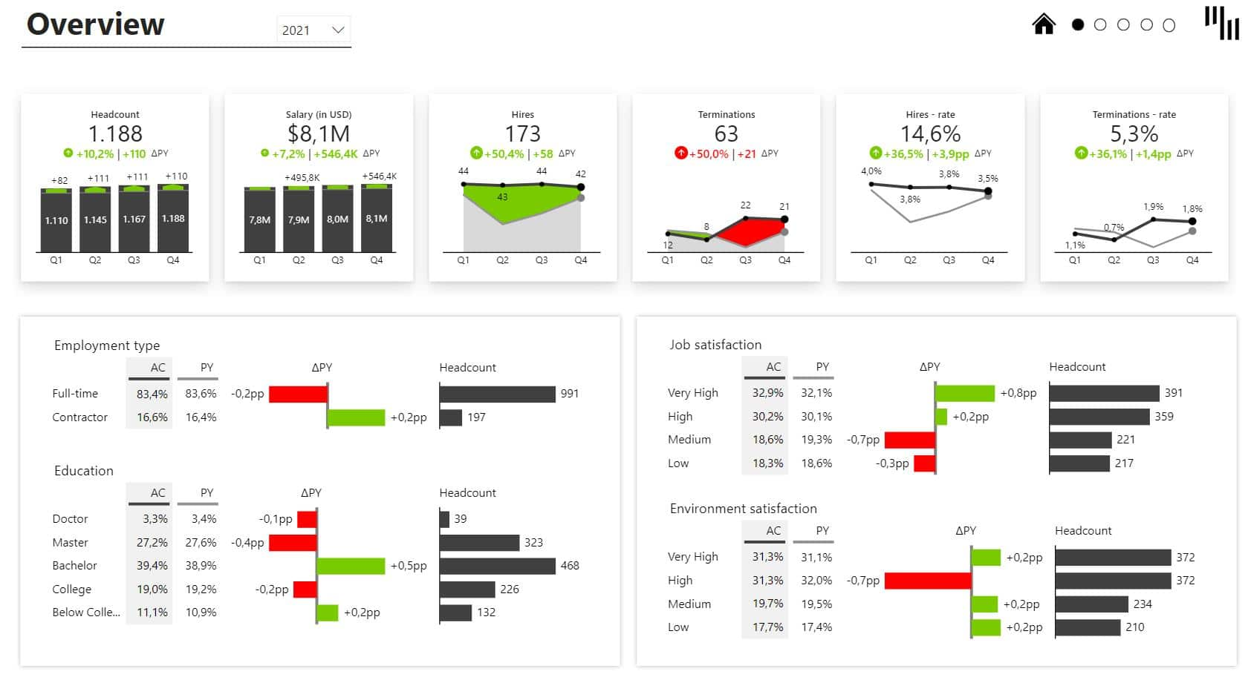Figure 1: HR Analytics in Power BI

*Source:* [*https://zebrabi.com/template/hr-analytics-power-bi-template/*](https://zebrabi.com/template/hr-analytics-power-bi-template/)

## Problem Statement

The challenge of this research will be to evaluate the benefits of integrating a Business Intelligence tool in an empirical situation. This study is in line with research by authors such as Jadhav, Shelar & More (2022), Bhosale et al. (2023) and Sousa & Dias (2020) who sought how to evaluate Business Intelligence tools in evaluating performance metrics help in making decisions about human resources management.

According to Sousa & Dias (2020), Business Intelligence tools help companies automate the transmission of information and thus generate a competitive gain over competitors. BI tools have modules for managing large volumes of data, such as data marts, for example, and thus provide automated information through dynamic reports.

In this context, it is a great competitive advantage for a company if its Human Resources department uses a BI tool to integrate and present data dynamically. This allows this department to make timely and informed decisions, as analyzed by Jadhav, Shelar & More (2022) who evaluated how the generation of dynamic reports through the Power BI Business Intelligence tool works as an analytical method used to display status and insights related to human resources. and metrics with the primary objective of improving workforce performance.

Therefore, in this research, a Power BI dashboard will be developed with the aim of meeting the human resources needs used by employees who work at Vodafone Portugal, aiming to evaluate how the BI tool helps to face the challenges of the Human Resources department of this company.

## Research objectives

• To create a personalized Power BI dashboard for the Vodafone Portugal HR department.

• To improve the visualization and reporting of data in order to support HR decision making.

• To assess the effects of a Power BI dashboard on HR operations and performance.

## Research Significance

Noteworthy information is that this study adds to the field of business intelligence and human resource analytics; one of them grows at an ever-growing rate. I think you should be informed of it since one of the things that are really significant. Taking Power BI dashboard for Vodafone Portugal HR produced as an example, other companies can enhance their human-related activities by capitalizing data informed insights in their operations. This is made possible through use of the dashboard. Since the dashboard was designed with Vodafone Portugal’s Human Resources department in mind, this is realistic at present.

## Research Questions

• What would a custom-made Power BI dashboard look like to supply specific reporting requirements for HR department of Vodafone Portugal?

• What is the role of Power BI in improving data visualization and reporting, specifically for HR decision-making?

• How do various stakeholders in the Vodafone Portugal HR department perceive and reflect on how operations are conducted within their respective area of influence with regard to effects that will come from Power BI dashboard implementation?

## Scope and Limitation

The focus of this inquiry will be on the creation and deployment of a Microsoft Power BI dashboard that was designed exclusively for Vodafone Portugal’s Human Resources Department. A single element of this project, the dashboard design would be focal. This will be the only thing that is to focus primarily. For example, one can point out that improvement is a constant need given the fact that human relationships are dynamic and change with time. The following is an example of a limit. Secondly, the data is subjected to limitations on confidentiality as well many other constraints that are related to it.

## Research Methodology

This inquiry is to be performed by employing a methodology, which is known as the qualitative research and several methods will be used. These methodologies include interviews, focus groups and content analysis among others. Within the scope of this study, the plan will be implemented in some form or another. This will be done to gather information, and it would include having detailed discussions with key stakeholders as well HR professionals in the Vodafone Portugal. The purpose of this is information gathering. In terms of developing the Power BI dashboard, a qualitative approach that is iterative and collaborative will be used. This technique will be applied. The whole of this procedure will be done as it was planned.

## Structure of the Project

In this project, the process of researching is approached in chapters that are organized sequentially within a systematic approach. These chapters, which are available in the places where they can be found, constitute this thesis. These chapters, which are available in the places where they can be found, constitute this project. The second chapter of this research presents a systematic review of research on HR analytics, business intelligence and in the use case Power BI within an HRM context. The investigation is discussed in chapter two of the dissertation. The activities involved in the construction and deployment of a personalized Power BI dashboard will be described, and discussed below in chapter 3 including an overall summary. Besides that, the chapter discusses a qualitative research methodology which will be used in this project. The other chapters in the report will constitute of finding presentation which encompasses data, analysis and conclusions that are made after investigation. These results will be discussed in the research further.

A major paradigm change has occurred in the dynamic and constantly changing modern business environment, pushing companies to lead data-driven initiatives instead of depending exclusively on intuition for decision-making. Human Resource Analytics (HR Analytics), a sophisticated and scientific technique created to harness the huge potential of data for the successful management of an organization's most precious and dynamic asset - its personnel - is at the center of this revolutionary journey. HR analytics, also known as people analytics, talent analytics, or workforce analytics, is a term used to describe a methodical process that encompasses more than just simple data collecting; it also involves the complex areas of obtaining, evaluating, analyzing, and disseminating personnel data inside an organization.

An era when organizations prioritize informed decision-making, strategic human resource management, and the development of a unique competitive advantage is being ushered in by this strategic move toward HR Analytics (Sherman, R. 2014). Its fundamental difference is its rejection of conventional, intuition-based decisions, which frequently have built-in biases and constraints. HR Analytics, on the other hand, emphasizes the use of evidence-based approaches to provide decision-makers with verifiable insights from data analysis. It also promotes a mutually beneficial partnership between organizational leaders and HR specialists, realizing that navigating the challenges of contemporary workforce management requires a combination of business savvy and HR know-how.

When it comes to employee referral programs, Tesla is a prime example of how HR analytics can be used in practice by providing data insights to refine strategy. In a different case study, Vodafone creates a dashboard using HR Analytics concepts to match strategic objectives with data-driven decision-making. For comprehensive insights and to promote a data-driven culture throughout organizations, HR Analytics and Business Intelligence (BI) must work together (Dahlbom, P., Siikanen, N., Sajasalo, P., & Jarvenpää, M. (2020). Ralph Kimball's BI principles emphasize that an efficient BI system must have the following essential components: user-friendliness, speed, consistency, credibility, flexibility, timeliness, and security (Reddy, P. R., & Lakshmikeerthi, P. (2017).

Within the field of business intelligence applications, Dimensional Modelling is a key strategy. This approach streamlines BI analysis and reporting by concentrating on building models that support efficient business reports.

As explained by Stephen Few and Rick Sherman, dashboards and data visualization are essential components of business intelligence. Dashboards facilitate decision-making at all levels of operation, from strategy to tactical execution. They are visual depictions of critical data. Using graphical elements and sophisticated analytics, effective data visualization improves understanding and facilitates data availability. Álvaro Reis addressed the lack of customized HR Analytics solutions in his master's thesis, which focused on practical growth in the academic setting. To support data-driven decision-making and organizational success, the thesis seeks to develop a customized HR Analytics dashboard for Vodafone. Utilizing a practical methodology, the study highlights the painstaking steps involved in data collecting, preparation, modeling, and usability evaluation. The ultimate goal is to advance the field of HR Analytics and improve Vodafone's HR operations.

# Literature review

## Chapter Introduction

The purpose of this chapter is to present the extant literature on human resource analytics, Business Intelligence (BI) in human resources, and the specific use of Power BI for supporting and improving HR operations.

## HR Analytics

Fitz-enz (2009) defines HR Analytics as people analysis or talent analysis and represents a systematic approach to human management, leveraging data-based methodologies. It involves collecting, analyzing, interpreting and reporting data about employees within organizations. The overall objective is to inform decision-making, meet strategic HR management objectives and maintain a competitive advantage in the rapidly evolving business ecosystem.

According to Minbaeva (2017), HR analytics tools are resources that aim to evaluate data exploration to gain insights into various related work within this sector. This is part of the emergence of data analytics for HR. This demonstrates how human resources analytics is becoming more meaningful within the context of technology and data analytics.

Based on what was exposed in the previous paragraph and the study by Marler and Boudreau (2017), based on HR analytics, many companies moved forward with operations reports and can create or internalize some well-designed and distributed dashboards retrospective reports to business units regularly.

Given this, it can be said that analysis related to human resources is on the rise as an activity that has become more crucial. With HR analysis through HR analysis tools, companies can optimize the use of human resources and make informed decisions, as evidenced in studies by Minbaeva (2017) and Rasmussen and Ulrich (2015).

That said, Lawler, Levenson and Boudreau (2004) show that this type of analysis allows companies to reach maximum levels of efficiency. This is because they can fully exploit the potential of their people. This objective can be achieved in several ways, including using tools provided based on employee performance analysis relevant to hiring and organizational engagement data.

### The Scientific Mentality in Decision-Making

According to Boudreau and Ramstad (2005), the basis of Human Resource Analysis (HR Analysis) is a tireless commitment to promoting a scientific approach within the complex network of decision-making procedures. This paradigm requires a conscious break from historically subjective judgments and emphasizes the use of techniques based on methods rather than evidence.

It is highly disturbing that HR professionals and organizational leaders adopt and apply a scientific methodology, moving from a purely intuitive, evidence-based approach to a method-based approach and utilizing empirical data when developing and updating workforce strategies (American Economic Association, Royal Economic Society and Simon, H. A. (1966)).

This shift to a methods-based rather than evidence-based paradigm is critical to improving the effectiveness of decision-making processes and aligns with a broader organizational trend that is being renewed: a deliberate attempt to establish and maintain an organizational culture deeply rooted in data-driven insights.

### Business Acumen and HR Analytics

According to Minbaeva (2017), a sophisticated business sense is essential for the effective application of science-based human resources (HR) techniques. According to this paradigm, the CEO and HR experts play a crucial and vital role in promoting the use of method-based practices to improve organizational performance.

According to to Minbaeva (2017), business savvy is a crucial component that serves as the foundation for HR Analytics’ successful implementation. HR Analytics’ strategic posture is strengthened by the mutually beneficial relationship between data-driven approaches and a deep understanding of the complex dynamics of the business landscape.

This relationship also makes HR Analytics an indispensable tool for achieving organizational objectives. This fusion, characterized by the harmonious convergence of empirical data analysis and a sophisticated grasp of business intricacies, not only amplifies the efficacy of HR practices but also establishes HR Analytics as an indispensable strategic asset in the organizational arsenal, playing a pivotal role in steering the trajectory towards successful goal achievement (Popovič, A., Hackney, R., Coelho, P. S., & Jaklič, J. (2012).

## Business Intelligence (BI)

The general objective of this section is to study the importance of the business intelligence system - BI, in the corporate segment. In this sense, information technology acts as an instrument to aid the management of companies.

### Fundamental Components of Business Intelligence

According to Rouhani, Asgari and Mirhosseini (2012) Business Intelligence (BI) is a management paradigm and methodology used to assist organizations manage and refine business information with the goal of making more effective and efficient business decisions.

In this sense, authors such as Wieder and Ossimitz (2015) show that the BI methodology focuses on creating interactive management panels, seeking to bring together all data in a specific way, facilitating interpretations of those who use the information. This way, managers and other leaders use interactive panels instead of spending time reading the content of complex reports and this helps them to make simple and accurate decisions.

Another important point about the BI methodology are the essential elements that are critical to the effectiveness of a system. According to Kasemsap (2016), accessibility and understandability are crucial components that emphasize ease of use to support intuitive understanding of information by business users. When designing a database, the speed and simplicity of the BI system are essential to improving user understanding and software performance.

Wieder and Ossimitz (2015) state that elements such as divergence and consistency are also crucial components of a strong business intelligence system. The BI system consistently displays data from multiple data sources, with a focus on standardized definitions and labeling. Furthermore, it largely depends on meticulous data collection, cleaning, and quality assurance. Therefore, data is only provided when user-specified consumption conditions are met.

In this context, Chan, Chiang and Storey (2012) show that the resilience of a BI system in changing organizational contexts strongly depends on its ability to adapt to changes. Transparency for end users is improved by smooth integration of modifications to descriptive data. To increase decision-making effectiveness, BI relies heavily on timely information, with the system providing actionable insights in real-time. The security of a BI system works as a secure barrier to restrict access to confidential organizational data, preventing its undue use or exposure.

### The Data Warehouse/Business Intelligence (DW/BI) Solution

According to Chan, Chiang and Storey (2012), the Data Warehouse/Business Intelligence (DW/BI) solution is the most credible and authoritative basis for improved decision-making. The DW/BI solution serves as a cornerstone for well-informed decision-making by providing analytic proof for important decisions.

The corporate community's adoption of a DW/BI system serves as the last arbiter of its efficacy (Antunes, A. L., Cardoso, E., & Barateiro, J. (2022). When the system seems to be a clear-cut, effective source of information that satisfies their requirements and expectations, users support it. BI principles are crucial in creating a customized BI system for Vodafone's HR division. The focus is on leveraging data to deliver accessible, dependable, and timely insights for HR decision-making.

The business community's acceptance and support are primarily dependent on data security, flexibility in response to evolving HR requirements, and informational clarity. The development of a business intelligence (BI) system aimed at meeting HR needs is consistent with the core ideas outlined by Kimball, guaranteeing that the BI system serves as an advantageous instrument for enhancing HR operations at Vodafone.

## Business Intelligence Tools: Power BI Special Case

The objective of this chapter section is to provide a brief literature review about the Power BI business intelligence tool. There are several other tools for the same purpose, but this one will be studied because of its application in this dissertation.

## Business Intelligence in HR

Smith and Davenport (2019) the usefulness of business intelligence to turn raw data into actionable insights in human resources. Business intelligence technologies enable human resource professionals to recognize trends, predict future needs for labour and increase the efficiency of organization in general.

Business intelligence (BI) offers an all-inclusive solution for data management, allowing human resources to move away from basic reporting towards predictive analytics. This on the other hand provides a total perception of data management.

## Power BI in HR

Power BI has an easy-to-use interface and allows HR professionals to create unique dashboards based on their needs. Johnson et al. (2018) pointed out that Power BI facilitates reporting with more accuracy and quicker execution as well as allows for data-driven decision making.

Power BI facilitates the creation of attractive, interactive dashboards because it uses drag and drop features. This is because assembling of the dashboards is easy. This is particularly because it easy to develop dashboards. This is because dashboards can be generated spontaneously, which is the reason for this measure. Thus, due to these practitioners in HR management will have a general enhancement of their user experience.

## Integration of Power BI in HR

The inclusion of Power BI in the procedures used by organizations for HR management requires a configuration that makes it applicable to specific organizational needs. Robbins (2021) argued that generic dashboards are not likely to meet the specialized measurement and reporting needs of most firms.

Convergence with business intelligence (BI) becomes a strategic requirement to improve HR Analytics’ capabilities. Business intelligence, according to Ralph Kimball’s definition in “The Data Warehouse Toolkit,” is the act of turning unprocessed data into information that can be used for business objectives by using technology, procedures, and tools (Sherman, R. 2014). The scope of data analysis is expanded beyond HR-specific data by the integration of HR Analytics with BI, providing insights that align with more general company goals.

This interdisciplinary approach fosters a data-driven culture across the whole organization in addition to improving decision-making across the board. Organizations may make well-informed decisions that affect both human capital management and overall business success thanks to synergistic teamwork. According to the literature, combining BI with HR Analytics offers a comprehensive method of data analysis that links HR activities with more general company goals.

## Customized Power BI Dashboard in HR

Power BI dashboard is a useful tool for strategic decision making in the field of human resources because this part delivers possibilities to adapt it, so that all changes are related with stated goals of the organization. Hernandez (2019) showed that customized dashboards provide better insight on key metrics related to human resources.

## Case Studies in Power BI Implementation in HR

Here, studies that used the Power BI tool in the HR sector will be shown. The objective is to evaluate how this tool can be applied in different contexts. Ameer and Manner (2020) used Power BI to conduct a study on human resources (HR) management, showing that it is a complex topic in which descriptive analysis is one of its main components, including the analysis of employee turnover, performance analysis, among others.

Pandey and Mehta (2020) evaluated through Power BI how each company makes every effort to extract maximum productivity from its employees to achieve business profitability. However, they encounter a few problems unique to their best employees, and this is often where people analytics comes into play. Daily operations, procedural efficiency and other strategic operational challenges are addressed by HR analytics. As a result, HR analytics considers all components of an organization at a high level, while workforce analytics focuses on personal data such as engagement, job satisfaction, and success. Machine learning approaches and business intelligence tools can be used to predict and evaluate staff turnover and retention. Every modern organization accumulates a huge amount of employee data. The authors used this data to extract insights from it so that the company can make better decisions about how to conduct employee work.

Kakulapati et al. (2020) evaluated how business tools optimize HR analytics, through system development that HR units in organizations. These authors applied the use of Power BI and machine learning techniques to analyze employee information to improve their position in the organization.

Baggyalakshmi et al. (2024) evaluated how users can automate tasks and processes in their Office 365 workflow with Microsoft Flow along with Power BI. The authors state that many organizations depend on several programs that are part of Microsoft Office 365 and through Microsoft Power Automate a wide variety of processes and tasks can be automated by integrating various applications and platforms. Whether in the cloud or on-premises, users can integrate Microsoft Office 365 applications with each other and with a vast library of other programs. This way, any member of the company with rudimentary knowledge of Office 365 can create simple automations to speed up routine tasks in your company. Power BI and Microsoft Power Apps allow power users to create their own unique business processes. This optimizes flows within HR.

## Summary of the Chapter

In all, the literature review focuses on BI in human resources, HRA and PBI for HR. That is a brief review summary. Businesses such as Vodafone Portugal have a significant opportunity for ameliorating the capability of making decisions based on data in their human resource management activities by incorporating Power BI into the same. This is a significant opportunity. A strong opportunity has been brought up here. With the help of Power BI dashboards, internal human resources departments that can tailor to their individual needs will have a better understanding of employee performance as well as effective recruitment and engagement strategies. Consequently, the departments will be in a position to offer better service delivery for its staff. It all happens with the help of business intelligence software.

As for the implementation process, challenges of Power BI deployment reveal how important proper preparation prior to installation and during its execution is. There are many such issues, some of which include security concerns about the data available there, integration problems with the system and user training possibilities.

There are several businesses that may benefit from the direction described by best practices and case studies for those who want to discover the ways in which Power BI creates opportunities within human resources. This direction, however simple these two types of resources may seem to be, can prove helpful for such businesses. Furthermore, the assessment of its effects gives a perceptive and insightful viewpoint on software efficiency. This is a significant contribution.

# Methodology

The objective of this chapter is to explain the methodology used in this research. The chapter will be divided into four sections: the first will explanate about the research hypothesis, second will describe the sample, the third on the application of descriptive statistics and fourth about limitations.

This research used quantitative and qualitative methodologies. Regarding the quantitative methodology, like the work of Sousa and Dias (2020), the survey research design method was used. In this case, a sample of data was collected in relation to variables relating to the human resources sector of the company Vodafone.

Based on the sample, it was possible to create indicators in the Power BI software relating to the total number of employees, admissions and dismissals, gender of employees, education, hierarchy, among others. As the data is not public, confidential treatment of the information was ensured.

From a qualitative point of view, this research was close to the methodology adopted by Sharma, Dashora and Saxena (2022) evaluating how the human resources sector can be well managed based on receiving authentic and relevant information through BI tools. Therefore, an iterative and collaborative qualitative approach was used.

## Hypothesis

In this study, the impacts of using Power BI on the expectations of the Human Resources sector were analyzed as a fundamental tool for managers, allowing them to access crucial information quickly, efficiently and visually attractive. This is measured in terms of the following aspects:

1. Satisfaction of the HR sector with the information from the dashboards generated by Power BI for their decision-making process.
2. Stakeholders a comprehensive, in-depth view of HR department trends and key details.

Therefore, the following hypothesis will be evaluated:

$H_{0}:$ Using dashboards in Power BI helps improve decision making by automating reports made in spreadsheets or old tools.

$H_{1}:$ What would a custom-made Power BI dashboard look like to supply specific reporting requirements for HR department of Vodafone Portugal?

What is the role of Power BI in improving data visualization and reporting, specifically for HR decision-making?

How do various stakeholders in the Vodafone Portugal HR department perceive and reflect on how operations are conducted within their respective area of influence about effects that will come from Power BI dashboard implementation?

In summary, by centralizing and visualizing data in a dynamic and effective way, dashboards and reports developed in Power BI can enable Vodafone Portugal's HR managers to identify opportunities for improvement, anticipate challenges and make informed, data-driven decisions to boost organizational success.

This initiative is expected to represent a significant step in the modernization and optimization of human resources management processes at Vodafone Portugal, empowering HR leaders with the necessary tools to promote a culture of excellence, innovation and continuous growth within the organization.

## Sample

In Statistics, sampling is the process of obtaining samples, which are nothing more than sets of as given population. As this is usually very large, carrying out a complete census would be practically impossible, so this type of process is used. From a mathematical point of view, a random sample from a population is given by the vector $X_{1},X_{2},…, X_{n}$ where each $X$ represents a sample element. The mathematical definition is important for constructing measurements and estimators.

A random sample is a sample whose formation required a procedure for selecting elements or groups of elements in a way that gives each element a probability of inclusion in the sample that is calculable and different from zero. Random sampling consists of enumerating the $N$ objects from a population and then extract a sample of $n$ objects of the same using. There are other types of sampling, but in this work random sampling will be used.

As the objective of this work is to evaluate the use of business intelligence methodology in the HR sector at Vodafone, it was defined as a sample the workers of this company in Portugal. The data was collected from the SQL Oracle database using PLSQL developer. The data was initially organized in CSV format and later uploaded to Microsoft Power BI for the development of dashboards using the M and DAX languages.

The choice of Power BI to build dynamic panels with the collected sample is justified by the existing Office 365 license infrastructure within the company. By integrating Power BI into the company's Office 365 environment, the value of the licenses already held by the company is maximized, ensuring efficient use of available resources and optimizing associated costs.

Additionally, Power BI's seamless integration with Office 365 makes collaboration and information sharing among team members easier. You can publish dashboards directly to SharePoint Online, email reports through Outlook, and collaborate in real time with coworkers using Microsoft Teams, all within the familiar Office 365 environment.

The element for building the sample was the Extract, Transform, and Load (ETL) system, which consists of a workspace, instantiated data structures, and a collection of procedures. As described by Kimball in "The Data Warehouse Toolkit", the ETL system plays a key role in the total data integration process, involved as a link between the DW/BI display area and the operational source systems.

The ETL procedure proceeds in several stages, starting with extraction. Reading and analyzing source data is what this step entails before sending it to the ETL system for additional processing. After the data is extracted, it goes through several transformations to enhance and add value, such as data cleaning, integration from numerous sources, and deduplication.

The role of ETL extends to improving data quality, generating diagnostic information and contributing to business process re-engineering for sustained improvement in source system data quality. The final stage of the ETL process involves physically formatting and loading data into target dimensional models within the presentation area. Monitoring the updating, indexing and quality assurance of dimension and fact tables, thus allowing the construction of the sample used.

Security and compliance also play a crucial role in our choice. As part of Office 365, Power BI inherits the robust security and compliance features offered by Microsoft. This includes advanced access controls, data encryption and compliance with regulations such as GDPR, ensuring sensitive HR data is protected and compliant with legal requirements.

Additionally, when using Power BI, you have access to regular updates and ongoing support from Microsoft. This ensures that the company is always using the latest features and has the support of an experienced team to deal with any problems that may arise.

Finally, Power BI offers a wide range of data visualization and analysis capabilities that allow you to create personalized and informative HR dashboards. From simple charts to advanced analytics, Power BI gives us the flexibility we need to represent HR data clearly and impactfully.

Another important point is that the data collected cannot be shared publicly because it is the company's confidential data. For this reason, this work will show samples generated by simulation.

## application of descriptive statistics

An important point to highlight is that this study is working with sampling. In this case, estimators will be calculated for the descriptive statistics parameters. Parameters are numerical (unknown) characteristics of the distribution of the elements of the population. Estimator is a function of the sample, constructed with the purpose of representing or estimating a parameter of interest in the population.

Estimators have three important properties: unbiased, consistency, and efficiency. An estimator is unbiased when it averages the value of the parameter. An estimator is consistent when its variance is minimal compared to other estimators. An estimator is efficient if it is unbiased and among unbiased estimators, present the lowest variance. In this work, estimators that have these three properties will be used.

Descriptive statistics are essential for an overview of the selected sample. In this research, the parameters of count, amplitude, mean and variation tax will be estimated. Each metric used will be duly explained.

To estimate headcount, the headcount estimator will be used. This estimator counts the total number of employees in a company over a given period. It is critical to understand the size of the workforce.

An estimator for the variation rate parameter used in this work will be the turnover rate. This measure compares two random variables, in this case the rate at which employees join and leave the company during a specific period. It can be expressed as a percentage and is vital for assessing workforce stability and the financial impact of turnover.

In this research, the parameter of the average age of the company's employees will be estimated. This can clarify workforce demographics and planning recruitment and retention strategies. The formula for this estimator can be seen in equation 1 below:

|  |  |  |
| --- | --- | --- |
|  | $$\overline{x}= \frac{1}{n}\sum_{i=1}^{n}{x_{i}}$$ | (1) |

Where $i$ is each Vodafone employee, $n$ is the employee count and x is the random variable relating to age.

A second estimator for the average used in this work is the Average Residence Time (Average Tenure). This measure calculates the average time that employees remain at the company. It helps you understand employee stability and loyalty. Equation 2 shows what the equation of this estimator looks like:

|  |  |  |
| --- | --- | --- |
|  | $$\overline{y}= \frac{1}{n}\sum_{i=1}^{n}{y_{i}}$$ | (2) |

Since $i$ is the ith employee in the sample, $n$ is the total number of employees and y is the random variable referring to time.

Another counting estimator used was new hires. It counts the number of new employees hired in each period. This can be useful for monitoring hiring volume and evaluating the success of recruitment strategies. Mathematically we will represent this estimator by $k$.

Again, an estimator will be used for counting, in this case the leavers. Counts the number of employees who left the company in each period. This is important to understand the reasons why employees are leaving and identify areas of concern in terms of retention. Your equation will be given by $l$.

A frequency estimator will also be used, in this case the management ratios. This measure compares the number of employees in management positions, mathematically represented by m, in relation to the total number of employees. It helps to understand the organizational structure and distribution of leadership in the company. The expression of this estimator is given by equation 3 below:

|  |  |  |
| --- | --- | --- |
|  | $$\hat{mr}= \frac{m}{n}$$ | (3) |

A new counting estimator will also be used, spans of control. This measure assesses how many subordinates a direct manager has. It can help identify whether there is an appropriate distribution of responsibilities and whether managers are overworked or underutilized. Mathematically it will be represented by $s$.

Finally, an estimator will be used for the frequency of Female% (percentage of women). Calculates the percentage of employees who are female, represented by $f$, in relation to the total number of employees. It helps monitor gender diversity in the workforce and can be useful in assessing progress towards gender equality. The mathematical expression is shown by equation 4 below:

|  |  |  |
| --- | --- | --- |
|  | $$\hat{Female\%}= \frac{f}{n}$$ | (4) |

## limitations

A limitation of the research is in relation to access to the company's sensitive data, this involves ethics for conducting of the research, as the results with the real sample can only be accessed by members of the company being researched. This limitation would occur in other private law organizations. Another limitation would be a more systematic bibliometric survey in regarding the use of Business Intelligence tools, as the technology used is very new and only very recent articles were found. Cloud database management systems are currently being used and this will certainly impact the use of business intelligence tools, such as Power BI.

Another limitation is in relation to the comparison prior to using the Power BI tool. It is difficult to control to evaluate performance before and after, so it would be necessary to carry out an observational study comparing performance indicators.

As this research is descriptive and not predictive, it is limited to stating with certainty how the use of the tool had a positive impact or not on Vodafone's HR sector. To answer this type of question more consistently, it would be important to work with regression models.

# Empirical Study

Aqui vou acrescentar os detalhes da construção dos dois dashboards.

# Results and discussion

The objective of this chapter is to discuss the results of the two dashboards developed at Vodafone. Simulated data was used for information security reasons. At this point, today's challenging business environment is vital for the organization to access information and knowledge for better decision making. The construction of dashboards used techniques and solutions to help managers understand the business situation in the company analyzed.

The rapid advancement of business technologies in recent years has made knowledge a essential asset that dictates the success of a company. The use of correct information in real time is a competitive differentiator in the market. Business intelligence systems provide corporate executives, business managers, and others with operational workers make better, more informed business decisions. The panel evaluates the impact of using Power BI on the decision-making process in organizations in Vodafone's human resources sector.

The first dashboard was developed for Vodafone Portugal's human resources department with the aim of providing insights into demographic information and another into team leader reporting. Minbaeva (2017), Rouhani, Asgari and Mirhosseini (2012) and Mehta (2020).

The second dashboard (vou acrescentar posteriormente).

Given the above, in relation to the first dashboard, the following business questions were asked: What is the Headcount? How many people of what nationality do we have? How many Portuguese? How many foreigners? By generation? And band? – Another dashboard Who reports to whom? Who is Vodafone external and internal employees? Who are the foreign people who report directly to a Vodafone Portugal employee? Indicators described in chapter 3.3 of this thesis were developed for such questions.

In relation to the construction of the first dashboard, information was protected directly from the database. Demographic information was extracted from Vodafone de Portugal employees. In Power BI, a relational model was developed between tables like the star schema. To generate the indicators, operations were carried out using the DAX (Data Analysis Expressions) language and the codes will be available in the appendix section of this dissertation. Below is Figure 2 with the relationship diagram between the dashboard tables.

**Figure 2 - Power BI Model in First Dashboard**

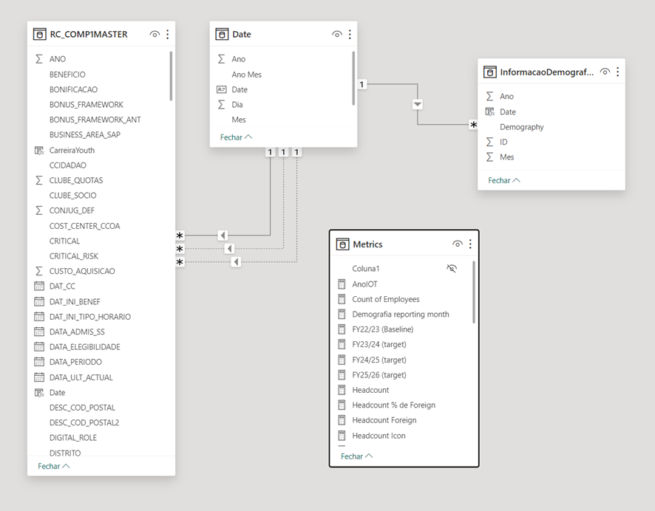

**Figure legend**. Source of author's elaboration based on research data. As can be seen, the relationship is close to a star schema, in which there are one-to-many relationships through a fact table with dimension tables. According to Emany et al. (2016), in the star schema, the fact table is the central table with information that can be repeated and is linked to dimension tables, whose information is unique. Dimension tables contain the attributes or keys.

In relation to the results of the first dashboard, information was compiled on the nationality of Vodafone de Portugal employees through counting. A date filter was created to evaluate this indicator over time and in March 2024 the company had a total of 1,617 workers, 1,571 Portuguese and 46 foreigners. Below figure 3 with a summary of the dashboard results.

**Figure 3 - Results of First Dashboard**

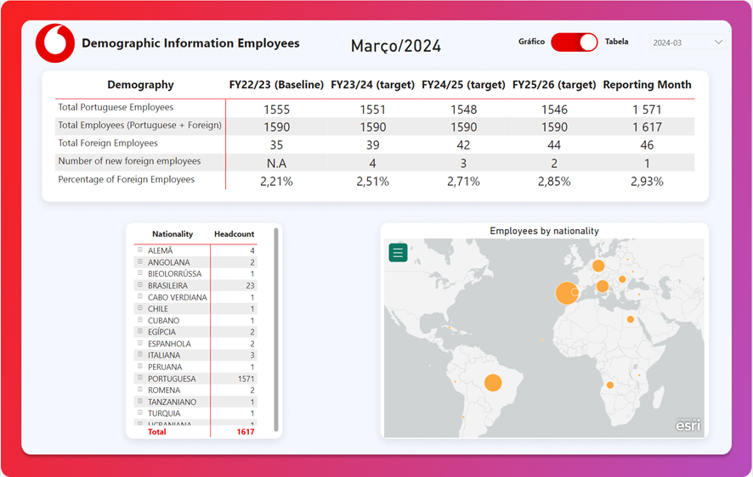

**Figure legend**. Source of author's elaboration based on research data. The colors and design chosen were based on Vodafone. The idea was to provide information on which nationalities we have within the company to the Sustainability, Health & Safety and Foundation team so that they can always have up-to-date information. Also having information on the generation and band that belongs to Vodafone. Important information was collected, such as how many new foreigners joined Vodafone, the percentage of foreigners, the number of Portuguese, the headcount, and the map to show where each nationality is located, as well as indicators of the targets to be achieved and the baseline. For validation, e-mails were sent to the respective collaborators with the information and asking for feedback and if they wanted anything else to be added. And explaining security and access to the dashboard.

# Conclusions and future works

Conclusion text Conclusion text Conclusion text Conclusion text Conclusion text Conclusion text Conclusion text Conclusion text Conclusion text Conclusion text Conclusion text Conclusion text Conclusion text Conclusion text Conclusion text Conclusion text Conclusion text Conclusion text.

# Bibliographical References [This title should not be numbered]

Use APA Style for the entire document

We suggest that students use a reference manager system (Zotero, Mendeley, EndNote),

Please review the style guide at: <https://apastyle.apa.org/style-grammar-guidelines/references/examples>:

Author, A. A., Author, B. B., & Author, C. C. (Year). Title of article. *Title of Periodical, volume number* (issue number), pages.

Ameer, M.L., Rahul, S.P., & Manne, S. (2020). Human Resource Analytics using Power Bi Visualization Tool. 2020 4th International Conference on Intelligent Computing and Control Systems (ICICCS), 1184-1189.

Baggyalakshmi, D., Dhanya, R., & Revathi, D. (2024). HR Onboarding Kit. International Academic Journal of Innovative Research.

Bernhard Wieder, Maria-Luise Ossimitz. The Impact of Business Intelligence on the Quality of Decision Making – A Mediation Model, Procedia Computer Science, Volume 64, 2015, Pages 1163-1171, ISSN 1877-0509, https://doi.org/10.1016/j.procs.2015.08.599.

Bersin, J. (2015). The datafication of HR. Deloitte University Press.

Boudreau, J. W., & Ramstad, P. M. (2005). Talentship, talent segmentation, and sustainability: A new HR decision science paradigm for a new strategy definition. Human Resource Management, 44(2), 129-136.

Brown, A., et al. (2020). Transforming employee performance analytics with Power BI: A case study. Journal of Business Analytics, 3(2), 123-137.

Chen, H., Chiang, R. H. L., & Storey, V. C. (2012). Business Intelligence and Analytics: From Big Data to Big Impact. MIS Quarterly, 36(4), 1165–1188. https://doi.org/10.2307/41703503.

Chen, Y., et al. (2019). Challenges and considerations in adopting business intelligence in human resources: A case study approach. International Journal of Human Resource Management, 30(1), 162-183.

Fitz-enz, J. (2009). The new HR analytics: Predicting the economic value of your company's human capital investments. AMACOM Div American Mgmt Assn.

Hernandez, M. (2019). The impact of customized dashboards on HR analytics. Journal of Organizational Analytics, 6(4), 275-289.

Jadhav, M. D, & Shelar, A.B, & More, S. (2022). HR People Data Analytics Using Power BI Data Visualization Tool. International Journal of Research Publication and Reviews (Vol. 3). Online. www.ijrpr.com

Johnson, R., et al. (2018). Empowering HR with Microsoft Power BI: A case study. Journal of Information Systems and Technology Management, 15(3), 317-330.

Jones, P., & Smith, L. (2019). Quantifying the impact of Power BI on HR efficiency: A case study. International Journal of Human Resource Management, 30(12), 1975-1994.

Kakulapati, V., Kalluri Krishna Chaitanya, Kolli Vamsi Guru Chaitanya and P. Shilhora Akshay. “Predictive analytics of HR - A machine learning approach.” Journal of Statistics and Management Systems 23 (2020): 959 - 969.

Kerzner, H.R. (2017) Project Management, Metrics, KPIs, and Dashboards. John Wiley, New York.

Kim, S., et al. (2021). Best practices in implementing Power BI for HR: Lessons learned from successful organizations. Journal of Information Technology Case and Application Research, 23(3), 119-135.

Lawler III, E. E., Levenson, A., & Boudreau, J. W. (2004). HR metrics and analytics: Use and impact. Human Resource Management, 43(1), 73-82.

Marler, J. H., & Boudreau, J. W. (2017). An Evidence-Based Review of HR Analytics. The International Journal of Human Resource Management, 28, 3-26. <https://doi.org/10.1080/09585192.2016.1244699>.

Microsoft. (2020). Power BI. Retrieved from <https://powerbi.microsoft.com/>.

Minbaeva, Dana. (2017). Human capital analytics: why aren't we there? Introduction to the special issue. Journal of Organizational Effectiveness: People and Performance. 4. 110-118. 10.1108/JOEPP-04-2017-0035.

Pandey, S., & Mehta, J. (2022). HRPA: Human Resource Prediction Analytics. 2022 Third International Conference on Intelligent Computing Instrumentation and Control Technologies (ICICICT), 721-726.

Rasmussen, T., & Ulrich, D. (2015). Learning from practice: How HR analytics avoids being a management fad. Organizational Dynamics, 44(3), 236-242.

Robbins, J. (2021). Customization of business intelligence tools for HR: A practical guide. HR Technology Solutions, 45(2), 89-104.

Rouhani, Saeed & Asgari, Sara & Mirhosseini, Vahid. (2012). Review Study: Business Intelligence Concepts and Approaches.

Smith, A., & Davenport, T. (2019). The role of business intelligence in transforming HR functions. Harvard Business Review.

Smith, J. (2017). Leveraging business intelligence for employee engagement: A comprehensive guide. Employee Engagement Journal, 2(1), 45-60.

Sousa, J. S., et al. (2020). Business Intelligence for Human Capital Management. International Journal of Business Intelligence Research (Vol. 11).

Wang, L., & Shanks, G. (2018). Business intelligence for recruitment analytics: A systematic literature review. Decision Support Systems, 114, 51-64.

Kimball, R. (1996). The data warehouse toolkit: practical techniques for building dimensional data warehouses. John Wiley & Sons, Inc..

Song, I. Y., Eder, J., & Nguyen, T. M. (Eds.). (2007). Data Warehousing and Knowledge Discovery: 9th International Conference, DaWaK 2007, Regensburg, Germany, September 3-7, 2007, Proceedings (Vol. 4654). Springer Science & Business Media.

Sherman, R. (2014). Business intelligence guidebook: From data integration to analytics. Newnes.

Dahlbom, P., Siikanen, N., Sajasalo, P., & Jarvenpää, M. (2020). Big data and HR analytics in the digital era. Baltic Journal of Management, 15(1), 120-138.

American Economic Association, Royal Economic Society, & Simon, H. A. (1966). Theories of decision-making in economics and behavioural science (pp. 1-28). Palgrave Macmillan UK.

Popovič, A., Hackney, R., Coelho, P. S., & Jaklič, J. (2012). Towards business intelligence systems success: Effects of maturity and culture on analytical decision making. Decision support systems, 54(1), 729-739.

Sherman, R. (2014). Business intelligence guidebook: From data integration to analytics. Newnes.

Kasemsap, K. (2016). The fundamentals of business intelligence. International Journal of Organizational and Collective Intelligence (IJOCI), 6(2), 12-25.

Antunes, A. L., Cardoso, E., & Barateiro, J. (2022). Incorporation of ontologies in data warehouse/business intelligence systems-a systematic literature review. International Journal of Information Management Data Insights, 2(2), 100131.

Collier, K. (2012). Agile analytics: A value-driven approach to business intelligence and data warehousing. Addison-Wesley.

Ballard, C., Farrell, D. M., Gupta, A., Mazuela, C., & Vohnik, S. (2012). Dimensional Modeling: In a Business Intelligence Environment. IBM Redbooks.

Dipak Kumar Bhattacharyya. (n.d.). HR analytics: understanding theories and applications.

Opatha, H. H. D. P. J. (2020). HR Analytics: A Literature Review and New Conceptual Model. International Journal of Scientific and Research Publications (IJSRP), 10(06), 130–141. <https://doi.org/10.29322/ijsrp.10.06.2020.p10217>

Reddy, P. R., & Lakshmikeerthi, P. (2017). 'HR Analytics'-An Effective Evidence-Based HRM Tool. In International Journal of Business and Management Invention ISSN (Vol. 6). Online. [www.ijbmi.org](https://chat.openai.com/c/www.ijbmi.org).

Sidi, Emany & El Merouani, Mohamed & Aoulad Abdelouarit, Dr. El Amin. (2016). Star Schema Advantages on Data Warehouse: Using Bitmap Index and Partitioned Fact Tables. International Journal of Computer Applications. 134. 11-13. 10.5120/ijca2016908108.

Zulqarnain, R. M., Siddique, I., Asif, M., Ahmad, H., Askar, S., & Gurmani, S. H. (2023). Extension of correlation coefficient based TOPSIS technique for interval-valued Pythagorean fuzzy soft set: A case study in extract, transform, and load techniques. Plos one, 18(10), e0287032.

Ballard, C., Herreman, D., Schau, D., Bell, R., Kim, E., & Valencic, A. (1998). Data modeling techniques for data warehousing (p. 25). San Jose: IBM Corporation International Technical Support Organization.

Oliveira, B., & Belo, O. (2017). Approaching ETL processes Specification Using a Pattern-Based ontology. In Data Management Technologies and Applications: 5th International Conference, DATA 2016, Colmar, France, July 24-26, 2016, Revised Selected Papers 5 (pp. 65-78). Springer International Publishing.

Youssef, M. W. A. F. (1993). Transaction behaviour in large database environments: A methodological approach (Doctoral dissertation, City, University of London).

Suomela, L. (2021). Implementing HR analytics: Premises for value creating analytics (Master's thesis).

# Appendix A (optional, appendixes should have letters instead of numbers)

[Appendixes are for materials, tables, or more explanation material only done by the student]

**[It is mandatory to include in the appendixes the Ethics Committee Report when the research “**[… *involves human participants and personal data, regardless of whether it is collected online or in person, whether it is based on a survey, an experiment, a dataset, or interviews (i.e., it is also compulsory for observational studies and field interviews with managers)]***”. You must get your report by answering a short questionnaire available here**: <https://novaims.eu.qualtrics.com/jfe/form/SV_eG085IyOwAj6a57>]

# Annexes (optional)

[Annexes are optional, since they have material and sources not developed by the students, so in most cases referencing them is enough]

