**Assignment Report**

|  |  |
| --- | --- |
| USN & Name: | 1MS17IS151 - Yash Jain |
| Design Pattern: | Facade Design Pattern |
| Course Code and Name: | IS62B Object Oriented Analysis and Design Patterns |

1. **Case Study:**

MOBILE SHOP

Let's consider a mobile shop. This mobile shop has a shopkeeper . There are lot of mobiles in the shop , e.g. Iphone , Samsung , BlackBerry . You, as client want access to look at different phones of different companies . You do not know what are the different mobiles they have. You just have access to shopkeeper who knows his shop well. Whichever mobile you want, you tell the shopkeeper and he takes it out of from the respective shelf and hands it over to you. Here, the shopkeeper acts as the **facade**, as he hides the complexities of the system shop.

1. **Explanation:**

* Facade pattern hides the complexities of the system and provides an interface to the client using which the client can access the system. This type of design pattern comes under structural pattern as this pattern adds an interface to existing system to hide its complexities. This pattern involves a single class which provides simplified methods required by client and delegates calls to methods of existing system classes.
* The Gang of Four says that the intent of the Facade pattern is to “provide a unified interface to a set of interfaces in a sub- system. Facade defines a higher-level interface that makes the subsystem easier to use.”

1. **Key Features of Facade Pattern:**

|  |  |
| --- | --- |
| Intent | You want to simplify how to use an existing system. You need to define your own interface. |
| Problem | You need to use only a subset of a complex system. Or you need to interact with the system in a particular way. |
| Solution | The Facade presents a new interface for the client of the existing system to use. |
| Participants and Collaborators | It presents a simplified interface to the client that makes it easier to use. |
| Consequences | The Facade simplifies the use of the required subsystem. However, because the Facade is not complete, certain functionality may be unavailable to the client. |
| Implementation | Define a new class (or classes) that has the required interface. |

1. **Class Diagram:**

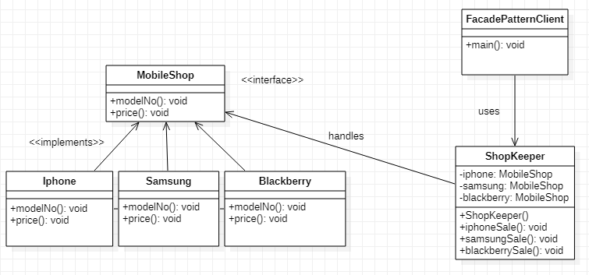

1. **Implementation in java and output:**

MobileShop.java

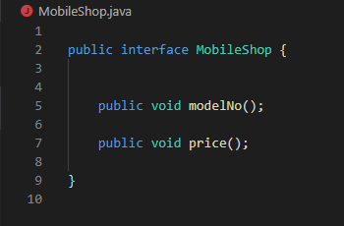

Blackberry.java

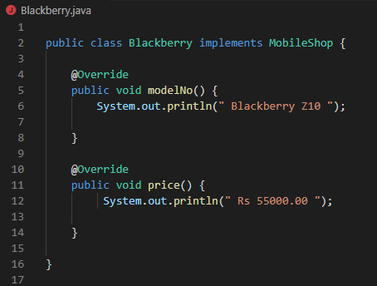

Iphone.java

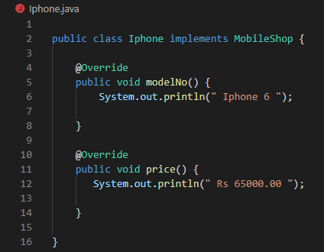

Samsung.java

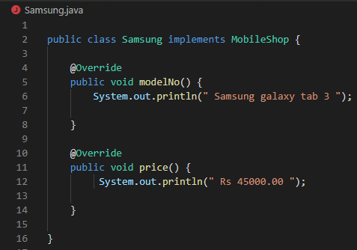

ShopKeeper.java

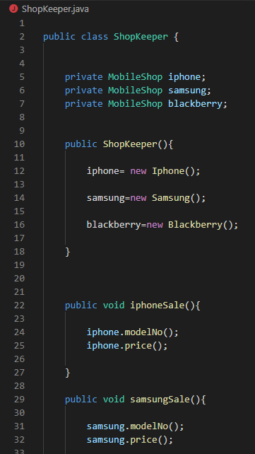

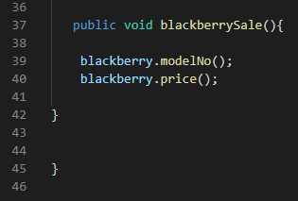

FacadePatternClient.java

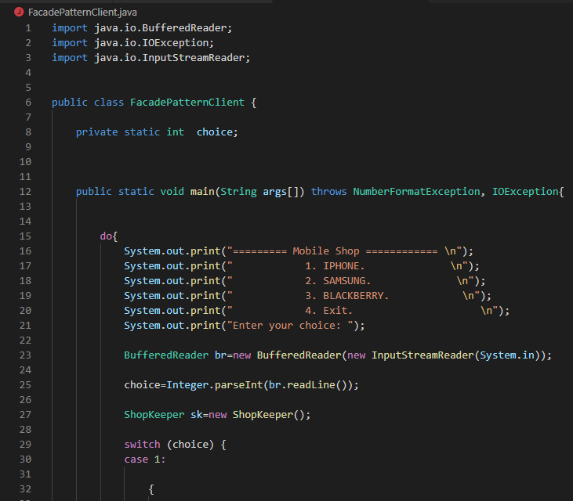

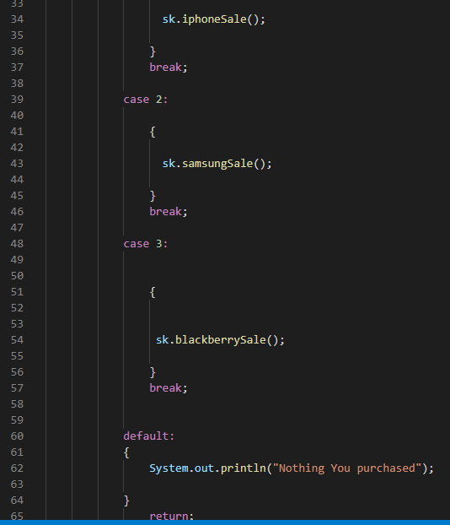

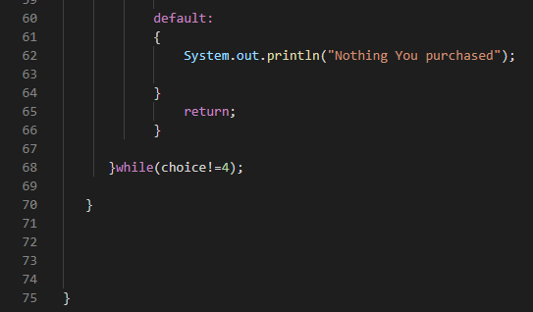

OUTPUT :-

