Config-Driven Data Platform × RAG/GenAI on Azure — Three Variants
Part 2 of 2 · Databricks · Microsoft Fabric · Hybrid · 2026-06-17
Companion: Azure_RAG_GenAI_reference_architecture_2026-06-17.md (the GenAI/RAG core, "Arch A"). Here the RAG/GenAI tier is grounded on governed GOLD data products produced by a configuration-driven data platform. Three deployment shapes; one canonical config model.

1. The configuration-driven idea (one control model, swappable engines)
The platform is metadata-first: pipelines are generic and parameterized — they *read config and
execute rather than carrying per-source bespoke code. This is your PwC *canonical configuration
metadata model** (Data-as-a-Product) expressed in cloud, and it mirrors two things you already run
locally: the harness-recipes "canonical recipes" registry and CloudLift's **contract-driven
adapters / bridge-adapter / multi-cloud-portability** spine (CoE patterns contract-driven-adapters,
multi-cloud-portability).
┌──────────────────────────────────────────────────────────┐
CONTROL PLANE │ CONFIG / METADATA STORE │
(config- │ • sources, canonical entities (CDM), mappings │
driven) │ • transformations, data-product defs, quality rules │
│ • access policies, AI-grounding bindings │
│ • per-workload platform: databricks | fabric selector │
│ Azure App Configuration + Git config repo + control DB │
└───────────────┬──────────────────────────────┬───────────┘
│ drives │ binds
┌───────────────▼───────────────┐ ┌───────────▼───────────────────┐
EXECUTION │ DATA ENGINE (Variant 1/2/3) │ │ RAG/GENAI TIER ("Arch A") │
│ bronze → silver → GOLD │──►│ embed GOLD → AI Search index │
│ governed data products │ │ + GraphRAG (Cosmos) → GPT-4o │
└────────────────────────────────┘ └────────────────────────────────┘
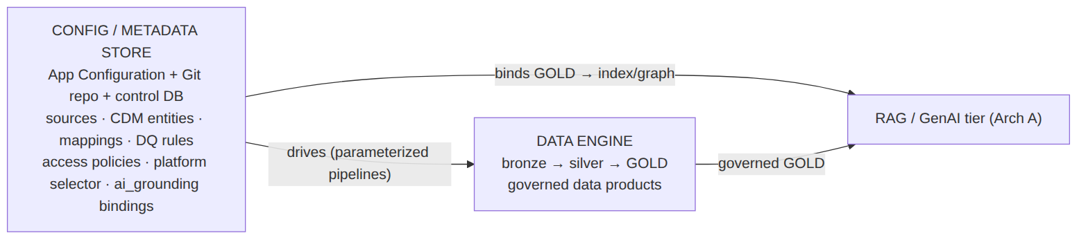
Figure 2 — Configuration-driven control model
Key principle: the config declares *which governed GOLD tables/semantic models become which AI
Search indexes / GraphRAG sets. Swapping the engine (Databricks ↔ Fabric) changes execution, not
the canonical model, the data-product contracts, or the RAG bindings.

2. Variant 1 — Databricks Lakehouse
Best when data engineering and ML scale dominate. (This is your real SPR POC outcome — Databricks
selected for engineering/ML fit.)
CONFIG STORE ──(DABs / job params; Unity Catalog = metadata authority)──┐
▼
SOURCES → ┌─────────────────── Azure Databricks ───────────────────────────────┐
ADLS/ │ DLT / PySpark pipelines (generic, config-parameterized) │
CDC/API │ BRONZE Δ ──► SILVER Δ ──► GOLD Δ (Delta Lake, medallion) │
│ Unity Catalog: lineage · row/column ABAC · governed data products │
│ Mosaic AI / Model Serving (OSS + feature serving) · Genie (NL→SQL) │
└───────────────┬───────────────────────────────────────┬────────────┘
│ GOLD Δ │ embeddings job
│ │ (Databricks + Azure OpenAI)
┌────────────▼─────────────┐ ┌──────────▼─────────────┐
│ Power BI (Import/DirectQ) │ │ Azure AI Search index │──► Arch A
└───────────────────────────┘ │ + Cosmos GraphRAG │ (GPT-4o,
└────────────────────────┘ orchestr.)
GOVERNANCE: Unity Catalog (primary) + Purview (estate catalog/lineage) · Content Safety on AI tier
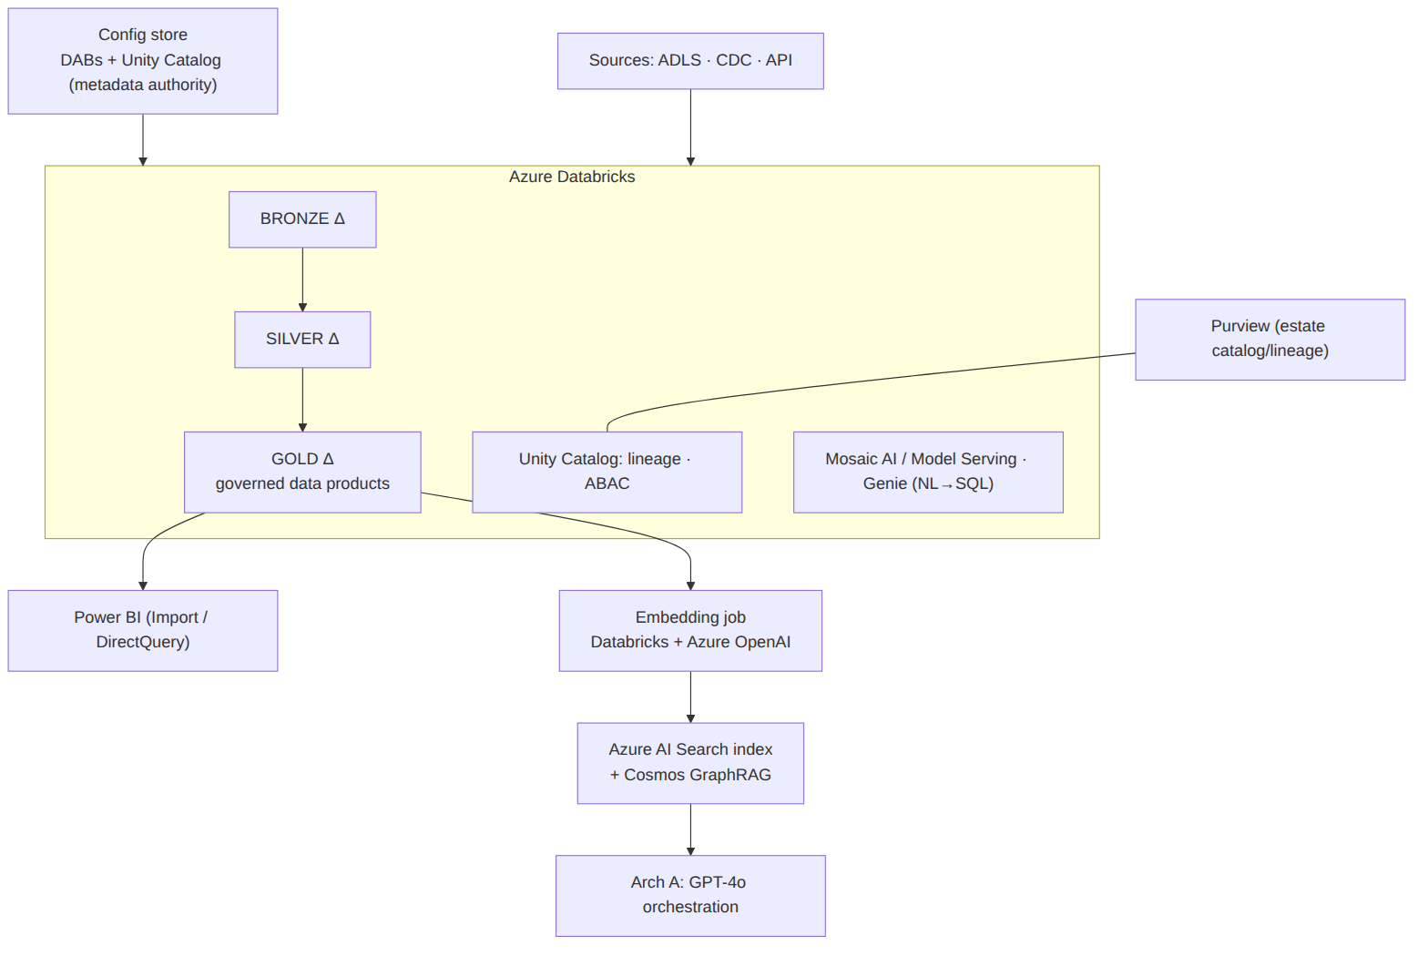
Figure 3 — Variant 1: Databricks Lakehouse
- Config → execution: Databricks Asset Bundles + job parameters; pipelines read config tables.
- Governance authority: Unity Catalog (lineage, ABAC, data products) federated into Purview.
- RAG binding: GOLD Delta → scheduled embedding job → AI Search; optional **Databricks Vector
Search** if you want the vector index co-located with the lakehouse.
- AI: Azure OpenAI for generation; Mosaic AI / Model Serving for OSS/fine-tuned (your vLLM
analogue); Genie/AI-BI for NL-to-SQL on governed gold.

3. Variant 2 — Microsoft Fabric
Best when the estate is BI-led / Power BI-centric and a unified SaaS analytics surface with low
ops overhead is the mandate.
CONFIG STORE ──(Fabric pipeline params + config Lakehouse table)──┐
▼
SOURCES → ┌────────────────────── Microsoft Fabric ──────────────────────────────┐
Dataflows│ Data Pipelines / Dataflows Gen2 / Spark notebooks (config-driven) │
Gen2 / │ OneLake: BRONZE ──► SILVER ──► GOLD (Delta, single-copy storage) │
shortcuts│ Direct Lake semantic models · Fabric Data Agents / AI Skills │
│ Purview-backed governance, sensitivity labels, lineage │
└───────────────┬───────────────────────────────────────┬───────────────┘
│ GOLD (OneLake Δ) │ embedding skillset
┌────────────▼─────────────┐ ┌──────────▼─────────────┐
│ Power BI Direct Lake + │ │ Azure AI Search index │──► Arch A
│ Copilot (BI-side GenAI) │ │ + Cosmos GraphRAG │ (GPT-4o,
└───────────────────────────┘ └────────────────────────┘ orchestr.)
GOVERNANCE: Purview + Fabric domain governance · Content Safety on AI tier
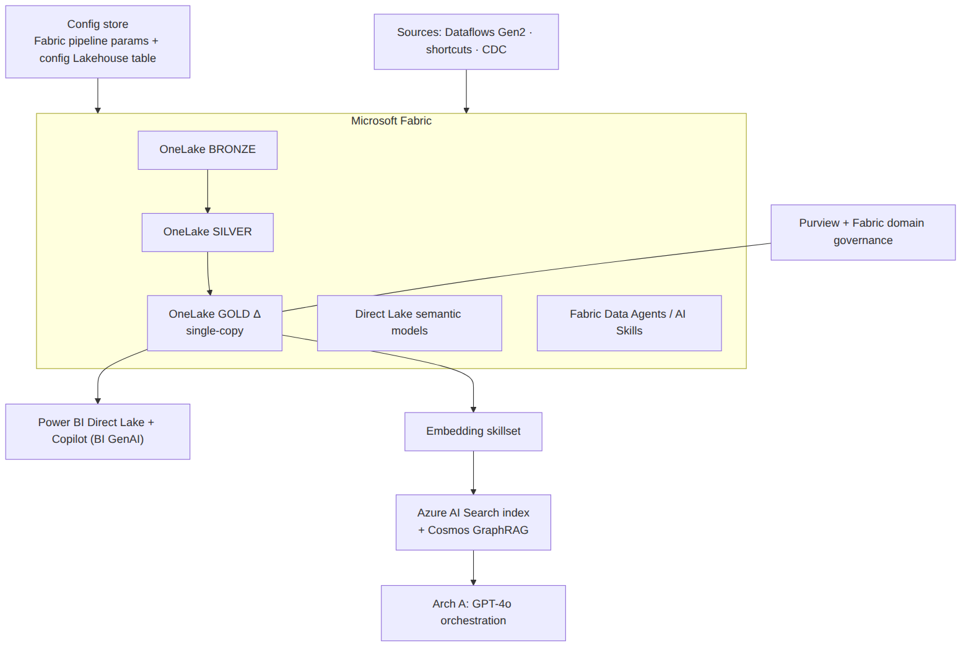
Figure 4 — Variant 2: Microsoft Fabric
- Config → execution: metadata-driven Fabric Data Pipelines / Dataflows Gen2; a config Lakehouse
table parameterizes notebooks and pipelines.
- Serving: Direct Lake semantic models give business users live gold; Power BI Copilot
handles BI-side NL questions.
- RAG binding: OneLake GOLD (Delta) → AI Search index (embedding skillset) → Arch A; app-side
GenAI via AI Foundry agent grounded on the same gold + semantic model.

4. Variant 3 — Hybrid (the showcase: config picks the engine per workload)
Databricks does the heavy engineering/ML; Fabric provides the BI/serving/semantic layer —
over one copy of the data (OneLake shortcuts to the Databricks Delta, no duplication). The
config's platform: selector routes each workload to the right engine. This is the literal
"configuration-driven" outcome you asked for.
CONFIG STORE ── per-workload selector: platform: databricks | fabric ──┐
│ canonical entities · data-product contracts · RAG bindings │
▼ (one canonical model, two engines) ▼
┌──────────────── Azure Databricks ────────────────┐ ┌──────── Microsoft Fabric ─────────┐
│ heavy ETL/ELT · DLT · ML (Mosaic AI) │ │ BI semantic models · Direct Lake │
│ BRONZE Δ ─► SILVER Δ ─► GOLD Δ (writes to ADLS/ │ │ Power BI + Copilot · Data Agents │
│ OneLake; Unity Catalog governance) │ │ Dataflows Gen2 for light marts │
└───────────────┬───────────────────────────────────┘ └───────────────┬───────────────────┘
│ GOLD Δ (single copy) OneLake SHORTCUT ◄───────────┘ (no data movement)
▼
┌────────────────────────────────────────────────────────┐
│ Embedding job → Azure AI Search (hybrid) + Cosmos GraphRAG│──► Arch A (GPT-4o orchestration,
└────────────────────────────────────────────────────────┘ Content Safety, eval loop)
GOVERNANCE (federated): Unity Catalog ⟷ Purview (lineage + ABAC across both engines)
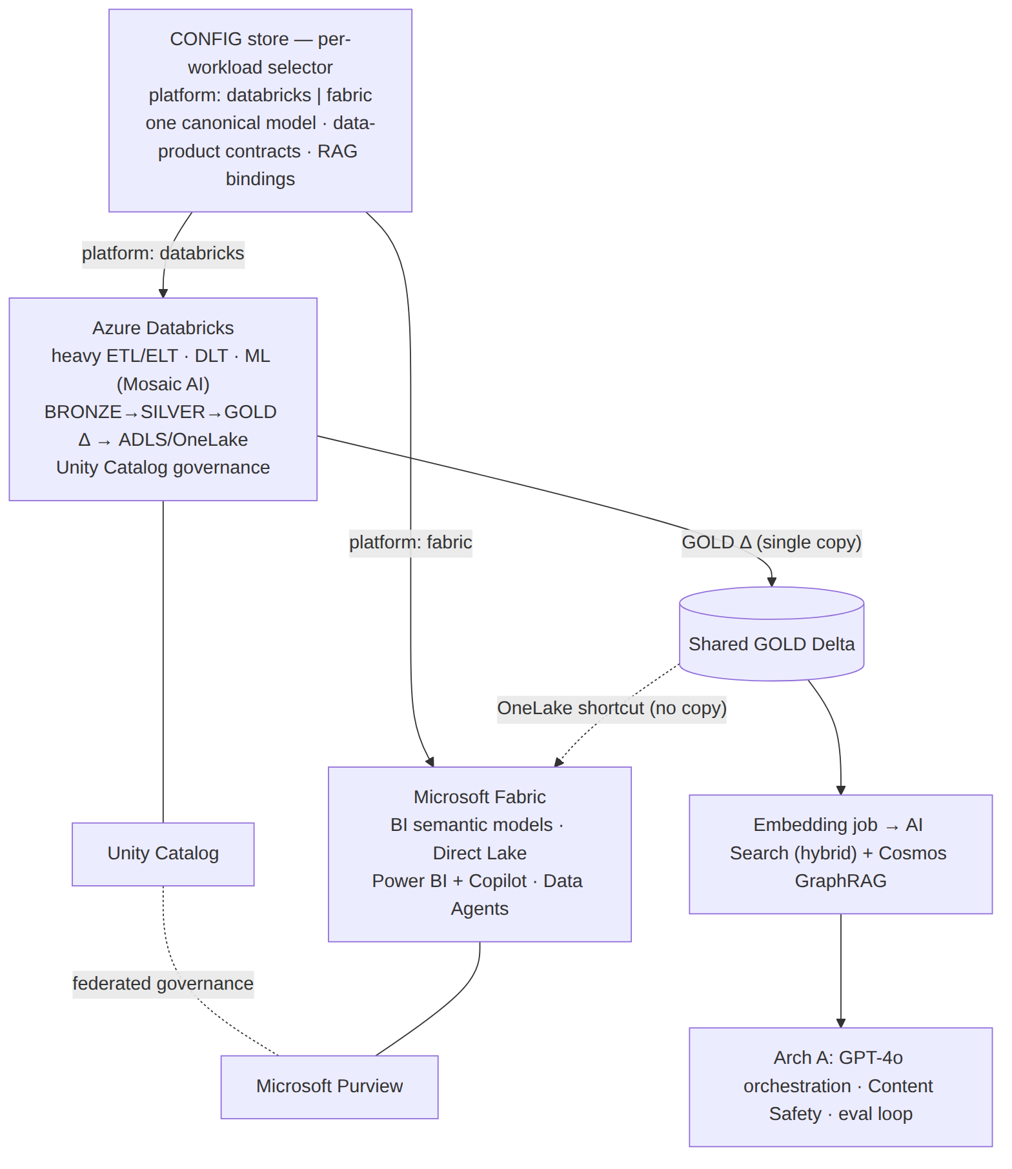
Figure 5 — Variant 3: Hybrid (config picks the engine per workload)
- Single source of truth: Databricks writes governed Delta once; Fabric reads it via **OneLake
shortcuts** — no copy, no drift. RAG grounds on that same gold.
- Federated governance: Unity Catalog (engineering/ML) + Purview (estate-wide catalog/lineage);
ABAC/sensitivity propagates to the AI Search index.
- Why it wins: business users get Fabric/Power BI simplicity; data scientists get Databricks
scale; the GenAI tier grounds on one governed copy — and the config decides per workload,
so adding a source or a use case is a config change, not a re-platforming.

5. Canonical config example (engine-agnostic; drives all three variants)
data_product:
name: pbm_claims_gold
canonical_entity: Claim # maps to the CDM, not a source schema
platform: databricks # databricks | fabric (Variant 3 selector)
sources:
- id: adjudication_api
mapping: mappings/claim_from_adjudication.yml
- id: eligibility_files
mapping: mappings/claim_from_eligibility.yml
transforms: [dedupe, conform_dimensions, scd2]
quality_expectations: # gate before GOLD is published
- not_null: [claim_id, member_id, service_date]
- row_count_delta_pct: 15
governance:
classification: PHI # Purview label; controls who/what can index it
access: abac(role in [analyst, ai_grounding_svc])
ai_grounding: # <-- the binding to Arch A
enabled: true
index: aisearch://claims-rag
graph: cosmos://claims-graph
chunk: {strategy: semantic, max_tokens: 800}
embed_model: text-embedding-3-large
refresh: on_gold_publish
Flip platform: fabric and the same declaration executes on Fabric pipelines/OneLake; the
ai_grounding binding to Arch A is unchanged. That invariance is the configuration-driven design.

6. When to pick which (decision guide)
Driver | Databricks (V1) | Fabric (V2) | Hybrid (V3)
Center of gravity | data engineering / ML at scale | BI-led, Power BI-centric, SaaS-simple | both, at scale
Team | data engineers, ML engineers | analysts, BI devs, business users | mixed org
Ops overhead | higher (clusters, tuning) | lowest (SaaS) | medium
Advanced ML / OSS models | strongest (Mosaic AI / Model Serving) | lighter (AI Skills / Copilot) | strongest (on the DBX side)
Governance authority | Unity Catalog (+ Purview) | Purview (+ Fabric domains) | federated UC ⟷ Purview
RAG grounding source | GOLD Delta | OneLake GOLD | one shared GOLD (shortcut)
Typical "right answer" | ML-heavy modernization | BI/semantic modernization | most large enterprises
The mature line (use it in the 3Cloud interview): *"It's rarely either/or — Variant 3 is where
most enterprises land: Databricks for engineering and ML, Fabric for the BI/semantic layer over one
OneLake copy, and the GenAI tier grounded on that single governed gold. I drive the engine choice
from the client's center of gravity, and I keep it a configuration decision so it stays reversible —
which is exactly the Fabric-vs-Databricks POC I ran where the data pointed to Databricks."*

6b. Cost & sizing per variant (illustrative, USD/month)
This is the data-platform engine cost, on top of the RAG/GenAI core (see Part 1 §4b). Order-of-magnitude — validate with the Azure Pricing Calculator + real DBU/capacity telemetry.
 | Small | Medium | Large | Primary cost driver & levers
V1 Databricks | $500–2K | $3–10K | $15–50K+ | DBU + cluster VMs. Levers: serverless SQL, Photon, autoscaling, spot, job (not all-purpose) clusters
V2 Fabric | F2–F4 ~$260–525 | F8–F16 ~$1–2.1K | F64+ ~$5–8.4K+ | Capacity SKU (F-SKU). F64 is the Copilot/AI threshold. Levers: 1-yr reservation (~–40%), pause non-prod capacity
V3 Hybrid | DBX small + F4 | DBX med + F8–F16 | DBX large + F32–F64 | Size Fabric for *serving only* (Databricks does the heavy engineering) — usually the cost-optimal shape at scale
Why Hybrid is often cheapest at scale: you don't pay for a giant Fabric capacity to do heavy
ETL/ML (Databricks DBUs handle that elastically), and you don't duplicate storage (OneLake shortcut
to one Delta copy). You size Fabric purely to the BI/serving + Copilot need (often F8–F64), and let
Databricks autoscale/spot the engineering load. Both engines read/write one governed GOLD copy,
so there's no double-storage or double-pipeline cost — the config-driven model is also a
cost-control model.

7. CoE citations
Patterns/blueprints from localhost:8000/api/architecture-coe: contract-driven-adapters,
multi-cloud-portability, bridge-adapter-pattern (CloudLift spine — the config-driven backbone);
rag-service, streaming-data-pipeline, document-processing-pipeline (ingestion); azure-openai-llm,
azure-blob-storage, azure-service-bus, azure-database-postgres. Local grounding via the API
Documentation Hub (localhost:8900): vLLM, PersonaForge (hybrid retrieval), Qdrant, ArangoDB, FTAL
harness, CloudLift.

