Production RAG / GenAI on Azure — Reference Architecture
Part 1 of 2 · grounded in the existing local hybrid-AI stack · 2026-06-17
Companion: Azure_ConfigDriven_DataPlatform_variants_2026-06-17.md (Databricks / Fabric / Hybrid).
This reference is derived from your actual running local architecture (discovered via the API
Documentation Hub at localhost:8900 and the Architecture CoE knowledge base at localhost:8000),
then mapped to managed Azure services. It is not generic — every Azure component below has a
working local analogue you already operate.

0. What the local stack already proves (the credibility anchor)
Your hybrid-AI platform is, in effect, a self-hosted production RAG/GenAI system. Inventory from
the live service catalog:
Local service (port) | What it does | This is the analogue of…
vLLM on RTX 5090 (8021) | OpenAI-compatible inference (/v1/chat/completions) | a managed model-serving endpoint
FTAL harness — gateway data plane (8001) | model routing/swap, benchmarking, scoring, capability scan | a model router + evaluation harness
PersonaForge (8090) | hybrid retrieval (document + vector + graph), weighted scoring, confidence thresholds, memory CRUD, governance runs, context compilation | the RAG orchestration + memory tier
Qdrant (6333) | dense vector store | the vector index
ArangoDB (ro_* collections, named graph) | knowledge graph + GraphRAG | the graph store
Embedding service (all-MiniLM-L6-v2, 384-dim) | text → vectors | the embeddings model
Gateway control plane (8000) | API, web UI, request proxying, circuit breakers | API gateway + resilience
CloudLift (8080) | agentic deploy orchestrator — Celery+Beat, WebSocket streaming, STS AssumeRole BYOC, multi-region, bridge-adapter spine | IaC + deployment control plane
harness-recipes (8000) | canonical, config-driven task recipes | the configuration/contract registry
resume-optimizer (5000) | the consuming application | the business app
The platform's signature moves — **control-plane / data-plane split, hybrid vector+graph retrieval
with confidence gating, human-in-the-loop memory governance, dual-write, circuit breakers, and
contract-/config-driven adapters (CloudLift)** — are exactly the production concerns this Azure
reference encodes.

1. Local → Azure mapping (the Rosetta stone)
Local | Azure (managed, production)
vLLM (OpenAI-compatible) | Azure OpenAI Service (GPT-4o, o-series) via Azure AI Foundry; OSS/fine-tuned models via AI Foundry serverless or Azure ML managed online endpoints (GPU)
FTAL harness routing + scoring | AI Foundry model router + Prompt Flow evaluations; API Management for throttling/keys; Azure ML pipelines for offline benchmarking
PersonaForge hybrid retrieval | Azure AI Search (vector + BM25 + semantic ranker = hybrid) as the retrieval core; orchestration in Semantic Kernel / AI Foundry Agent Service
Embedding service | Azure OpenAI `text-embedding-3-large/small`
Qdrant | Azure AI Search vector profiles (or Qdrant on AKS/ACA if a dedicated engine is required)
ArangoDB graph / GraphRAG | Azure Cosmos DB (Gremlin or NoSQL) + AI Search for the GraphRAG index
Memory store + governance | Cosmos DB (memory items) + Content Safety + HITL review queue
Gateway control plane | API Management + Azure Container Apps (or AKS)
Gateway data plane (heavy/async) | AKS / Container Apps + Azure Service Bus + KEDA autoscale
CloudLift deploy spine | Container Apps Jobs / AKS + Service Bus + Managed Identity + Bicep/Terraform + SignalR (WebSocket streaming)
harness-recipes (config registry) | Azure App Configuration + a config Git repo (the config-driven backbone — see Part 2)
Circuit breakers / capability scan | APIM policies + Azure Monitor health + Defender for Cloud
App relational store (db_engine/DATABASE_URL) | Azure Database for PostgreSQL Flexible Server
App object/doc storage | ADLS Gen2 / Blob + Cosmos DB

2. Reference Architecture A — Production RAG / GenAI on Azure
┌──────────────────────────────────────────────┐
EXPERIENCE │ Web app · Teams/Copilot · API consumers │
└───────────────┬────────────────────────────────┘
│ HTTPS (Entra ID auth)
┌───────────────▼────────────────────────────────┐
EDGE / GATEWAY │ Azure API Management (authN/Z, throttling, │
│ keys, request shaping, circuit-breaker policy) │
└───────────────┬────────────────────────────────┘
│
┌───────────────▼────────────────────────────────┐
ORCHESTRATION │ AI Foundry Agent Service / Semantic Kernel app │
(Container Apps) │ query plan → retrieve → assemble prompt → │
│ tool/function calls → synthesize → guard │
└───┬───────────────┬──────────────────┬───────────┘
│ │ │
┌────────────────────▼──┐ ┌────────▼─────────┐ ┌─────▼──────────────┐
RETRIEVAL│ Azure AI Search │ │ Cosmos DB │ │ Azure OpenAI │ MODEL
│ hybrid: vector + BM25 │ │ GraphRAG (graph) │ │ GPT-4o generation │
│ + semantic ranker │ │ + memory store │ │ text-embedding-3 │
│ (confidence gated) │ └──────────────────┘ │ + model router │
└───────────┬───────────┘ └─────┬──────────────┘
│ grounding chunks + citations │ OSS/FT models →
│ │ Azure ML / AI Foundry
┌────────────────────▼─────────────────────────────────────┐ │ GPU endpoints
│ INGESTION (Functions / ACA Jobs / ADF) │ │
│ source → chunk → embed → upsert index + graph (dual-write)│◄────┘ (embeddings)
│ incremental via change feed / event triggers │
└────────────────────┬─────────────────────────────────────┘
│ reads governed GOLD data products (see Part 2)
┌────────────────────▼──────────┐ ┌───────────────────────────────────────────┐
DATA │ ADLS Gen2 (raw/docs) │ │ GOVERNANCE & SAFETY (cross-cutting) │
│ Cosmos DB (memory/graph)│ │ • AI Content Safety (in/out, jailbreak) │
│ AI Search indexes │ │ • Purview (catalog, lineage, classify) │
│ PostgreSQL (app state) │ │ • Prompt Flow evals (groundedness/relevance)│
└─────────────────────────┘ │ • prompt/response logging → Log Analytics │
│ • HITL review queue · Responsible AI gates │
┌────────────────────────────────┐ └───────────────────────────────────────────┘
PLATFORM │ Key Vault · Managed Identity · Private Endpoints/VNet · Azure Monitor /
│ App Insights (tokens, latency, groundedness) · Defender · Service Bus
└────────────────────────────────────────────────────────────────────────────────┘
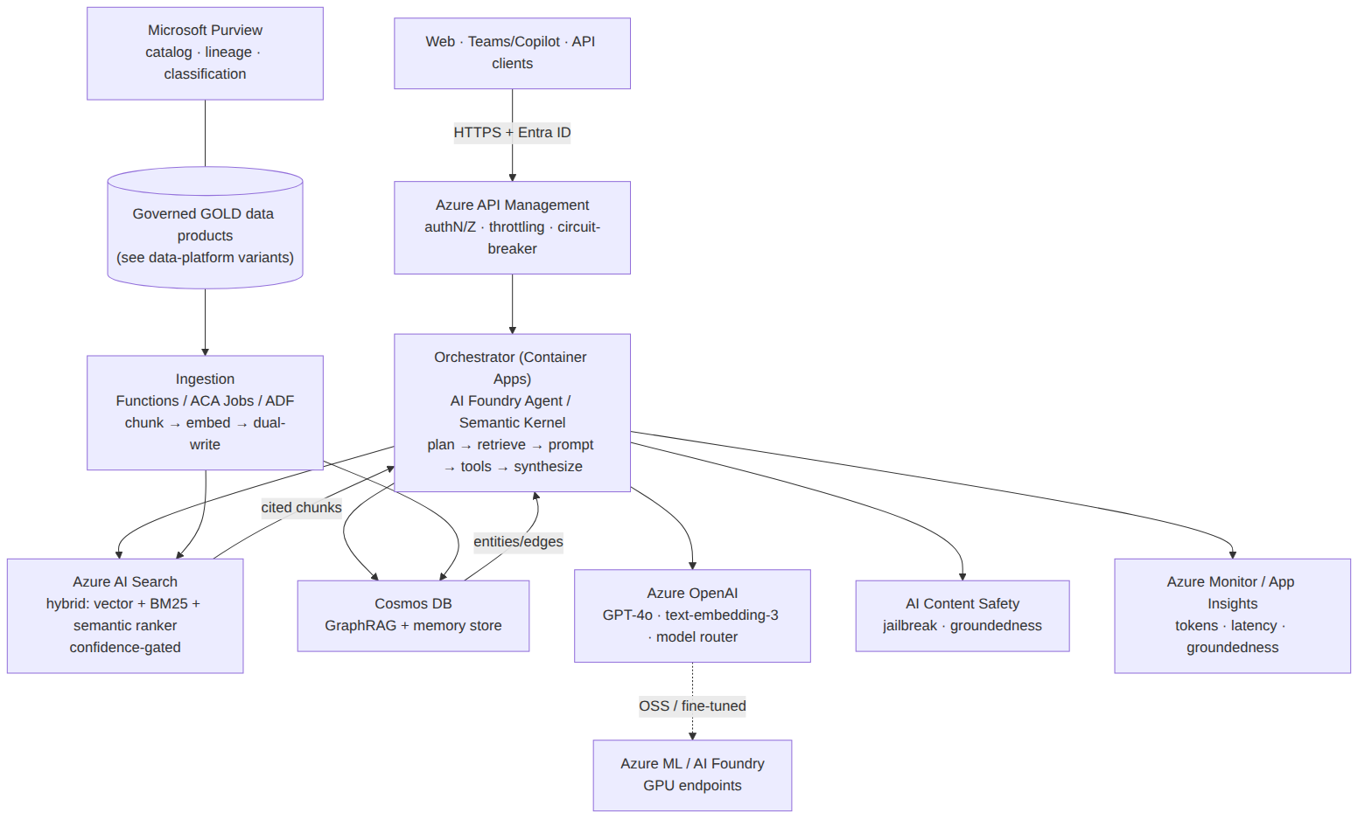
Figure 1 — Production RAG/GenAI on Azure (rendered)
Query path (runtime)
- Client → APIM (Entra ID token, rate-limit, key) → Orchestrator (ACA).
- Orchestrator runs the retrieval plan: AI Search hybrid query (vector + keyword + semantic
re-rank) and, when the query is relational/entity-centric, a GraphRAG traversal in Cosmos —
the same document + vector + graph weighted pattern PersonaForge uses, with a **min-confidence
gate** (drop low-score grounding rather than hallucinate).
- Retrieved, cited chunks + compiled context → Azure OpenAI (GPT-4o) for synthesis;
the model router sends cheap/long-context or OSS workloads to the right deployment.
- Content Safety screens input and output; prompt/response + token + groundedness telemetry
stream to Log Analytics; low-confidence or policy-flagged answers route to the HITL queue.
Ingestion path (build-time / incremental)
Source docs (Blob/ADLS) → chunk → embed (text-embedding-3) → dual-write: upsert vectors to
AI Search + entities/edges to the Cosmos graph. Triggered by change feed / events for
incremental freshness. Grounding sources are the governed GOLD data products from the data
platform (Part 2) — never raw, ungoverned data.

3. Cross-cutting concerns (the "production" in production RAG)
- Security/network: Entra ID (workload identities, no keys), Private Endpoints + VNet
integration on AI Search / OpenAI / Cosmos / Storage, Key Vault for secrets, Defender for Cloud.
- Governance/lineage: Microsoft Purview catalogs and lineage-tracks every grounding source;
classification/sensitivity labels propagate so PHI/PII never enters an index it shouldn't. (Your
HIPAA/regulated background maps straight onto this.)
- Safety: Azure AI Content Safety (prompt-shield/jailbreak, groundedness detection,
protected-material checks) on both directions; Responsible AI review gates = your HITL memory-review.
- Evaluation loop: offline Prompt Flow / Azure ML evaluations score groundedness, relevance,
coherence, safety on a golden set — the managed analogue of the FTAL harness benchmarking/scoring.
- Observability/cost: App Insights traces per request (tokens in/out, latency, retrieval hit
rate, groundedness); cost controls via model routing (route to cheapest sufficient model),
caching, and PTU vs. pay-as-you-go sizing.
- Resilience: APIM circuit-breaker + retry/back-off, multi-region OpenAI with failover (mirrors
your gateway circuit breakers and CloudLift multi-region/BYOC posture).

4. Architecture CoE citations (real artifacts from the local KB)
Grounded in the shop-wide Architecture CoE (localhost:8000/api/architecture-coe):
- Blueprints: rag-service (ingest→embed→vector→LLM; Azure topology = Functions + Cosmos +
Blob + Azure OpenAI embeddings), personaforge-agentic-memory, gpu-inference-service,
conversational-ai-assistant, cloudlift-deployment-plane (bridge-adapter spine).
- Patterns: azure-openai-llm (managed OpenAI on Azure), qdrant-vector-search,
managed-vector-search-opensearch, azure-blob-storage, azure-service-bus,
azure-database-postgres, contract-driven-adapters, multi-cloud-portability,
local-first-development, sts-assume-role-pattern.
- Contracts: ILLMInference, IDocumentDatabase, IObjectStorage, IMessageQueue,
ICacheStore, IRelationalDatabase — the adapter contracts that make the config-driven swap in
Part 2 possible.
- Decision (ADR): documentdb-no-aql-cosine-similarity — informs the choice of a purpose-built
vector engine (AI Search) over bolting cosine onto a doc store.
Note: the CoE advise generator was briefly returning a vLLM parse error at authoring time, so this reference was grounded against the CoE search / blueprints / patterns endpoints directly. Re-run POST /api/architecture-coe/advise once vLLM parsing is healthy for the auto-generated bridge plan + cost envelope.

4b. Cost & sizing — RAG/GenAI core (illustrative, USD/month)
Order-of-magnitude only — validate with the Azure Pricing Calculator + real token volumes. Unlike the CoE rag-service envelope ({50/150/500}, which is compute-only on AWS Lambda), production GenAI cost is dominated by model tokens (Azure OpenAI), then the search tier.
Component | Small (pilot, <50K q/mo) | Medium (~500K q/mo) | Large (enterprise, multi-region)
Azure OpenAI (GPT-4o + embeddings) | $200–600 PAYG | $1.5–3K PAYG or 1 PTU | $8–30K+ reserved PTUs
Azure AI Search | Basic/S1 ~$75–250 | S1–S2 ~$250–1,000 | S2/S3 + replicas ~$2–6K
Cosmos DB (graph + memory) | serverless ~$25–100 | provisioned ~$200–800 | multi-region ~$1.5–5K
Compute (orchestrator) | ACA ~$50–150 | ACA scale ~$300–800 | AKS ~$1.5–4K
APIM | Developer/Consumption ~$50 | Standard ~$700 | Premium ~$3K+
Safety + Monitor + Defender | ~$50 | ~$200 | ~$1K
Approx. total | $450–1,200 | $3–7K | $18–50K+
Biggest knobs: (1) PTU vs. pay-as-you-go for Azure OpenAI — reserve PTUs once volume is
steady; (2) model routing — send cheap/long-context work to smaller models (your FTAL-harness
routing pattern); (3) caching retrieval + frequent answers; (4) AI Search tier/replicas
sized to QPS + index size. Reservations (1-yr) cut OpenAI/Cosmos/compute ~30–40%.

5. Interview tie-in (3Cloud · Data & AI SME)
This doc doubles as live proof for two of the highest-probability 3Cloud technical questions:
- "Architect a production RAG/GenAI app on Azure" → walk Section 2 top-to-bottom; emphasize
hybrid retrieval + confidence gating + Content Safety + Purview lineage + eval loop.
- "How do you keep it grounded/safe in a regulated client?" → Purview classification + Content
Safety + HITL gates + private networking — tie to your HIPAA PBM (AWS) governance, noting the
architecture is identical on Azure.
You can legitimately say: *"I run this exact pattern hands-on locally — vLLM inference, hybrid
vector+graph retrieval, governed memory with review gates — so the Azure managed version is a
mapping exercise, not a learning curve."*

