HOWTO:

This program is intended to be installed in /root/go/src/mvouve/github.com/COMP8006.IPS.

If it installed in a different context, the program must be recompiled, and the line

const configIni string = "/root/go/src/github.com/mvouve/COMP8006.IPS/config.ini"

must be changed in defines.go to reflect the location of the configuration file.

Before running install.sh ensure WEB_DIR is pointing to your apache folder, and that html is the apache root directory.

Ensure that the manifest file, and the rsyslog auth.log are configured correctly in config.ini. If manifest does not exist it will be created when the program is run.

Add a cronjob to crontab assuming the default file location is used the entry should look like this:

*/1 * * * * /root/go/src/github.com/mvouve/COMP8006.IPS/COMP8006.IPS

At any point the IPS monitor can be viewed on localhost. This can be configured to have a password using apache, a later version of this IPS may include protection for this.

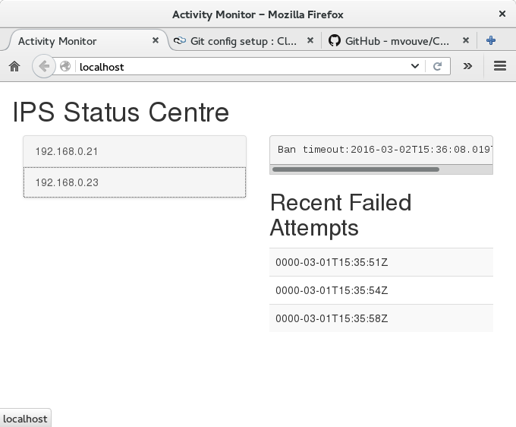

As you can see the monitor has several features, on the left hand side, it displays hosts that have failed to enter the correct password since the program was initialized.

When a host is selected there are several pieces of information listed on the left about the host. At the top, the time stamp of when a ban, if it exists will end is shown. In a table below the time of all the clients failed log-ins will be listed.